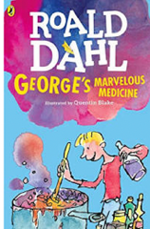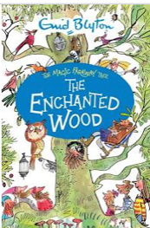 Year 2 Summer 1 Curriculum Overview

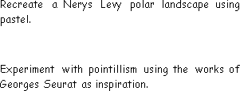

**Science**

**Unit: Plants and Life cycles**

**Key questions/ experiments:**

* How do bulbs and seeds change over time?
* How does temperature affect the growth of plants?
* Are there patterns between the life cycles of different animals?

**Mathematics**

**Focus:** Fractions and Time

**Objectives include:**

* Find one third of a quantity
* Find two quarters of a quantity
* Find three quarters of a quantity
* I can tell the time to the nearest five minutes as well as quarter past and quarter to.
* I can draw hands on a clock face to show this.

**Art/Design Technology**

**Sculpture and 3D: Clay Houses**

* Begin to shape and decorate clay, create a pinch pot, design and create a clay tile with house features.
* Use hands and tools to develop basic skills when cutting, shaping and joining materials.

**PSHE**

**Unit: Relationships**

**Overview:**

* Being aware of how my choices affect others
* Awareness of how other children have different lives

**Religious Education**

**Unit:** Judaism

**Key Question:** How special is the relationship Jews have with God?

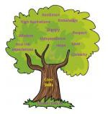

**PE**

Net and Wall

Develop skills needed for sports such as

Tennis, badminton, and volleyball.

Yoga

Develop fitness skills such as flexibility,

balance and control.

**This half term, at story time, Year 2 HG/SW will be enjoying Enid Blyton books and Year 2 AT will be reading books by Roald Dahl.**

**Computing**

**History**

**Music**

**Unit: Orchestral Instruments**

Listen to and analyse instruments

in different versions of traditional Western stories. Play and perform

a story script with accompanying

music.

**English**

**Text: Vlad and the Great Fire of London**

**Skills:**

* First person
* Conjunctions
* Possessive apostrophes
* Similes, adverbs
* Past and present progressive verbs
* Diary entry, description, and a recount.

**Unit: The Great Fire of London**

**Key Question:**

Who was to blame for the Great Fire of London?

**Unit: Creating Media: Stop Motion**

* Understanding what animation is
* Planning and creating stop motion animations