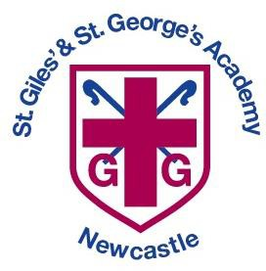
St. Giles’ & St. George’s Church of England Academy
St Paul’s Road Off Orme Road
Newcastle
Staffs ST5 2NB
Telephone: 01782 917640 e-mail : office@stgg.org.uk
Website: www.stgilesstgeorgesacademy.co.uk

21st February 2024
Dear Parents,

Swimming is a fundamental part of the National Curriculum and all schools are required to ensure that by the end of Primary school pupils are taught to;

- swim competently, confidently and proficiently over a distance of at least 25 metres
- use a range of strokes effectively [for example, front crawl, backstroke and breaststroke]
- perform safe self-rescue in different water-based situations.

In order to ensure we can provide this for our pupils this year we have organised for a temporary swimming pool to be placed on the school site for 3 weeks from Monday 4th March (and again for 3 weeks from Monday 10th June). The pool will be 32 x 16 ft - 55,000 litres, filtered, heated between 26-32 degrees and covered with a secure marquee. There will also be a fully qualified swimming teacher and lifeguard on duty in the pool throughout the school day.

This provides an excellent opportunity for all pupils in school to experience swimming with the aim of all children achieving an award by the end of the three weeks. Children in EYFS, Year 1, Year 2 and Year 6 will have 1 30 min session each week with children from Year 3-5 having 2 30 min sessions each week. Separate changing facilities will be provided for boys and girls and all children will be split into ability groups of no more than 12.

All children will require;
- Swimming costume/trunks
- Towel
- Swimming hat (this includes boys)
- Goggles cannot be worn

Swimming Timetable

Day | Year groups Swimming
Monday | Nursery, Reception and Year 1
Tuesday | Year 3 and 4 and and children needing additional support
Wednesday | Year 3 and 4
Thursday | Year 5 and Year 2
Friday | Year 5 and Year 6

As mentioned above Swimming is a compulsory part of the National Curriculum so we expect all children to take part. If you have concerns, please speak to your child’s class teacher. Swimming will begin on Monday 4th March.

Yours sincerely

Mrs Pointon Headteacher

