St Giles’ and St George’s C of E Academy
Aspire Believe Achieve
Thursday 22nd February
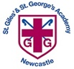

Diary Dates
Wednesday 21st February | LKS2 DT GLOW service
Thursday 22nd February | Year 1 trip to Chester Zoo
Monday 4th March (for 3 weeks) | Swimming pool at school
Wednesday 6th March | Recorder Festival
Wednesday 6th March | EYFS (Squirrels) SHINE event
 | EYFS (Badgers and Hedgehogs) SHINE event
Thursday 7th March | Stoke’s Gotta Sing
Sunday 10th March | Mothering Sunday All Age Worship at St Giles’
Tuesday 12th March | Yr 5&6 NSPCC Speak out, Stay safe Workshops
Wednesday 13th March | Year 2 AT GLOW service
Thursday 14th March | LKS2 trip to Poole’s Cavern
Friday 15th March | Non-uniform day -bring an Easter Egg
Thursday 21st March | PTFA Easter Bingo
Friday 22nd March | Finish for Easter holidays
Monday 8th April | Return from the holiday
Thursday 11th April | Parents evening
Wednesday 17th April | Ye SW/HG GLOW service
Friday 3rd May | Class photos
Monday 13th – Thursday 16th May | Year 6 SATs
Wednesday 15th May | Year 1 EP GLOW service

The Spread the Love Disco that was due to take place before half term has now been rearranged for Wednesday 28th February.

EYFS: In school time
Year 1 – Year 3: 4.45pm – 5.45pm
Year 4 – 6: 6pm – 7pm

Healthy Eating

As a school, we promote healthy eating to our children and provide fruit for EYFS and KS1 as a snack at breaktime and we also have fruit available for KS2. We know that some parents like to send their child with a snack from home to eat ar breaktime; could we please ask that this is a healthy snack and limited to just one item. Please also ensure your child has a water bottle in school each day (no energy drinks)
World Book Day!

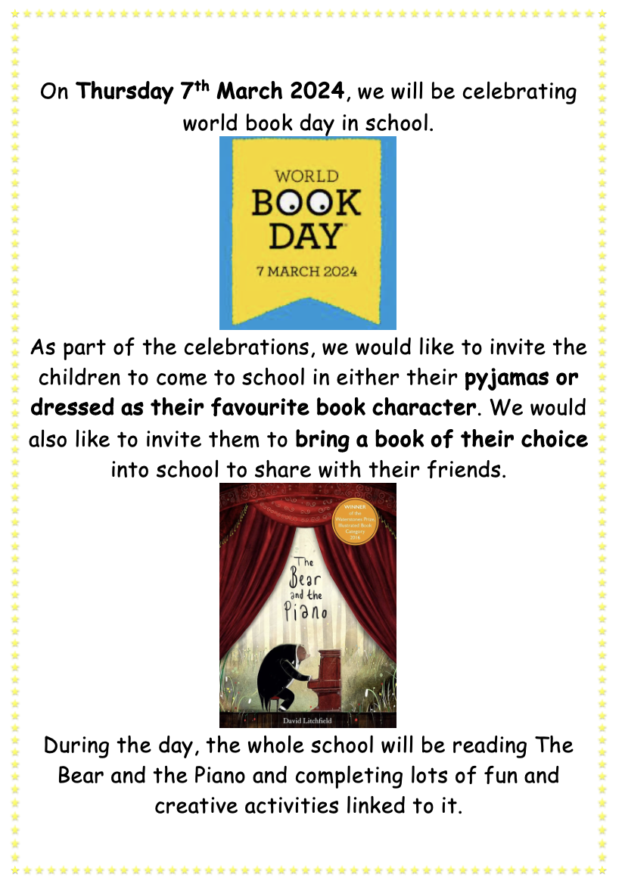
Swimming

Swimming is a fundamental part of the National Curriculum and all schools are required to ensure that by the end of Primary school pupils are taught to;

- swim competently, confidently and proficiently over a distance of at least 25 metres
- use a range of strokes effectively [for example, front crawl, backstroke and breaststroke]
- perform safe self-rescue in different water-based situations.

In order to ensure we can provide this for our pupils this year we have organised for a temporary swimming pool to be placed on the school site for 3 weeks from Monday 4th March.

All children will require;
- Swimming costume/trunks
- Towel
- Swimming hat (this includes boys)
- Goggles cannot be worn

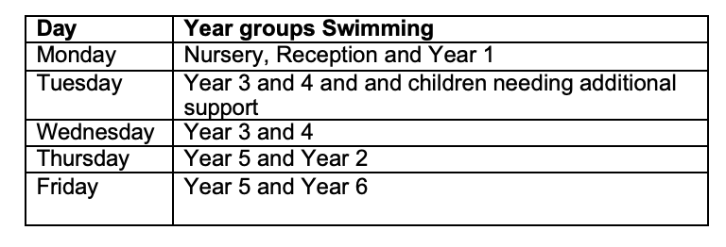

Easter Bonnets and Eggs
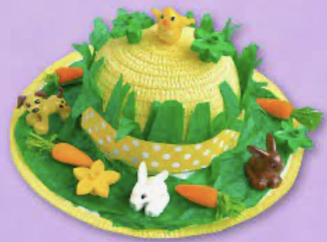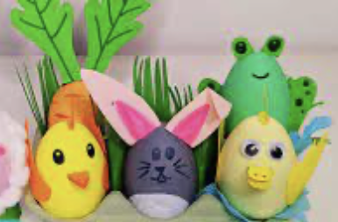
On Thursday 21st March, we will be having our annual Easter bonnet parade (for EYFS and KS1) and decorate an egg competition (for KS2) and we would like to encourage the children to be creative and get thinking about their designs.

