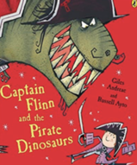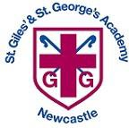 Year 2 Autumn 2 Curriculum Overview

**This half term, at story time, Year 2 AT will be enjoying books by Tom Percival and Year 2 HG/SW will be reading the Captain Flinn series.**

**English**

**Text: The Lighthouse Keeper’s Lunch**

**Skills:**

* Commas used accurately for lists.
* Sentence types (2A sentence and … as a, … like a sentence)
* Imperative verbs are used to instruct.
* Sentence openers, including time adverbials.
* Apostrophes are used accurately and consistently for contracted forms.

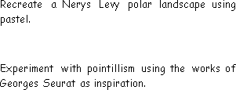

**Science**

**Unit:** Materials and Plastic

**Key questions/ experiments:**

* Why is it important to reuse and recycle materials?
* Which material would be the best for an umbrella?

**Mathematics**

**Focus:** Addition & Subtraction; Geometry

**Objectives include:**

* Fact families to 20
* Number bonds to 100.
* Add and subtract 1s
* Add and subtract 2 digit numbers
* Sorting 2D and 3D shapes
* Counting edges, vertices and faces on 3D shapes
* Identifying lines of symmetry

**PSHE**

**Unit:** Celebrating differences

**Overview:**

* Bullying
* Including others
* Giving compliments

**Religious Education**

**Unit:** Gospel

**Key Question:** What is the Good news that Jesus brings?

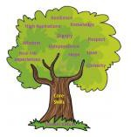

**PE**

Fitness

Develop fitness skills such as stamina,

balance and agility

Forest Schools

Build a lean to shelter and learn how to

use a compass to follow a map

.

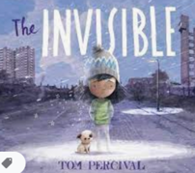

**Music**

**On this island: British songs and sounds**

Children will learn folk songs and create soundscapes for different environments

**Humanities**

**Geography**

**Key Question:**

What is it like to live on the coast?

**Computing**

**Unit:** Algorithms and debugging

* What is an algorithm?
* How are algorithms used in technology?

**Art/Design Technology**

**Art:** Painting and mixed media

Children explore collage, painting and the work of Romare Bearden to create a seaside collage.