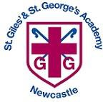 Year 2 Autumn 1 Curriculum Overview

**This half term, at story time, Year 2 HG/SW will be enjoying books by Tom Percival and Year 2 AT will be reading the Captain Flinn series.**

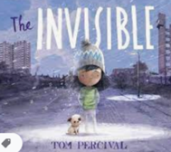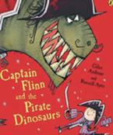

**English**

**Text:** The Queen’s Hat

**Skills:**

* Full stops, questions marks, exclamation marks and commas
* Sentence types
* Conjunctions
* Time adverbials

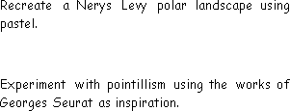

**Science**

**Unit:** Animal needs for survival and Humans

**Key questions/ experiments:**

* How can we group animals based on their needs for survival?
* How are the needs of humans similar or different from those of other animals?
* Do the oldest children have the most teeth?

**Mathematics**

**Focus:** Place Value, Addition & Subtraction

**Objectives include:**

* Tens and ones, using a part whole model and addition.
* Compare and order objects and numbers.
* Count in 2s, 5s, 10s and 3s.
* Fact families to 20
* Number bonds to 100.
* Add and subtract 1s

**PSHE**

**Unit:** Being Me In My World

**Overview:**

* Hope and fears
* Rights and responsibilities
* Rewards and consequences

**Music**

**Myths and Legends**

Children will explore structure, notations and texture and create their own graphic scores

**Religious Education**

**Unit:** What Did Jesus Teach?

**Religion:** Christianity

**Key Question:** Is it possible to be kind to people all the time?

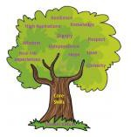

**PE**

Fundamentals

Focus on running, jumping, hopping and

skipping

Ball skills

Focus on sending and receiving a ball

.

**Humanities**

**Unit:** History- Monarchy

**Key Question:**

What is a monarch?

**Computing**

**Unit:** What is a computer?

* What does a computer need?
* What everyday items use technology and how?

**Art/Design Technology**

**DT Unit:** Structures

Children design and build a throne for a monarch.