v

**THE SCHOOL DAY**

School begins at 8:40am and ends at 3:15pm on Wednesday 6th September. Children will need to come to school in their uniform with a bag and a water bottle. Please make sure these are clearly labelled with full names. Our Teaching Assistant will be Mrs Leech, who is a very experienced teaching assistant, she has taught in our school for many years and knows the children and families well. PE days will be **WEDNESDAY** and **THURSDAY,** although this will be confirmed in September. Our proposed timetable is below.

My name is Mrs Gray.

I will be teaching Year 2 on a Monday, Tuesday and Wednesday. This will be my 5th year teaching at St Giles’ and St George’s Academy. I have taught in Years 1,2 and 3/4 and am looking forward to be being back in Year2 this year. I also hold responsibility for the teaching of music within school.

Outside of school, I enjoy spending time with my two daughters and completing different craft activities with them.

**Mrs Wright**

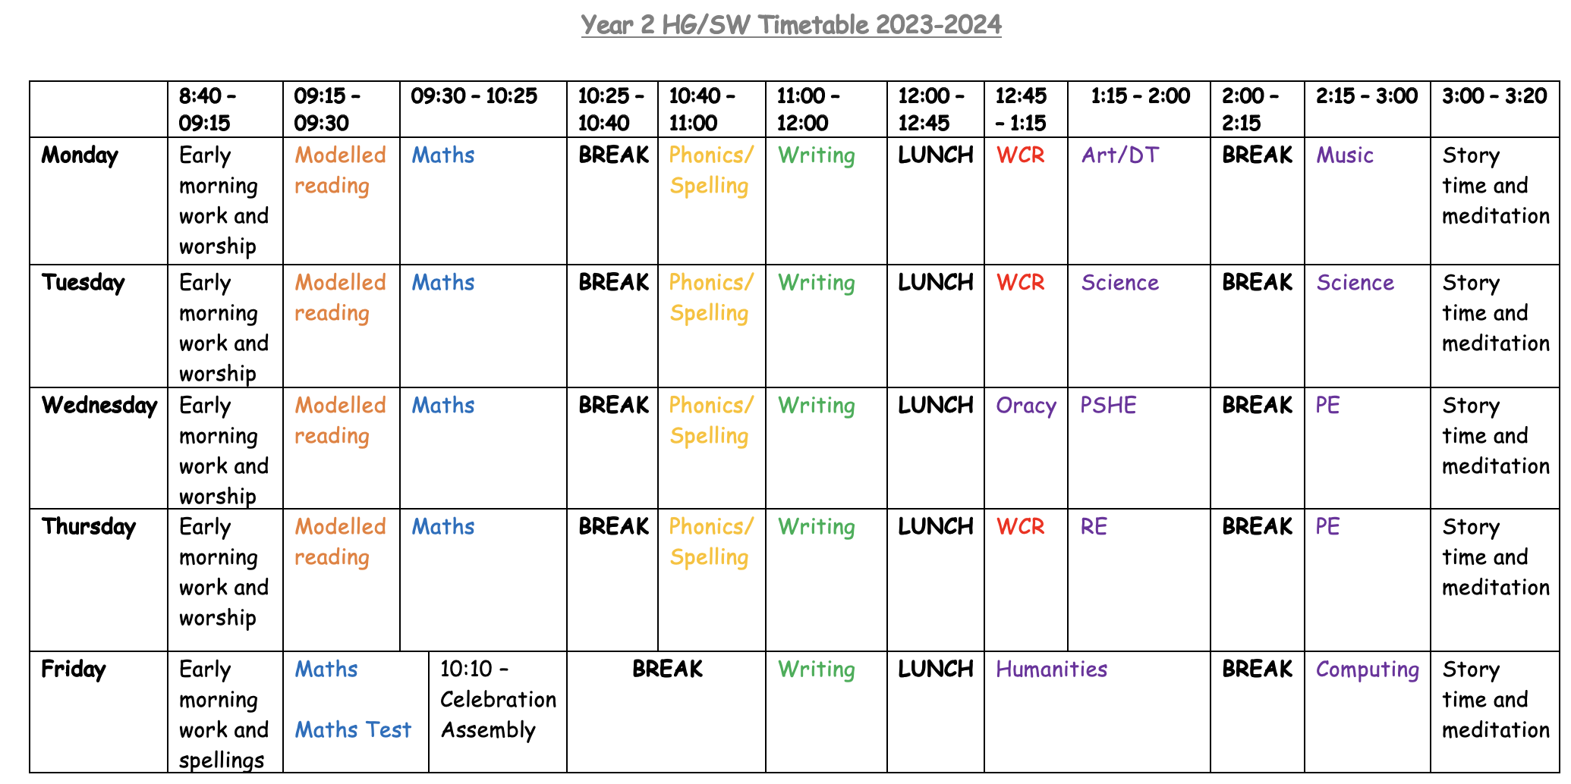

**HOMEWORK**

Homework will be set every week (on a Friday) via Class dojo with a focus on either English or Maths. You can return the homework by the following Friday via Class dojo so we can see it. If you require paper copies of the homework, please just let us know. We also encourage you to read at home with your child at least 3 times a week and practise their spellings and maths facts with them on a regular basis.

**We hope you have a super summer holiday and we look forward to being your new class teachers in September.**

**Mrs Gray and Mrs Wright**

My name is Mrs Wright.

I will be teaching Year 2 on a Thursday and a Friday. This will be my 10th year teaching at St Giles’ and St George’s Academy. I have taught in Years 3, 4, 5 and 6, and look forward to teaching Year 2 this year. I also hold responsibility for the teaching of RE within school.

Outside of school, I enjoy spending time with my two children and exploring the outdoors with them.

**Mrs Gray**

**Welcome to Year 2 HG/SW**