St Giles’ and St George’s Primary Academy
Homework Menu
Class: Nursery Theme: Seaside & Holiday’s Term: Summer 2
Set Menu: Daily reading, sound fans
We are asking children to share their library book each week and for parents to record this in their child’s reading record. You can introduce early reading skills such as: turning the pages carefully, holding the book correctly, talking about the pictures and anticipating what might happen next.
Added Extras:
Please encourage your child to complete as many activities from the menu as they can, but NO LESS than 3 over the half term. We will ask for homework to be handed in during the last week of each half term, in order for us to share and celebrate this learning.
Draw/Write it | Count it | Visit it
Draw a picture of where you would like to go on holiday. Add your name and some initial sound labels if you can. | Teddy Bears Picnic counting game. Roll a dice, take that number of teddies out of the box and put them around the picnic rug.”  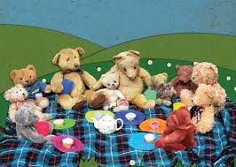  Prompts: Tell me what the dice says. Have we got room for any more teddies? Is that more than/less than/the same as your last roll? | Visit a park or the seaside. Enjoy! Take some pictures of the different types of transport that you see on your journey, or talk to your grown up about what you have noticed.
Create it | Listen to it | Make it
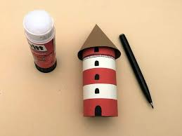  Design and create a lighthouse. This could be a craft model, a lego model, a painting or collage. Take a picture of your lunch box and add to evidence me, or bring it to school. | Listen to our special songs, and try to learn the chorus for each one  You got a friend in me  https://www.youtube.com/watch?v=cNIg45GZ_ts  Reach for the stars  https://www.youtube.com/watch?v=D6raJluIg40  ` | 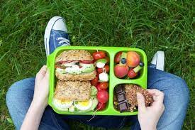  Design and make your own packed lunch picnic. What healthy food will you add to it? Talk to your grown up about which food s are heathy or unhealthy and why. Can you use the kitchen tools to make a sandwich? Or weigh ingredients to bake a cake? Can you chop fruit for a fruit salad? Take a picture of your lunch box and add to evidence me, or bring it to school for your lunch one day.

