St Giles’ and St George’s Primary Academy
Homework Menu
Class: 3/4 NB Teacher: Miss Bowers Topic: Electricity (Science Unit) Term: Summer 2
Set Menu: Daily reading, spellings, my maths, TT rockstars
We are asking children to read at least 3 times each week and for parents to record this in their child’s reading record. Listening to children read will enable them to practise their sounds and develop their reading fluency. Please talk to your child about their book, the pictures inside and what might happen next. This will help to develop their comprehension skills and have a better understanding of the text. Furthermore, we ask that children practise their spellings regularly, as they will be tested on them in school. Children are also required to access My Maths, Maths Shed and TT Rockstars on a regular basis, as activities will be set on there for them to complete. We are grateful for your support with this.
Added Extras:
Please encourage your child to complete as many activities from the menu as they can, but NO LESS than 3 over the half term. Please record the activities in your child’s homework book, this can include photographs. We will ask for homework books handed in during the last week of each half term, in order for us to share and celebrate this learning.
Write it | Research it | Explain it
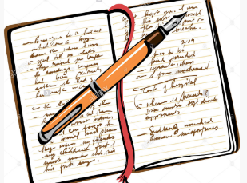  Imagine a world with no electricity. Write a diary entry as if you live in that world. | Research a famous scientist linked to electricity and present your findings.  Ideas:  - Nikola Tesla  - Thomas Edison  - Alessandro Volta  - Georg Simon Ohm | Explain how electricity is created. Draw diagrams to support your explanation.
Compose it | Sort it | Create it
Compose an acrostic poem about electricity. | Look for items around you home and sort them into mains powered devices and battery powered devices.  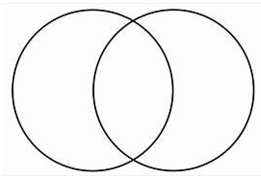 | 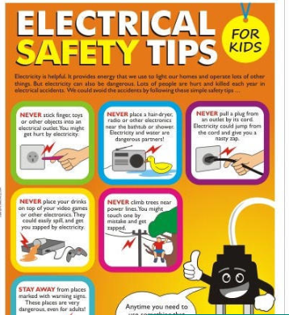  Create a poster advising people how to be safe when using electricity.

