St Giles’ and St George’s Primary Academy
Homework Menu
Class: Reception Topic: Commotion in the Ocean! Term: Summer 2
Set Menu: Daily reading, sound fans
We are asking children to read at least 3 times each week and for parents to record this in their child’s reading record. Listening to children read will enable them to practise their sounds and develop their reading fluency. Please talk to your child about their book, the pictures inside and what might happen next. This will help to develop their comprehension skills and have a better understanding of the text. We will be sharing a variety of texts related to our Pirates topic and helping your child to foster a love of books. We are grateful for your support with this. We also ask that you practise saying the sounds and tricky words on your sound fan daily. Please see the link on our website to ‘Mr Thorne does Phonics’ if you are unsure as to how we pronounce the Phase 2 sounds.
Added Extras:
Please encourage your child to complete as many activities from the menu as they can, but NO LESS than 3 over the half term. Please record the activities in your child’s homework book, this can include photographs. We will ask for homework books handed in during the last week of each half term, in order for us to share and celebrate this learning.

Perform it | Research it | Design it
Can you learn and perform ‘once I caught a fish alive’ and ‘I had a little turtle’? Can you send a video on evidence me so we can see your performance? | 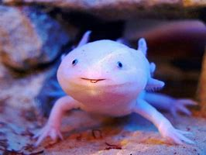  Research about animals that live in the sea. Can you find the most unusual sea creature as you can and write about them? How deep in the sea do they live? What do they eat? What colour are they? | 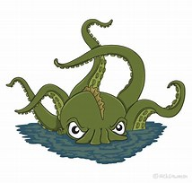  Create your very own sea creature! Go as wild as you want. How many legs will your monster have? What will it eat? Design and write about your very own sea creature.
Taste it | Make it | Solve it
What things grow under the sea that we can eat? Can you taste some things that live/grow under the sea? Can you try fish or sea weed? Can you think of anything else you could try? Send photos and videos into evidence me. Record if you liked it or not.  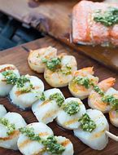 | 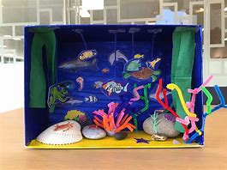  Can you make a 3D sea/ocean scene? Can you make the animals that live in the sea? Can you make any parts movable? How will you join the pieces together? | Can you count the sea animals and write how many there are? Can you solve the addition calculations? Can you make any more additions of your own?  