St Giles’ and St George’s Primary Academy
Homework Menu
Class: Nursery Theme: Super Safari Term: Summer 1
Set Menu: Daily reading, sound fans
We are asking children to share their library book each week and for parents to record this in their child’s reading record. You can introduce early reading skills such as: turning the pages carefully, holding the book correctly, talking about the pictures and anticipating what might happen next.
Added Extras:
Please encourage your child to complete as many activities from the menu as they can, but NO LESS than 3 over the half term. We will ask for homework to be handed in during the last week of each half term, in order for us to share and celebrate this learning.
Draw/Write it | Practice it | Compare it
Fill in the ‘Very Hungry Caterpillar’ food diary, by drawing what you ate each day, you can make marks to add labels to your drawings too. How does this compare to what ‘The Very Hungry Caterpillar’ ate? Which foods are healthy foods? 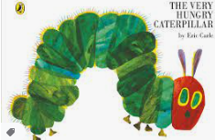 | Practice our poem of the half term ‘5 Little Monkey’s swinging through the trees’ including the actions.  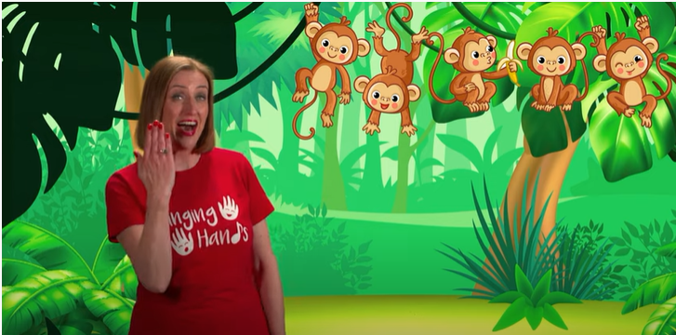https://www.youtube.com/watch?v=cwPMzrwsehs | Go on a number hunt around home or local area, can you find numbers 1,2,3,4 and 5? What numbers did you find at home? What numbers did you find outside? Did you find the same number in different places? Take photos of the numbers you found and add to evidence me or send via Dojo.  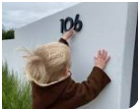
Create it | Talk about it | Investigate it
Design and create a mask of your favourite animal.  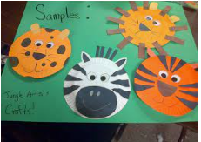  (or other animal inspired arts and craft of your choice) | Have look at this ‘See, Think, Wonder’ picture and talk together, asking: What do you see? What do you think is happening? What does it make you wonder? | Go on a mini beat hunt in your garden or at the park. What can you find? Where did you find it? How many legs does it have? Can you identify it? Can you draw a picture of what you found?  