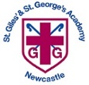
St Giles’ and St George’s C of E Academy
Homework Menu
Year Group: 5/6 Topic: Mayan Civilisation Term: Summer 1 2022
Set Menu Timetables, spellings, daily reading, phonics practise
We will be looking for children to be reading at home with their parents or carers. Listening to children read will enable them to grow in confidence as they become fluent readers. Once children are able to read fluently and with expression, hold discussions around the comprehension of the text (we will provide a bank of ideas to support this). If your child is reluctant to read, they could listen to audio books. We want them to foster a love of books so please do not underestimate the value of reading to your child.
Added Extras
We will encourage your child to complete as many of the activities for the menu as they like at home but NO LESS than 3 over the half term. This can be recorded (if appropriate) in our home books. We will ask for homework books on the last Monday of each half term in order for us to share and celebrate the learning.
Read it | Research it | Design it and make it
Visit your local library to read about the Mayan Civilisation.  If not possible, visit these sites to find out some fun facts and key information about that period of history.  www.bbc.co.uk/bitesize/topics/zq6svcw  www.dkfindout.com/uk/history/mayans/  https://historyforkids.org/ancient-mayans-facts-for-kids/ | 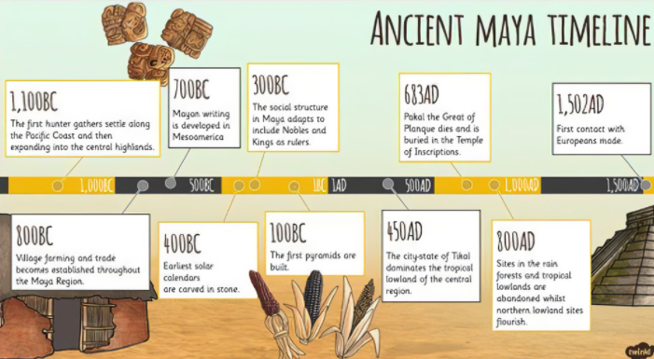  Research ‘The Mayans’ and create a timeline of the key events. | Design your own Maya Mask!  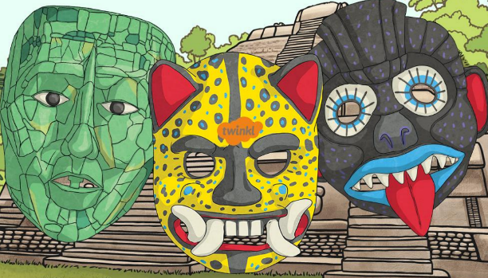  Masks played a central role in Maya culture. They were made for a variety of occasions and purposes.  Event masks  They were often inspired by animals; they were vibrant and colourful.  Death masks  Mayas were buried with a death mask, which was intended to protect the wearer on their journey to the afterlife.
Practise it | Write it
Make sure that you can fluently recall your maths facts. Log on to EdShed: Practise your spellings and complete maths challenges.  https://www.edshed.com/en-gb/login | Use the Mayan writing system of hieroglyphs to write your own name or coded work or message that can be decoded.  (See reverse of the this sheet)

