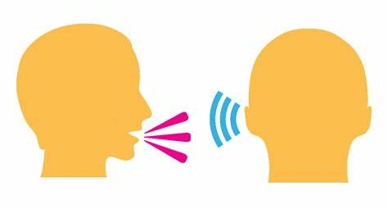

Oracy, Communication and Language
Curriculum

Intent

Our Oracy, Communication and Language curriculum reflects the importance of listening, understanding and spoken language in pupils’ development. St Giles’ and St George’s believe that these areas of communication and language underpin the development of reading and writing. The quality and variety of language that pupils hear and speak are vital for developing their vocabulary and grammar and their understanding for reading and writing. We believe that pupils at our school should develop these skills to enable them to explain their understanding of books and other reading, and to prepare their ideas before they write.

As a Church of England school, our Oracy, Communication and Language curriculum is underpinned by our gospel values. Our children are learned and wise in the way that they practise and apply their communication and language skills in a variety of different contexts and use these skills to become independent and resilient learners. They show active learning through their use of applying their communication and language skills through all areas of the curriculum. Our gospel values create a solid moral background for our children and encourage them to become better members of society.

Our curriculum starts with our youngest of pupils, ensuring that they can pay attention, listen and understand what has been communicated to them. This then develops into speech and spoken language. Embedding the curriculum from Nursery allows our pupils to have all the building blocks that they need in order to develop and apply their communication and language skills further in their school journey. At St Giles’ and St George’s Academy, we believe pupils’ communication skills are essential for socialising, learning and to reach their potential. We know that the majority of communication development takes place in the early years of life, so we ensure that our Early Years pupils are supported as well as they can be, as well as through the school.

Our children come from a wide range of backgrounds and many are not equipped with the communication and language skills and experiences they need to become the communicators that they can be. We have worked together to create our main outcomes that we want for our children. Through our oracy, communication and language curriculum, we want to allow our children to develop the independence and resilience needed in order to have high aspirations and achieve their full potential.

New Framework EYFS Early Learning Goals

ELG: Listening, Attention and Understanding Children at the expected level of development will:

- Listen attentively and respond to what they hear with relevant questions, comments and actions when being read to and during whole class discussions and small group interactions;
- Make comments about what they have heard and ask questions to clarify their understanding;
- Hold conversation when engaged in back-and-forth exchanges with their teacher and peers.

ELG: Speaking Children at the expected level of development will:

- Participate in small group, class and one-to-one discussions, offering their own ideas, using recently introduced vocabulary
- Offer explanations for why things might happen, making use of recently introduced vocabulary from stories, non-fiction, rhymes and poems when appropriate
- Express their ideas and feelings about their experiences using full sentences, including use of past, present and future tenses and making use of conjunctions, with modelling and support from their teacher.

EYFS Wellcomm Overview
EYFS Wellcomm Overview

In the Early Years, we use the Early Communication Screening (ECS) tool to identify children who may need support with an aspect of speech and language (understanding, spoken language and speech). Following this, we might feel that a child would benefit from ‘Time to Talk’, an intervention developed by speech and language specialists.
We use Wellcomm as a taught session during ‘Snack and Social’ for all Reception pupils. We use a ‘Word Wizard’ and phonics sessions, to develop children’s communication, language and vocabulary skills. In Nursery, the Wellcomm sessions are taught through provision or during ‘Snack and Social’ to ensure the skills are embedded.

 | Autumn 1 | Autumn 2 | Spring 1 | Spring 2 | Summer 1 | Summer 2
Nursery  (Wellcomm Section 6 and 7) | Baseline and ECS  Recap Section 5 chosen areas to suit the cohort. | Section 6.1  Understand the pronouns ‘he’ and ‘she’  Section 6.2  Understand prepositions ‘behind’ and ‘in front’  Section 6.3  Understand the negative form (no/not isn’t, can’t) | Section 6.4  Understand the function of body parts (eyes for looking, ears for listening)  Section 6.5  Play sociably and learn to share  Section 6.6  Developing expressive language | Section 6.7  Understand and use verbs in the past tense  Section 6.8  Generating ideas about the function of objects (semantic links)  Section 6.9  Understand and answer ‘why’ questions  Section 6.10  Learn to remember and then say the names of three things | Section 7.1  Role play  Section 7.2  Understanding ‘many’ and ‘few’.  Section 7.3  Understanding ‘long’ and ‘short’  Section 7.4  Learning the meaning of ‘why’  Section 7.5  Understanding ‘first’ and ‘last’ | Section 7.6  Understanding and using four-word sentences  Section 7.7  Using comparatives: ‘bigger’, ‘longer’ and ‘smaller’  Section 7.8  Understanding opposites: ‘wet’/‘dry’  Section 7.9  Understanding and using pronouns: ‘his’ and ‘her’  Section 7.10  Linking sentences using ‘because’

 | Autumn 1 | Autumn 2 | Spring 1 | Spring 2 | Summer 1 | Summer 2
Reception  (Wellcomm Section 8 and 9) | Baseline and ECS  Recap Section 7  Discussion - What makes a good speaker/listener?  Section 8.1 Understanding ‘when  Section 8.2 Understanding that things that go together are not always the same.  Section 8.3 Learning the meaning of ‘after’.  Section 8.4 Understanding post modified sentences  Section 8.5 Understand sentences containing ‘either’ and ‘or’. | Section 8.6  Using an increasing range of prepositions:  ‘behind’, ‘in front’, ‘next to’ and ‘between  Section 8.7  Understanding emotions from facial expressions  Section 8.8  Understanding question words using stories  Section 8.9  Learning to remember and then say 5 things  Section 8.10  Using superlatives ‘biggest’ and ‘smallest’ | Consolidate Section 8  Section 9.1  Understanding which day comes next  Section 9.2  Understanding passive sentences  Section 9.3  Identifying an increasing range of emotions and feelings in ourselves and others  Section 9.4  Begin to understand idioms  Section 9.5  Predicting what might happen next | Section 9.6  Understanding periods of time  Section 9.7  Remembering more and more information  Section 9.8  Using category names and explaining the differences between things in the same category/finding the odd one out  Section 9.9  Make inferences using idioms  Section 9.10  Talk about things that are going to happen (future tense)  Consolidate Section 9 | Early Learning Goals  Communication and Language opportunities  Listening, Attention and Understanding:  • Listen attentively and respond to what they hear with relevant questions,  comments and actions when being read to and during whole class discussions  and small group interactions.  • Make comments about what they have heard and ask questions to clarify their  understanding.  • Hold conversation when engaged in back-and-forth exchanges with their teacher  and peers. | Early Learning Goals Communication and Language opportunities  Speech:  • Participate in small group, class and one-to-one discussions, offering their own  ideas, using recently introduced vocabulary.  • Offer explanations for why things might happen, making use of recently introduced  vocabulary from stories, non-fiction, rhymes and poems when appropriate.  • Express their ideas and feelings about their experiences using full sentences,  including use of past, present and future tenses and making use of conjunctions,  with modelling and support from their teacher.

Spoken language – National Curriculum

Pupils should be taught to:
- listen and respond appropriately to adults and their peers
- ask relevant questions to extend their understanding and knowledge
- use relevant strategies to build their vocabulary
- articulate and justify answers, arguments and opinions
- give well-structured descriptions, explanations and narratives for different purposes, including for expressing feelings
- maintain attention and participate actively in collaborative conversations, staying on topic and initiating and responding to comments
- use spoken language to develop understanding through speculating, hypothesising,
- imagining and exploring ideas
- speak audibly and fluently with an increasing command of Standard English
- participate in discussions, presentations, performances, role play, improvisations and debates
- gain, maintain and monitor the interest of the listener(s)
- consider and evaluate different viewpoints, attending to and building on the contributions of others
- select and use appropriate registers for effective communication.

The Oracy Framework

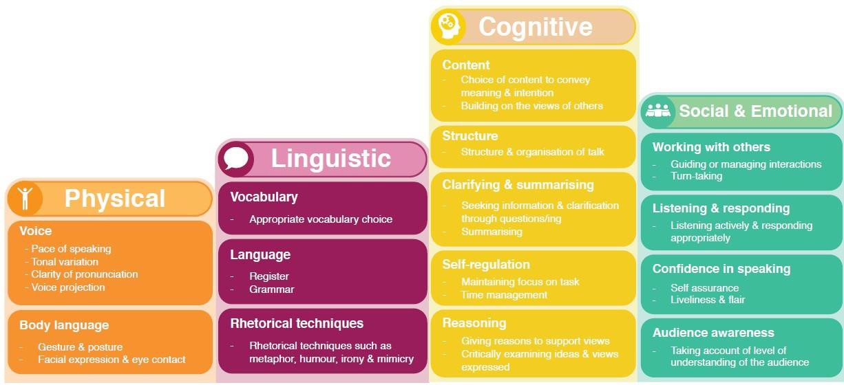

Progression of skills – Year 1
Physical  - To use the appropriate tone of voice in the right context. E.g. speaking calmly when resolving an issue in the playground.  - To speak clearly and confidently in a range of contexts. | Linguistic  - To use vocabulary appropriate specific to the topic at hand.  - To take opportunities to try out new language, even if not always used correctly.  - To use sentence stems to link to other’s ideas in group discussion. E.g. ‘I agree with… because …’ ‘Linking to …’  - To use conjunctions to organise and sequence ideas e.g. firstly, secondly, finally.
Cognitive  - To offer reasons for their opinions.  - To recognise when they haven’t understood something and asks a  question to help with this.  - To disagree with someone else’s opinion politely.  - To explain ideas and events in chronological order. | Social and Emotional  - Listens to others and is willing to change their mind based on what they have heard.  - To organise group discussions independently of an adult.
Teaching Ideas
- Introduce pupils to different protocols to scaffold turn-taking e.g. putting a thumb in when they want to speak, or taking turns passing talk around a circle.
- Use visual aids to support pupils’ awareness of talk e.g. using counters to represent contributions to a discussion or passing wool from speaker to speaker to show how contributions in a conversation should link to each other.
- As a teacher, explicitly model your own use of questions to clarify your understanding, e.g. ‘I didn’t understand that so I’m going to ask a question to help
me. What did you mean by X?’
- Draw pupils’ attention to the role that listening has in developing understanding. E.g. ‘Now that we have heard that, has anyone changed their mind?’
Experiences
- To take part in small group discussions without an adult.
- To be filmed speaking and use this for reflection.
- To speak in front of a larger audience e.g. during an assembly.

Progression of skills – Year 2
Physical  - To start to use gesture to support the delivery of ideas e.g. gesturing towards someone if referencing their idea, or counting off ideas on their fingers as they say them. | Linguistic  - To adapt how they speak in different situations according to audience.  - To use sentence stems to signal when they are building on or challenging  others’ ideas.
Cognitive  - To ask questions to find out more about a subject.  - To build on others’ ideas in discussions.  - To make connections between what has been said and their own and  others’ experiences. | Social and Emotional  - To start to develop an awareness of audience e.g. what might interest a certain group.  - To be aware of others who have not spoken and to invite them into discussion.  - Confident delivery of short pre-prepared material.
Teaching Ideas
- Introduce sentence stems with accompanying gestures to support meaning for both speaker and their audience. E.g. linking fingers together for ‘linking to’
and holding up one finger to emphasise their first point.
- Create different role play scenarios which enable pupils to practice speaking in different contexts e.g. having tea with the Queen, talking to sibling, talking to a neighbour or a friend on the playground.
- Play games which encourage pupils to elaborate on their ideas, e.g. ‘tell me more’ or ‘just a minute’.
- Use hot-seating and question tennis to develop pupils’ questioning skills.
- Praise pupils who invite others into discussions and as a class develop ideas for how this can be done, e.g. saying their name, asking them a question, turning to them.
- Before students deliver presentational talk create structured opportunities for pupils to reflect on what will engage their audience e.g. how can they make their object for ‘show and tell’ interesting for their peers.
Experiences
- Speak to unfamiliar people with real purpose e.g. asking questions to a museum curator or having a conversation with a visitor in the classroom.
- Participate in a short ‘show and tell’ session.

Progression of skills – Year 3
Physical  - Deliberately varies tone of voice in order to convey meaning.  E.g. speaking authoritatively during an expert talk or speaking with pathos when telling a sad part of a story.  - Considers position and posture when addressing an audience. | Linguistic  - To be able to use specialist language to describe their own and  others’ talk.  - To use specialist vocabulary.  - To make precise language choices e.g. instead of describing a cake as  ‘nice’ using ‘delectable’.
Cognitive  - To offer opinions that aren’t their own.  - To reflect on discussions and identify how to improve.  - To be able to summarise a discussion.  - To reach shared agreement in discussions. | Social and Emotional  - To adapt the content of their speech for a specific audience.  - To speak with confidence in front of an audience.
Teaching Ideas
- Expose students to a range of models for talk, e.g. by meeting an expert or watching a talk online. Unpick why each speaker is successful e.g. how they establish their authority.
- Develop a shared language to describe talk in the classroom through creating a class set of ‘discussion guidelines’. These can be used as success criteria to
support pupils to reflect on their discussions.
- Spend time teaching pupils what it means to be a chair, e.g. a chair should be prepared to ask probing and clarifying questions and encourage others to do so too.
- Scaffold pupils’ summaries by allocating one student in a trio discussion the role of the ‘silent summariser’. While the other members of the trio discuss an idea, the silent summariser must remain quiet, listen and then feedback the main points at the end of the discussion.
- Play ‘articulate’ with specialist subject vocabulary
Experiences
- Take on an expert role e.g. to deliver a talk or speech as an astrologist or archaeologist.
- Become a storyteller for an authentic audience.
- Present to an audience of older or younger students.
- Chair a discussion.
- Hold a class meeting.

Progression of skills – Year 4
Physical  - To consider movement when addressing an audience.  - To use pauses for effect in presentational talk e.g. when telling a anecdote or telling a joke. | Linguistic  - To carefully consider the words and phrasing they use to express their ideas and how this supports the purpose of talk.
Cognitive  - To be able to give supporting evidence e.g. citing a text, a previous example or a historical event.  - To ask probing questions.  - To reflect on their own oracy skills and identify strengths/weakness. | Social and Emotional  - To use more natural and subtle prompts for turn taking.  - To be able to empathise with an audience.  - To consider the impact of their words on others when giving feedback.
Teaching Ideas
- Introduce pupils to sentence stems to cite evidence and ask probing questions.
- Teach the conventions for different types of talk, e.g. in oral storytelling using similes, metaphors, time connectives, rich description and techniques to
build suspense. In a persuasive pitch using a ‘hook’ to grab the audience’s attention, rhetorical devices such list of three and rhetorical questions.
- Create opportunities for pupils to reflect on their own oracy skills and those of their peers, and set targets for improvement.
- Set up discussions where each pupil has key information to bring to the discussion. E.g. each pupil has read a different historical source or piece of evidence and the group needs to decide the cause of the central event.
- When using trio discussions, allocate one member of the trio the role of questioner. Their sole responsibility during the trio discussion is to ask questions of the rest of the group.
Experiences
- To use talk for a specific purpose e.g. to persuade or to entertain.
- To speak in front of a larger audience of adults e.g. a group of eight.
- To collaboratively solve a problem.
- To speak with an unknown adult for a specific purpose, e.g. for market research or making an order.
- To receive feedback from a peer or audience member on their oracy skills.
- Create TV or Radio adverts.
- Peer teaching.
- Perform poetry by heart.

Progression of skills – Year 5
Physical  - To project their voice to large audience.  - For gestures to become increasingly natural. | Linguistic  - To use an increasingly sophisticated range of sentence stems with fluency and accuracy.
Cognitive  - To be able to draw upon knowledge of the world to support their own point of view and explore different perspectives. E.g. In a discussion about vegetarianism, rather than saying ‘my mum is a vegetarian so eating meat is wrong’ to be able to say ‘lots of people don’t eat meat because they believe killing animals is cruel’.  - To identify when a discussion is going off topic and to be able to bring it back on track. | Social and Emotional  - Listening for extended periods of time.  - To speak with flair and passion.
Teaching Ideas
- Equip students with the language to describe when a discussion has gone off track and support them to identify when this has happened e.g. by looking at transcripts or video examples. Develop sentence stems for students to bring discussions back on track e.g. ‘That might be true, however what do you think about X?’ ‘It feels a bit like we are going off topic here. Let’s get back to X’.
- Teach strategies to be able to listen for an extended period of time, e.g. note-taking or drawing visuals.
- Use vocal warm ups and diaphragm breathing exercises to support voice projection. Some examples are in the book, This is a Voice.
- Develop a bank of sentence stems which have a similar meaning to those students are already familiar with e.g. for agreement: ‘I agree and I would like to
add …’ ‘I would like to echo what X said because …’ ‘I see it in a similar way to X because …’ ‘I have a similar opinion because ...’
Experiences
- Enter a debate competition.
- BBC school report.
- Meet professionals e.g. a lawyer, an MP or councillor to ask questions about their job.
- Leading a parents’ evening.
- Compering a school talent show or event.
- Slam poetry.
- Stand-up comedy.

Progression of skills – Year 6
Physical  - To speak fluently in front of an audience.  - To have a stage presence.  - Consciously adapt tone, pace and volume of voice within a single situation. | Linguistic  - To vary sentence structures and length for effect when speaking.  - To be comfortable using idiom and expressions.
Cognitive  - To construct a detailed argument or complex narrative.  - To spontaneously respond to increasingly complex questions, citing evidence where appropriate. | Social and Emotional  - To use humour effectively.  - To be able to read a room or a group and take action accordingly e.g. if everyone looks disengaged, moving on or changing topic, or if people look confused stopping to take questions.
Teaching Ideas
- Play games like ‘just a minute’ to practise fluency when talking about a given topic e.g. climate change.
- Practise ‘power poses’ to explore physical aspects of speaking.
- Teach structures for building evidence-based arguments.
Experiences
- Give a speech to an audience of peers and adults.
- Lead School Council.
- Mentor or teach younger students.
- Lead an assembly.
- Act as a tour guides for prospective parents.
- Record their own sports commentary.
- Interview/be interviewed.

