St Giles’ and St George’s Primary Academy
Homework Menu
Class: Yr2 Teacher: Miss Thurley/Mrs Pearce Topic: The Great Fire of London Term: Spring 1
Set Menu: Daily reading, Spelling Shed, Maths Shed
We are asking children to read at least 3 times each week and for parents to record this in their child’s reading record. Listening to children read will enable them to practise their sounds and develop their reading fluency. Please talk to your child about their book, the pictures inside and what might happen next. This will help to develop their comprehension skills and have a better understanding of the text. We will be sharing a variety of texts related to our topic and helping your child to foster a love of books. We will also be assigning your child Maths and Spelling assignments on EdShed to be practised as often as possible. Thank you for your support with this.
Added Extras:
Please encourage your child to complete as many activities from the menu as they can, but NO LESS than 3 over the half term. Please record the activities in your child’s homework book, this can include photographs. We will ask for homework books to be handed in during the last week of each half term, in order for us to share and celebrate this learning.

Write it | Make it | Work it out
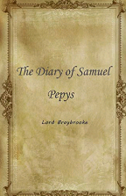  Samuel Pepys kept a diary of events during The Great Fire of London. Keep your own diary for a weekend and write about all the things you do. | 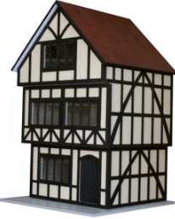  Make your own 17th century home which we will then use to create our own street in London. We will then set it on fire to see how the fire spread. | Complete the Great Fire of London maths activities in your homework book.  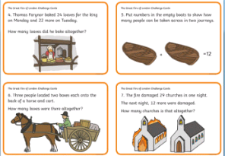
Bake it | Map it out | Research it
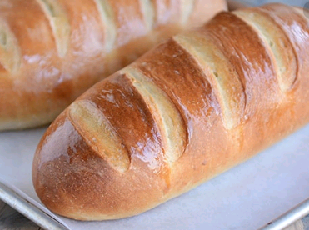  The Great Fire of London started in a bakery on Pudding Lane. Have a go at baking something you could sell in bakery. Take a picture of the final product to show us. | 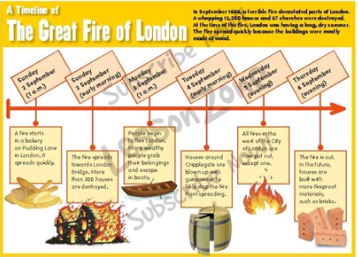  Create a time line of your life so far, that includes key events such as the year you were born, the year you started school etc. Choose how you would like to present it. | Go to the library or use the internet to research events that happened during the Great Fire of London. Record what you have found out in any way you choose.  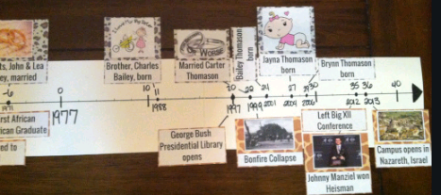

Work it out

