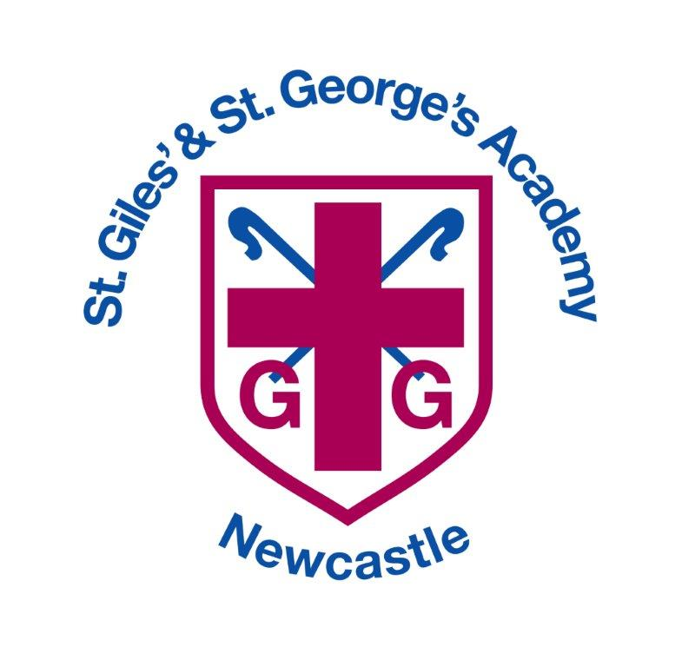

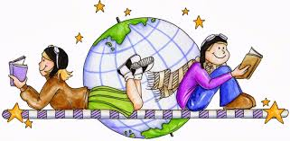

History and Geography Curriculum

History and Geography Overview

 | Autumn Term |  | Spring Term |  | Summer Term
Nursery  A | 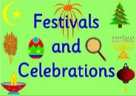  Festivals and Celebrations |  | It’s Cold Outside | 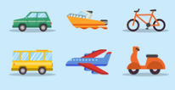  Off We Go! | 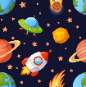  Zoom Zoom off to Space | 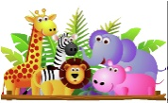  Animal Kingdom
Nursery  B | 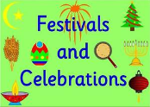  Festivals and Celebrations |  | Bedtime stories | 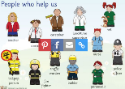  People Who Help Us | 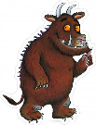  Monsters | 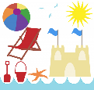  Seasides & Holidays
Reception | 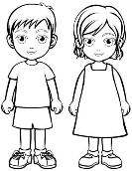  Marvellous Me |  | 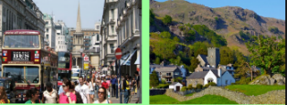  The Farm |  | 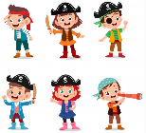  2 Pirates
Year 1 | Toys Over Time  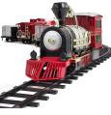 |  | Our School  Wonderful Weather  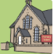 | Our Country  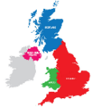 | Castles and Knights  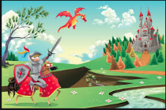
Year 2 | Great Explorers  Inc Neil Armstrong  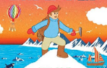 | What a Wonderful World | The Great Fire of London  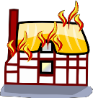 |  | Beside the Seaside  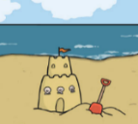 | Sensational Safari
Year 3 | Riotous Royalty  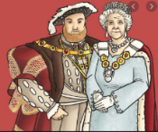 |  | Land Use  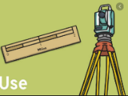 | Extreme Earth  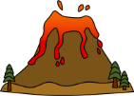 | Roman Empire  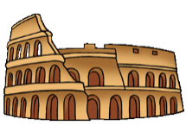
Year 4 | Anglo Saxons  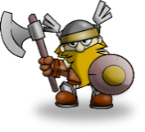  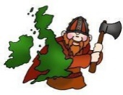  Vikings |  | Water  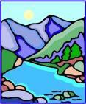 | All Around the World  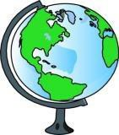 | Ancient Egypt  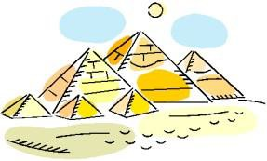
Year 5 | Stone Age to the Iron Age  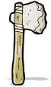  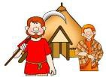 | Marvellous  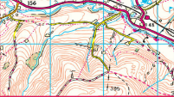  Maps | Local History  Study  The Potteries  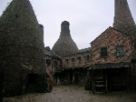 | Exploring Eastern Europe  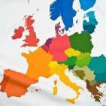 | Maya Civilization  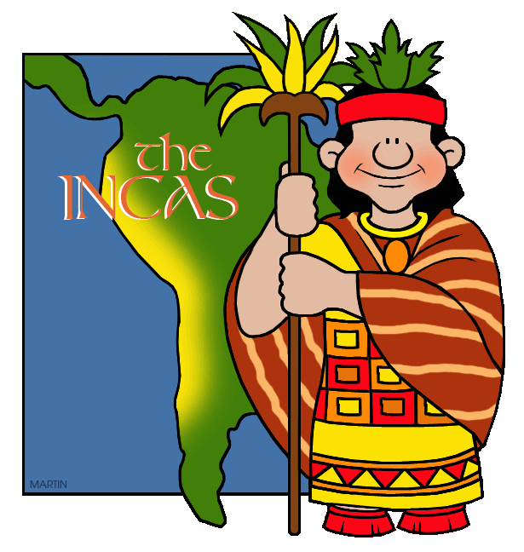
Year 6 | World War 2  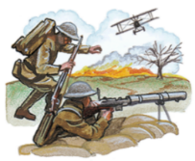 |  | Our Changing World  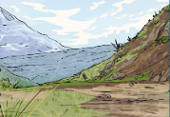 | The Amazing Americas  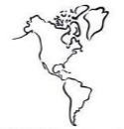 | Ancient Greece  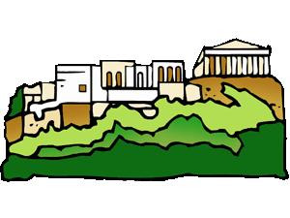

Enquiry Questions
 | Autumn Term |  | Spring Term |  |  |  | Summer Term
 | Autumn 1 | Autumn 2 | Spring 1 |  | Spring 2 | Summer 1 |  | Summer 2
Nursery  A | How did I celebrate my past birthdays? |  | Why is the weather cold now? | Have cars and bikes always looked the same? |  |  | Can we live on the moon? |  | How does a puppy change over time?
Nursery  B | How did I celebrate my past birthdays? |  | Have my feet changed since I was a baby? | How do I get to school from home? |  |  | How does our environment compare to the woods? |  | How did people spend time at the seaside in the past?
 | All About Me |  | The Farm |  |  |  | Pirates
Reception | How have I changed since I was a baby? |  | How does our environment compare with the farm? |  |  |  | How do pirates find their treasure?
Year 1 | Toys over time |  | Our School  Seasons and Weather |  | Our Country | Castles and Knights
 | How are the toys I play with different to those in the past? |  | What is it like where we go to school?  How does the weather in the UK change across the year? |  | Where in the country are we? | Would you like to live in a castle?
Year 2 | Great Explorers Inc. Neil Armstrong | What a Wonderful World | The Great Fire of London |  |  |  | Beside the Seaside |  | Sensational Safari
 | Why were Christopher Columbus and Neil Armstrong brave people? | Would you rather be a penguin or a meerkat? | Who was to blame and who helped in the Great Fire of London? |  |  | Why do we like to be beside the seaside? |  | Would you prefer to live in England or Africa?
Year 3 | Riotous Royalty |  | Land Use |  | Extreme Earth | Roman Rule of Britain
 | King or Queen – who would you prefer to have rule the country? |  | How is the land around us used? |  | What makes the Earth angry? | Why were the Romans so powerful and what did we learn from them?
Year 4 | Anglo Saxons  Vikings |  | Water |  | All Around the World | Ancient Egypt
 | The Vikings – ruthless killers or peaceful settlers? |  | Where does all the water go? |  | Why do we have time zones? | How does Ancient Egyptian life compare with ours today?
Year 5 | Stone Age to the Iron Age | Marvellous Maps | Local History Study |  | Exploring Eastern Europe | The Maya Civilization
 | How did Britain change from the Stone Age to the Iron Age? | I’m a Year 5 pupil, can you get me out of here? | How did the Victorian period help to shape the Stoke on Trent we know today? |  | How does living in Eastern Europe differ to living in our area? | Who were the Mayans and what can we learn from them?
Year 6 | WW2 |  | Our Changing World |  | Amazing Americas | Ancient Greece
 | What was it really like during WW2? |  | How is our world changing? |  | What’s so amazing about the Americas? | What did the Ancient Greeks do for us?

Geographical Skills

Nursery: development matters
Locational Knowledge |  | Know that there are different countries in the world and talk about the differences they have experienced or seen in photos.
Place  Knowledge |  | Talk about what they see using a wide range of vocabulary.
Human and Physical Geography |  | Begin to understand the need to respect and care for the natural environment and all living things.
Geographical Skills and Fieldwork |  | Talk about what they see, using a wide vocabulary.
Gospel Skills |  | Attentive – What is the weather like at this time of year?  Curious – How does where we live compare with the woods?  Active – Earth or the Moon, where would you prefer to live?
Reception: development matters
Locational Knowledge |  | Recognise some similarities and differences between life in this country and life in other countries.
Place  Knowledge |  | Understand that some places are special to members of their community.
Human and Physical Geography |  | Recognise some environments that are different to the one in which they live.
Geographical Skills and Fieldwork |  | Draw information from a simple map.
Gospel Skills |  | Curious and Active – What do I like about where I live?  Faith-filled & Hopeful – Where do I hope to travel to?
Year 1: National curriculum
Locational Knowledge | Develop knowledge about their school and locality.  Begin to use geographical skills, including first – hand observation, to enhance locational awareness  Name, locate and identify characteristics of the four countries and capital cities of the United Kingdom and its surrounding seas.
Place Knowledge | Understand geographical similarities and differences through studying the human and physical geography of a small area of the United Kingdom.
Human and Physical Geography | Identify seasonal and daily weather patterns in the United Kingdom.  Use basic geographical vocabulary to refer to:  key physical features, including: forest, hill, mountain, soil, valley, vegetation.  key human features, including: city, town, village, factory, farm, house, office.  Identify human and physical features in the school grounds and local area.
Geographical Skills and Fieldwork | Use world maps, atlases and globes to identify the United Kingdom and its countries.  Use simple fieldwork and observational skills to study the geography of their school and its grounds and the key human and physical features of its surrounding environment.
Gospel Skills | Faith Filled - Locate the churches of St Giles and St Georges on a local map.  Grateful – Are we lucky to live in the United Kingdom?
Year 2: National curriculum
Locational Knowledge | Develop knowledge about the world, name and locate the world’s seven continents and five oceans.
Place Knowledge | Understand geographical similarities and differences through studying the human and physical geography of a small area of the United Kingdom, and of a small area in a contrasting non-European country concentrating on sea sides and the context of Africa.
Human and Physical Geography | Identify the location of hot and cold areas of the world in relation to the Equator and the North and South Poles  Use basic geographical vocabulary to refer to:  key physical features, including: beach, cliff, coast, forest, hill, mountain, sea, ocean, river, soil, valley, vegetation, season and weather  key human features, including: city, town, village, factory, farm, house, office, port, harbour and shop
Geographical Skills and Fieldwork | Use aerial photographs and plan perspectives to recognise landmarks and basic human and physical features; devise a simple map; and use and construct basic symbols in a key.  Use simple compass directions (North, South, East and West) and locational and directional language [for example, near and far; left and right], to describe the location of features and routes on a map.
Gospel Skills | Faith-filled– When have I had to have faith and be brave?  Grateful – What am I thankful for in our world?  Loving & Compassionate – What is there for me to love about the seaside?
Year 3: National Curriculum
Locational Knowledge | Locate and name the continents on a World Map.  Extend knowledge and understanding beyond the local area to include the UK and Europe.  Identify the position and significance of Equator, N. and S. Hemisphere, Tropics of Cancer and Capricorn. Develop their use of geographical knowledge, understanding and skills to enhance their locational and place knowledge.  Linking with History, compare land use maps of UK from past with the present, focusing on land use.
Place Knowledge | Compare a region of the UK with a region in Europe, eg. local hilly area with a flat one or under sea level. Link with Science, rocks.
Human and Physical Geography | Describe and understand key aspects of:  Physical geography, including: climate zones, biomes and vegetation belts, rivers, mountains, volcanoes and earthquakes, and the water cycle. Linking to Science: rock types.  Human geography including trade links in the Pre-roman and Roman era.  Types of settlements in Early Britain linked to History. Why did early people choose to settle there?
Geographical Skills and Fieldwork | Use maps, atlases, globes and digital/computer mapping (Google Earth) to locate countries and describe features studied.  Use fieldwork to observe and record the human and physical features in the local area using a range of methods, including sketch maps, plans and graphs, and digital technologies.
Gospel Values | Learned and Wise – What changes can I make to look after our planet?  Curious and Active - How do Earth’s actions affect people and the environment?
Year 4: National Curriculum
Locational Knowledge | On a world map, locate areas of similar environmental regions, either desert, rainforest or temperate regions.  Locate and name the main counties and cities in/around Staffordshire.
Place Knowledge | Understand geographical similarities and differences through the study of human and physical geography of a region of the United Kingdom.  Identify the position and significance of latitude, longitude, Equator, Northern Hemisphere, Southern Hemisphere, the Tropics of Cancer and Capricorn, Arctic and Antarctic Circle, the Prime/Greenwich Meridian  and time zones (including day and night).
Human and Physical Geography | Describe and understand key aspects of:  Physical geography including: climate zones, biomes and vegetation belts, rivers, mountains, volcanoes and earthquakes, and the water cycle.  Types of settlements in modern Britain: villages, towns, cities.  Types of settlements in Viking, Saxon Britain linked to History
Geographical Skills and Fieldwork | Use maps, atlases, globes and digital/computer mapping (Google Earth) to locate countries and describe features studied.
Gospel Values | Grateful & Generous – Is everyone lucky enough to have water?  Curious & Active – How can we be more conscious of where our food comes from?
Year 5: National Curriculum
Locational Knowledge | Locate the world’s countries, using maps to focus on Europe (including the location of Russia) and North and South America, concentrating on their environmental regions, key physical and human characteristics, countries, and major cities.  Locate and name the main counties and cities in England.
Place Knowledge | Name and locate counties and cities of the United Kingdom, geographical regions and their identifying human and physical characteristics, key topographical features (including hills, mountains, coasts and rivers), and land-use patterns; and understand how some of these aspects have changed over time.
Human and Physical Geography | Understand geographical similarities and differences through the study of human and physical geography of a region of the United Kingdom, a region in a European country.
Geographical Skills and Fieldwork | Use maps, atlases, globes and digital/computer mapping (Google Earth) to locate countries and describe features studied  Use the eight points of a compass, four and six-figure grid references, symbols and key (including the use of Ordnance Survey maps) to build their knowledge of the United Kingdom and the wider world.
Gospel Values | Learned and Wise – How should we look after our land?  Compassionate and Loving - What do I like most about my local area?
Year 6: National Curriculum
Locational Knowledge | Locate the world’s countries, using maps to focus on Europe (including the location of Russia) and North and South America, concentrating on their environmental regions, key physical and human characteristics, countries, and major cities.  Name and locate counties and cities of the United Kingdom, geographical regions and their identifying human and physical characteristics, key topographical features (including hills, mountains, coasts and rivers), and land-use patterns; and understand how some of these aspects have changed over time.
Place Knowledge | Compare a region in UK with a region in N. or S. America with significant differences and similarities. Understand some of the reasons for similarities and differences.
Human and Physical Geography | Understand geographical similarities and differences through the study of human and physical geography of a region of the United Kingdom, a region in a European country, and a region within North or South America.  Describe and understand key aspects of physical geography, including: climate zones, biomes and vegetation belts, rivers, mountains, volcanoes and earthquakes, and the water cycle.  Describe and understand key aspects of human geography, including: types of settlement and land use, economic activity including trade links, and the distribution of natural resources including energy, food, minerals and water.
Geographical Skills and Fieldwork | Use maps, atlases, globes and digital/computer mapping (Google Earth) to locate countries and describe features studied.  Use fieldwork to observe, measure and record the human and physical features in the local area using a range of methods, including sketch maps, plans and graphs, and digital technologies.
Gospel Values | Hopeful - How can we protect the Amazon?  Attentive and discerning – What changes in the world might take place again that will affect me in my lifetime?

Historical Skills

Nursery: Development matters
Chronological Understanding |  | Make connections between features of their family and other families.
Events, people, changes in the past |  | Begin to make sense of their own life- story and family’s history.
Historical Interpretation |  | Continue to develop positive attitudes about the differences between people.
Historical  Enquiry |  | Explore collections of materials with similar and/ or different properties
Organisation and Communication |  | Explore how things used to work.
Gospel Values |  | Grateful – Why do we get gifts for our birthday?  Compassionate – How can we show kindness towards our pets?
Reception: Development Matters
Chronological Understanding |  | Comment on images of familiar situations in the past.
Events, people, changes in the past |  | Compare and contrast characters from stories, including figures from the past
Historical Interpretation |  | Understand that some places are special to some places in their community.
Historical  Enquiry |  | Compare and contrast characters from stories, including figures from the past.
Organisation and Communication |  | Use talk to help work out problems and organise thinking and activities, explain how things work and why they might happen.
Gospel Values |  | Loving and Compassionate – We are all part of God’s family, how do we show our family that we love them?
Year 1: National curriculum
Chronological Understanding | Understand the difference between things that happened in the past and the present.  Describe things that happened to themselves and other people in the past.  Order a set of events or objects.  Use a timeline to place important events.  Use words and phrases such as: now, yesterday, last week, when I was younger, a long time ago, a very long time ago, before I was born. When my parents/carers were young.
Events, people, changes in the past | Recall some facts about people/events before living memory.  Say why people may have acted the way they did.
Historical Interpretation | Look at books, videos, photographs, pictures and artefacts to find out about the past.  Use stories to encourage children to distinguish between fact and fiction and to find out about the past
Historical  Enquiry | Identify different ways in which the past is represented.  Explore events, look at pictures and ask questions i.e, “Which things are old and which are new?” or “What were people doing?”  Explore pictures/ objects from the past and ask questions i.e, “What were they used for?” and try to answer.
Organisation and Communication | Sort events or objects into groups (i.e. then and now.)  Tell and order some events from their own past and other events.  Communicate their knowledge about the past using different genres of discussion, pictures, drama/role play, making models, writing and using ICT.
Gospel Values | Loving – Who do we have to thank for the toys we love?  Hopeful – What job would I most like to do when I am older?
Year 2: National curriculum
Chronological Understanding | Understand and use the words past and present when telling others about an event.  Use a simple timeline to order events and people.  Understand how to put people, events and objects in order of when they happened, using a scale the teacher has provided.  Use a timeline to place important events.
Events, people, changes in the past | Use information to describe the past.  Describe the differences between then and now.  Look at evidence to give and explain reasons why people in the past may have acted in the way they did.  Recount the main events from a significant event in history.
Historical Interpretation | Look at and use books and pictures, stories, eye witness accounts, pictures, photographs, artefacts, historic buildings, museums, galleries, historical sites and the internet to find out about the past.
Historical  Enquiry | Identify different ways in which the past is represented.  Ask questions about the past e.g. What happened in the past? What was it like for people in the past?  Use a wide range of information to answer questions.
Organisation and Communication | Use timelines to order events or objects or place significant people.  Communicate their knowledge about the past using different genres of discussion, pictures, drama/role play, making models, writing and using ICT.
Gospel Values | Faith filled and Hopeful –What hopes did the Explorers have?  Learned and Wise – What can we learn from the events during the Great Fire of London?
Year 3: National curriculum
Chronological Understanding | Understand that a timeline can be divided into BC (Before Christ) and AD (Anno Domini)  Place the timeline being studied on a timeline.  Place historical events in chronological order and name key events.  Describe dates of and order significant events from the period studied.
Events, people, changes in the past | Find out about everyday lives of people in time studied.  Use evidence to describe buildings and their uses, actions of people and their way of life in the past.  Compare similarities and differences between some people/ artefacts.  Describe the legacy of the past.
Historical Interpretation | Explore the idea that there are different accounts of history.
Historical  Enquiry | Use documents, printed sources (e.g. archive materials) the Internet, databases, pictures, photographs, music, artefacts, historic buildings, visits to museums and galleries and visits to sites as evidence about the past.  Ask questions and find answers about the past.
Organisation and Communication | Communicate their knowledge about the past using different genres of discussion, pictures, drama/role play, making models, writing and using ICT.
Gospel Values | Generous – What personal qualities do I contribute to our class?  Grateful – What can we thank the Romans for?
Year 4: National curriculum
Chronological Understanding | Continue to develop a chronologically secure knowledge and understanding of British and world history.  Understand that a timeline can be divided into BC (Before Christ) and AD (Anno Domini)  Order significant events and dates on a timeline.  Describe the main changes in a period in history.
Events, people, changes in the past | Use evidence to describe what was important to people from the past.  Use evidence to show how the lives of rich and poor people from the past differed.  Describe similarities and differences between people, events and artefacts studied.  Describe how some of the things I have studied from the past affect/influence life today.
Historical Interpretation | Look at different versions of the same event in history and identify differences.  Know that people in the past represent events or ideas in a way that persuades others.
Historical  Enquiry | Understand how our knowledge of the past is constructed from a range of sources and that different versions of past events may exist, giving some reasons for this.  Use documents, printed sources (e.g. archive materials) the Internet, databases, pictures, photographs, music, artefacts, historic buildings, visits to museums or galleries and visits to sites to collect evidence about the past.  Ask questions and find answers about the past.
Organisation and Communication | Communicate their knowledge and understanding about the past using different genres of writing, drawing, diagrams, data-handling, drama role-play, storytelling and using ICT.
Gospel Values | Attentive & Discerning – How did the choices of the last Anglo Saxon king shape the Britain that we know?  Prophetic – What achievements am I most proud of?
Year 5: National curriculum
Chronological Understanding | Know and sequence key events of time studied.  Make comparisons between different times in the past, including from previous learning.  Place an event in the right place on a timeline using specific words: era, period, century, decade, BC, AD  Understand that a timeline can be divided into BC (Before Christ) and AD (Anno Domini)  Describe the main changes in a period in history.
Events, people, changes in the past | Choose reliable sources of information to find out about the past.  Give own reasons why changes may have occurred, backed up by evidence.  Describe similarities and differences between some people, events and artefacts studied  Describe how historical events studied affect/influence life today.  Make links between some of the features of past societies. (e.g. religion, houses, society, technology.)
Historical Interpretation | Understand that some evidence from the past is propaganda, opinion or misinformation, and that this affects interpretations of history.  Give reasons why there may be different accounts of history.  Evaluate evidence to choose the most reliable forms.
Historical Enquiry | Begin to identify primary and secondary sources.  Choose reliable sources of evidence to answer questions and build up a picture of a past event, realising that there is often not a single answer to historical questions.  Investigate own lines of enquiry by posing questions to answer.
Organisation and Communication | Communicate their knowledge and understanding about the past using different genres of writing, drawing, diagrams, data-handling, drama role-play, storytelling and using ICT.  Plan and present a self-directed project or research about the studied period.
Gospel Values | Learned – What is so special about my local area?  Discerning – Why were some food choices of the Maya so significant?
Year 6: National curriculum
Chronological Understanding | Order significant events, movements and dates on a timeline.  Identify and compare changes within and across different periods.  Understand how some historical events occurred concurrenxtly in different locations.
Events, people, changes in the past | Choose reliable sources of information to find out about the past.  Give reasons why changes may have occurred, backed up by evidence.  Describe similarities and differences between some people, events and artefacts studied.  Describe how some of the things studied from the past affect/influence life today.  Make links between some of the features of past societies. (e.g. religion, houses, society, technology.)
Historical Interpretation | Evaluate evidence to choose the most reliable forms.  Know that people both in the past have a point of view and that this can affect interpretation.  Be aware that different evidence from the past will lead to different conclusions.
Historical Enquiry | Recognise primary and secondary sources.  Use a range of sources to find out about an aspect of time past.  Choose reliable sources of evidence to answer questions, realising that there is often not a single answer to  historical questions.  Bring knowledge gathered from several sources together in a fluent account.
Organisation and Communication | Plan and present a self-directed project or research about the studied period.  Select and organise information to produce structured work, making appropriate use of terms and dates.
Gospel Values | Intentional and Prophetic- How did Reginald Mitchell, a man with little training, fulfil his hopes of designing an aircraft that would play a vital role in the Battle of Britain?  Wise – How might Christians show their religious beliefs?

Humanities Knowledge organisers:

Nursery Years A and B
Reception
Year 1
Year 2
Year 3/ 4 (A)
Year 3.4 (B)
Year 5/6 (A)
Year 5/6 (B)

Nursery (A) knowledge organisers:

Festivals and celebrations
It’s cold outside
Off we go
Zoom zoom off to space
Animal kingdom

Nursery – Festivals & Celebrations
Autumn 2 – History - How did I celebrate my past birthdays?

Key Events/ People & Facts
- Investigate how birthdays are celebrated in different cultures
- When is your birthday? Know the month and the date of your birthday.
- How old will you be?
- How do you celebrate your birthday?
- Why do we celebrate birthdays?
- How is this the same or different to your friends?
- How is this the same or different to how your family celebrated past birthdays?
- Learn about other celebrations in different cultures:
- Diwali - The story of Rama and Sita
- The story of Hanukkah
- The Christian story of Christmas

- Begin to make sense of their own life-story and family’s history
- Talk about things that happened in the past.
- Use common words to talk about events from the past or present.

Key Vocabulary
Birthday | Cake | Celebration
Balloon | Present | Party
Celebrate | Past | Gift
Presents | Custom | Wedding
Bonfire Night | Hannukah | Diwali
Advent | Christmas | New Year
Festival | Fireworks
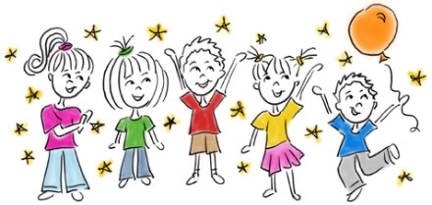
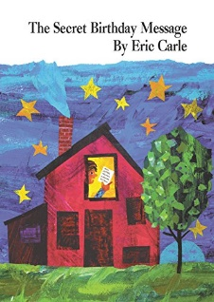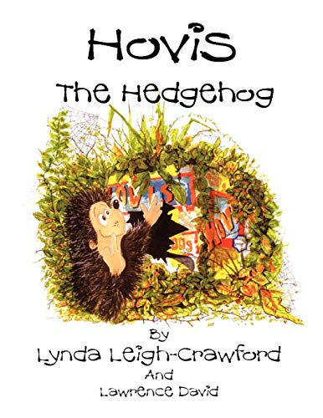
Hands on Experience
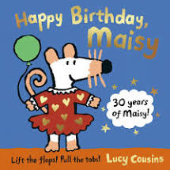
Looking at past birthday photos.
Invite a baker.
Look at some family wedding photos and talk about who is in them and what their role is.
Look at photographs of celebrations from a variety of cultures and discuss.

To learn about traditional birthday parties and how the children have celebrated past birthdays.

Understanding and using the past tense

Gospel Values

Grateful – Why do we get gifts for our birthday?

Overview
Skills

Nursery – Geography - Winter “It’s cold outside”
Spring 1 – Why is the weather cold now?

Key Events/ People & Facts
How do we know it is winter? Notice the changes in their own environment
What happens in winter?
What do the trees look like in the winter time? Compare to the summer time.
What is ice made from?
What happens to ice when it gets warm?
What is the weather like in winter?
How can we keep warm in winter?
-The weather changes at different times in the year. -The four seasons are winter, spring, summer and autumn. It is coldest in the winter and warm in summer. -We can see different plants and animals in the different seasons.
Understand and notice weather changes throughout the year and weather in different parts of the world
Understand clothes change throughout the year based on weather and temperature.
Look at photographs of a winter’s day and list the features. Compare to a summer’s day.
Look at photographs of a winter’s day in other countries, discuss features and compare.
What animals live in the cold/snow?
- Talk about what they see using a wide range of vocabulary
- Know that there are different countries in the world and talk about the differences they have experienced or seen in photos
- Begin to understand the need to respect and care for the natural environment and all living things
- Explore and talk about the different forces they feel
- Talk about the differences between materials and changes they notice
Key Vocabulary
Cold | Winter | Snow
Spring | Summer | Autumn
Ice | Frost | Change
Weather | Woolly hat | scarf
Gloves | Coat | warm
Arctic | Antarctic | Polar bears
Penguins | Reindeers | Igloo

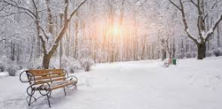

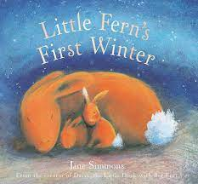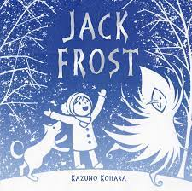

Overview
Hands on Experience
Skills
How do we know it is winter?
What is the weather like in winter?
How can we keep warm in winter?
What do animals do in winter? (Birds / British Wildlife)
What is the Arctic/Antarctic like?

Winter Walk to look for signs of winter – getting dressed for winter
Making hot chocolate
Make bird feeder for British winter wildlife
Look at photographs of winter
Gospel Values
Attentive – What is the weather like at this time of year?

Nursery – Transport - Off we go!
Spring 2
History - Have cars and bikes always looked the same?

Key Vocabulary
Transport | Past | Present
Future | Change | Road sign
Travel | engine | Car
Van | Bus | aeroplane
Train | Ship | Boat
Bike | Scooter | Lorry

Key Events/ People & Facts
- A vehicle is a mode of transport to help a person travel from one place to another
- Engines are used to power most vehicles today
- Some modes of transport are healthier for people than others
- Some vehicles can travel on roads or tracks, but some can only travel in water or in the air
- Observe the features of transport and compare from past to present
- Vehicles can be used to help people do their jobs
- Look out for familiar road signs, crossings etc
- Talk about safety in the minibus e.g. seatbelts
- Sort pictures of past and present transport and compare.
- Look at past and present photographs of different modes of transport and compare to the present day.

Skills
- Describe a familiar route
- Discuss routes and locations, using words like ‘in front of’ and ‘behind’
- Begin to make sense of their own life history and family’s history
- Talk about what they see using a wide range of vocabulary
- Talk about the differences between transport and any changes they notice
- Talk about the different transport that they have seen and observed
- Understand transport has changed through the years

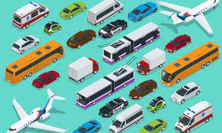

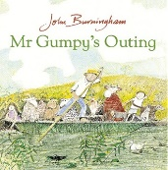
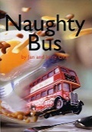

Children to go in the school minibus and take a drive around the local environment. Encourage them to look at different road signs. What can you see? What marks do you notice on the roads?
Bring your bike to school day
Look at maps
Look at past and present photographs of different transport and compare; talk about their features.
Speak to parents/grandparents of the transport they used to use when they were young/How did they used to travel to school?

Hands on Experience

How do you get to school from home?
What different transport is there?
How do vehicles travel around?
How has transport changed over the years?

Overview

Gospel Values
Curious and Active:
How has transport changed over the years?

a
Nursery – Space – 3,2,1 Blast off!
Summer 1 – Geography – Can we live on the moon?

Key Events/ People & Facts
- There are 8 planets in our solar system.
- The sun is a big star.
- Stars are burning balls of fire.
- Some planets have moons
- The planets orbit the sun and gain heat from the sun’s energy.
- An astronaut is a person who is specially trained to travel into outer space.
- Our world is a planet called Earth.
- It is one of a number of planets that go around the Sun.
- On Earth, there are many different countries.
- In each country, there are cities, towns and villages. Which country do you live in? Which town/city?
- Draw your own space map
- Explore light and dark using torches and cardboard boxes. Talk about things that can be seen in the dark or at night-time.

- Ask and answer questions about space and the world
- Talk about what they see using a wide range of vocabulary
- Notice features of the world around them
Key Vocabulary
Planet | Solar System | Orbit
Astronaut | Rocket | Alien
Moon | Sun | Star
Dark | Gravity | Rocket
Earth | Mercury | Venus
Saturn | Mars | Jupiter
Uranus | Neptune | Galaxy
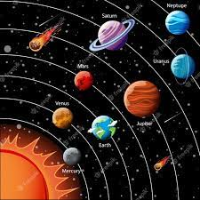
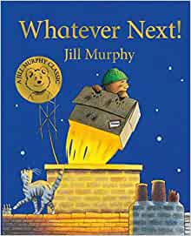
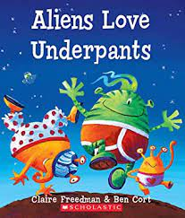
Hands on Experience
Star Gazing and looking at space maps
Building Junk Model rockets
Looking at pictures of the moon, planets and space
Space/rocket role play area

Talk about the names of different planets and what they look like.
Talk about the features of space.

Gospel Values

Active – Earth or the Moon, where would you prefer to live?

Overview
Skills

Nursery – Animal Kingdom “All creatures great and small”
Summer 2 – History – How does a puppy change over time?

Key Events/ People & Facts
Some animals you may see around you: Cats, Dogs, Rabbits, Lizards, Bees, Flies, Cows, Horses, Sheep, Pigs, Goats, Chickens, Pigeons, Worms, Beetles, Badgers

Talk about what the children were like when they were babies. How have they grown since then?
Compare this to the life cycle of different animals. What are the similarities and differences?
Look at footprints.

Skills
- Begin to make sense of their own life from past to present.
- Develop an understanding of growth and change over time.
- Use common words to talk about events from the past or present.
- Begin to ask their own questions about their past.
- Understanding and using the past tense.
- Ask questions about the past.

Key Vocabulary
Animal | Puppy | Dog
Change | Life cycle | compare
Growth | Past | present

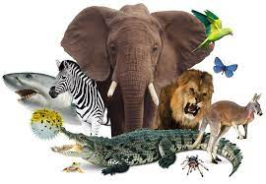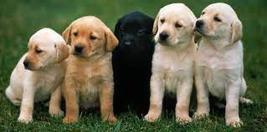

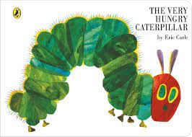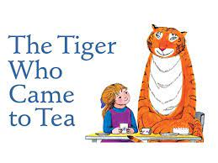

Overview

How have you changed over time?
How do puppies change over time?
Do all animals change over time?
Do all animals change over time in the same way?

Hands on Experience

Visit from school dogs
Visit from Animal person e.g. Unconventional menagerie
Visit from PDSA
Hatch Caterpillars & Butterfly
Gospel Values
Compassionate – How can we show kindness towards our pets?

Nursery (B) knowledge organisers:

Bedtime stories
People who help us
Monsters
Seaside and holidays

Nursery – Spring 1 – Bedtime Stories

History - Have my feet changed since I was a baby?

Key Vocabulary
Past | Present | Future
Change | Shoe | Feet
Growth | Bedtime | Stories
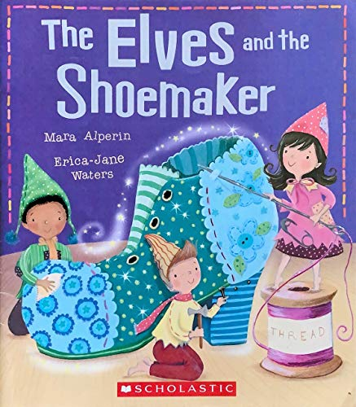
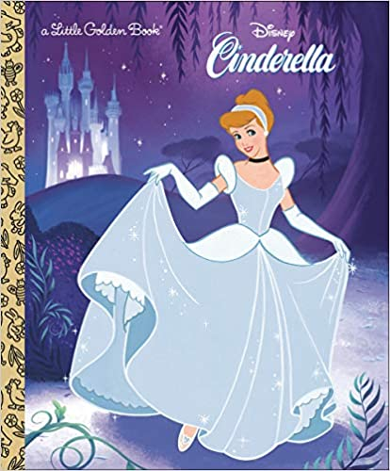
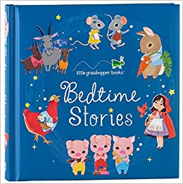
Key Events/ People & Facts
- Know that shoes/footwear are worn for different purposes.
- As we grow, our feet grow bigger and our shoe size changes.
- Look at photographs of you as a baby and compare shoe size/feet to now. Discuss changes.
- Create own timeline.
- Children to generate their own questions, e.g. Do we all have the same size feet? How are they different to others?

- Begin to make sense of their own life from past to present.
- Develop an understanding of growth and change over time.
- Use common words to talk about events from the past or present.
- Begin to ask their own questions about their past.

Hands on Experience
Shoe shop role-play.
Bringing in baby shoes.
Look at a baby photos looking at their feet/shoes and compare to their shoes/feet now.

Skills
Gospel Values
Learned and wise – What can we learn from our past and about ourselves?

Overview
Why does our shoe size change?
How does our shoe size/feet change over time?

Understanding and using the past tense

Nursery – People who help us
Geography - Where do the people who help us work in our community?

Key Vocabulary
Emergency Services | Vet | Police
Firefighter | Doctor | Nurse
Ambulance | 999 | Hospital
Lifeguard | Paramedic | Rescue
Lollipop man/lady | Dentist | Teacher
Head teacher | Healthy | Caretaker
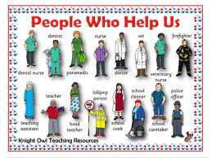
Key Events/ People & Facts
To know that people do different jobs
A community is a group of people who live in a particular place or have something in common. -E.g. all of the teachers, parents and children at your school make up your school community.
Key people:
Vet - People who make poorly animals better
Police - People who help the community to stay safe
Firefighter - People who put out fires
Doctor - Someone who makes us feel better
Lifeguard - A person who is a really good swimmer who can save people in the water
Paramedic - People who come out to help you in an emergency
Dentist – Dentists help people keep their gum, teeth and mouths clean and healthy
Teacher – A person who helps people to learn. A teacher often has a classroom. There are many different types of teachers.
Head teacher – A person who manages a school.
Caretaker – A person who takes care of a school.
Rescue – An act of freeing someone or something from danger
Healthy – To be healthy means not to be sick; eat a healthy diet and exercise.
Skills

- Show interest in different occupations
- Continue to develop positive attitudes about the differences between people
- Talk about things I have observed using a wide range of vocabulary
- Answer simple questions about my familiar world
- Talk about own experiences

Hands on Experience
Visit from a person that helps us e.g. fireman/nurse/vet
Teeth Brushing
What do our parents do?
Different occupations in the role play area

Overview

Who helps us at home?
Who helps us at school?
Who helps us in our community?
Who helps to keep us safe, healthy and provides us with food?
How do we ask for help?
Who do we ask for help?

Curious and active: How can we stay safe and healthy in our community?
Gospel Values

Nursery – Monsters
Geography - How does our environment compare to the woods?

Key Events/ People & Facts
- Look at where we live – house; environment
- Look at where animals live – woodland, cave, trees.
- Compare animal homes to our homes.
- Listen to animal noises
- How do animals move?
- What do animals eat?
- Do all animals eat the same things?

- Talk about what they see using a wide range of vocabulary
- Explore collections of materials with similar and/or different properties
- Notice detailed features of their environment

Key Vocabulary
Monster | Scary | Teeth
Claws | Furry | Horns
Scales | Claws | House
Home | Windows | Door
Roof | Woodland | town

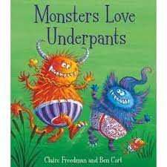
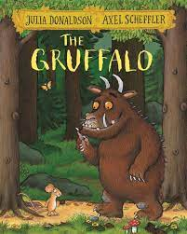

Hands on Experience

Woodland walk – explore/describe the environment around them
collect a small item that belongs in the woodland area e.g. twig, leaf etc to use to model houses
Share the story of the Gruffalo during a woodland walk, giving focus to the setting.
Forest School activities

Overview
Skills

Why is a woodland area called a woodland area?
What sort of things can be found in the woods/woodland area?
Do all the leaves look the same?
What makes this leaf different to another?

Attentive and discerning -
Curious – How does where we live compare with the woods?

Gospel Values

Nursery – History – Seaside and holidays”
Summer 2 – How did people spend time at the seaside in the past?

Key Vocabulary
Seaside | Beach | Sand
Sea | Ocean | Holiday
Shells | Swim | Water
Creatures | Bucket | spade
Past | Present | change
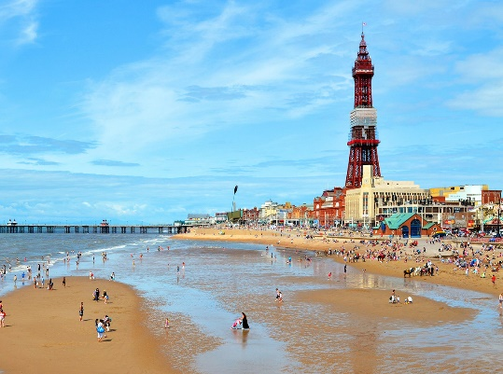
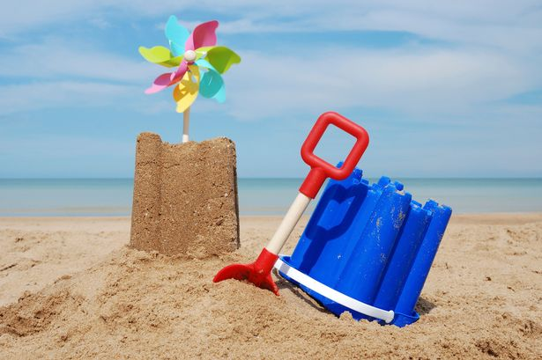
Key Events/ People & Facts
What is a seaside?
What is at the seaside? Compare between past and present.
What animals live at the seaside?
What is a holiday?
Have you been on holiday before? What did you see? What did you do?
Notice and talk about features of a seaside.
Look at clothing worn on holiday at the seaside compared to clothing worn in the past.
Look at the features of a seaside.

Skills
- Talk about what they see using a wide range of vocabulary
- Know that there are lots of beaches in the world, different countries in the world and talk about the differences they have experienced or seen in photos
- Begin to understand the need to respect and care for the natural environment and all living things
- Talk about the differences they see between the seaside past and present.

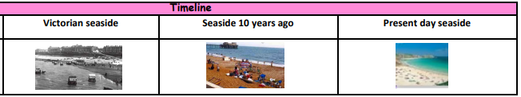
Create own ‘seaside’ role play area.
Create a beach scene for the children to experience with sand, water, buckets and spades.
Look at past and present photographs of the seaside.
Children to bring in their own photographs of their holidays – compare to past; compare to seaside holidays looking at its features.
Hands on Experience
What is at a seaside?
What used to be at a seaside?
What are the differences between a seaside in the past compared to now?

Overview
Gospel Values
Compassionate and loving -
How can we show love and kindness to our world?

Reception knowledge organisers:

Marvellous me
On the farm
Pirates

History: Reception – Marvellous Me!
Autumn 1 – How have I changed since I was a baby?

Key Vocabulary
Grow | A natural development by increasing size and change.
Change | When something is different, alters or modifies.
Similarities | Something being similar.
Past | The time before the moment. Gone by in time.
Present | Existing or occurring now.
Differences | A way in which people or things are different.
Ancestors | A person, typically one more remote than a grandparent. From whom one is descended.
Key Events/ People & Facts
Know what a family is and how all families are different.
Know who is in their family starting with who lives in their home.
Think about how the people in their family are related to them.
Discuss what a family tree is and how they are used to go back generations. They show a ‘family history’.
A baby is born. They then grow and change over time. Every baby develops at a different rate. There are some things that don’t change as you grow.
What is their childhood like? Is it similar or different to their parent’s/grandparent’s childhood? What is different about being a child in the present day, compared to the past?
What events from their past can they remember? (e.g. birthdays, family members being born, celebrating different festivals)
Discuss and think about changes that are still yet to happen to them in the future.

Understand the difference between things that happened in the past and present.
Talk about past and present events, customs and routines in their own lives and in the lives of family members.
Ask questions about my own past.
Talk about and draw things from the past or present.
Look closely at similarities, differences, patterns and change.
Use common words to talk about events from the past or present.

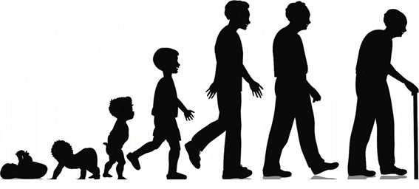

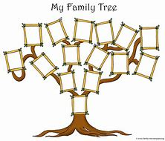

Overview
Hands on Experience
Skills
Does everyone change in the same way?
How was my teacher’s childhood different to mine?
Who are the members of my family?
What things have happened to me in the past?
How was my family’s childhood different to mine?
Will my friends continue to change in the same way as me?

Look at images of themselves as babies and now.

Have a visit from someone who has had a baby.

Have a visit from a doctor.
Gospel Values
Curious and Active
Show curiosity about how we change and develop over time

Geography: Reception – Life on the farm.
Spring 2 – How does our environment compare with the farm?

Key Vocabulary
Animals | A living being that feeds, has senses, breathes. They need food and water to survive.
Crops | Living plants grown by farmers.
Tractor | A strong work vehicle used for farming. It can pull many different tools.
Farmer | Someone who grows crops and raises animals to be used as food.
Land | Solid part of the surface of the earth. An area of ground or soil.
Scarecrow | An object made to look like a person to scare birds away from crops.
Vegetable | Parts of plants that people eat. They grow under or above the ground.
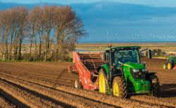
Key Events/ People & Facts
A farm is a part of land that is used for raising animals or growing crops.
There are different types of farms e.g. dairy and poultry farms.
UK farms often grow crops such as wheat, barley and vegetables.
UK farms often raise a range of animals such as cows, sheep, chicken, goats and pigs.
A hen is a female chicken. A cockerel is a male chicken.
Know about the life cycle of a hen – from egg, to chick, to hen.
Know that female hens produce and lay eggs, on their own.
Know which animals live on a farm – pig, cow, goat, alpaca, chickens, ducks, horses, geese, sheep, sheepdog.
Know baby animal names – pig/piglet, cow/calf, duck/duckling, goat/kid, horse/foal, dog/puppy, sheep/lamb.
Know what makes an animal an insect – they are small enough to fit in your hand, they have six legs.
Know that milk comes from a cow or goat.
Know where your food comes from – eggs from hens, bacon from pigs, sausages from pigs, beef from a cow, lamb from a baby sheep.

Answer simple questions about my immediate environment.
Investigate places using all of my senses. I can identify similarities and differences between places.
Recognise changes in my environment (e.g. the weather, seasons).
Understand that maps show us where places are.
Ask simple questions when exploring my environment.
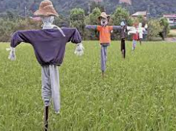

Overview
Hands on Experience
Skills
What lives on a farm?
What are baby animals called?
What are the stages of a life cycle of a chick?
What is an insect?
What is farming?
What changes have we seen to our environment in spring time?
Gospel Values
Curious and Active
What do I like about where I live?
Visit to a farm.

Incubator – actively watch life cycle of a chick.

Vegetable tasting and classifying.

Geography: Reception – A Pirate’s Life For Me
Summer 1 – How do pirates find their treasure?

Key Vocabulary
Pirate | A pirate is a sailor who attacks other ships at sea and steals their property.
Jolly Roger | Traditional flag which made people aware of pirate ships.
Map | A drawing of all or parts of the earth’s surface, which helps you to find your way.
Cutlass | A short sword with a slightly curved blade used by pirates.
Booty | Treasure (like money or jewels) stolen by pirates.
Sloop | A type of ship that moved very quickly and easily. It was perfect for chasing another ship to steal from them.
Enemy | A person who is opposed to somebody or something.
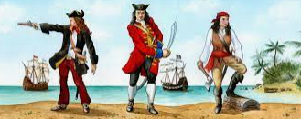
Key Events/ People & Facts
Key People
Black Beard | An English pirate who sailed around the West Indies and North America. He became a renowned pirate. He got his nickname because of his thick black beard
Sir Francis Drake | An English sea captain, privateer and explorer. He carried out the second circumnavigation of the world in a single expedition.
Anne Bonny | An Irish pirate who often disguised herself as a man and became one of the most recognisable wanted faces of the ‘Golden Age of Piracy’.
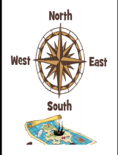

Skills

Answer simple questions about my immediate environment.
Investigate places using all of my senses. I can identify similarities and differences between places.
Recognise changes in my environment (e.g. the weather, seasons).
Understand that maps show us where places are.
Ask simple questions when exploring my environment.

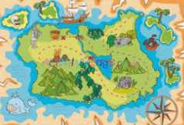

Hands on Experience
Overview

Pirate school day.

Design, make and sail your own boat.

Receive our own message in a bottle.

What makes a pirate a pirate?
What makes a pirate’s life different to ours?
How did pirates know where to go?
Where did pirates travel to and how did they get there?
What floats and sinks?
Can you be a pirate too?
Gospel Values
Curious and Active
Would you prefer to live in your house or on a pirate ship?

Year 1 knowledge organisers:

Toys over time
Our school- wonderful weather
Our country
Castles and knights

History: Toys Over Time

Autumn – How are the toys I play with different from those in the past?

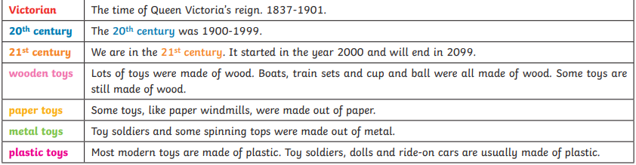
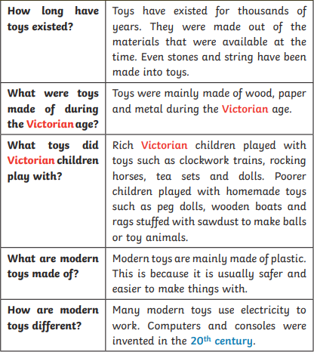
Key Events/ People & Facts

Key Vocabulary
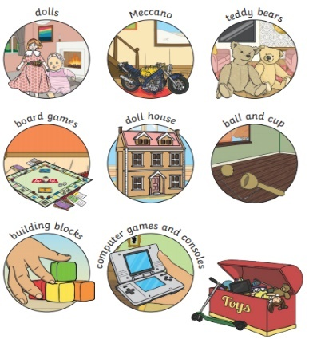
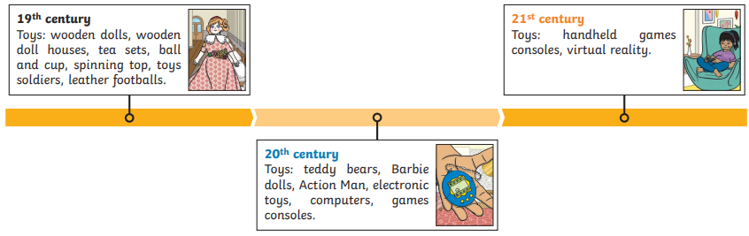
Hands on Experience

- Children bring in their own favourite toys to explore and play with.
- Teddy Bears’ picnic.
- Ask parents/grandparents to bring in their toys for a sharing afternoon and compare.
- Explore a range of Victorian toys.
- The Bramption
Gospel Values
Skills
- To learn about changes within living memory by exploring toys from today.
- To learn about changes beyond living memory by exploring toys from the past.
- Order some events from their own past.
- To use secondary sources of information to find out about the history of teddy bears.
- Order a set of events or objects.

Overview

Grateful - Who do we have to thank for the toys that we love?

- What is my favourite toy?
- What toys might my parents and grandparents have played with?
- What changes have happened during my lifetime?
- Where did teddy bears originate?
- How are our teddy bears similar and different?

Spring – What is it like where we go to school?

Geography: Year 1 – Our School

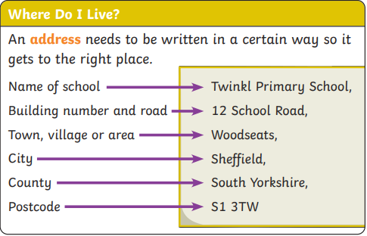
Key Events/ People & Facts
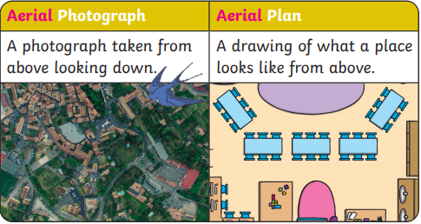

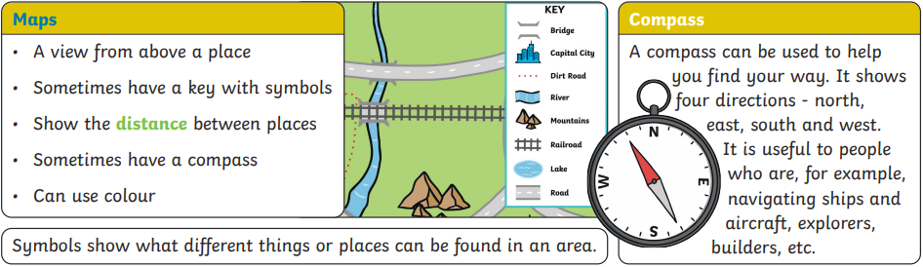

Key Vocabulary
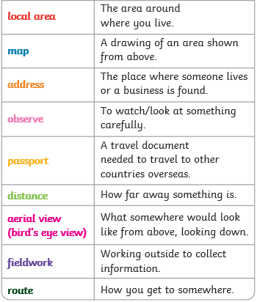

- Where do I live?
- What is an aerial photograph?
- Where is our school in the local area?
- What are human and physical features?
- What features do we have around our school?
- What are the 4 points of a compass called?

- Use simple observational skills to study immediate surroundings.
- Identify human and physical features within the local area.
- Be aware of the local area and the route that children take to school.
- Understand different types of houses and homes that surround our school.

Skills
Gospel Values
Hands on Experience
Overview

Faith Filled - Locate the churches of St Giles and St Georges on a local map.

Fieldwork in the school grounds.
Walk of the local area.

History: Year 1 – Castles and Knights

Summer – Would you like to live in a castle?

Key Events/ People & Facts
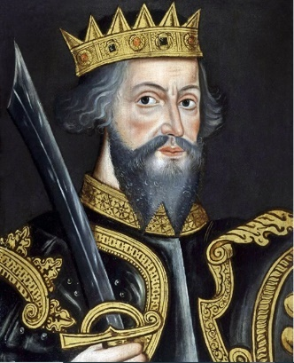
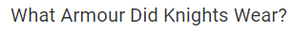
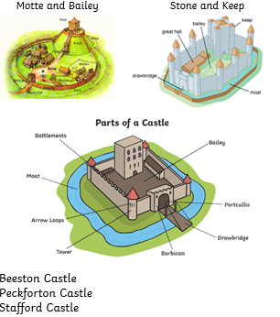
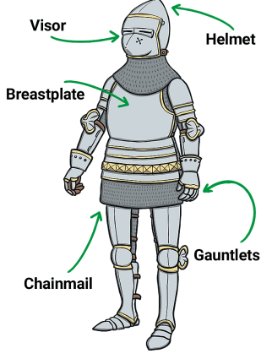

1066-1087

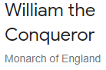

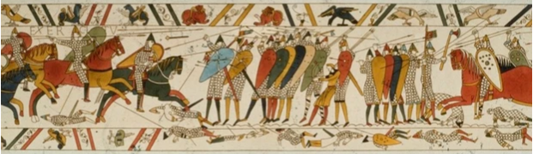

Key Vocabulary
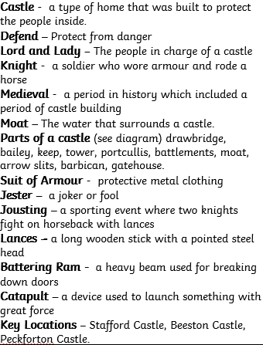

Hands on Experience
Gospel Values
Skills

- Use some geographical vocabulary to describe the key features of castle locations.
- Describe things that happened to people in the past.
- Order a set of events or objects.
- Find information by exploring a range of sources.

Overview

Hopeful – What job would I most like to do when I am older?

Visit Stafford Castle
Shine day – Banquet, jousting.

- What is a castle?
- Who was William the Conqueror?
- What was the Battle of Hastings?
- Who lived in a castle?
- What job roles were important?
- What are the key features of a castle?
- Where can we find castles in the United Kingdom?

Year 2 knowledge organisers:

Great explorers
What a wonderful world!
The Great Fire of London
Beside the seaside
Sensational safari

History: Year 2- Great Explorers
Autumn 1: Why were Christopher Columbus and Neil Armstrong such brave people?

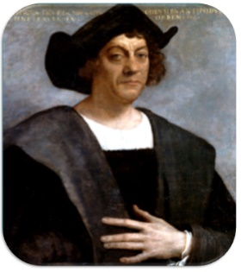
Key Vocabulary
Significant person | Someone who has changed events, improved  people’s lives or had a long- lasting impact on  their country or the world.
Commemorate | To celebrate and remember a person or event.
Explorer | An explorer is someone who goes on an exploration.
Exploration | A journey where explorers travel to unfamiliar places.
Polar | Used when talking about anything to do with the North or South pole.
Recent | In the past but not long ago
Rihla | The shortened name of the book when Ibn Battuta’s travels were written down. The word Rihla means ‘journey’ in Arabic.
Voyage | A long journey, especially by ship. The word voyage can also be used to describe journeys into space.
Key Events/ People & Facts
Ibn Battuta was born in 1304. He was a great explorer who spend nearly 30 years travelling. It is thought he travelled over 78,000 miles visiting the same as 44 modern countries. In 1354, he told a writer what happened on his journeys and these stories were written up in the Rihla.
Skills
It is not certain whether Matthew Henson and the other explorers with him were the first to reach the North Pole in April 1909. Even so, Matthew Henson should be remembered as a skilled polar explorer. For years, he did not receive the same recognition as his white co-explorer due to racism.
When Neil Armstrong took those first steps on the Moon in July 1969, he was joined by Buzz Aldrin whilst Michael Collins stayed in the main spacecraft during the Moon landing.
Felicity Aston’s polar exploration is part of recent history. In 2012, Felicity became the first person to ever travel along across Antarctica.
There are lots of reasons why someone might be considered to be important in history. It might be that their actions changed things for people or that they achieved something great.
Significant people, including explorers, are remembered in lots of different ways. Some explorers have places named after them. Some have their pictures on stamps or have statues.

Use a simple timeline to order events and people.
Ask questions about the past
Recount the main events from a significant event in history.
Use a wide range of information to answer questions
Use timelines to order events or objects or place significant people.

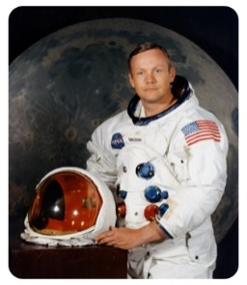

Overview

Questions

What makes people significant?

Who was Ibn Battuta?

Who was Christopher Columbus?

Comparing explorers
Why was Neil Armstrong important?

National space centre

Faith filled and hopeful: What hopes did the Explorers have?

Hands on Experience
Gospel Values

Geography: Year 2 – What a wonderful world
Autumn 2 – Would you rather be a penguin or a meerkat?

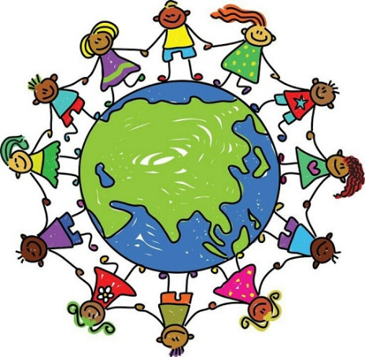
Key Vocabulary
Continent | A massive area of land that is separated from others by water or other natural features.
Ocean | An ocean is a huge body of salt water. Oceans cover nearly 71 percent of Earth’s surface.
Country | A country is land that is controlled by a single government.
Physical features | Natural features of the earth’s surface – coast, sea, mountains, valley.
Human features | Something that is built by humans and would not have existed in nature without humans.
Climate | The average measurements of temperature, wind, humidity, snow, and rain in a place over the course of years.
Equator | It is an imaginary line around the middle of a planet which is halfway between the North Pole and the South Pole. It divides the planet into a Northern Hemisphere and a Southern Hemisphere.
Hemisphere | A hemisphere is half of a sphere, or ball. People use the word to describe one half of Earth.
Landmark | 1.) Something (as a building, a large tree, or a statue) that is easy to see and can help a person find the way to a place near it. 2.) A building of historical importance.
Aerial view | When we look at something from above.
Key Events/ People & Facts
The seven continents are Africa, Antarctica, Asia, Australia, Europe, North America, and South America.
Mnemonic – Eat an apple as a night time snack.
There are 5 oceans. The 5 oceans (smallest to largest) are: Arctic, Southern, Indian, Atlantic and Pacific.
Mnemonic – Penguins are interesting and smart.
The UK is in the continent of Europe. Europe is the second smallest continent in the world. Europe is home to foxes, wolves and bears. Stonehenge and the Eiffel Tower are landmarks in Europe.
Antarctica is the coldest and windiest continent. It is the third smallest continent in the world. It is almost completely covered in ice. Antarctica is home to penguins, albatross and seals.
Australia is the smallest continent. The Great Barrier Reef is in Australia and it is the largest coral reef in the world. Australia is home to lots of unique animals, such as kangaroos, koalas and emus. Sydney Opera House, Ayer’s Rock and Murray River are just a few of the landmarks in Australia.
Asia is the largest continent on Earth and it has over 48 countries. Himalayas are the world’s tallest mountains and are found in Asia. Asia is home to tigers, monkeys and giant pandas. Mount Everest is a famous landmark that can be found in Asia.
Africa is the second largest continent in the world. It has 54 countries, more than any other continent. Africa is home to the largest desert in the world; the Sahara desert. It also is home to one of the longest rivers in the world; the river Nile. Africa is home to giraffes, elephants and lions. Egypt, Nigeria and South Africa are major countries found in Africa. The Egyptian pyramids are a landmark found in Egypt, Africa.
North America is twice the size of Europe and it has 9 time zones. Major countries found in North America include the USA and Canada. North America is home to bears, moose and skunks. Empire State building, the Statue of Liberty and Mississippi bridge are just some of the landmarks in North America.
South America is the fourth biggest continent and only has 12 countries. The major countries in this continent are Brazil and Argentina. The Amazon is the largest rainforest which can be found here. South America is home to llamas, sloths and jaguars.
A physical feature occurs naturally on the earth's surface - the land or water. Weather is also a physical feature.
A human feature is something that has been put there by man/humans.
North, South, East and West are the compass points. We use these points when referring to a map.
Mnenomic – Never eat shredded wheat; Never eat soggy waffles.
Weather is the day to day changes that we see happen. Climate is the average weather usually taken over 30 years for a particular place. Countries around the world have different climates either hot or cold. There are cold or polar, warm, tropical and temperate climates. The UK has a temperate climate.

Understand geographical similarities and differences through studying the human and physical features of geography.

Use basic geographical vocabulary to refer to:
Physical features – beach, cliff, coast, sea, ocean.
Human features – city, town, village, port, harbour.

Use simple compass directions and locational and directional language to describe the location of features on a map.

Use aerial photographs and plan perspectives to recognise landmarks and basic human and physical features.
Skills

List the 7 continents.

Name the 5 oceans.

What are the differences between human and physical features?

What features can you see on an aerial view photograph?

What is climate? Where are the hot and cold climates of the world?

Can you name a continent that is in the Northern Hemisphere? Southern Hemisphere?

Overview

Hands on Experience
Gospel Values

Grateful
What am I thankful for in our world?
World maps/Atlases/a globe.
Explore aerial view photographs.
Video clips of the different continents/oceans.

Geography: Year 2 – The Great Fire of London
Spring 1/2 – Who was to blame and who helped in the Great Fire of London?

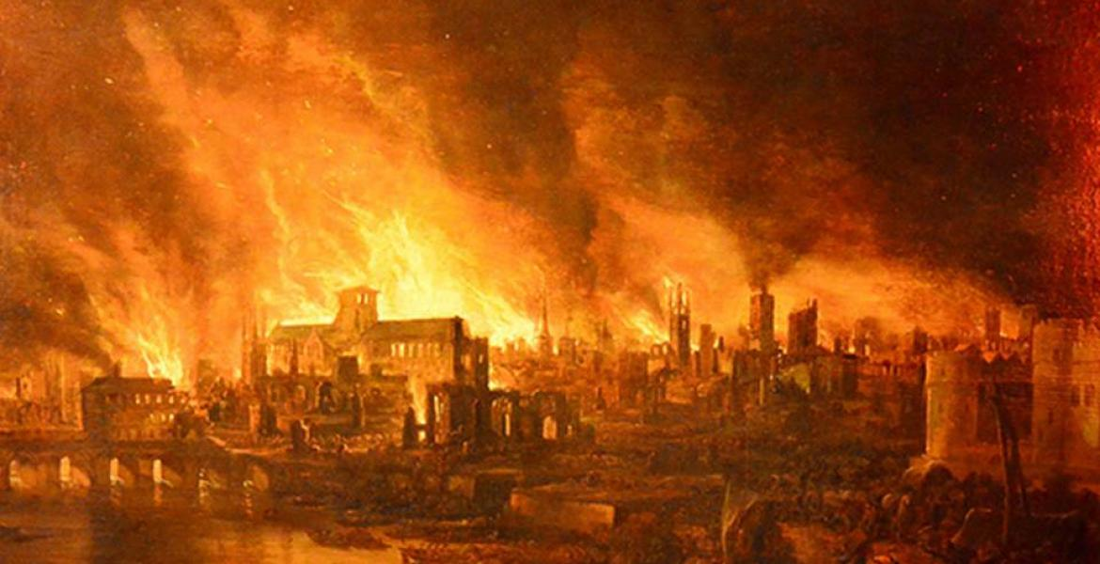
Key Vocabulary
London | The capital city of England.
Thomas Farriner | Was a British baker in the 17th century of London. His bakery was the source point for The Great Fire of London.
Samuel Pepys | Was a Clerk to the Royal Navy and someone who lived during the time of the GFOL. He is most famous for the diary he kept during this time.
Fire brigade | A body of people trained and employed to extinguish fires.
Leather bucket | Ancient fire bucket made to carry water to put out fires.
Axe | A tool used to chop wood.
Water squirt | A tool used to shoot out water.
River Thames | A river that flows through southern England including London. It is the longest river in England.
Monument | A statue built to remember a past event or person.
Key Events/ People & Facts
The Great Fire of London began in the early hours (around 1am) of Sunday 2nd September, 1666 and lasted for four days.
It began on Pudding Lane, in a bakery belonging to a baker named Thomas Farriner.
Following a long, dry summer the city was suffering a drought. Water was scarce and the wooden houses had dried out, making them easier to burn.
Buildings were built very close together and made from wood, roofed with thatch and tightly packed together. Streets were very narrow and there was a strong wind which all helped the fire spread more quickly.
Horse and carts were banned from going near the fire due to the carts being made from wood.
Houses were pulled down in an attempt to stop the fire from spreading.
As news of the fire spread, people ran to escape from its path. People gathered their belongings and tried to escape to safety on foot and on boats on the River Thames.
At first, few were concerned – fires were such a common occurrence at the time. However, the fire moved quickly down Pudding Lane and carried on down Fish Hill and towards the River Thames. It spread rapidly, helped by a strong wind from the east.
There was no organised Fire Brigade. Fire-fighting was very basic with little skill or knowledge.
People tried to help put the fire out by pulling houses down and gathering buckets of water from the River Thames. They used leather buckets, axes, hooks and water squirts.
The Fire destroyed St. Paul’s Cathedral.
The Navy stepped in and put out the fire by blowing some of the buildings up.
Samuel Pepys was someone who lived at the time and was a Clerk to the Royal Navy. He kept a diary of The Great Fire of London. He buried his possessions of cheese and wine to keep them safe away from the fire.
Sir Christopher Wren planned the new city and the rebuilding of London took over 30 years. The site where the fire first started is now marked with a monument built between 1671 – 1677.
New buildings were made from brick or stone and streets were made wider.
Skills

Use a simple timeline to order events and people.
Ask questions about the past.
Recount the main events from a significant event in history.
Use a wide range of information to answer questions.
Use timelines to order events or objects or place significant people.
Identify similarities and differences between ways of life in different periods.
Overview

Where did the GFOL take place and how did it start?
What made the fire spread so quickly?

What is Samuel Pepys most famous for?

Why did Samuel Pepys bury his possessions?

How can we learn about events that happened in the past?

Comparing periods of time
Compare similarities between London from past and present.

Learned and Wise
What can we learn from the events during the Great Fire of London?
Virtual tour of Ford Green Hall.

Videos/books of GFOL.

Maps of London.

Create your own house from the GFOL and set the Great Fire of London in school responsibly.

Samuel Pepys diary.

Hands on Experience
Gospel Values
Geography: Year 2 – Beside the seaside
Summer 1 – Why do we like to be beside the seaside?

Key Vocabulary
Pier | A platform on pillars, going from the shore to the  sea, typically with entertainment and arcades.
Promenade | A paved public walkway, along the seafront  at a resort.
Coast | The part of the land, adjoining the sea.
Sand dunes | A large mass of wind-blown sand, in deserts and  near beaches.
Physical features | Natural features of the earth’s surface – coast, sea, mountains, valley.
Human features | Something that is built by humans and would not have existed in nature without humans.
Resort | A place that is frequently visited for holiday or recreation purposes.
Bay | A body of water that is partly surrounded by land, which empties out into larger bodies of water.
Harbour | A deep body of water that protects boats near land.
Key Events/ People & Facts
Around 70% of the Earth’s surface is covered by ocean.

The largest ocean on Earth is the Pacific Ocean; it covers around 30% of the Earth’s surface.

Beaches are landforms along the shoreline of water bodies such as an ocean, sea, lake or river. They are made up of loose rock particles of materials such as sand, gravel, shingle, pebbles, cobblestones or sometimes shells.

Beaches can come in many different colours such as white, grey, gold-yellow, brown, red and even black!

A beach that remains undisturbed by modern humans (such as houses, resorts, shops, or hotels) is often called a wild beach.

Beaches became popular as tourist attractions during the 18th century.

The longest beach in the world is Casino Beach in the city of Rio Grande, Brazil. It is approximately 132 miles long!

Fraser Island off the coast of Queensland, Australia, is the largest sand island in the world and it has a beach that is 40 miles long.

Tourists visit beaches for many different activities such as sunbathing, swimming, walking, building sandcastles, surf and body boarding.

According to the Guinness World Records, the tallest sandcastle ever made was made in Connecticut, USA, in May 2011. It was 11.53 m tall.

The highest cliffs in the UK are St John's Head cliffs at Hoy on the Isle of Orkney in Scotland.
The White Cliffs of Dover are famous cliffs on the south coast of England. They are white because they are made of chalk.

Understand geographical similarities and differences through studying the human and physical geography of two small areas of the UK.

Use basic geographical vocabulary to refer to:
Physical features – beach, cliff, coast, sea, ocean.
Human features – city, town, village, port, harbour.

Use simple compass directions and locational and directional language to describe the location of features on a map.

Use aerial photographs and plan perspectives to recognise landmarks and basic human and physical features.
Skills
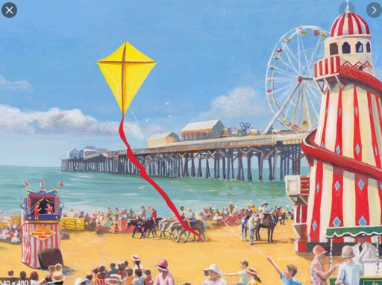

Overview

Where are our seasides?

What are the features of seasides?

Let’s compare seasides in the past and present.

Let’s explore a seaside town.

How is an island different from mainland?

Who can see the sea?

Visit to Llandudno – ice-cream, Punch and Judy show, walk along the prom, make sandcastles.

Artefacts from the seaside – shells, sand, water.

Create your own seaside in the classroom.

Loving and compassionate
What is there to love about the seaside?

Hands on Experience
Gospel Values

Key Events/ People & Facts
Kenya is located in East Africa, which lies on the equator.

The capital city of Kenya is Nairobi. This is also the largest city.

Kenya is officially called The Republic of Kenya.

Mount Kenya is the highest mountain in Kenya, standing at 5199 metres high.

Kenya’s longest river is the River Tana, which runs for 1000 km.

The "Big Five" animals of Africa can be found in Kenya: the lion, leopard, buffalo, rhinoceros, and elephant.

The two official languages in Kenya are English and Swahili.

Kenya has many national parks and wildlife reserves, with safaris being a popular activity for tourists.

Many people in Kenya work in agriculture.

The currency in Kenya is the Kenyan Shilling.

Geography: Year 2 “Sensational Safari”

Where is Kenya?

Let’s explore Kenya!

What is a national park?

What animals live in Africa?

Who are the Maasai?

What is a Kenyan child’s life like compared to my life?
Overview
Summer 2 – “Would you prefer to live in England or Africa?”

Key Vocabulary
Africa | One of the seven continents.
Kenya | A country in Africa.
Nairobi | The capital city of Kenya.
Safari | An expedition to observe or hunt animals in their natural habitat.
Maasai | A tribe of people who live in the African savannah.
Tourists | A person who is travelling or visiting a place for pleasure.
National park | An area of countryside, or occasionally sea or fresh water, protected by the state for the enjoyment of the general public or the preservation of wildlife.
Agriculture | The science or practice of farming, including cultivation of the soil for the growing of crops and the rearing of animals to provide food, wool, and other products.
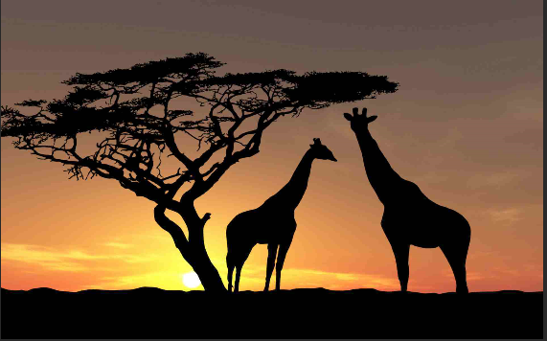

Skills

Understand geographical similarities and differences through studying the human and physical geography of a small area of the United Kingdom.

Use basic geographical vocabulary.

Use aerial photographs and plan perspectives to recognise landmarks and basic human and physical features.

Devise a simple map and construct basic symbols in a key.

Use simple compass directions and locational and directional language to describe the location of features and routes on a map.

Gospel Values
Hands on Experience

Loving and Compassionate

“What is there to love about Kenya?”

Visit to Knowsley Safari Park.

Year 3/ 4 (A) knowledge organisers:

Riotous royalty
Land use
Extreme Earth
Roman Empire

History: Year 3/4– Riotous Royalty
Autumn – King or Queen – who would you prefer to have rule the country?
?

Key Events/ People & Facts
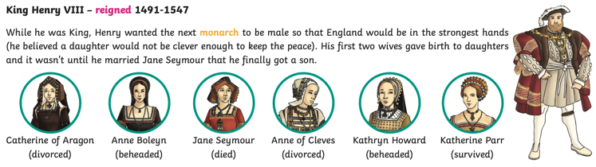
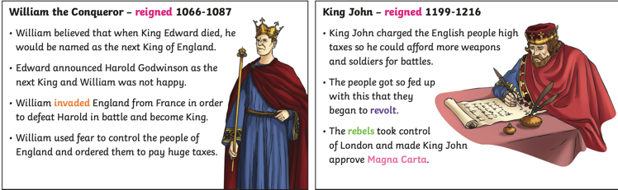
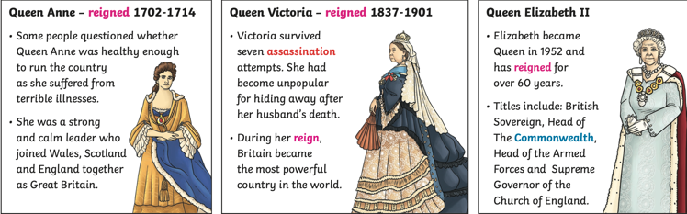
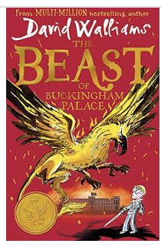
Overview

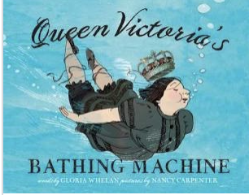

Who was William the Conqueror?
What did King John do wrong?
Why was the Magna Carta so important and how does it affect the world today?
How did Henry VII influence the world we live in today?
How was Great Britain created?
What was the British Empire?
Who is our current monarch?

Key Vocabulary
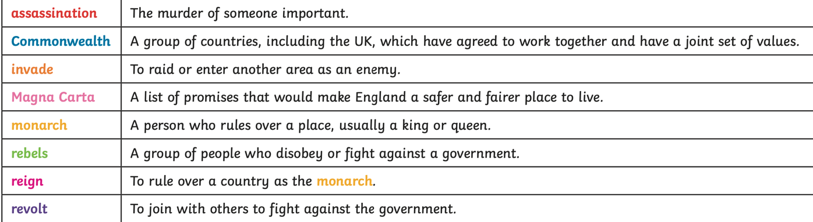

Skills
Hands on Experience
Gospel Values
Generous – What personal qualities do I contribute to our class?

In school visit from touring actor in role to talk about Henry VIII and his wives

- Understand that a timeline can be divided into BC (Before Christ) and AD (Anno Domini)
- Place the timeline being studied on a timeline.
- Place historical events in chronological order and name key events.
- Describe dates of and order significant events from the period studied.
- Compare similarities and differences between some people/ artefacts.
- Describe the legacy of the past.
- Ask questions and find answers about the past.
- Describe how some of the things I have studied from the past affect/influence life today.

Geography: Year 3/4– Land Use
Spring 1– How is the land around us used?
?

Key Events/ People & Facts
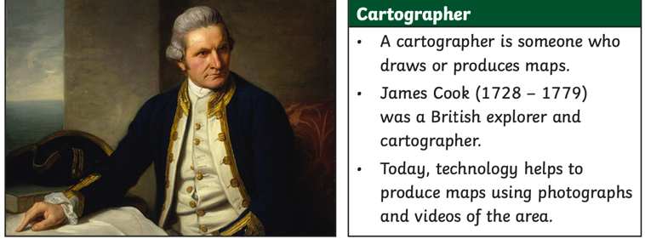
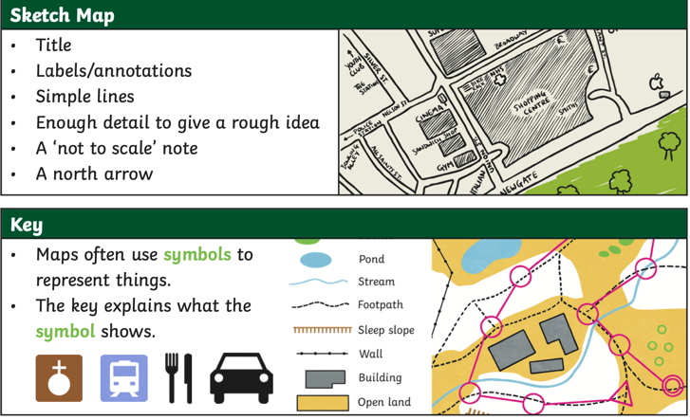
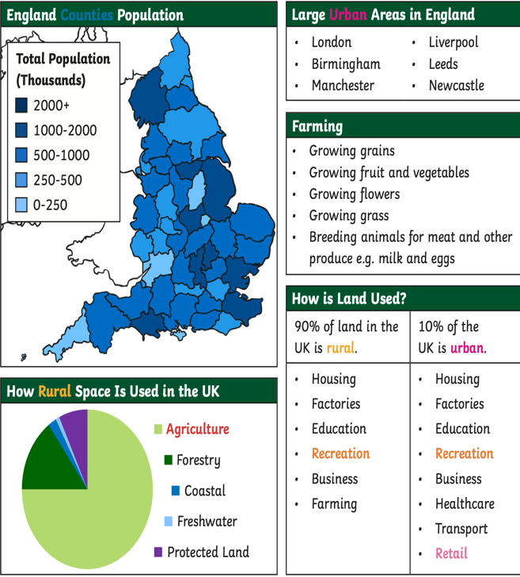
Overview

What is a sketch map and how is it useful?
What are the similarities and differences between sketch maps and published maps?
Why is a key important on a map?
What is the difference between urban and rural?

Key Vocabulary
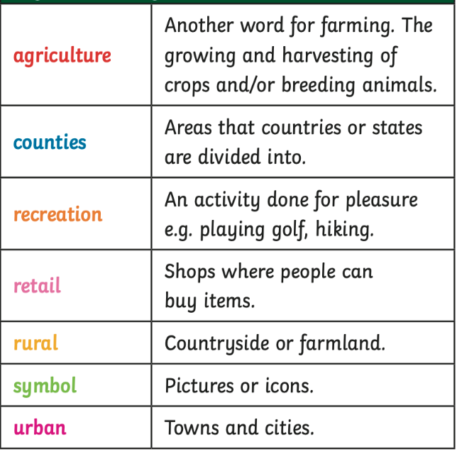

Learned and Wise – What changes can I make to look after our planet?

Gospel Values
Skills
- Linking with History, compare land use maps of UK from past with the present, focusing on land use.
- Use fieldwork to observe and record the human and physical features in the local area using a range of methods, including sketch maps, plans and graphs, and digital technologies.
- Locate and name the main counties and cities in/around Staffordshire.
- Understand geographical similarities and differences through the study of human and physical geography of a region of the United Kingdom.

`Fieldtrip around Newcastle to look at local land maps in order to complete maps
Hands on Experience

Geography: Year 3/4– Extreme Earth
Spring 2 - What makes the Earth angry?
?

Key Events/ People & Facts
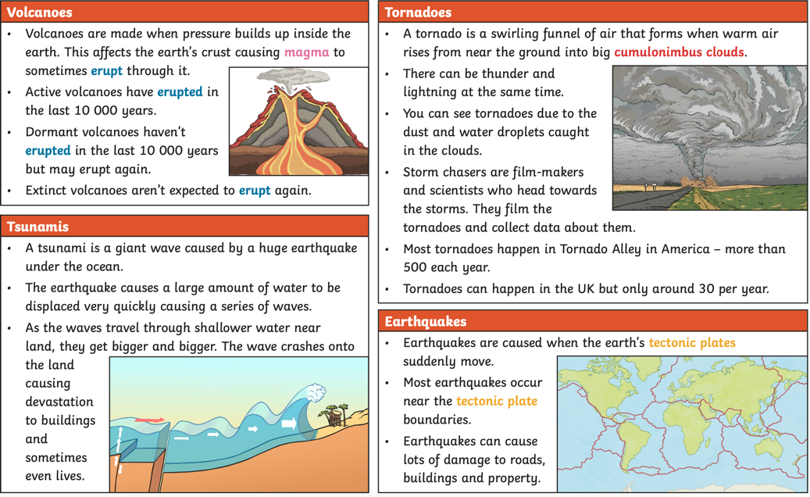
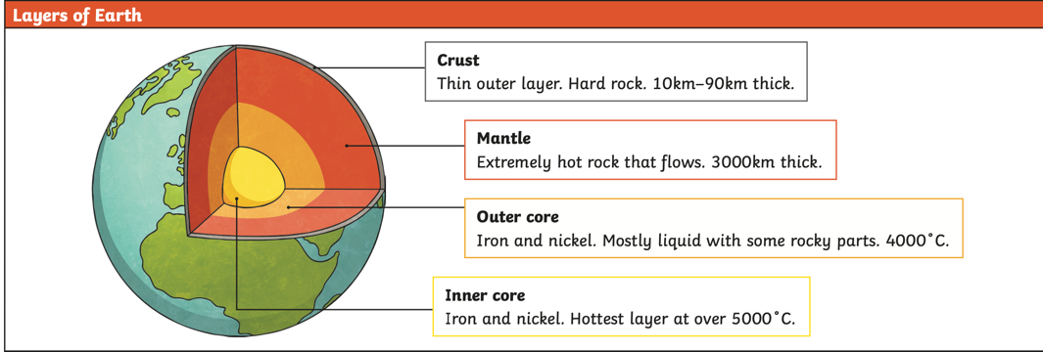
Overview

What is the Earth’s structure like?
How are volcanoes formed?
What is a tornado and what effect can it have?
How are tsunamis created?
How do tectonic plates link with Earthquakes?

Skills

- Describe and understand key aspects of:
- Physical geography, including: climate zones, biomes and vegetation belts, rivers, mountains, volcanoes and earthquakes, and the water cycle. Linking to Science: rock types.
- Use maps, atlases, globes and digital/computer mapping (Google Earth) to locate countries and describe features studied
- On a world map, locate areas of similar environmental regions, either desert, rainforest or temperate regions.

Key Vocabulary
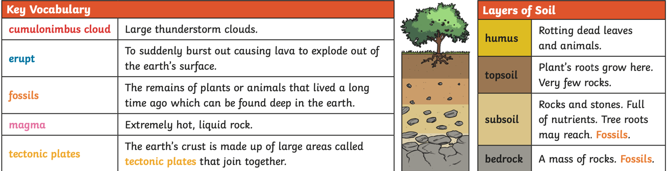

?
Curious and Active - How do Earth’s actions affect people and the environment?

`Making volcanoes
Creating tsunami in a bottle
Hands on Experience
Gospel Values

History: Year 3/4– Romans
Summer - Why were the Romans so powerful and what did we learn from them?

Key Events/ People & Facts
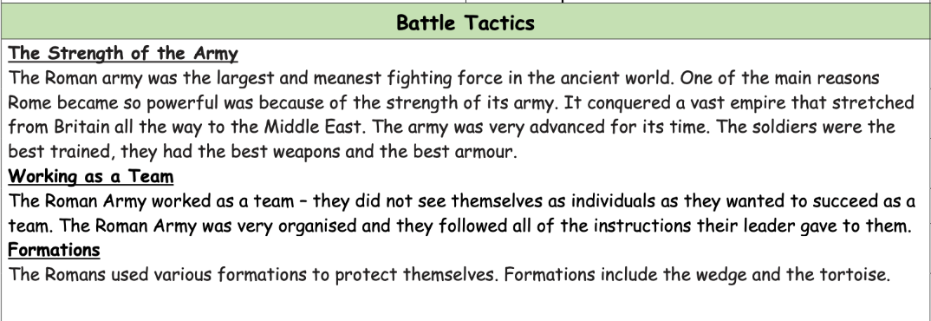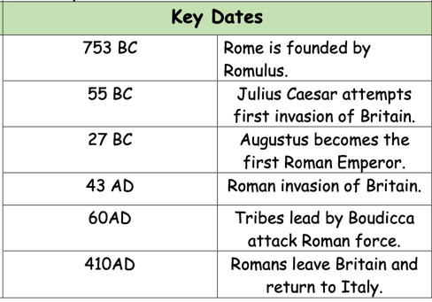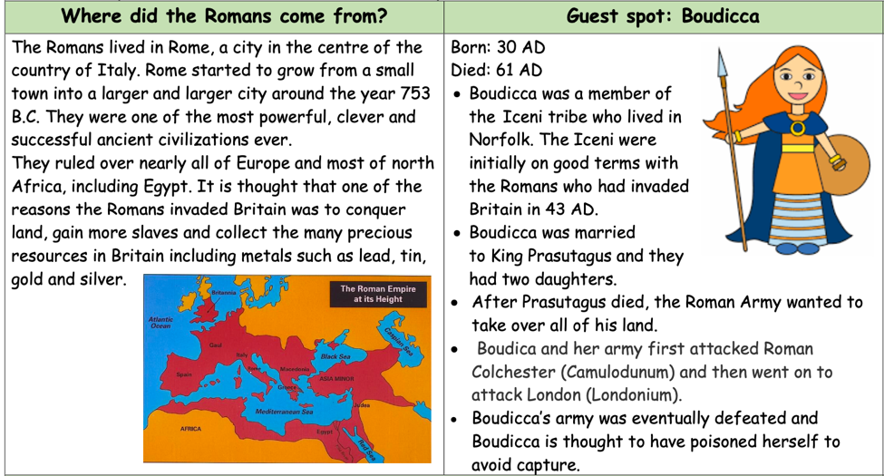

Hands on Experience
Overview

Who were the Romans?
Why were the Romans important?
Was the Roman Empire important?
What weapons did the Romans use in battle?
Which battle tactics were effective?
What was life like in Roman times?
Who is Boudicca and why was she so important?

`Making volcanoes
Creating tsunami in a bottle

Gospel Values

Curious and Active - How do Earth’s actions affect people and the environment?

Key Vocabulary
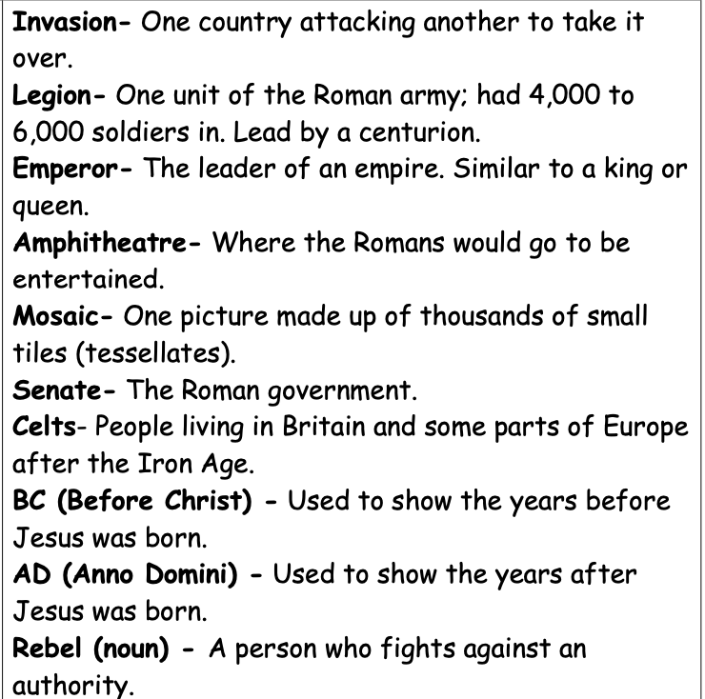

Skills

- Place the timeline being studied on a timeline.
- Place historical events in chronological order and name key events.
- Find out about everyday lives of people in time studied.
- Describe the legacy of the past
- Use documents, printed sources (e.g. archive materials) the Internet, databases, pictures, photographs, music, artefacts, historic buildings, visits to museums and galleries and visits to sites as evidence about the past
- Explore the idea that there are different accounts of history

?

Year 3/ 4 (B) knowledge organisers:

Anglo- Saxons and Vikings
Water
All around the world
Ancient Egypt

History: Year 3/4–Anglo-Saxons and Vikings
Autumn - The Vikings – ruthless killers or peaceful settlers?

Key Events/ People & Facts
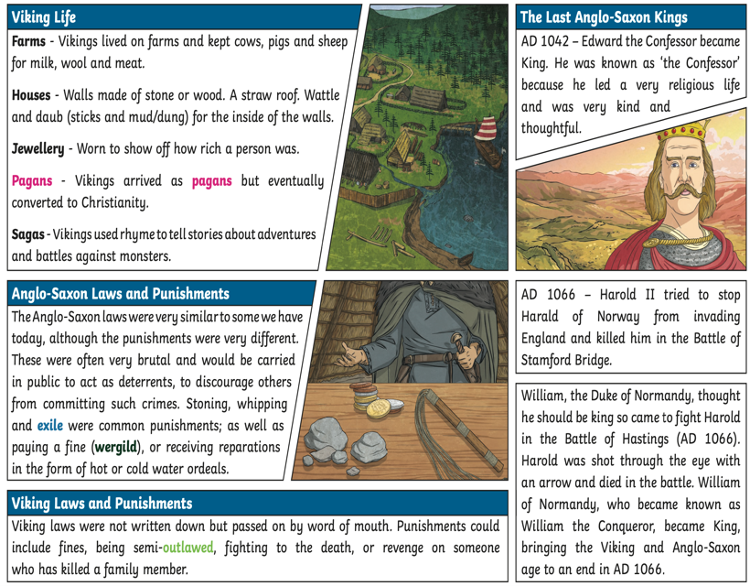
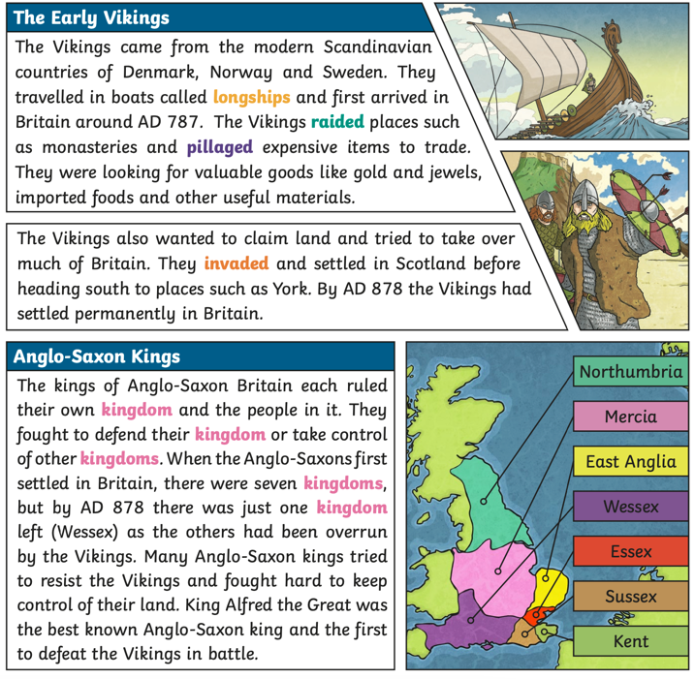
Key Vocabulary
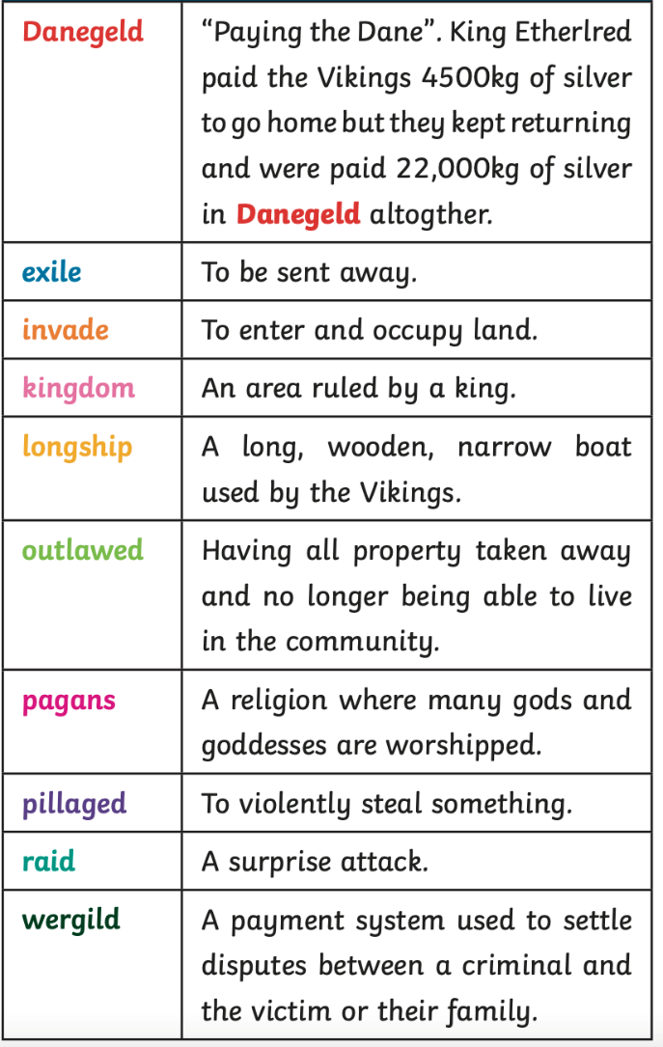
Skills
Overview

- Where did the Vikings come from?
- Why did they invade Britain?
- How did British kings deal with the invasion?
- How did the Vikings live?
- What were Viking warriors like?
- What are Viking artefacts used for and what do they tell us about the past?

- Continue to develop a chronologically secure knowledge and understanding of British and world history.
- Understand that a timeline can be divided into BC (Before Christ) and AD (Anno Domini)
- Order significant events and dates on a timeline.
- Describe the main changes in a period in history.
- Use evidence to describe what was important to people from the past.
- Use evidence to show how the lives of rich and poor people from the past differed.
- Describe similarities and differences between people, events and artefacts studied.
- Describe how some of the things I have studied from the past affect/influence life today.
- Understand how our knowledge of the past is constructed from a range of sources and that different versions of past events may exist, giving some reasons for this.

Gospel Values
Hands on Experience

Local museum visit or actor into school to do workshops

Tatton Park

Attentive & Discerning – How did the choices of the last Anglo Saxon king shape the Britain that we know?

Geography: Year 3/4–Water
Spring 1 - Where does all the water go?

Overview
Key Events/ People & Facts
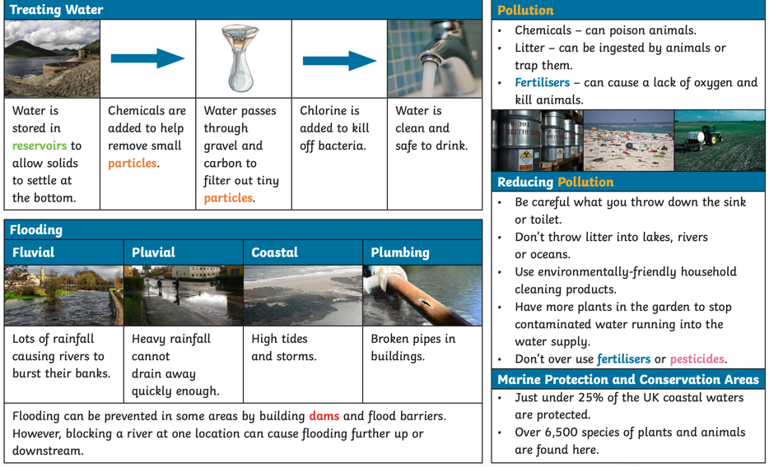
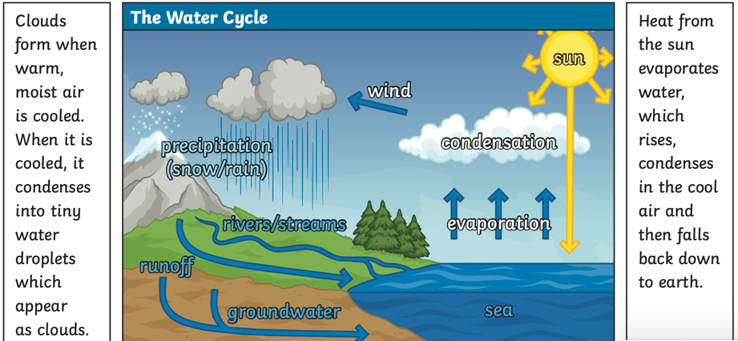
Key Vocabulary
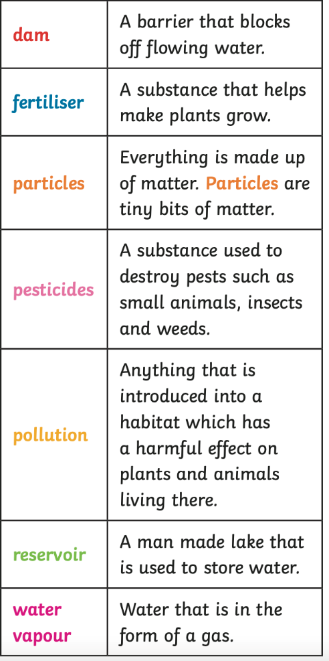

- What are the three states of matter?
- What is the Water Cycle?
- How are clouds and rain formed?
- How is drinking water cleaned?
- Why do we have floods?
- What are the effects of water pollution?

Gospel Values
Curious and Active - How do Earth’s actions affect people and the environment?

- Describe and understand key aspects of:
- Physical geography, including: climate zones, biomes and vegetation belts, rivers, mountains, volcanoes and earthquakes, and the water cycle. Linking to Science: rock types.
- Use maps, atlases, globes and digital/computer mapping (Google Earth) to locate countries and describe features studied.
- Use fieldwork to observe and record the human and physical features in the local area using a range of methods, including sketch maps, plans and graphs, and digital technologies.

Skills

Visit to a water treatment plant

Water Cycle experiment
Hands on Experience

Geography: Year 3/4– All Around the World WorldWorld
mans
Spring 2 - Why do we have time zones?

Key Events/ People & Facts
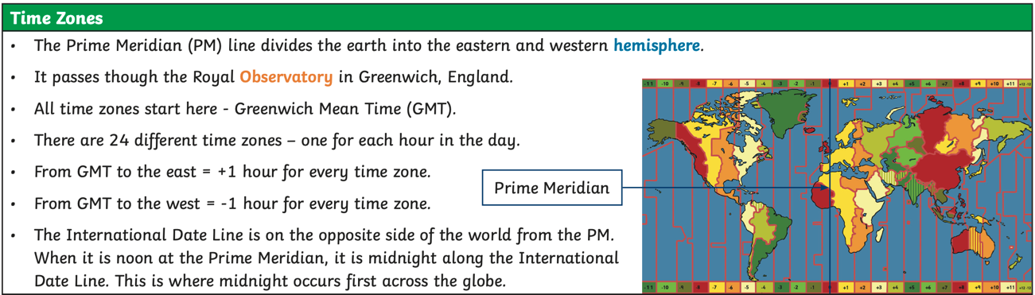
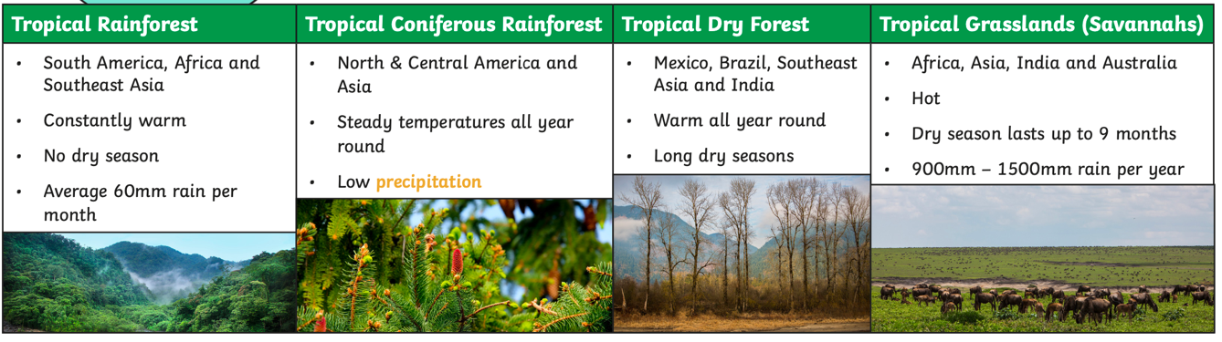
Key Vocabulary
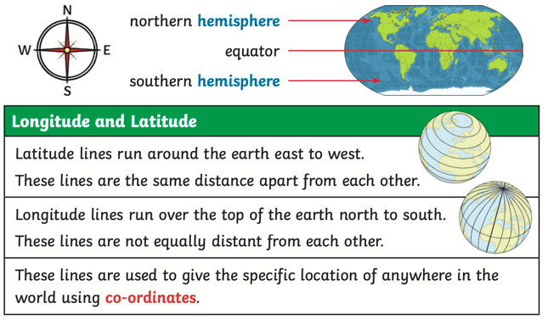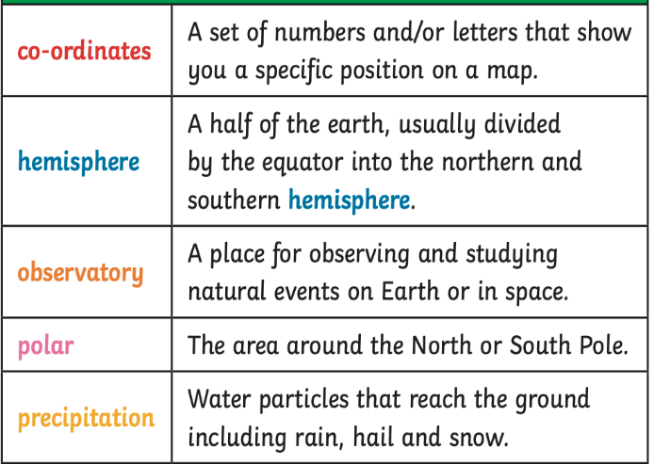

- Where is the equator?
- What do longitude and latitude mean?
- Where are the Arctic and the Antarctic Circle and why are they important?
- How does the climate of the Tropics compare with the UK?
- What are time zones and why are they used?

Overview

Skills
Hands on Experience

?
Learned and Wise – How should we look after our land?

Gospel Values
- Identify the position and significance of Equator, N. and S. Hemisphere, Tropics of Cancer and Capricorn. Develop their use of geographical knowledge, understanding and skills to enhance their locational and place knowledge.
- Physical geography, including: climate zones, biomes and vegetation belts, rivers, mountains, volcanoes and earthquakes, and the water cycle. Linking to Science: rock types.
- On a world map, locate areas of similar environmental regions, either desert, rainforest or temperate regions.
- Use maps, atlases, globes and digital/computer mapping (Google Earth) to locate countries and describe features studied.

Creating bottle biomes – rainforest

Local visit to a forest

History: Year 3/4– Egyptians
mans
Summer - How does Ancient Egyptian life compare with ours today?

Key Events/ People & Facts
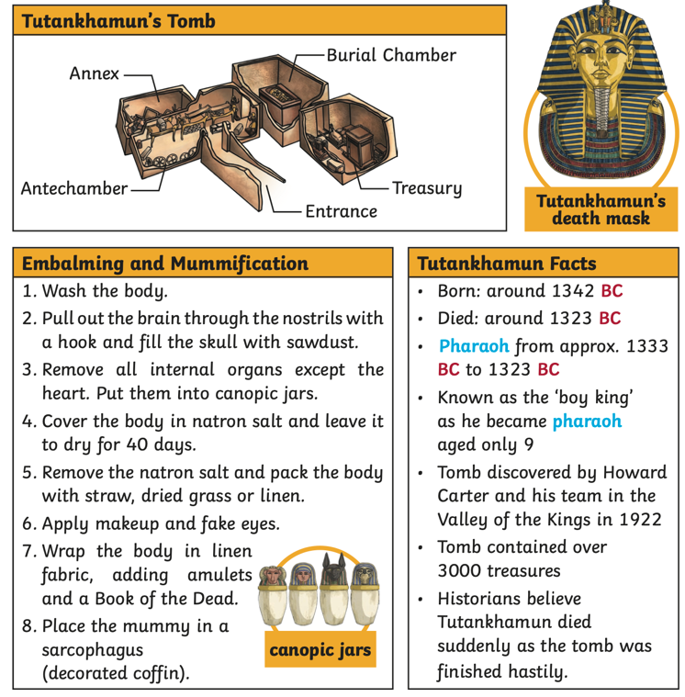
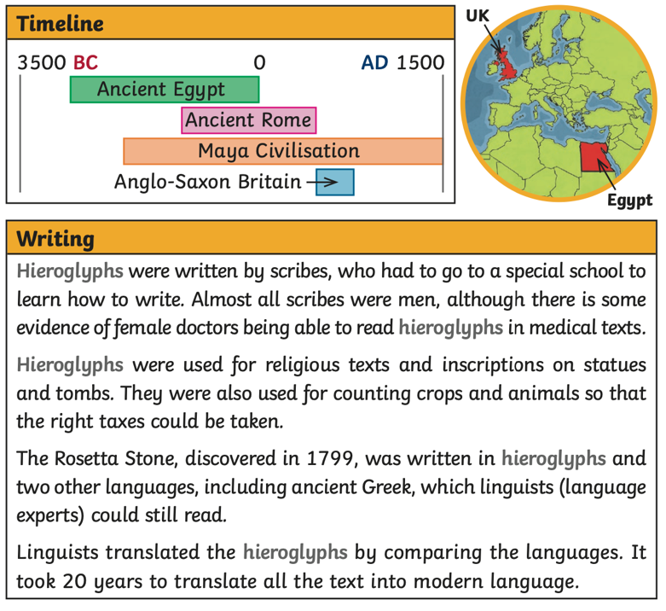
Overview

- Who were the Ancient Egyptians?
- What was life like in Ancient Egypt?
- How ere mummies made?
- Who was Tutankhamen?
- Who did the Egyptians worship?
- How did they write?

Key Vocabulary
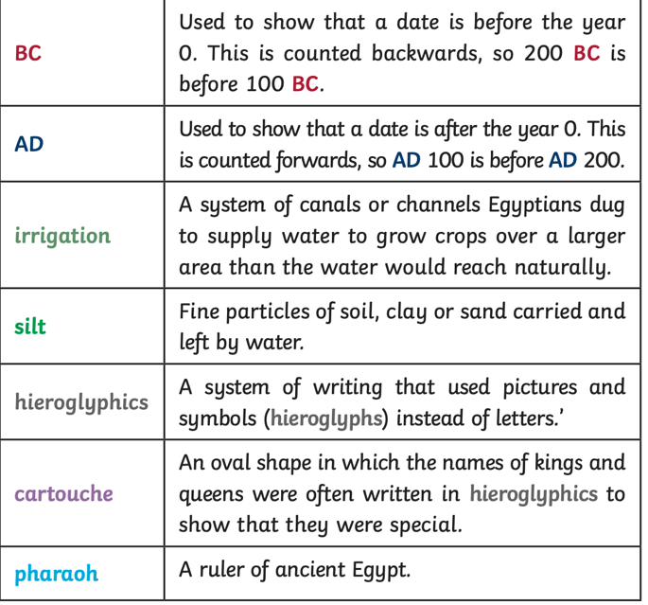

Skills
Hands on Experience

- Understand that a timeline can be divided into BC (Before Christ) and AD (Anno Domini)
- Order significant events and dates on a timeline.
- Use evidence to describe what was important to people from the past.
- Use evidence to show how the lives of rich and poor people from the past differed.
- Describe similarities and differences between people, events and artefacts studied.
- Understand how our knowledge of the past is constructed from a range of sources and that different versions of past events may exist, giving some reasons for this.

`Mummifying oranges

Gospel Values
?
Prophetic – What achievements am I most proud of?

Year 5/ 6 (A) knowledge organisers:

Stone Age to Iron Age
Marvellous Maps
Local History Study: The Potteries
Exploring Eastern Europe
Maya Civilisation

c

History: Year 5/6– Stone Age to Iron Age
mans
Autumn - How did Britain change from the Stone Age to the Iron Age?

Overview
Key Events/ People & Facts
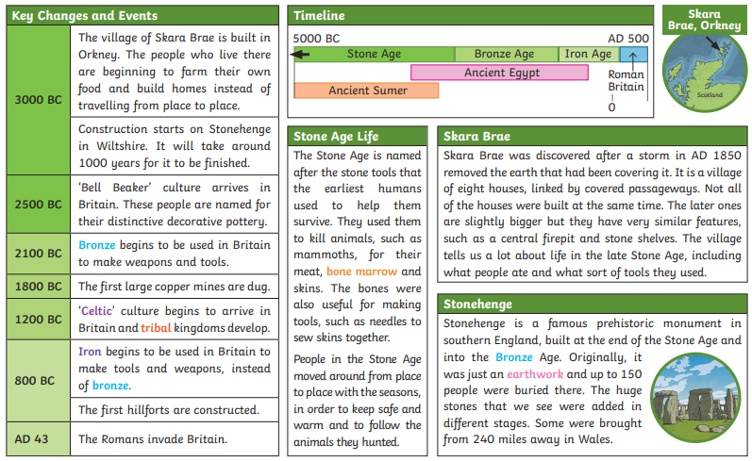

What

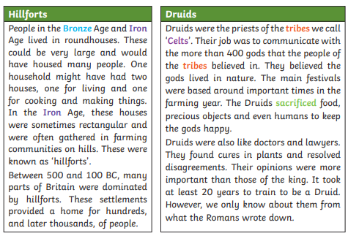
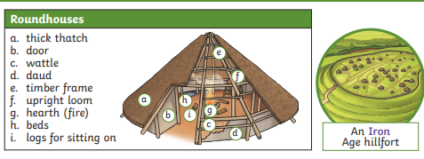

- What did humans need in order to survive in the Stone Age?
- What was found at Skara Brae and why was it important?
- What answers about the past does Stonehenge give us?
- What was the importance of hillforts?
- Who were the Druids?

Key Vocabulary
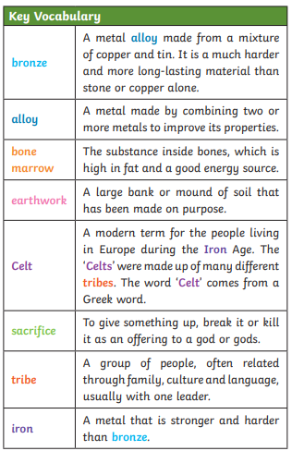

Hands on Experience
Curious and active- how has life changed for people since the Stone Age?

Gospel Values
- Know and sequence key events of time studied.
- Make comparisons between different times in the past, including from previous learning.
- Place an event in the right place on a timeline using specific words: era, period, century, decade, BC, AD
- Choose reliable sources of evidence to answer questions and build up a picture of a past event
- Describe similarities and differences between some people, events and artefacts studied
Skills
`Make a druid crown out of natural materials from the local environment.
Drama – record news interview

History: Year 5/6– Marvellous Maps
mans
Autumn – I’m a Y5/6 pupil, can you get me out of here?

Overview
Key Events/ People & Facts
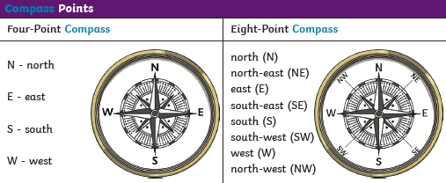
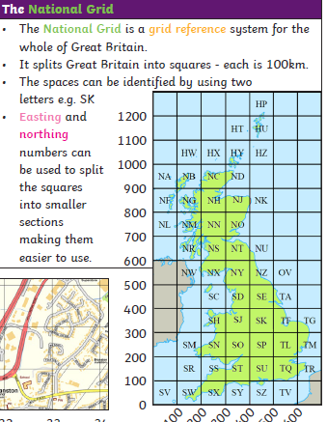

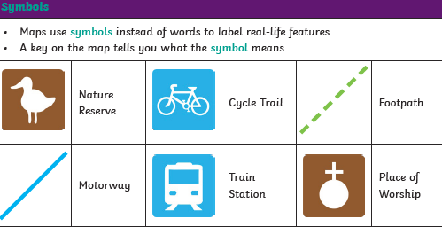

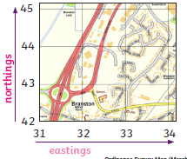

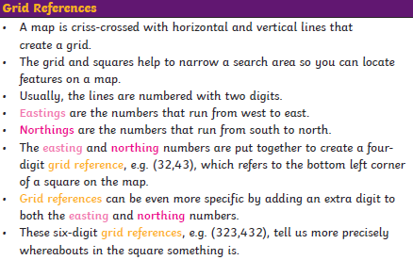

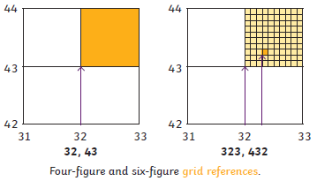

- Using atlases, can you locate places around the world?
- What do symbols on maps mean?
- Can you identify and use compass points?
- Can you locate places on maps using grid references?
- Can you plan a route using compass points and grid references?

Key Vocabulary
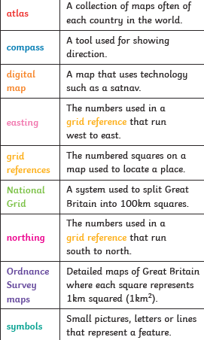

Skills
Use the eight points of a compass, four and six-figure grid references, symbols and key (including the use of Ordnance Survey maps) to build their knowledge of the United Kingdom and the wider world.
Use maps, atlases, globes and digital/computer mapping (Google Earth) to locate countries and describe features studied

Exploring the environment around us using compasses and maps of our school grounds –
Orienteering

Hands on Experience
Curious and active –
Where in the world are you?
Gospel Values

History: Year 5/6– Local History Study
mans
Spring – How did the Victorian period help shape the Stoke on Trent we know today?

Overview
Key Events/ People & Facts
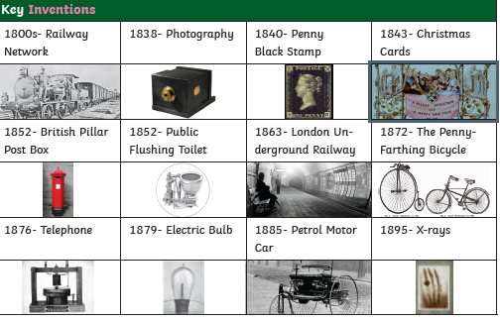
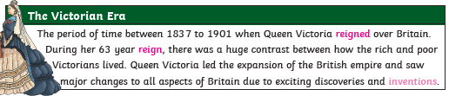

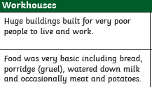
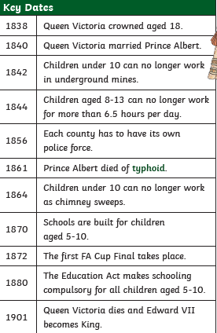

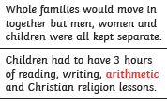
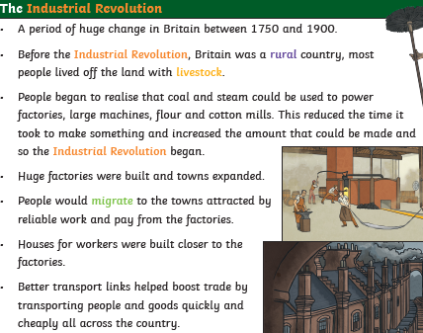

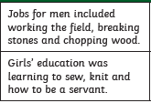

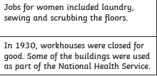

Stoke-on-Trent is known for its pottery trade.
Pottery was made from fired clay in places called
Bottle kilns. During the Victorian period, children
Were made to work in these for up to 72 hours a week, which affected their
Education and health.

Where does the Victorian era sit on the British time line? Who were the Monarchs?
What was life like during this time, including differences between rich and poor?
What was the Industrial Revolution?
How did life in Stoke-on-Trent differ during this time?
What key inventions happened during this time?

Key Vocabulary
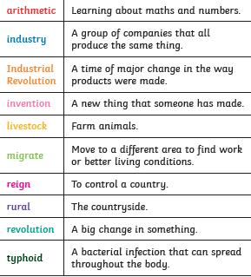

Know and sequence key events of time studied.
Make comparisons between different times in the past, including from previous learning.
Describe the main changes during a period of history.
Give own reasons why changes may have occurred, backed up by evidence.
Describe similarities and differences between some people, events and artefacts studied
Describe how historical events studied affect/influence life today.
Make links between some of the features of past societies. (e.g. religion, houses, society, technology.)
Skills
Hands on Experience
Gospel Values
Visit the Brampton Museum

Compassionate and Loving - What do I like most about my local area?

History: Year 5/6– Exploring Eastern Europe
mans
Spring – How does living in Eastern Europe differ to living in our local area?

Overview
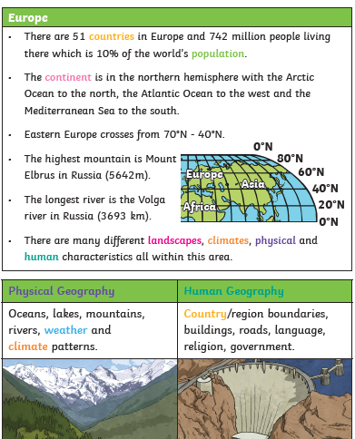
Key Events/ People & Facts
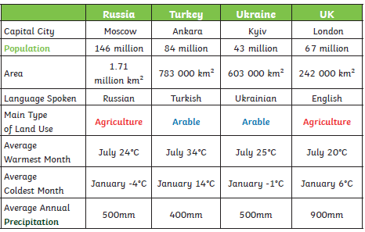

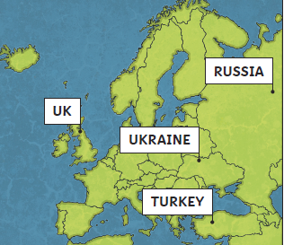

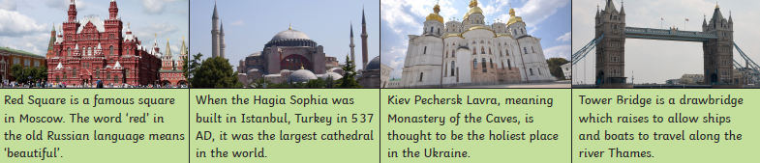

Can you locate countries, capitals and cities?
Can you compare different landscapes and climates around the world?
Can you compare cities in Europe to our local area?
Can you research a place in Eastern Europe and plan a trip there?
What happened in Chernobyl?

Key Vocabulary
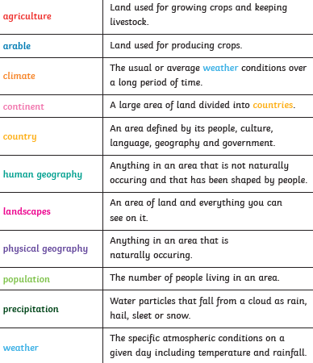
Skills
Use maps, atlases, globes and digital/computer mapping (Google Earth) to locate countries and describe features studied.
To understand geographical similarities and differences through the study of human and physical geography of a region of the United Kingdom, a region in a European country, and a region within North or South America in the context of comparing towns. Locate the world’s countries, using maps to focus on Europe (including the location of Russia)

Hands on Experience
Gospel Values
Curious and active –
Where in the world are you?
Compassionate and Loving - What do I like most about my local area?
Use a range of sources and research to plan a trip abroad.

Key Events/ People & Facts
John Lloyd Stephens – Explored Copan 1839-1841
Fredrick Catherwood
2000 BC
El Mirador
The Spanish arriving in the 16th century caused their
ancient cities to fall to ruin
Blood letting
Playing Ball games
Priests wore masks and costumes
Maya Gods:
Itzamna,
Ix Chel,
Maize God,
Chac,
Kimi,

History: Year 5 – Maya Civilization
Summer – Who were the Mayans and what can we learn from them?

Key Vocabulary
Belize, Costa Rica, El Salvador, Guatemala
Coba, Copan, Tikal, Tulum, Xunantunich, Chichen Itza,
Uxmal
Worship
Sacrifice
Priest
Ritual
Earth ‘Middleworld’
Heavens ‘Upperworld’
Xibalba ‘Underworld’
Base 10
Base 20
Vigesimal Number System
Evidence
Primary Source
Lithography
Camera Lucida
Palenque
Hieroglyphs
Syllaborgram
Logogram
Codex
Codices
Cacao
Maize

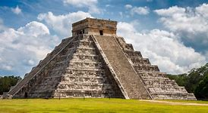

Overview

Who were the Mayas?

When and where did they live?

What beliefs did the Maya Civilization have?

Who are the main Gods that the Mayas believed in?

What did the Maya number system look like? How is this different than today?

How do we know about Ancient Maya Civilization? How accurate is this evidence?

How did Mayas write?

Gospel Values
Hands on Experience
Skills

Make hot chocolate from a Maya recipe
Try foods that the Mayas ate that we still can get today e.g. avocado, corn etc.
Compassionate and Loving – in appreciation of what the Maya Civilization taught us today.
Discerning – Why were some food choices of the Maya so significant?
Use some geographical vocabulary to describe where the Ancient Maya Civilization originated.
Make comparisons between different times in the past, including from previous learning.
Place an event in the right place on a timeline using specific words: era, period, century, decade, BC, AD.
Choose reliable sources of information to find out about the past.
Understand that some evidence from the past is propaganda, opinion or misinformation, and that this affects interpretations of history.
Begin to identify primary and secondary sources.

Year 5/ 6 (B) knowledge organisers:

World War Two
Our changing world
The Amazing Americans
Ancient Greece

World War 2
Autumn – What was it really like during WW2?

Key events/people/facts
Key individuals:
Adolf Hitler- German politician and leader of the Nazi Party. During his dictatorship from1933-1945, he WW2 initiated by invading Poland on 1st September 1939.

Neville Chamberlain- British Conservative politician who served as Prime Minister of the United Kingdom from May 1937 – May 1940.

Key events:
1st September 1939 – Hitler’s troops invade Poland
10th May 1940- The Battle of France
10th July 1940- The Battle of Britain
7th September 1940- The Blitz
26th May 1940- The Evacuation at Dunkirk (codenamed Operation Dynamo)
22nd June 1941- The German invasion of Russia
7th December 1941- Japan bombs Pearl harbour in Hawaii
17th May 1943- The Dambusters Raid
6th June 1944- D-Day the Normandy landings
16th December 1944- The Battle of the Bulge
8th May 1945- Victory in Europe Day
6th-9th August 1945- USA drops atomic bombs on Japan

Key Vocabulary
evacuation | The action of evacuating a person/place
rationing | Allow each person to only have a fixed amount of a commodity.
munitions factory | The place where supplies (weapons) are made for war.
The Blitz | An intensive and sudden military attack (German bombing of UK in 1940-1941.
D-Day | The day (6th June 1944) in the second world war on which Allied forces invaded northern France by means of beach landings in Normandy.
anti-Semitism | Hostility to or prejudice towards Jews.

Overview

How and why did war breakout?

Why were children evacuated?

Why were essentials rationed?

How did women support the wartime effort?

Why were Jews subject to Nazi prejudice and discrimination during the war?

Gospel Values

Intentional and Prophetic- How did Reginald Mitchell, a man with little training, fulfil his hopes of designing an aircraft that would play a vital role in the Battle of Britain?

Wise – How might Christians show their religious beliefs?

Skills

- Order significant events, movements and dates on a timeline.
- Identify and compare changes within and across different periods.
- Understand how some historical events occurred concurrently in different locations.
- Choose reliable sources of information to find out about the past.
- Give own reasons why changes may have occurred, backed up by evidence.
- Describe similarities and differences between some people, events and artefacts studied
- Describe how historical events studied affect/influence life today.
- Make links between some of the features of past societies. (e.g. religion, houses, society, technology.)
- Understand that some evidence from the past is propaganda, opinion or misinformation, and that this affects interpretations of history.
- Give reasons why there may be different accounts of history.
- Evaluate evidence to choose the most reliable forms.
- Begin to identify primary and secondary sources.
- Investigate own lines of enquiry by posing questions to answer.
- Communicate their knowledge and understanding about the past using different genres of writing, drawing, diagrams, data-handling, drama role-play, storytelling and using ICT.
- Plan and present a self-directed project or research about the studied period.

- Trip to Arboretum- November
- Air-raid drama
- Build a Morrison shelter
Hands on Experience

History: Year 5/6– Our changing world
mans
Spring - How is our world changing?

Overview
Key Events/ People & Facts
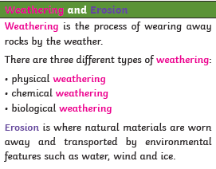
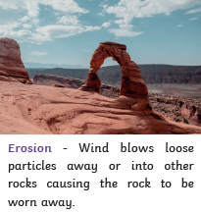
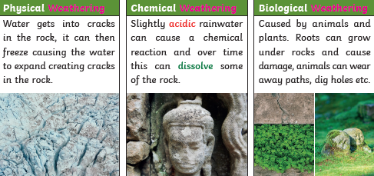

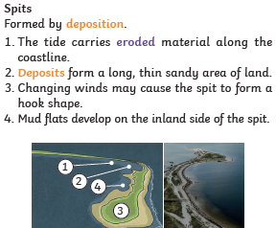
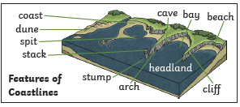
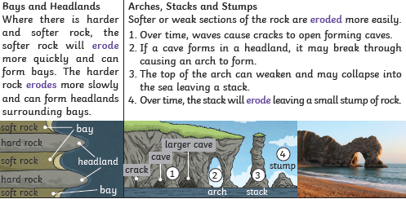

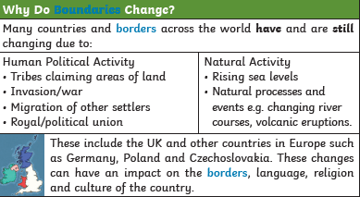
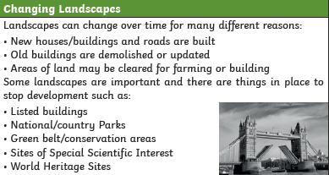

- What is weathering and erosion?
- What are the features of a coastline?
- How and why do coastlines change?
- How and why do boundaries change and how have they changed through history?
- To explain how landscapes change over time
- What does the future hold?

Key Vocabulary
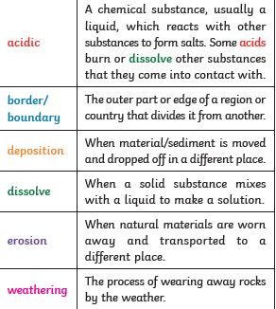

Gospel Values
Attentive and discerning – What changes in the world might take place again that will affect me in my lifetime?
`Make a 3D landscape/coastline
Experiment with materials to demonstrate erosion.

Skills
Understand geographical similarities and differences through the study of human and physical geography of a region of the United Kingdom, a region in a European country, and a region within North or South America.
Name and locate counties and cities of the United Kingdom, geographical regions and their identifying human and physical characteristics, key topographical features (including hills, mountains, coasts and rivers), and land-use patterns; and understand how some of these aspects have changed over time.
Understand geographical similarities and differences through the study of human and physical geography of a region of the United Kingdom, a region in a European country, and a region within North or South America.

Hands on Experience

Geography: Year 6 – Amazing Americas
Spring – What is so amazing about The Americas?

Overview
Key Vocabulary
Equator | an imaginary line around the middle of a planet
Northern  Hemisphere | part of the planet that is north of the equator
Southern Hemisphere | Part of the planet that is south of the equator
Tropic  of Cancer | the most northerly circle of latitude on Earth at which the Sun can be directly overhead
Tropic of Capricorn | is the circle of latitude that contains the subsolar point on the December (or southern) solstice
Arctic Circle | is one of the five major circles of latitude that mark maps of the Earth
Antarctic Circle | is a parallel of latitude on the Earth at approximately 66.5 degrees south of the equator
Prime/Greenwich Meridian | the north-south line at Greenwich is used as the reference for all other meridians of longitude, which are numbered east or west of it
time zone | The local time within a time zone is defined by its offset (difference) from Coordinated Universal Time (UTC), the world's time standard

Key Vocabulary
Country | an area of land that has its own government, army, etc
Continent | is one of several very large landmasses
Climate | the weather conditions prevailing in an area in general or over a long period.
Biome | a large naturally occurring community of flora and fauna occupying a major habitat
Latitude | the angular distance of a place north or south of the earth's equator
Longitude | the angular distance of a place east or west of the Greenwich meridian
polar | relating to the North or South Pole.
arctic | relating to the regions around the North Pole.
temperate | relating to or denoting a region or climate characterized by mild temperatures.
tropics | he region of the Earth near to the equator and between the Tropic of Cancer in the northern hemisphere and the Tropic of Capricorn in the southern hemisphere

Where in the world are The Americas?

How are North and South America similar? How are they different?

How can we find out about countries of the world?

What makes the Americas wonderful?

What is the weather like in North and South America? Why?

How are places in North and South America different to places near to us?

- North America is the third largest continent
- All major types of biomes in the world are found in North America (desert, grassland, tundra, coral reefs)
- Five physical regions in North America (The Rocky Mountains, The Great Plains, The Canadian Shield, Easter region and The Caribbean)
- Natural wonder in North America are Copper Canyon, Yellowstone Part, Denali and The Great Lakes
- North America named after Amerigo Vespucci
- Early North American civilisations (e.g Maya) built the first cities on the continent
- Tourism is an important part of its economy especially the small island nations of the Caribbean

- South America is the fourth largest continent in size and the fifth largest in population
- South America has three physical regions: mountains (Andes) and highlands, river basins (Amazon, Orinoco and Paraguay) and coastal plains (coast of Brazil and Peru)
- South America can be divided into four climatic regions: tropical (cover more than half of the continent), temperate (located south of The Tropic of Capricorn), arid (deserts, coastal areas and interior regions) and cold (southern ends of Argentina and Chile)
- Natural wonder in South America are Macchu Piccu, Iguazu Falls, Angel Falls and Patagonia

Key facts

Skills
- I can identify the countries of North and South America.
- I can identify the capital city of a country.
- I can use geographical terminology to describe the
location and characteristics of a range of places across
the Americas.
- I can describe the climates and biomes of different regions across the Americas.
- I can identify physical and human geographical features of my local area.
- I can identify similarities and differences in the human
and physical geography of my local area and a region
of North America.
- I can tell you the names and locations of the ancient and
new wonders of the world.
- I can describe the characteristics and significance of a
natural wonder of the Americas.
Hands on Experience

Faith-filled and hopeful about the wonders of God’s creation

Curious and Active to find out about countries in the wider world

Hold a Brazil-style carnival in school

Make their own rainforest biome in a bottle

Gospel Values

History: Year 5/6– Ancient Greece
mans
Summer – What did the Ancient Greeks do for us?

Key Events/ People & Facts
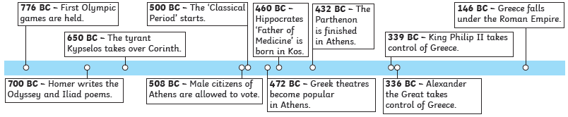

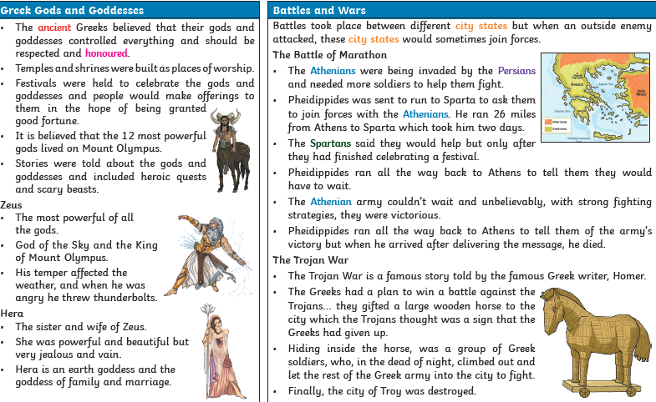
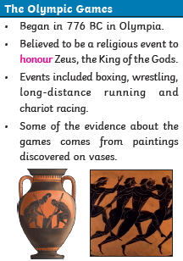

Overview

Key Vocabulary
Ancient | Something from a very long time ago
Athenian | People from the Greek city of Athens
City state | A small area that ancient Greeks was divided into which had its own government, laws and army
Civilisation | The people, culture and way of life of a certain area
Democracy | A fair political system where adults vote for an elected government who then make decisions on how to run the country
Empire | A group of countries that is ruled by one ruler or country
Honour | To show respect and admiration for someone or something
Persian | People from the area of Persia
Philosopher | Someone who studies the idea of right or wrong, the value of things and knowledge
Spartans | People from the Greek city of Sparta

Skills
Order significant events, movements and dates on a timeline.
Identify and compare changes within and across different periods.
Choose reliable sources of information to find out about the past.
Describe how some of the things studied from the past affect/influence life today.
Make links between some of the features of past societies. (e.g. religion, houses, society, technology.)
Choose reliable sources of evidence to answer questions, realising that there is often not a single answer to
Questions about history.

Ancient Greek Olympics day
Making Greek pottery
Hands on Experience
Attentive & Discerning – How did the choices of the Ancient Greeks shape the Britain that we know?

Gospel Values

Assessment

To keep track of children’s individual progress, use the example assessment spreadsheet.

Use the statements relating to each unit and key stage below to assess if a child is Working Towards, Working Within
or Greater Depth.

Based on the objectives taught.
Up to 60% of statements highlighted = Working Towards
61-90% of statements highlighted = Working Within
90%+ of statements highlighted = Greater Depth
 | Locational Knowledge | Place Knowledge | Human and Physical Geography | Geographical Skills and Fieldwork
KS1  Objectives | I can name, locate and identify characteristics of the four countries and capital cities of the United Kingdom and its surrounding seas on a map.  I can name and locate the seven continents and five oceans on a globe or atlas.  I can identify the location of hot and cold areas of the world in relation to the Equator and the North and South Poles.  I can name, locate and identify characteristics of the four countries and capital cities of the United Kingdom and its surrounding seas on a range of maps.  I know the relative locations of the continents and oceans to the Equator and North and South Poles.  I can ask and answer a good range of relevant geographical questions. | I can make observations about, and describe, the local area and its physical and human geography.  I can understand geographical similarities and differences through studying the human and physical geography of a small area of the United Kingdom e.g. town and countryside.  I can understand geographical similarities and differences through studying the human and physical geography of a small area in a contrasting non-European country e.g. Kenya.  I can confidently compare and contrast two capital cities, describing the human and physical geography.  I can make observations about, and describe, the local area and its physical and human geography, and suggest how they are connected. | I can identify and describe seasonal and daily weather patterns in the United Kingdom with some detail.  I can discuss the features of hot and cold countries.  I can use basic geographical vocabulary to refer to:  Key physical features including:  beach, cliff, coast, forest, hill, mountain, sea, ocean, river, soil, valley, vegetation, season and weather.  Key human features including: key human features, including: city, town, village, factory, farm, house, office, port, harbour and shop.  I can identify and describe in detail seasonal and daily weather patterns in the United Kingdom, completing careful daily observations.  Use a range of key vocabulary for human and physical features consistently and accurately within their written and verbal work. | I know that maps give information about the world.  I can use world maps, atlases and globes to identify the UK, countries, continents and oceans studied.  I can describe a journey on a map using simple compass directions (N, S, E,W).  I can use locational and directional language to describe the location of features and routes on a map.  I can keep a weekly weather chart based on first-hand observations using picture symbols and present this data.  I can draw a simple map (real or imaginary place) and use basic symbols and a key.  I can find information on aerial photographs e.g. landmarks, human & physical features of the locality being studied.  I can use a range of maps to locate and identify the four countries of the UK, its surrounding seas, continents and oceans.  I can keep a weekly weather chart based on first-hand observations using picture symbols and present this data, identifying patterns.  I can use aerial photographs to identify a range of human & physical features of a locality and describe using key vocabulary.  I can complete maps and drawings with detail for a wide amount of purposes and provide reasons for my choices of symbols and key.
Geography Assessment

 | Locational Knowledge | Place Knowledge | Human and Physical Geography | Geographical Skills and Fieldwork
LKS2 Objectives | I can identify and explain land-use patterns in the United Kingdom.  I can identify key topographical features (including hills, mountains, coasts and rivers).  I can identify key human and physical characteristics within the United Kingdom.  I can locate places studied in relation to the Equator, Tropics of Cancer and Capricorn, and relate this to their time zone, climate, seasons and vegetation.  I can locate places studies in relation to the Equator, latitude and longitude, and relate this to their time zone, climate, seasons and vegetation. | I can explain how land is used for different purposes and recognise broad land-use patterns of the UK.  I can identify lines of longitude and latitude and use this to find places on a map.  I can understand geographical similarities and differences through the study of human and physical geography for the units taught.  I can use appropriate vocabulary to describe the main land uses within urban areas and identify the key characteristics of rural areas.  I can describe the water cycle in sequence, using appropriate vocabulary, and name some of the processes associated with rivers and mountains e.g. make a working model of a volcano, label its features and explain what happens when it erupts.  I can investigate the main land uses within urban areas and the activities that take place there.  I can give examples of the key characteristics of rural areas.  I can describe and name the key landscape features of river and mountain environments in the UK.  I can describe some of the processes associated with rivers and mountains e.g. make a working model of a volcano, label it with features and describe how and why it erupts. Giving examples of volcanoes around the world.  I can explain the water cycle using appropriate geographical language. | I can describe and understand key aspects of physical geography, including: climate zones, biomes and vegetation belts, rivers, mountains, volcanoes and earthquakes, and the water cycle.  I can describe and understand key aspects of human geography, including types of settlement and land use.  I can compare features of human and physical geography and various landscapes with my own area.  I can use key language for human and physical features consistently and accurately within my written and verbal work.  I can compare places using the careful and correct terminology to offer reason and explanation, when looking at similarities and differences.  I can compare a range of features of human and physical geography and various landscapes with my own area. | I can use maps, atlases, globes and digital/computer mapping to locate countries and describe features studied.  I can draw a simple sketch map.  I can use a key on a map to show how land is used.  I can use maps and aerial views to help me talk about an area and a scale bar to calculate some distances,  I can present information gathered in fieldwork using simple graphs.  I can use the zoom function of a digital map to locate places.  I can complete sketch maps and drawing with details for a wide amount of purposes.  I can provide reasons for the choices of symbols and key.  I can present information gathered in fieldwork using a range of graphs.  I can confidently lead my own fieldwork activity that I choose to investigate.  I can pull together a range of mapping images to be able to investigate and answer relevant questions.
Geography Assessment
Geography Assessment
 | Locational Knowledge | Place Knowledge | Human and Physical Geography | Geographical Skills and Fieldwork
UKS2  Objectives | I can locate capital cities, countries and regions of Europe and North and South America using maps.  I can locate Russia on a map or atlas.  I can name and locate counties and cities of the United Kingdom.  I can explain how characteristics may have changed over time.  I can locate capital cities, countries and regions of Europe and North and South America, and can identify the distinct characteristics of some regions.  I can describe, compare and contrast key physical and human characteristics and environmental regions of Europe and North and South America. | I can understand geographical similarities and differences through the study of human and physical geography of a region of the United Kingdom.  I know information about a region of Europe or North and South America, its physical environment and climate and economic activity.  I understand how a region has changed and how it is different from another region of the UK.  I understand the importance of a region of Europe or North and South America, its physical environment and climate and economic activity, and how they are connected.  I understand how and why regions have changed and how the regions of the UK are distinctive. | I can describe and understand key aspects of human geography, including: trade links, and the distribution of natural resources including energy, food, minerals and water.  I can locate and describe several physical environments in the UK e.g. coastal and mountain environments and how they change.  Use key language for human and physical features consistently and accurately within their written and verbal work.  I can understand and describe in detail a wide range of key aspects of physical and human geography.  I can locate and describe a range of contrasting physical environments in the UK e.g. coastal, river, hill and mountain environments and how they change. | I can use the eight points of a compass.  I can use four figure and six-figure grid references to locate places on a map.  I can give maps a key with standard symbols, (including the use of Ordnance Survey maps) to build my knowledge of the United Kingdom and the wider world.  I can use digital maps to research factual information about features.  I can present information gathered in fieldwork using a range of graphs.  I can use fieldwork to observe, measure, record and present the human and physical features in the local area, using a range of methods, including sketch maps, plans and graphs, and digital technologies.  I can plan and carry out a fieldwork investigation in an urban area and/or rural area using appropriate techniques.  I can use four figure and six-figure grid references with ease to locate places on a map.  I can work confidently use maps (including the use of Ordnance Survey maps), atlases, globes and digital mapping to locate countries and features and build my knowledge of the wider world.  I can design, plan and carry out a fieldwork investigation in an urban area and/or rural area using appropriate techniques.  I can present information gathered in fieldwork using a range of graphs and other data presentation techniques e.g. plan an investigation to find out how the local area is changing using a range of digital resources.
History Assessment
 | Chronology | Events, people, changes in  the past | Historical interpretation | Historical Enquiry | Organisation and Communication
KS1 Objectives | I can recount changes in my own lifetime.  I can order and sequence some familiar events, objects or people in order of time.  I can use words and phrases relating to the passing of time: old, now, then, yesterday.  I can identify some similarities and differences between ways of life at different times (Y1 within living memory, Y2 beyond living memory).  I can sequence events and objects on an annotated timeline and recount changes within living memory, giving an explanation for my sequence of objects and events. | I can understand key features of events.  I can identify independently a range of similarities, differences and changes between ways of life in specific time periods.  I can demonstrate awareness of the lives of significant individuals in the past who have contributed to national and international achievements.  I can describe some changes within living memory (including aspects of national life where appropriate).  I can describe significant historical events, people and places locally and nationally and use some to compare aspects of life in different periods.  I can sort historical objects/ artefacts from ‘then’ and ‘now’.  I can recount episode from stories about the past.  I understand why events happened and what happened as a result.  I can describe independently and accurately similarities, differences and changes both within and across time periods. | I can distinguish between fact and fiction.  I can make simple observations about different people, objects and events.  I can relate my own account of an event and understand that others may give a different version.  I can compare pictures or photographs of people or events in the past.  I can recount some details from the past from pictures and stories.  I can recognise some basic reasons why people in the past acted the way they did.  I can consider why things may change over time.  I can recount in detail people or events from the past.  I can use evidence to explain why people acted in the past the way they did. | I can find answers to some simple questions about the past from simple sources of information.  I can ask and answer relevant basic questions about the past.  I can choose parts of stories and other sources to show what I know about the past.  I can sort objects/ artefacts from ‘then’ and ‘now.’  I can show understanding of some of the ways in which we find out about the past and identify different ways in which it is represented.  I can describe, in detail, what I know about the past.  I can sort objects/ artefacts from ‘then’ and ‘now’ and give reasons for my choices. | I can show an awareness of the past, using simple historical terms and phrases relating to the passing of time.  I can speak about how I have found out about the past.  I can retell simple stories or events from the past.  I can talk, draw, make models role play or write about aspects of the past e.g. simple recounts, simple stories, labelled diagrams and write about them.  I can plan questions and produce answers to a few historical enquiries using historical terminology e.g. plan and find information required to write a paragraph about which explorer was most successful.  I can use a variety of historical terms and phrases relating to the passing of time.

History Assessment
 | Chronology | Events, people, changes in  the past | Historical interpretation | Historical Enquiry | Organisation and Communication
LKS2 Objectives | I can identify where people and events fit into a chronological framework.  I understand where the time studied fits on a timeline.  I can use dates and historical terms when ordering events and objects.  I understand that the past can be divided into different periods of time.  I can use some dates and historical terms when ordering.  I can sequence several events or artefacts.  I understand timelines can be divided in to BC and AD, using the key words century and decade.  I can develop a chronologically secure and accurate knowledge and understanding of British, local and world history.  I have a secure knowledge of chronology and can accurately place a range of historical events from around the world on a timeline.  I can compare a range of historical periods, identifying differences between them. | I can compare periods studied with our life today.  I can identify reasons for and results of people’s actions.  I can identify features and significant events of the time studied.  I can offer a reasonable explanation for some events.  I can demonstrate that I understand about the changes between periods of time studied.  I can describe some historical changes.  I can demonstrate knowledge of aspects of history significant in their locality.  I can describe and give reasons for some historical changes.  I can offer a secure explanation for some events. | I understand how our knowledge of the past is constructed from a range of sources.  I can talk about some of the ways the past can be represented – pictures, letters, artefacts etc.  I can recognise that our knowledge of the past is constructed from different sources of evidence.  I can use sources to address historically valid questions.  I can begin to evaluate the usefulness of different sources.  I understand that our knowledge of the past is constructed from different sources of evidence.  I can explore and describe some of the ways the past can be represented – pictures, letters, artefacts etc.  I can identify and give reasons for the different ways in which the past is represented. | I can recognise why some events happen and what happens as a result.  I can select and record information relevant to the period of study.  I can ask some questions about the time period.  I can recognise how sources of evidence are used to make historical claims.  I can identify historically significant people and events in different situations.  I can use evidence to build up a picture about a past event.  I can use a range of sources to find out about a time period.  I can ask a range of questions about the time period.  I can use a range of evidence to build up a picture about a past event. | I can use appropriate historical terms and vocabulary linked to chronology.  I can talk, draw or write about aspects of the past including historical events, issues, connections and changes.  I can select and organise relevant historical information to present in different ways.  I can begin to evaluate the usefulness of different sources.  I can discuss some historical events, connections and changes.  I can recall, select and organise historical information.  I can talk, draw, drama, role play, write or use the computer to communicate my knowledge.  I can begin to evaluate the usefulness of different sources.  I can discuss significant aspects of, and connections between, different historical events.  I can select and organise relevant historical information to present in a range of ways.  I can use relevant and appropriate historical terms and vocabulary linked to chronology.
 | Chronology | Events, people, changes in  the past | Historical interpretation | Historical Enquiry | Organisation and Communication
UKS2 Objectives | I know and can sequence key events of time studied.  I can use relevant terms and period labels.  I can use dates and appropriate historical terms to sequence events and periods of time.  I can identify where people, places and periods of time fit into a chronological framework.  I can describe links and contrasts within and across different periods of time including short term and long term time scales.  I have a chronologically secure knowledge and understanding of British, local and world history across the periods I have studied.  I can describe links and contrasts within and across different periods of time including short term and long term time scales with relevant examples. | I can give reasons for some important historical events.  I can use evidence to support arguments.  I can examine causes and results of significant events and the impact on people.  I can compare an aspect of life with the same aspect in another period.  I can demonstrate knowledge of aspects of history significant in their locality.  I understand why things happened and what its impact or consequences were.  I can give reasons and explain in detail significant historical events.  I can use specific historical evidence to support arguments. | I can make comparisons between aspects of periods of history and the present day.  I understand that the type of information available depends on the period of time studied.  I understand how our knowledge of the past is constructed from a range of sources.  I can offer some reasons for different versions of events.  I can evaluate sources and make simple inferences.  I can consider ways of checking the accuracy of interpretations – fact or fiction and opinion.  I can recognise that some event, people and changes are judged as more significant than others.  I can evaluate a range of sources, understanding the reliability and make simple inferences.  I understand there are different viewpoints and sources and can discuss why these may not be the same. | I can begin to identify primary and secondary sources.  I can use a range of sources to find out about an aspect of time.  I can recognise how our knowledge of the past is constructed from a range of sources.  I can compare sources of information available for the study of different times in the past.  I can make use of a variety of sources for independent research.  I can confidently use books and the internet for research.  I can describe the impact of historical events and changes.  I can begin to understand the reliability of secondary sources.  I can apply my skills and knowledge consistently, confidently and fluently. | I can present findings and communicate knowledge and understanding in different ways.  I can discuss and debate historical issues.  I can use appropriate vocabulary when discussing and describing historical events.  I can recall, select and organise historical information.  I can choose relevant ways of communicating different historical findings.  I can talk, draw, drama, role play, write or use the computer to communicate my knowledge.  I can acknowledge contrasting evidence and opinions when discussing and debating historical issues.  I can choose the most appropriate way of communicating different historical findings.  I can select and organise information to produce structured work, making appropriate use of dates and terms.
History Assessment

