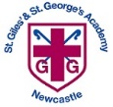
St Giles’ and St George’s C of E Academy
Homework Menu
Year Group: 5/6 Topic: Marvellous Maps/Forces Term: Autumn 2 2021
Set Menu Timetables, spellings, daily reading, phonics practise
We will be looking for children to be reading at home with their parents or carers. Listening to children read will enable them to grow in confidence as they become fluent readers. Once children are able to read fluently and with expression, hold discussions around the comprehension of the text (we will provide a bank of ideas to support this). If your child is reluctant to read, they could listen to audio books. We want them to foster a love of books so please do not underestimate the value of reading to your child.
Added Extras
We will encourage your child to complete as many of the activities for the menu as they like at home but NO LESS than 3 over the half term. This can be recorded (if appropriate) in our home books. We will ask for homework books on the last Monday of each half term in order for us to share and celebrate the learning.
Read it | Research it | Design it
Visit your local library to read about forces and space. If not possible, visit these sites to find out some fun facts and key information.  http://www.primaryhomeworkhelp.co.uk/space.html  https://superbrainybeans.com/science/earth-and-space/  https://www.twinkl.co.uk/homework-help/science-homework-help/earth-and-space/top-10-space-facts-for-kids | 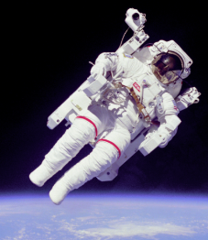  Research what life is like for an astronaut and how forces affect their daily tasks and work. | 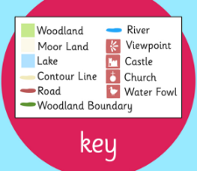  Design a map of your own local area. Think about the symbols you could use to represent objects such as trees, houses, schools, churches and rivers.
Practise it | Write it | Make it
Log on to EdShed: Practise your spellings and complete maths challenges.  https://www.edshed.com/en-gb/login | 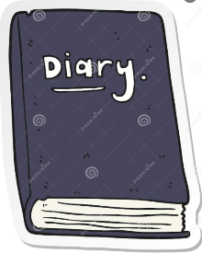  Write a diary entry about a day in space from an astronaut’s point of view. | 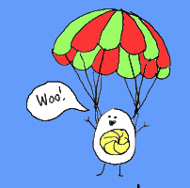  Make a parachute using any materials that you can find at home. At school, we will attach an egg and the one that reaches the ground last will be the winner.  BONUS QUESTION: What forces will act on the parachutes?

