RE Learning Journey

RE Over RE Overview
view
RE Vision and Aims

Inspired by our Christian faith, we guide children on a personalised journey towards achievement. As a learning community, we are committed to ensuring that children are equipped with, skills and aspirations to reach their full potential in mind, body, heart and spirit.

All areas of our curriculum are underpinned by our Gospel values and we ensure that our curriculum makes links to these values.
At the heart of each subject is a set of core skills which form a subject learning journey, this journey is built from EYFS through to year 6 and the skills progressive as you move through the school. Knowledge is communicated to ensure coverage of National curriculum and it is through this knowledge that children apply their skills.

Children at St Giles’ and St George’s leave with a secure knowledge of both the academic knowledge and skills needed for the next stage of their education. They will have developed a clear set Christian and moral values which they can apply in all areas of their lives and will have taken part in real-life experiences which will have raised their aspirations and given them a thirst for wisdom
and knowledge.

RE Overview

Two different resources which complement each other are used. Understanding Christianity and Discovery RE which focuses on other religions

 | Autumn Term |  | Spring Term |  | Summer Term
 | Autumn 1 | Autumn 2 | Spring 1 | Spring 2 | Summer 1 | Summer 2
Nur | Special People  What makes people special? (Child-lead)  (Christianity)  Visitor in school | Christmas/ Incarnation  What is Christmas?  (Christianity)  *Drop down day opportunity | God  How can we care for our wonderful world? | Easter/Salvation  What is Easter?  (Christianity)  Create and post Easter cards to nursing homes | Stories  What can we learn from stories? (Child-lead)  (Christianity) | Special Places  What makes places special? (Child-lead)  (Christianity)
Rec | Special People  What makes people special?  (Christianity/  Judaism) | Incarnation  Why do Christians perform nativity plays at Christmas?  Create and post Christmas cards to nursing homes | Celebrations  How do people celebrate?  Hinduism  *Drop down day opportunity | Salvation  Why do Christians put a cross in the Easter garden? | Stories  What can we learn from stories?  (All religions) | Special Places  What makes places special?  (All religions)  Visit St Giles’ Church
Year 1 | Creation  Who made the world?  Christian Aid charity link | Incarnation  What does Christmas matter to Christians?  Advent candles and prayer delivered to houses on Orme Road | Jesus as a friend  Was it always easy for Jesus to show friendship?  (Christianity) | Salvation  Why does  Easter matter to Christians? | Shabbat  Is Shabbat important to Jewish children?  (Judaism)  Visit Synagogue, NuL  *Drop down day opportunity | Rosh Hashana and Yom Kippur  Are Rosh Hashana and Yom Kippur important to Jewish children?  (Judaism)
Year 2 | What did Jesus teach  Is it possible to be kind to people all the time?  (Christianity) | Gospel  What is the good news that Jesus brings? | Passover  How important is it to Jewish people to do what God is asking?  (Judaism)  Fair Trade charity link  Bake and deliver cookies to local residents | God  What do Christians believe God is like?  Visit St Giles’ (Maypole)  *Drop down day opportunity | The Covenant  How special is the relationship Jews have with God?  (Judaism) | Rites of Passage and good work  What is the best way for a Jew to show commitment to God?  (Judaism)
Year 3 | Divali  Would celebrating Divali bring a sense of belonging to a child?  (Hinduism) | Incarnation  What is the Trinity?  Planting in the local community | Creation/Fall  What do Christians learn from the Creation Story?  *Drop down day opportunity | Salvation  Why do Christians call the day Jesus died ‘Good Friday’?  Visit St George’s (Lent crafts) | Hindu Beliefs  How can Brahman be in everything and everywhere?  (Hinduism) | Pilgrimage to the River Ganges  Would visiting the River Ganges be important for a non- Muslim?  (Hinduism)  Water Aid charity link
Year 4 | Buddah’s Teachings  Is it possible for everyone to be happy?  (Buddhism) | People of God  What is it like for Christians to follow God?  Visit St George’s (Advent crafts)  Christian Aid charity link | The 8-fold path  Can the Buddah teachings make the world a better place?  (Buddhism) | Easter  Is forgiveness always possible for Christians?  *Drop down day opportunity | The 8-fold path  What is the best way for a Buddhist to lead a good life?  (Buddhism)  Read to the elderly in nursing homes | Kingdom of God  When Jesus left what was the impact of Pentecost?
Year 5 | Belief into Action  How far would a Sikh go for his religion?  (Sikhism) | Incarnation  Was Jesus the Messiah?  Feed the Hungry charity link | Belief and modern values  Are Sikh stories important today?  (Sikhism) | Salvation  What did Jesus do to save human beings?  Litter picking in community | Prayer and Worship  What is the best way for a Sikh to show commitment to God?  (Sikhism)  *Drop down day opportunity | God  What does it mean if God is holy and loving?  What kind of king was Jesus?  Dovedale residential
Year 6 | Beliefs and Practise  What is the best way for a Muslim to show commitment to God?  (Islam) | People of God  What would Jesus do?  Christmas  How important is Mary as the mother of God?  (Christianity)  Sing at Beaumaris Court  Christian Aid charity link | Creation  Creation and science: conflicting or complementary? | Salvation  What does the Resurrection mean for Christians?  Visit St George’s (Pentecost) | Belief in moral values  Does belief in Akhirah (after life) help Muslims to lead good lives?  (Islam)  Visit Mosque (Hanley)  *Drop down day opportunity

*Drop down day (opportunity to delve deeper into the topic. It could be linked to trip, art work)
*Extra-curricular visit opportunity
*Community outreach opportunity
*Fundraising opportunity/exploring Christian charity

RE Skills Progression

EYFS
AF1: Thinking about religion and belief | Shows interest in the lives of people who are familiar to them.  Remembers and talks about significant events in their own experience.  Recognises and describes special times or events for family or friends.  Enjoys joining in with family customs and routines.  Show sensitivity to their own needs and others’ needs (ELG- PSED)  Talk about the lives of people around them and roles in society (ELG- UofW)
AF2: Enquiring, investigating and interpreting | In pretend play, imitates everyday actions and events from own family and cultural background  Explores the similarities and differences that connect them to, and distinguish them from, others.  Shows interest in different occupations and ways of life  Knows some of the things that make them unique, and can talk about some of the similarities and differences in relation to friends or family  Comments and asks questions about aspects of their familiar world such as the place where they live or the natural world.  Developing an understanding of growth, decay and changes over time.  Looks closely at similarities, differences, patterns and change.  Understand the past through settings, character and events encountered in books read, in class and in storytelling. (ELG-UofW)  Know some similarities and differences between different religious and cultural communities in this country, drawing on their experiences and what has been read in class. (ELG- UofW)
Creation and Fall | Recognise ‘God’ as a name  Know that Christians believe God is the creator of the universe.  Comments on what makes our world wonderful and how we should look after it.
God | Pupils know that Christians remember Jesus’ last week at Easter, Holy Week  Jesus’ name means ‘He saves’.  Christians believe Jesus came to show God’s love.  Christians try to show love to others.
Incarnation | Know that Christians celebrate Christmas as Jesus’ birth.  Pupils know that Christians believe God came to Earth in human form as baby Jesus.  Know that Christians believe Jesus came to show that all people are precious and special to God.
Gospel | N/A

KS1
AF1: Thinking about religion and belief | recognise and name features of religions and beliefs  recall features of religious, spiritual and moral stories and other forms of religious expression  retell religious, spiritual and moral stories  identify how religion and belief is expressed in different ways  identify similarities and differences in features of religions and beliefs
AF2: Enquiring, investigating and interpreting | identify what they find interesting and puzzling in life  recognise symbols and other forms of religious expression  recognise that some questions about life are difficult to answer  ask questions about their own and others’ feelings and experiences  identify possible meanings for symbols and other forms of religious expression
Creation and Fall | Pupil know that Christians believe that God created the universe. That the earth and everything in it are important to God.  Pupil can identify the sequence of the creation story and know the importance Christians attach to a day of rest.  Pupils know that Christians believe that God has a unique relationship with human beings as their creator and sustainer.  Pupils know that Christians believe they should give thanks to God for his creation and that Harvest Festival is a time to do this.  Pupils know that Christians believe they should care for the world because it belongs to God. They can give an example.
God | Pupils know that Christians believe in God and that they find out about him in the Bible.  They know that a parable is ‘a story (in this case told by Jesus) to help people understand ideas’. They can find and say what some of these ideas are in the parable of the Lost Son and/or the Story of Jonah.  They know that Christians believe that God is loving kind forgiving and fair. They know that Christians worship God and pray to him. They can identify different types of prayer i.e. Praise: saying sorry: asking: and saying thank you.
Incarnation | Pupils know that Christians celebrate Jesus’ birth; Advent for Christians is a time for getting ready for Jesus’ coming.  Pupils know that Christians believe that Jesus is God. They know the birth narrative i.e. The Angel appeared to Mary, Mary and Joseph travelled to Bethlehem where Jesus was born as a baby and he was placed in a manger. Angels appeared to the shepherds. The wise men brought gifts.  The Bible points out that his birth showed that he was extraordinary (e.g. he is worshipped as a king in Matthew) and that he came to bring good news (e.g. to the poor in Luke)  Pupils use the term incarnation. They can talk about examples of how this theme has been explore in art and music (including hymns) by Christians.
Gospel | Pupils will know that Christians believe that Jesus brings the good news (Gospel) and that God loves them and he will forgive them when they go wrong.  Pupils will know that Christians believe that by forgiving they will find peace in their own lives, with others, and with God.  Pupils know the story of the calling of Matthew (including why the tax collector was unpopular, and how people reacted) the tax collector and that Jesus chose as his closest friends (disciples) many who were friendless.  Pupils know that Christians will pray to God prayers to say sorry to ask for things to say thank you.

LKS2
AF1: Thinking about religion and belief | make links between beliefs, stories and practices  identify the impacts of beliefs and practices on people’s lives  identify similarities and differences between religions and beliefs  comment on connections between questions, beliefs, values and practices  describe the impact of beliefs and practices on individuals, groups and communities  describe similarities and differences within and between religions and beliefs
AF2: Enquiring, investigating and interpreting | investigate and connect features of religions and beliefs  ask significant questions about religions and beliefs  describe and suggest meanings for symbols and other forms of religious expression  gather, select, and organise ideas about religion and belief  suggest answers to some questions raised by the study of religions and beliefs  suggest meanings for a range of forms of religious expression, using appropriate vocabulary
Creation and Fall | Pupils know that Christians believe that although God made the world the Bible tells in Genesis 3 how humans spoiled that friendship with God, and that Christians call this the Fall.  Pupils know the story of Adam and Eve including Gods command not to eat the fruit, the serpent tempting Eve, Adam and Eve hiding from God, Adam and Eve expelled from paradise.  Pupils know that Christians believe that God wants to help people to get close to him again. He gives them guidelines such as the 10 commandments and offers forgiveness when they fall short.  Pupils understand that many Christians believe they are asked to be stewards or caretakers of God’s creation and they know about examples where Christians have tried to put this idea in to practice e.g. Forest Churches, A Rocha movement.  They know that some people don’t believe that God made the world.
God | Pupils know that Christians believe God is Trinity: Father, Son and Holy Spirit. The Father creates; he sends the Son who saves his people; and the Holy Spirit on his people. Christians believe the Holy Spirit is God’s power at work in the world and in their lives today, enabling them to follow Jesus  Pupils know that Christians often try to describe God using symbols, similes, and metaphors, in song, story, poems and art and have created art to help to express this belief.  Pupils know the story of Jesus Baptism (Matthew 3; 11-17) including that Jesus was baptised by John the Baptist that a voice came from above and the dove appeared. They know the symbolism this suggests.  Pupils can describe a Christian Baptism (child and adult) including the terminology of ‘in the name of the father, the son and the Holy spirit’
Incarnation | Pupils know that Christians believe God is Trinity: Father, Son and Holy Spirit. The Father creates; he sends the Son who saves his people; and the Holy Spirit on his people. Christians believe the Holy Spirit is God’s power at work in the world and in their lives today, enabling them to follow Jesus  Pupils know that Christians often try to describe God using symbols, similes, and metaphors, in song, story, poems and art and have created art to help to express this belief.  Pupils know the story of Jesus Baptism (Matthew 3; 11-17) including that Jesus was baptised by John the Baptist that a voice came from above and the dove appeared. They know the symbolism this suggests.  Pupils can describe a Christian Baptism (child and adult) including the terminology of ‘in the name of the father, the son and the Holy spirit’
Gospel | Pupils will know that Christians believe that the Gospel of Jesus is not just about setting a good example but also about healing the damage done (by sin) in the world.  Pupils will know a range of Jesus teachings: The wise and foolish builder’s/the sermon on the mount/the healing of the centurion’s servant/Jesus and the moneylenders/the woman caught in adultery. (select specific detail to retell).  Pupils will be able to relate these teachings to activities undertaken by Christian groups and by the church to bring these teachings to life in their churches and communities.  Pupils will know that although these texts are fixed the way that different Christians have interpreted them over the years and in different cultures will vary.

UKS2
AF1: Thinking about religion and belief | explain connections between questions, beliefs, values and practices in different belief systems  recognise and explain the impact of beliefs and ultimate questions on individuals and communities  explain how and why differences in belief are expressed.  use religious and philosophical terminology and concepts to explain religions, beliefs and value systems  explain some of the challenges offered by the variety of religions and beliefs in the contemporary world  explain the reasons for, and effects of, diversity within and between religions, beliefs and cultures.
AF2: Enquiring, investigating and interpreting | suggest lines of enquiry to address questions raised by the study of religions and beliefs  suggest answers to questions raised by the study of religions and beliefs, using relevant sources and evidence  recognise and explain diversity within religious expression, using appropriate concepts.  identify the influences on, and distinguish between, different viewpoints within religions and beliefs  interpret religions and beliefs from different perspectives  interpret the significance and impact of different forms of religious and spiritual expression
Creation and Fall | I know that there is much debate and controversy around the relationship between creation stories in  Genesis and scientific accounts. I can outline both points of view.  I know that there are many scientists who are also Christians.  I know that the discoveries of science often make Christians even more in awe of the power and majesty of God.  I know that some of this controversy is connected with the way in which the Genesis text is interpreted and the genre of writing it is considered to be; i.e. poetic account or historical account.  I know that not all Christian believe the same about the relationship between Creation and science.  I understand the significance of Psalm 8
God | Pupils know that Christians believe God is omnipotent, omniscient and eternal. They know that some people do not believe God exists (i.e. Humanist’s) and can say why i.e. Humanist’s don’t believe God is omnipotent omniscient and eternal because..,.  They know that there are different types of text in the Bible and can give examples of psalms, letters and prophecy  Pupil know that Christians believe God is holy and loving but that he is also angered by sin and injustice. That not all Christians agree about what God is like but that all try and follow his teachings as they understand it. They can explain that this is why Christians can respond differently both in reaction to social injustice but also in styles of worship and church building.  Pupils can give an example of how biblical ideas about holiness love or forgiveness have made a difference in the world for example Coventry Cathedral.
Incarnation | Pupils know that Jesus was Jewish. They understand that ‘Christ’ is the Greek word for ‘anointed one’, or ‘Messiah’. And that the Old Testament talks about a ‘rescuer’ or ‘anointed one’ – a Messiah. That Isaiah 9 v2-7 texts talks about what this ‘Messiah’ would be like.  Pupils know that most Christians believe Jesus is God incarnate and they believe that his birth, life, death and resurrection were part of a longer plan by God to restore the relationship between humans and God.  Pupils understand that Christians believe that Jesus fulfilled these expectations, and that he is the Messiah. (Jewish people do not think Jesus is the Messiah.) That Christians see Jesus as their Saviour (See Salvation). They can give their own view to answer the questions ‘Was Jesus the Messiah?’ supported by a reasoned argument
Gospel | Pupils will know that Christians believe that the Gospel of Jesus is not just about setting a good example but also about healing the damage done (by sin) in the world.  Pupils will know a range of Jesus teachings: The wise and foolish builder’s/the sermon on the mount/the healing of the centurion’s servant/Jesus and the moneylenders/the woman caught in adultery. (select specific detail to retell).  Pupils will be able to relate these teachings to activities undertaken by Christian groups and by the church to bring these teachings to life in their churches and communities.  Pupils will know that although these texts are fixed the way that different Christians have interpreted them over the years and in different cultures will vary.

RE Knowledge Organiser
Reception- Autumn 1

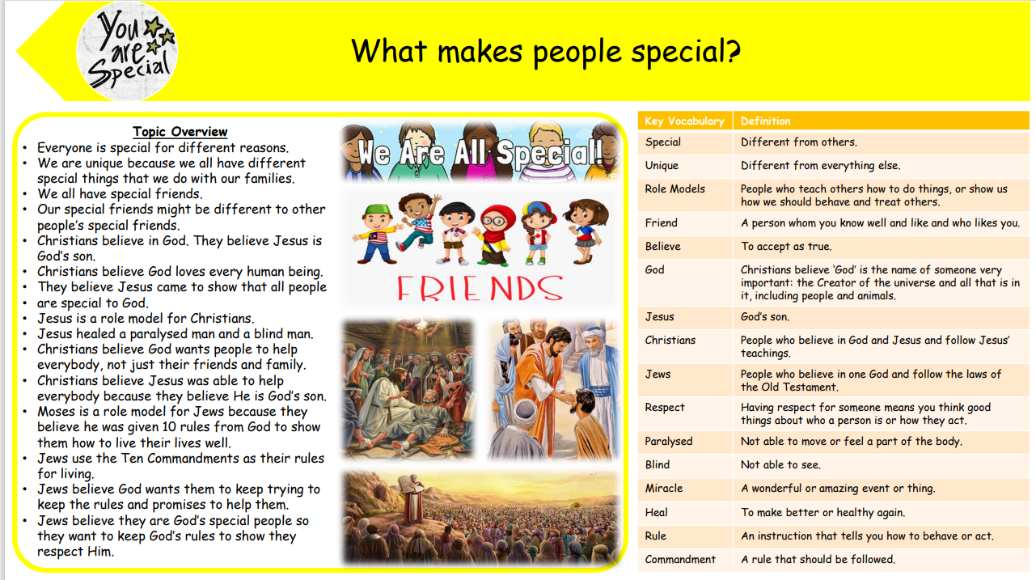

Gospel Value:
Compassionate and Loving- To show love and kindness to everyone as everyone is unique

RE Knowledge Organiser
Reception – Autumn 2

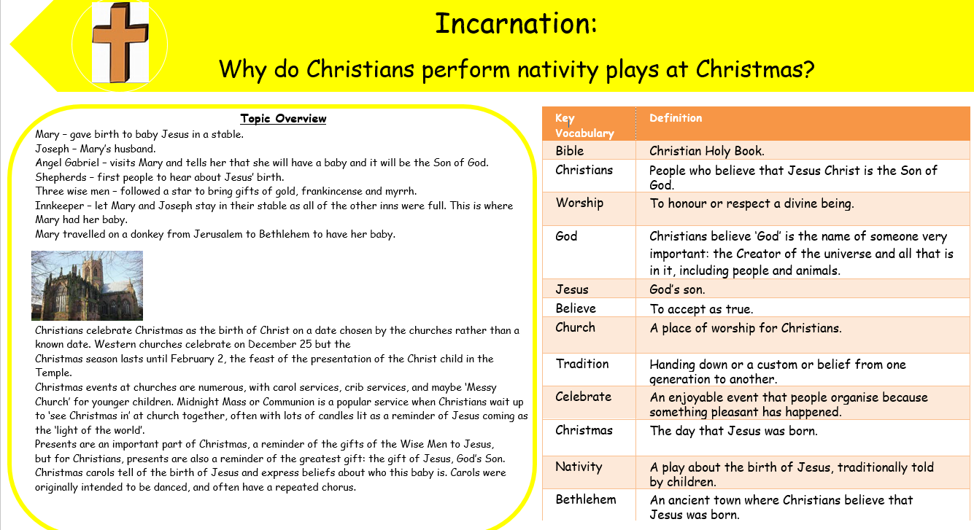

Gospel Value:
Curious and Active- To be curious about Jesus’ birth and why God sent Him

RE Knowledge Organiser
Reception – Spring 1

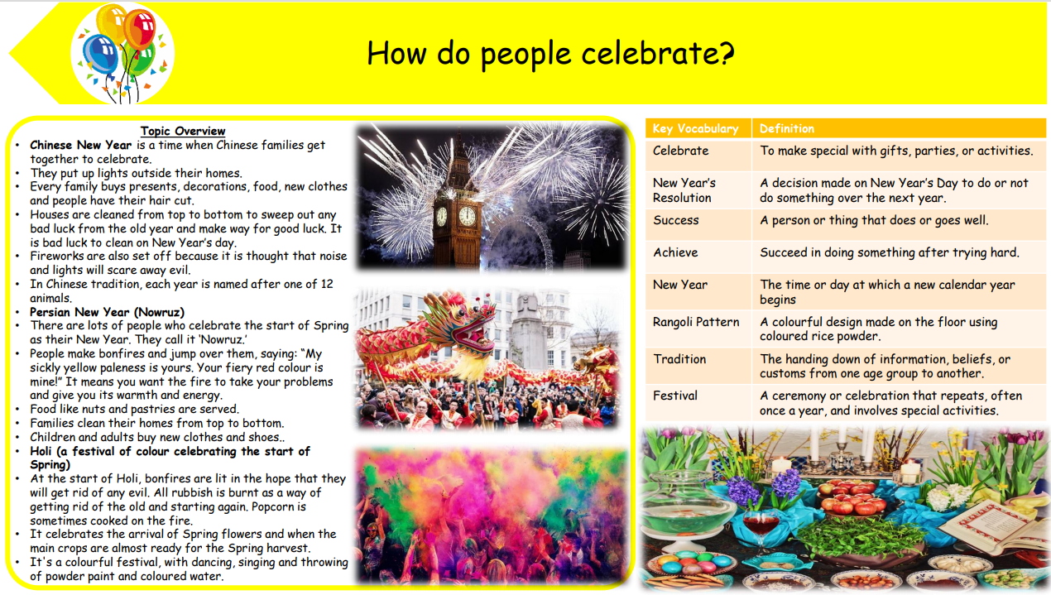

Gospel Value:
Grateful and Generous- To be grateful for the festivals that we celebrate

RE Knowledge Organiser
Reception – Spring 2

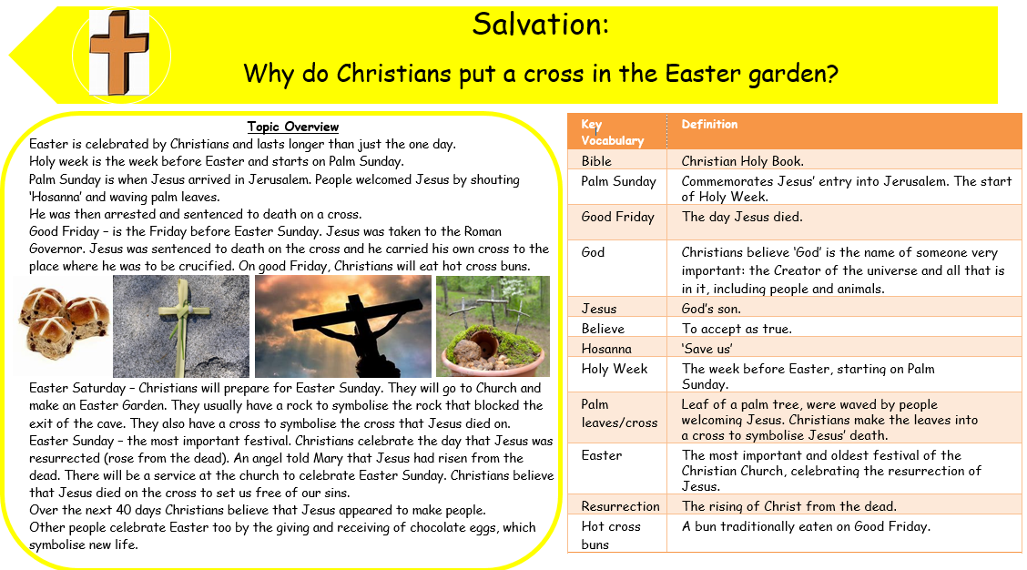

Gospel Value:
Curious and Active- To be curious about why the cross is an important symbol for Christians

RE Knowledge Organiser
Reception - Summer 1

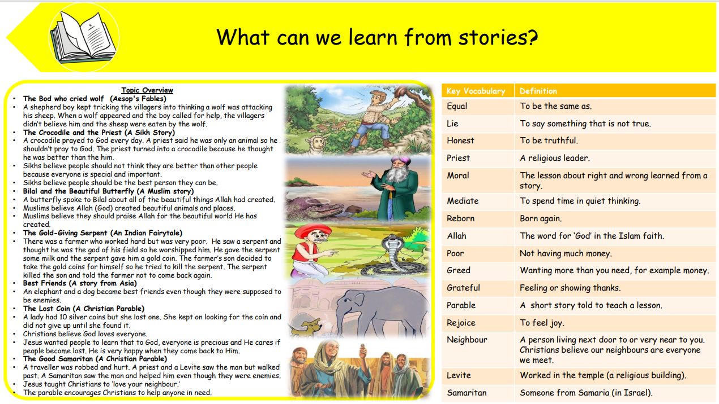

Gospel Value:
Learned and Wise- To learn from characters in stories

RE Knowledge Organiser
Reception – Summer 2

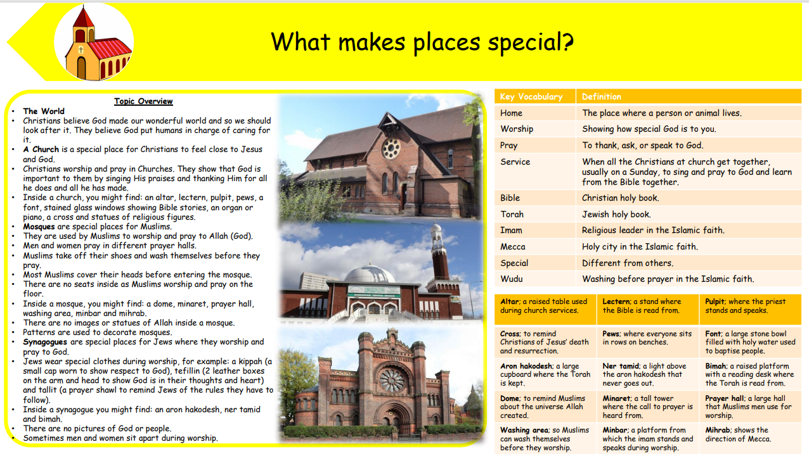

Gospel Value:
Grateful and Generous- To be grateful for our special places like school and home

RE Knowledge Organiser
Year 1– Autumn 1

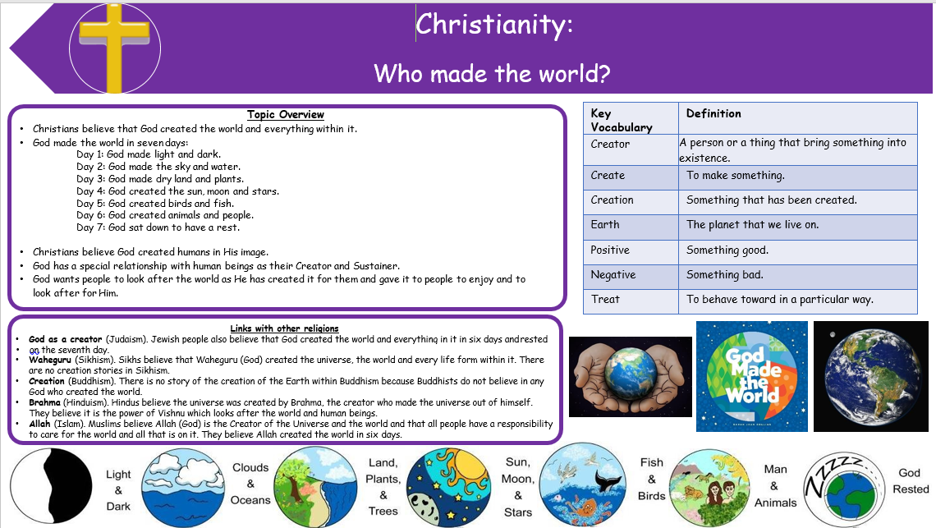

Gospel Value:
Curious and Active- To be curious about who made the world and where we live

RE Knowledge Organiser
Year 1– Autumn 2

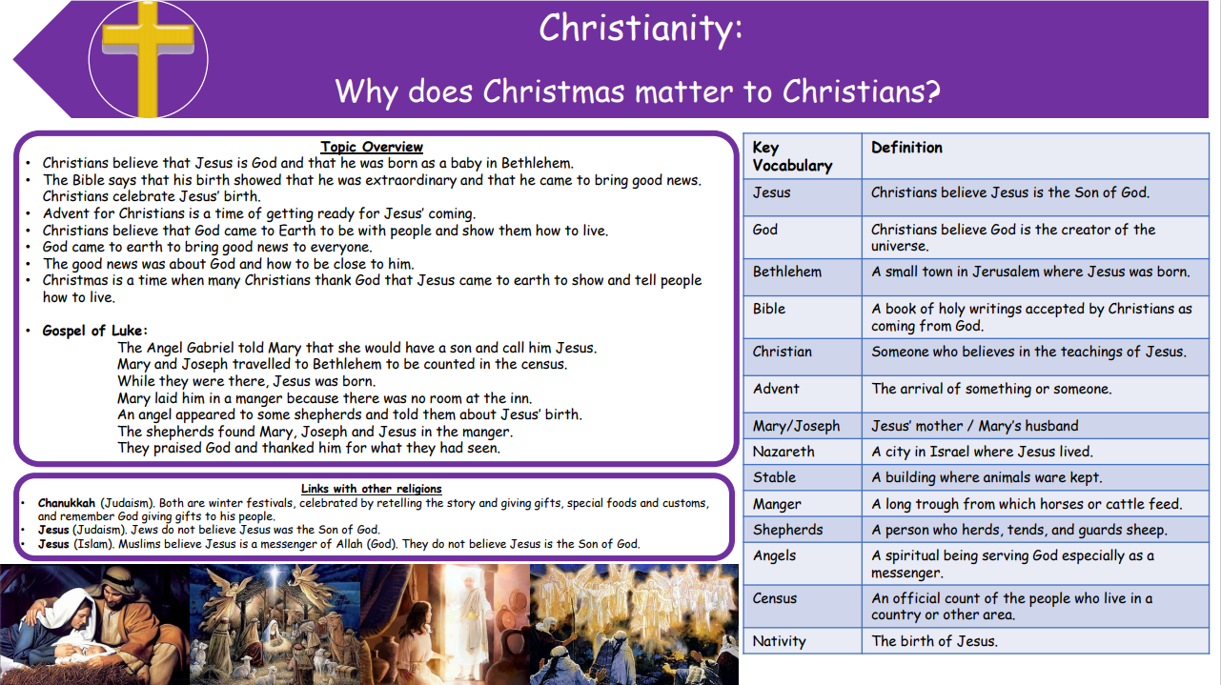

Gospel Value:
Grateful and Generous- To be grateful for the gift of Jesus at Christmas time

RE Knowledge Organiser
Year 1– Spring 1

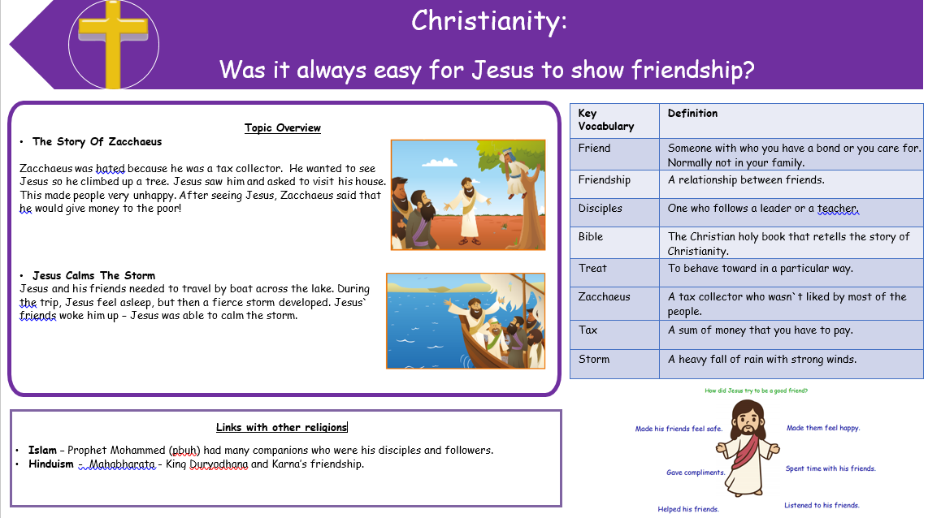

Gospel Value:
Compassionate and Loving- To be a good friend and forgive others

RE Knowledge Organiser
Year 1– Spring 2

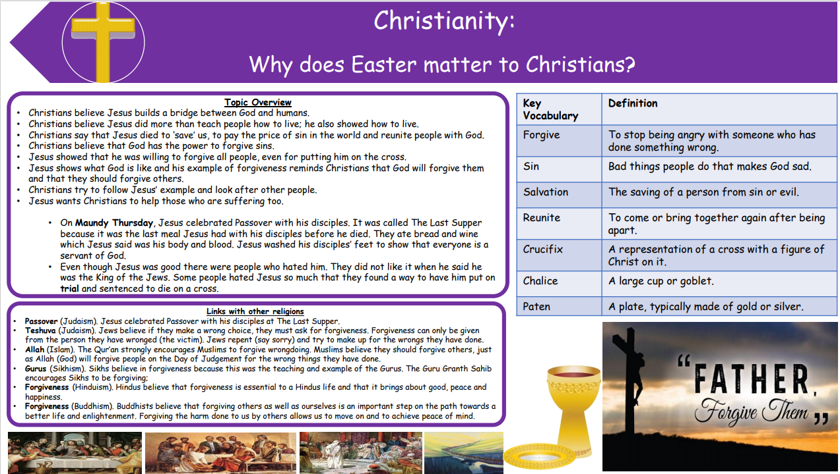

Gospel Value:
Compassionate and Loving- To be understanding and show love towards Jesus for the ultimate sacrifice to save us

RE Knowledge Organiser
Year 1– Summer 1

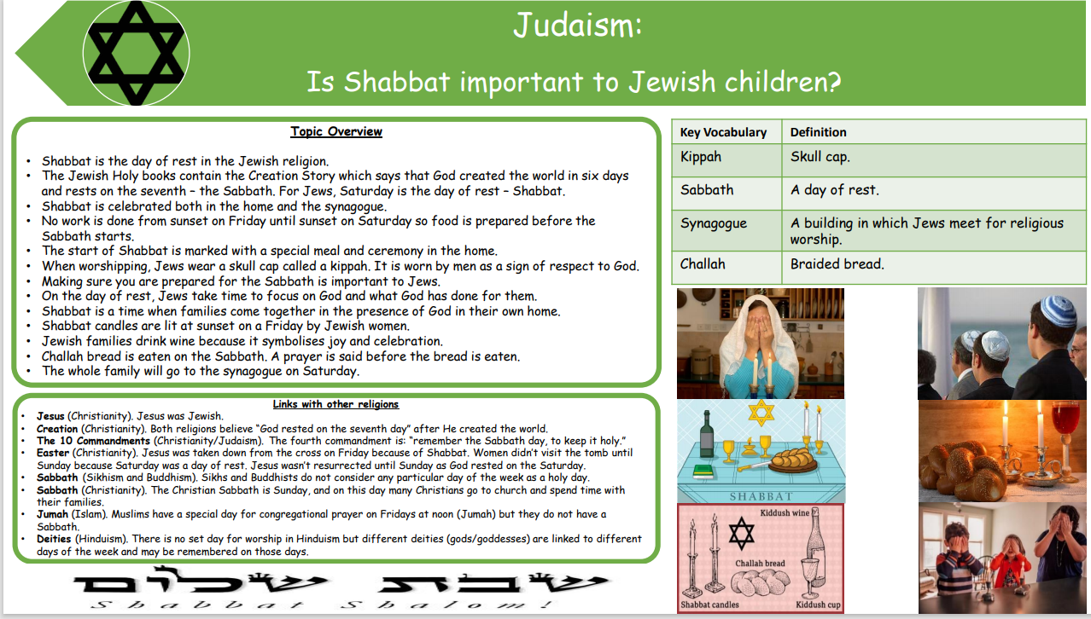

Gospel Value:
Compassionate and loving- To be compassionate towards others and respect their beliefs

RE Knowledge Organiser
Year 1– Summer 2

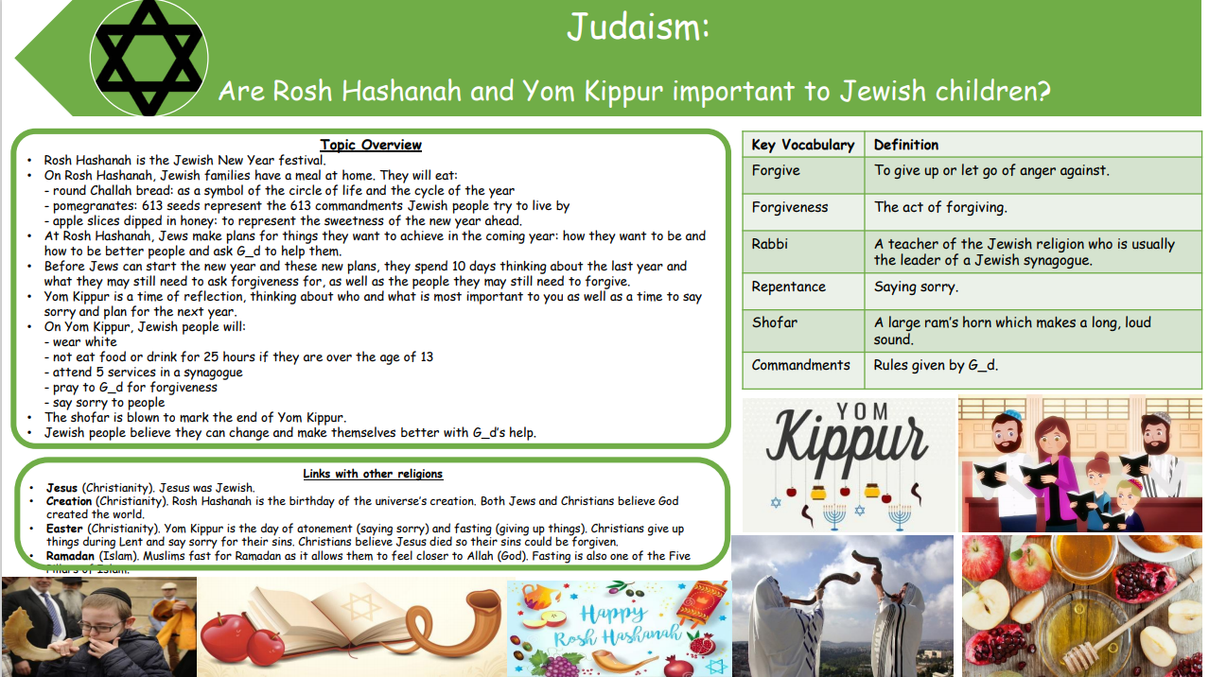

Gospel Value:
Grateful and Generous- To be grateful for the religious festivals that we enjoy

RE Knowledge Organiser
Year 2– Autumn 1

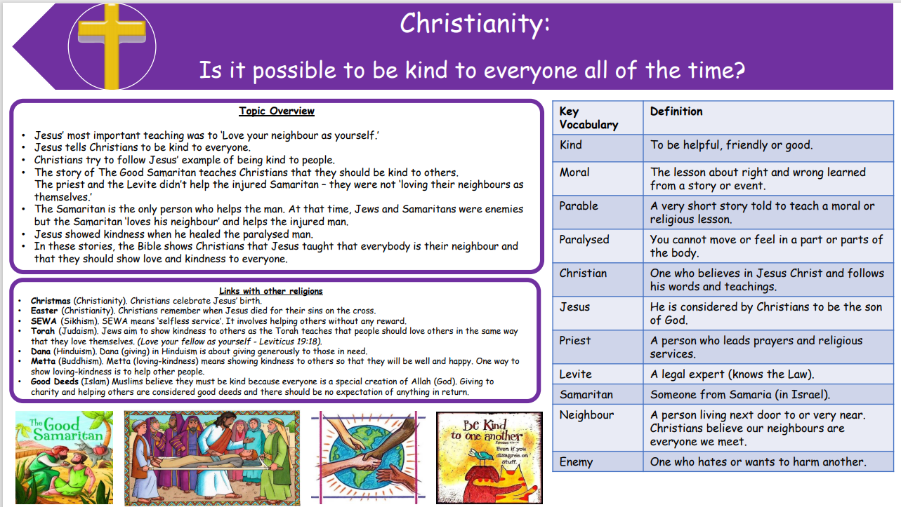

Gospel Value:
Compassionate and Loving- To be kind and show love to all using actions and words

RE Knowledge Organiser
Year 2– Autumn 2

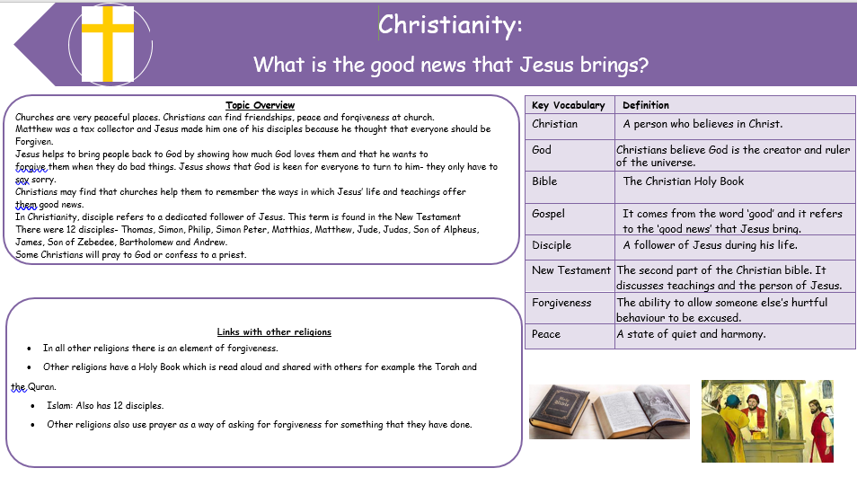

Gospel Value:
Intentional and Prophetic- To share the good news that Jesus brings with others

RE Knowledge Organiser
Year 2– Spring 1

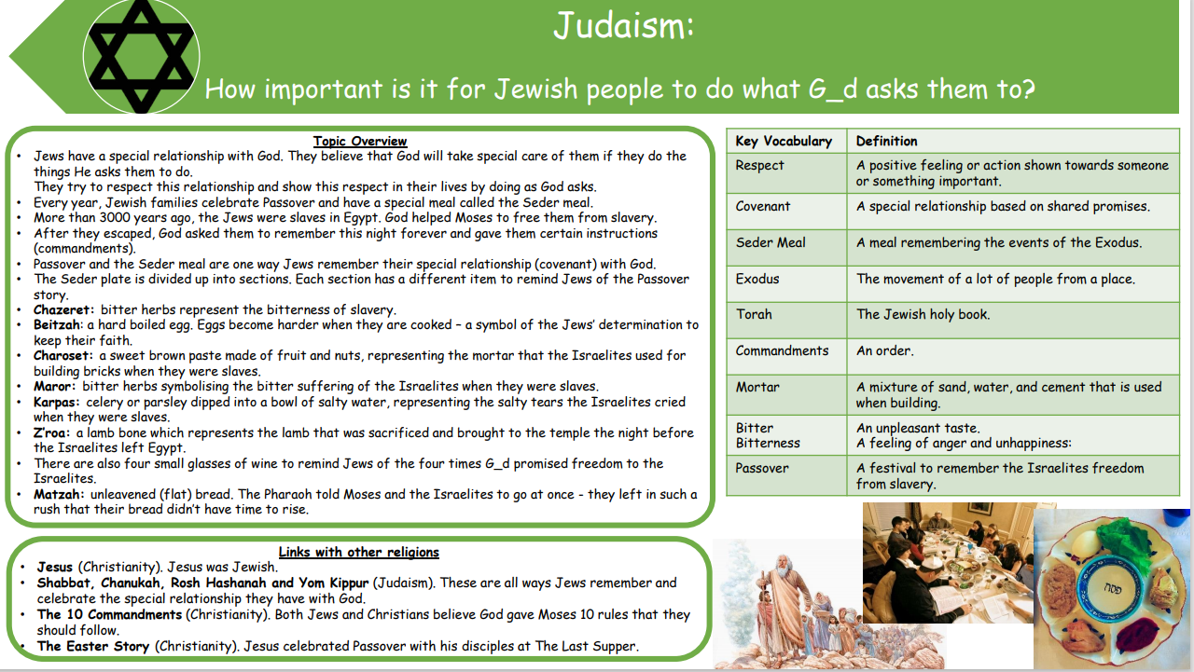

Gospel Value:
Attentive and Discerning- To consider the choices that we have and the effect they may have on others

RE Knowledge Organiser
Year 2– Spring 2

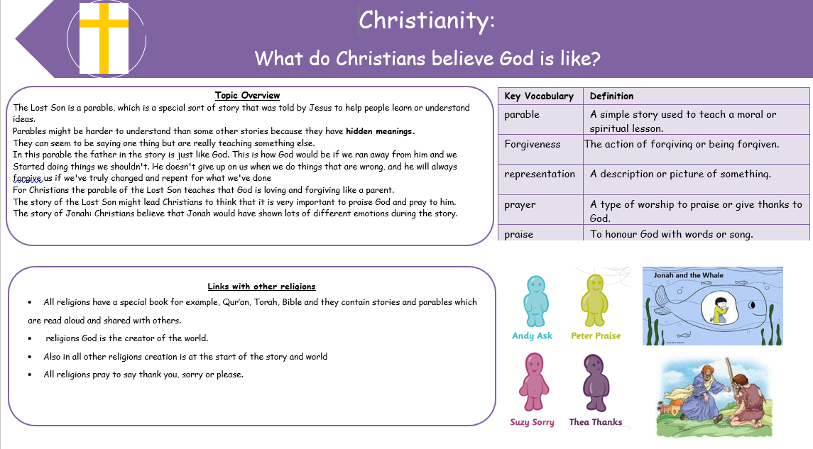

Gospel Value:
Learned and Wise- To take all opportunities and share with others the good things that God does

RE Knowledge Organiser
Year 2– Summer 1

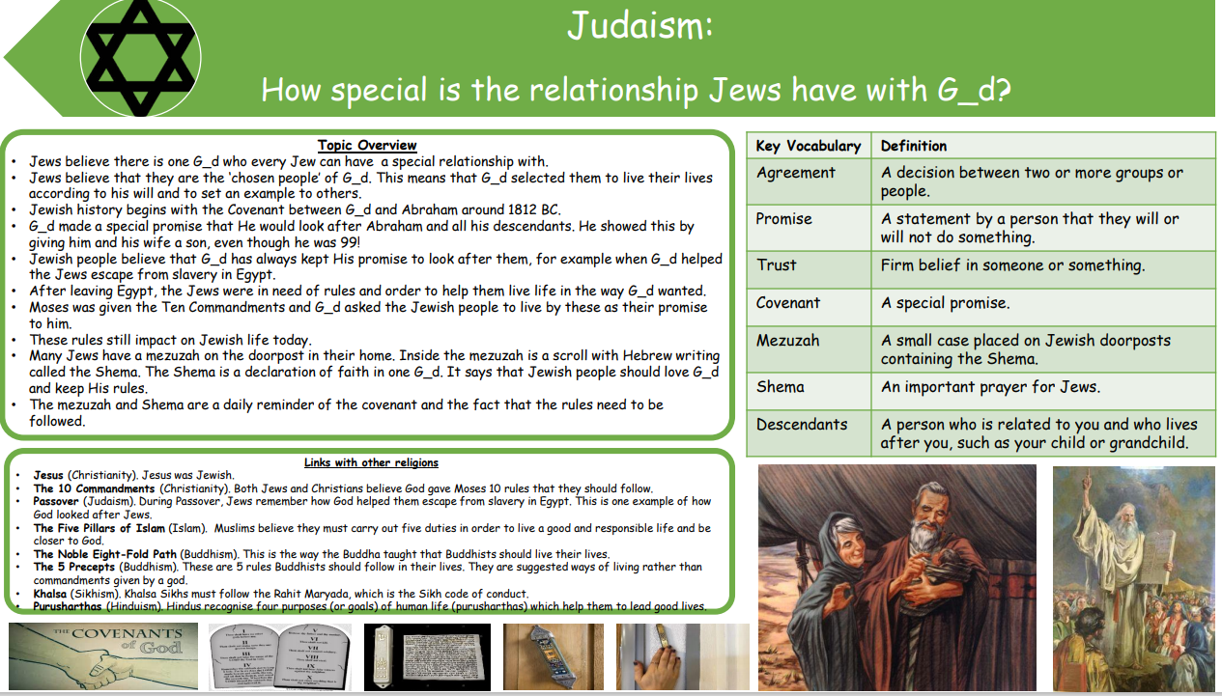

Gospel Value:
Intentional and Prophetic- To learn from the example set by others in their relationship with God and set a good example yourself

RE Knowledge Organiser
Year 2– Summer 2

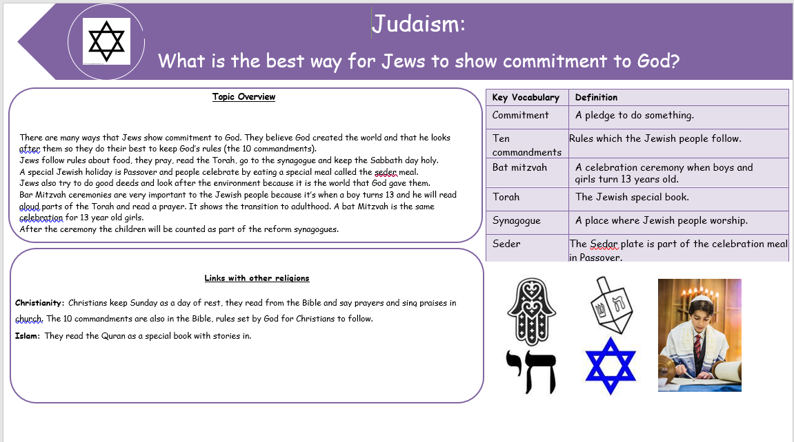

Gospel Value:
Compassionate and Loving- To show compassion for how Jews show their commitment and love for God

RE Knowledge Organiser
LKS2 Year A– Autumn 1

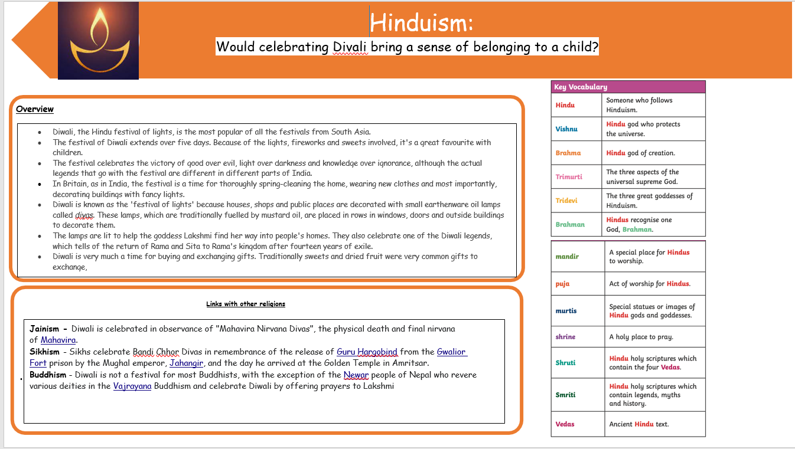

Gospel Value:
Attentive and Discerning- To be attentive about the experiences that others have and the sense of belonging they gain from them.

RE Knowledge Organiser
LKS2 Year A– Autumn 2

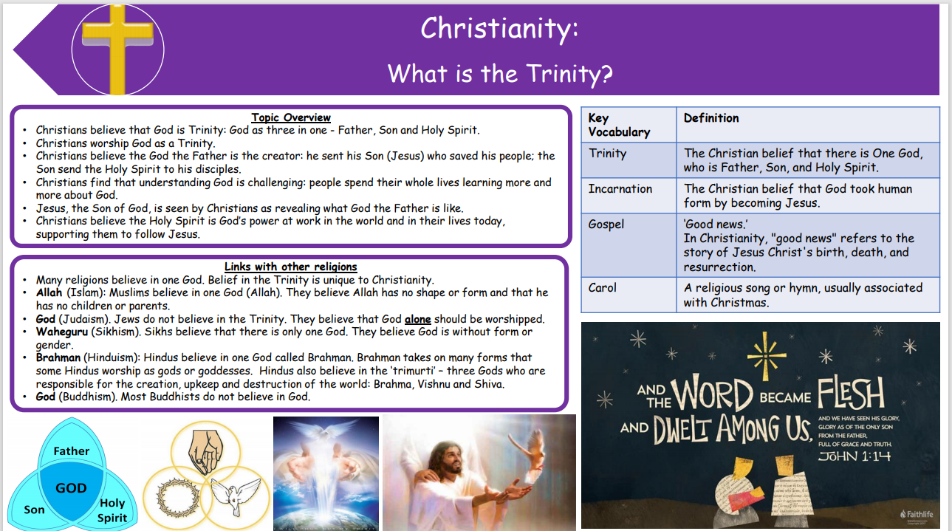

Gospel Value:
Curious and Active- To be curious about the way God represents himself to us

RE Knowledge Organiser
LKS2 Year A– Spring 1

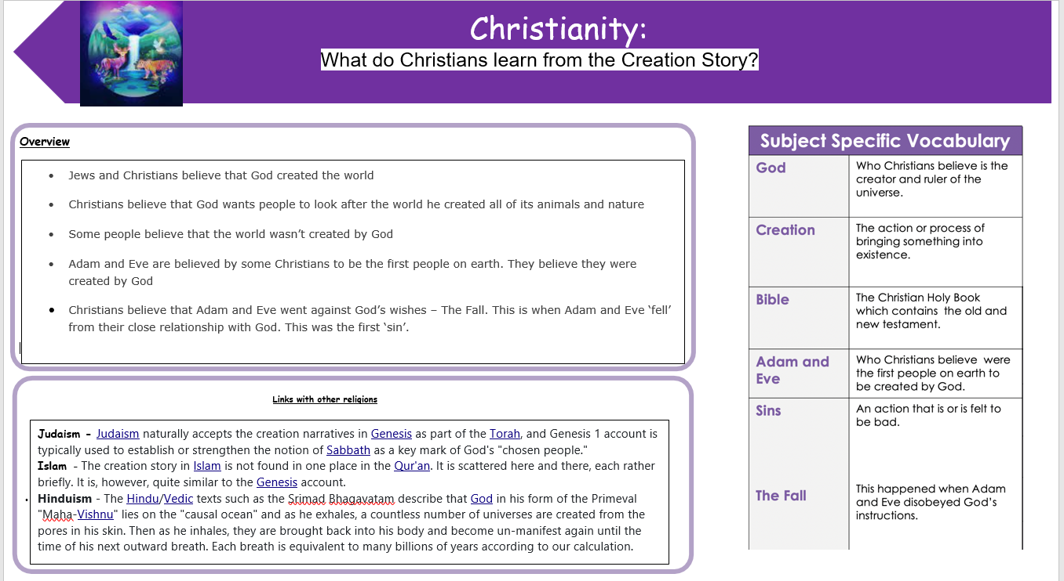

Gospel Value:
Grateful and Generous- To be grateful for the gift of the world

RE Knowledge Organiser
LKS2 Year A– Spring 2

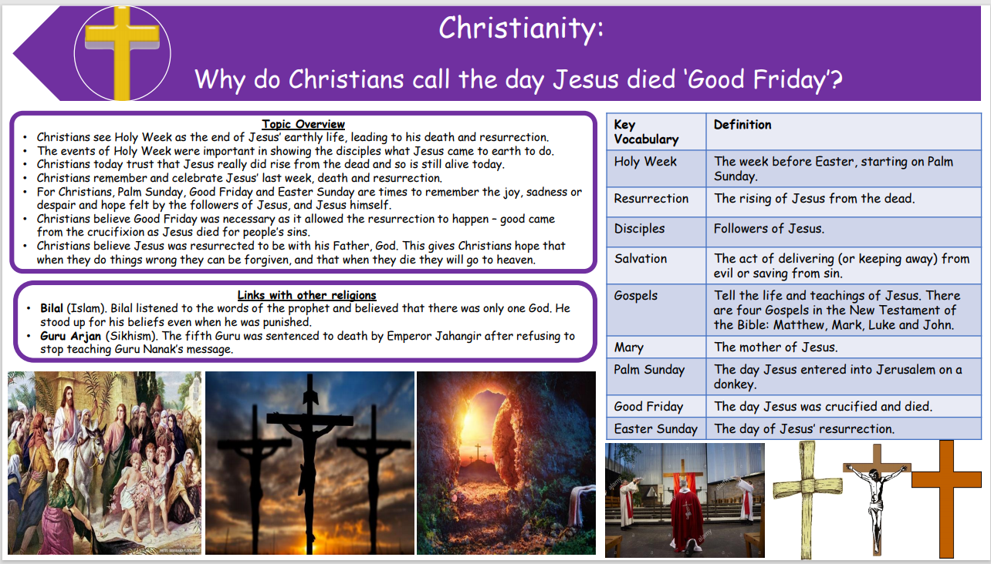

Gospel Value:
Learned and-Wise To learn and share the reasons why Jesus died and saved us

RE Knowledge Organiser
LKS2 Year A– Summer 1

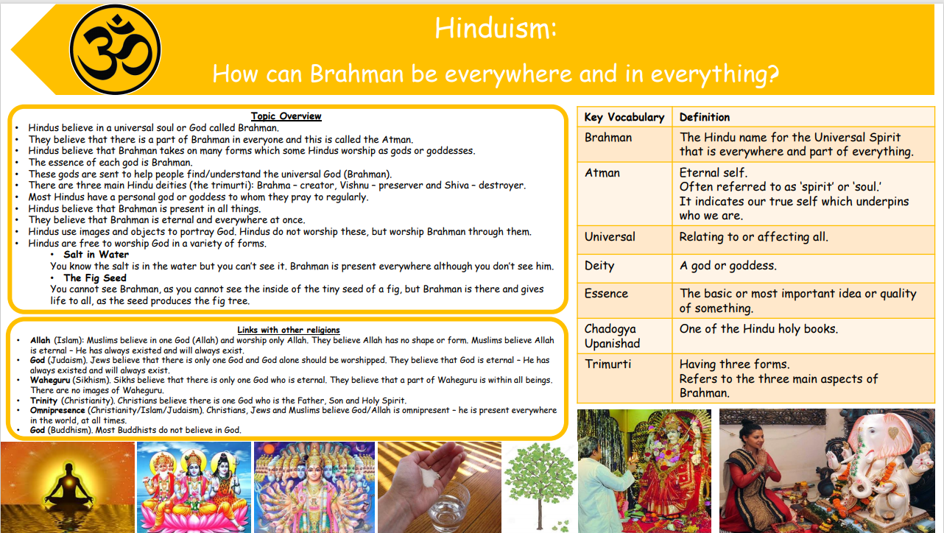

Gospel Value:
Curious and Active- To be curious about how a soul can be all around and support Hindus in their life

RE Knowledge Organiser
LKS2 Year A–Summer 2

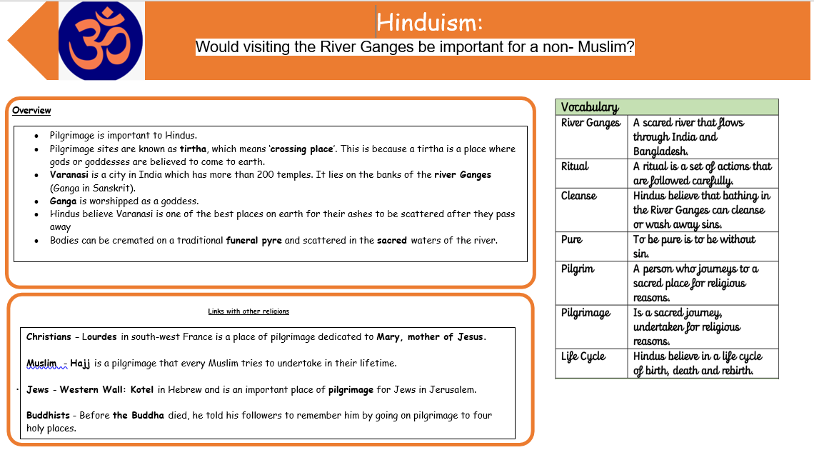

Gospel Value:
Curious and Active- To be curious about the pilgrimage Hindus and Muslims make

RE Knowledge Organiser
LKS2 Year B– Autumn 1

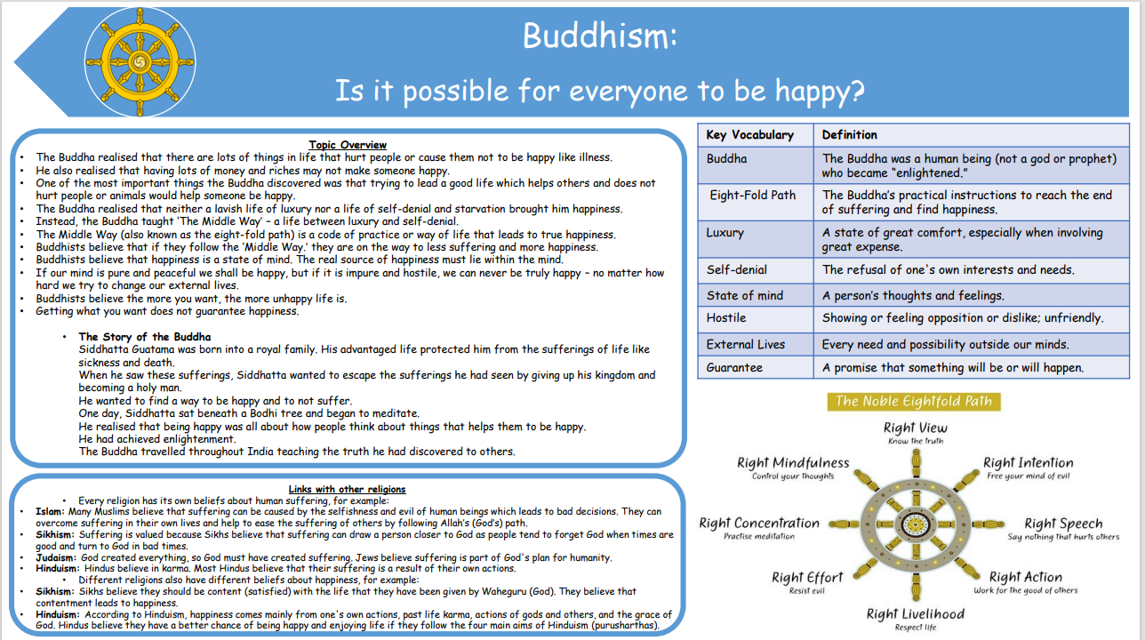

Gospel Value:
Grateful and Generous- To be grateful for our own lives and happiness, and generous in how we treat others

RE Knowledge Organiser
LKS2 Year B– Autumn 2

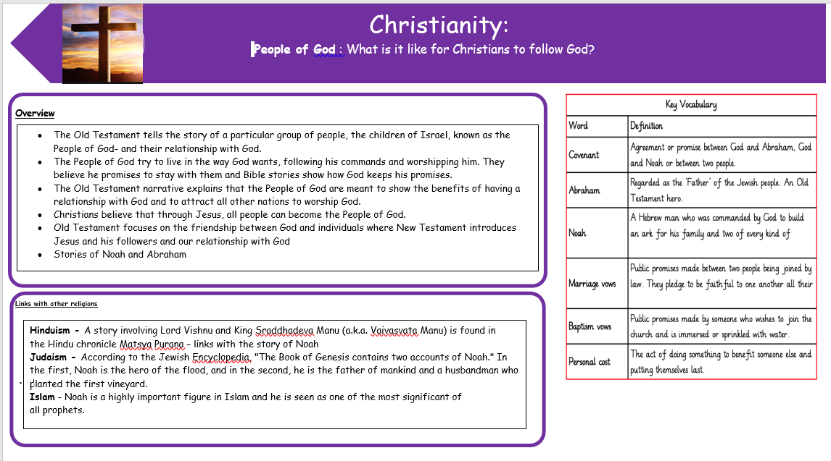

Gospel Value:
Curious and Active- To be active in the way in which we follow God

RE Knowledge Organiser
LKS2 Year B– Spring 1

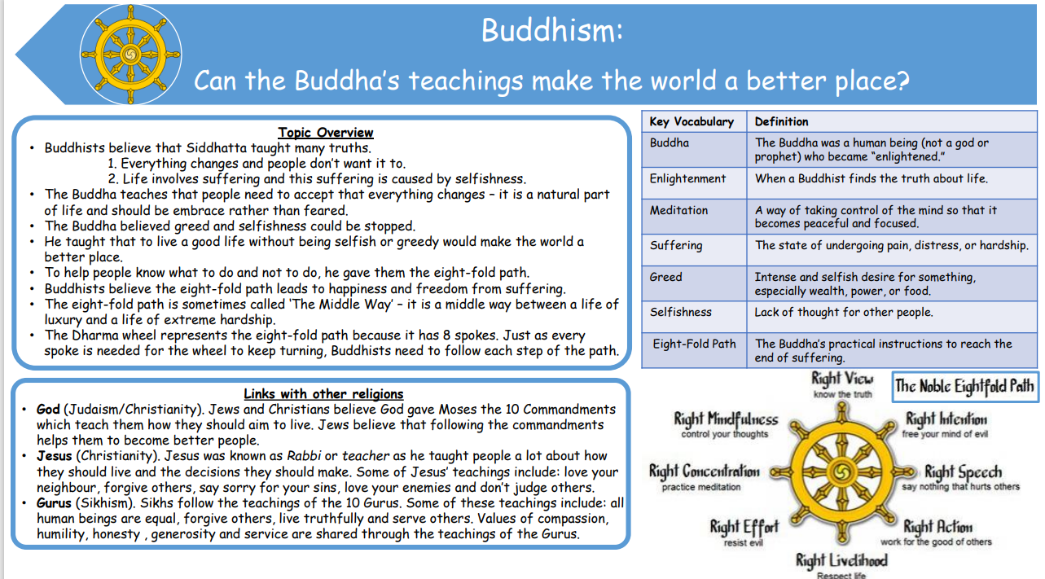

Gospel Value:
Learned and Wise- To learn about the way in which others live and wise to use this knowledge to improve our own

RE Knowledge Organiser
LKS2 Year B– Spring 2

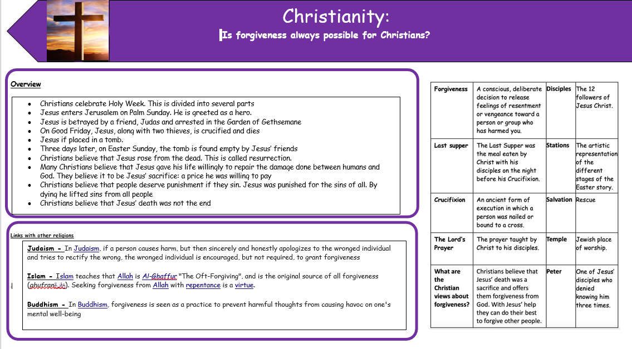

Gospel Value:
Compassionate and Loving- To empathise with others and show compassion by forgiving

RE Knowledge Organiser
LKS2 Year B– Summer1

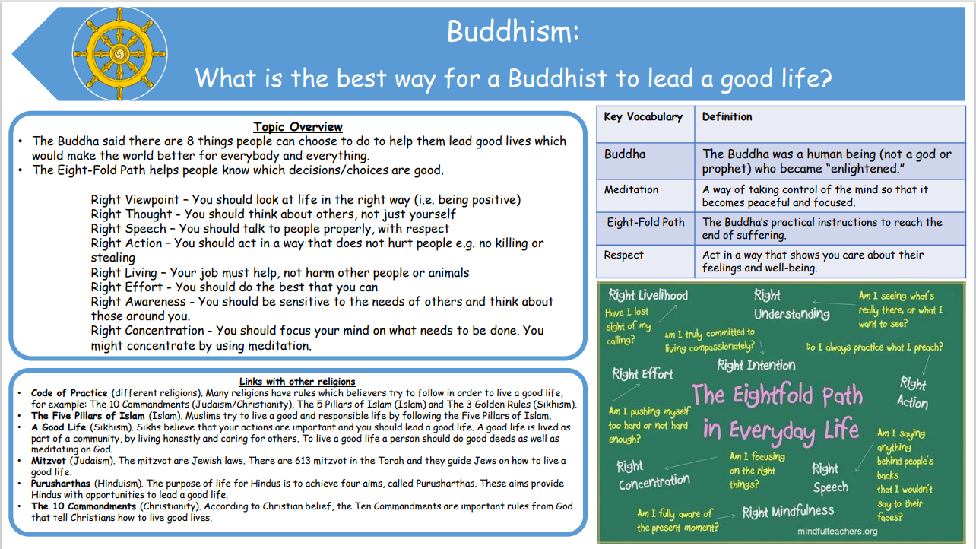

Gospel Value:
Intentional and Prophetic- To be intentional and conscientious in the way in which we live

RE Knowledge Organiser
LKS2 Year B– Summer 2

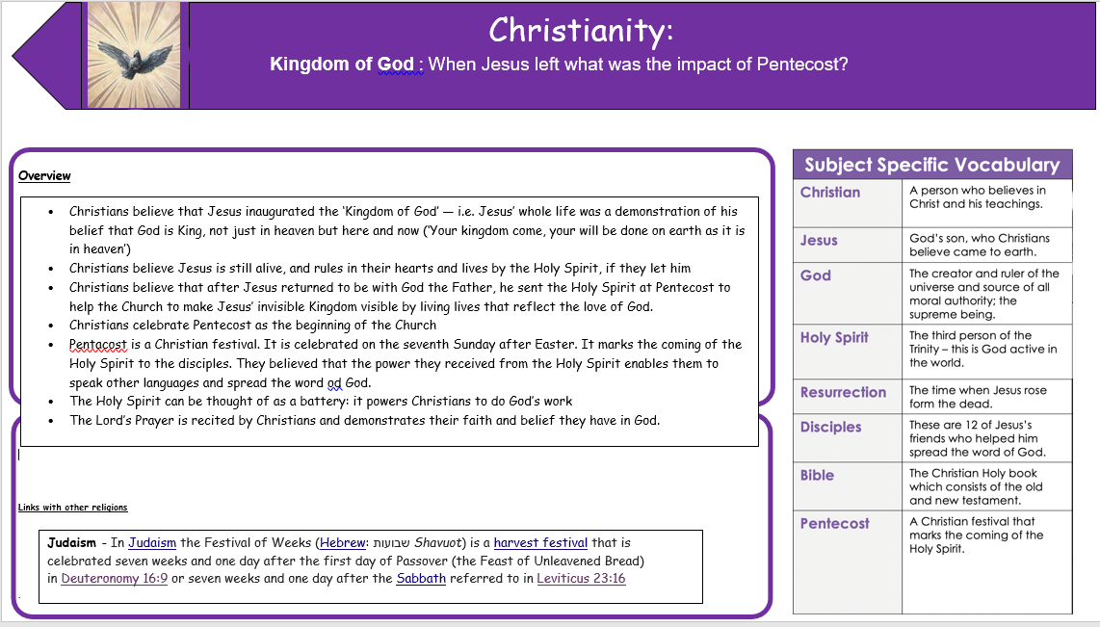

Gospel Value:
Faith-filled and Hopeful- To be consumed by the belief of the Holy Spirit and the hope this brought to Jesus’ disciples

RE Knowledge Organiser
UKS2 Year A– Autumn 1

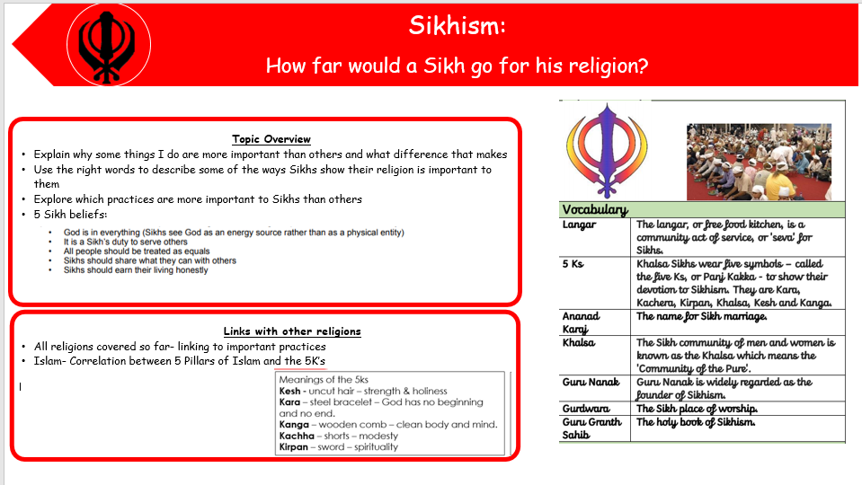

Gospel Value:
Attentive and Discerning- To consider your own experiences and be discerning in the choices you make because of them

RE Knowledge Organiser
UKS2 Year A– Autumn 2

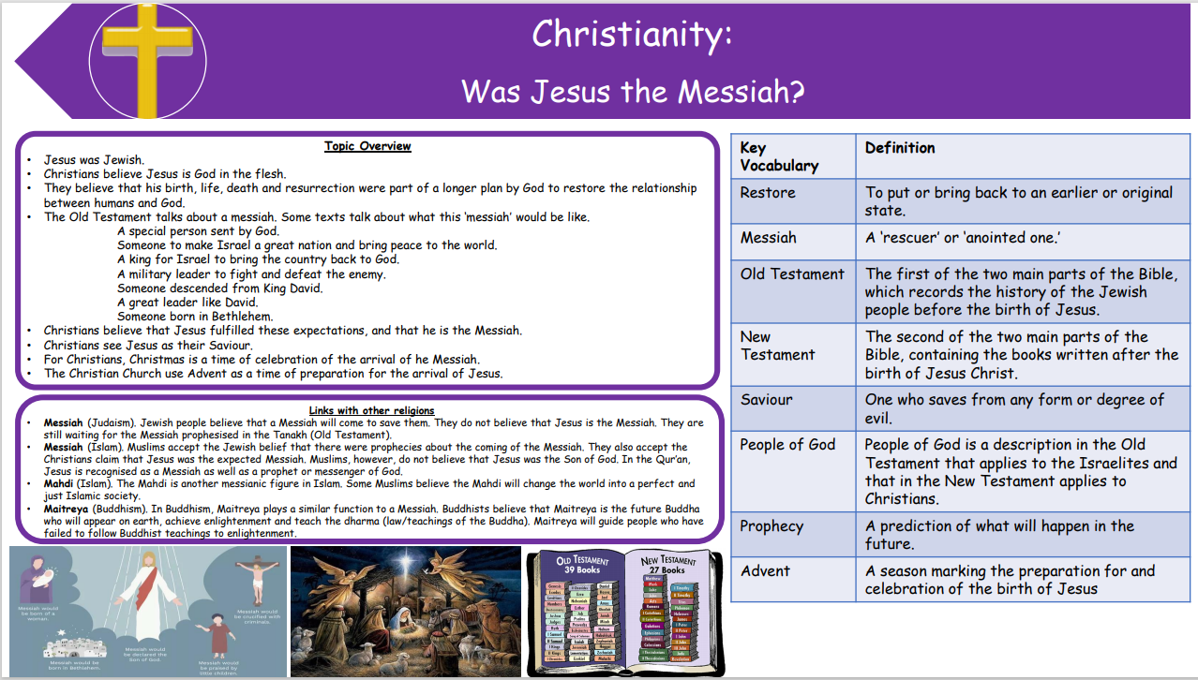

Gospel Value:
Intentional and Prophetic- To learn from the Bible about people’s view of Jesus and share this knowledge with others

RE Knowledge Organiser
UKS2 Year A– Spring 1

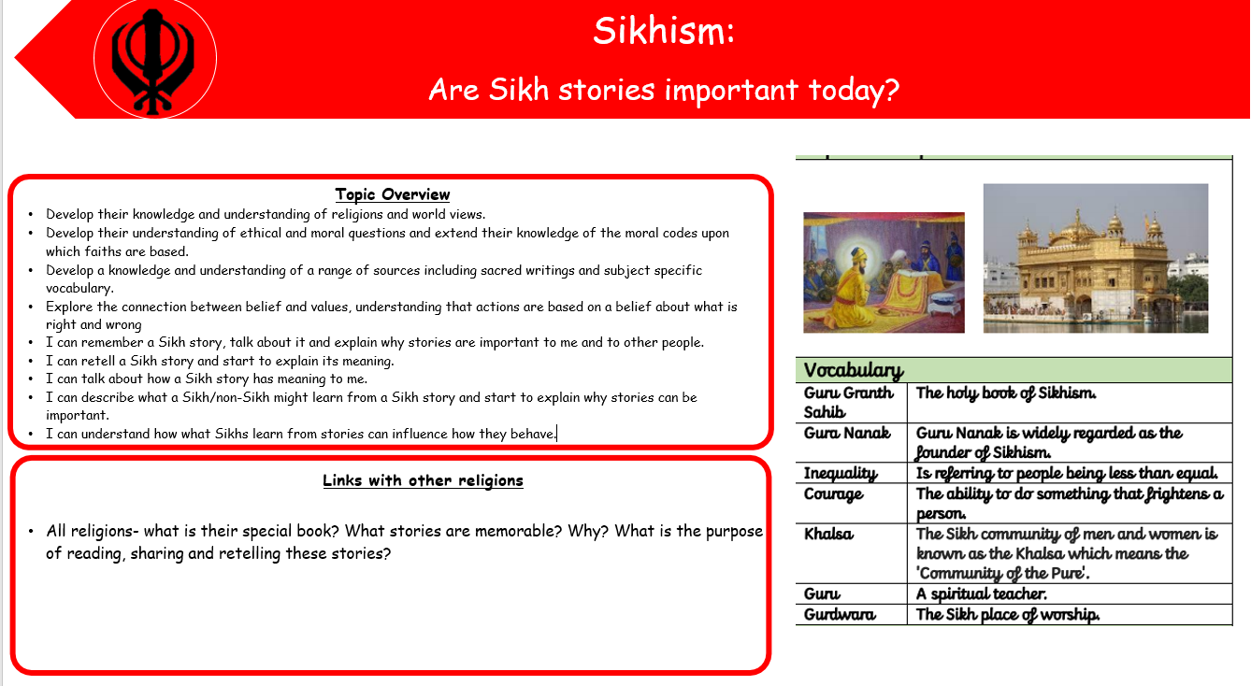

Gospel Value:
Learned and Wise- To immerse ourselves in the stories from the Guru Granth Sahib and wise in the links we can make to the Bible

RE Knowledge Organiser
UKS2 Year A– Spring 2

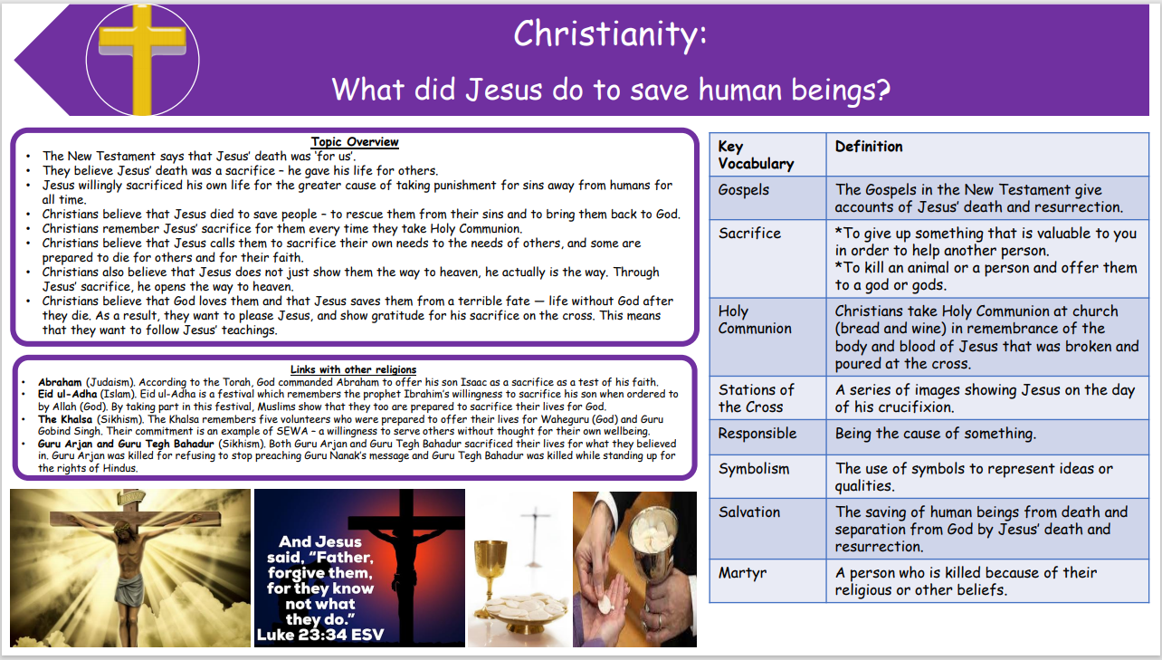

Gospel Value:
Grateful and Generous- To be grateful for the sacrifice made by Jesus to save us all

RE Knowledge Organiser
UKS2 Year A– Summer 1

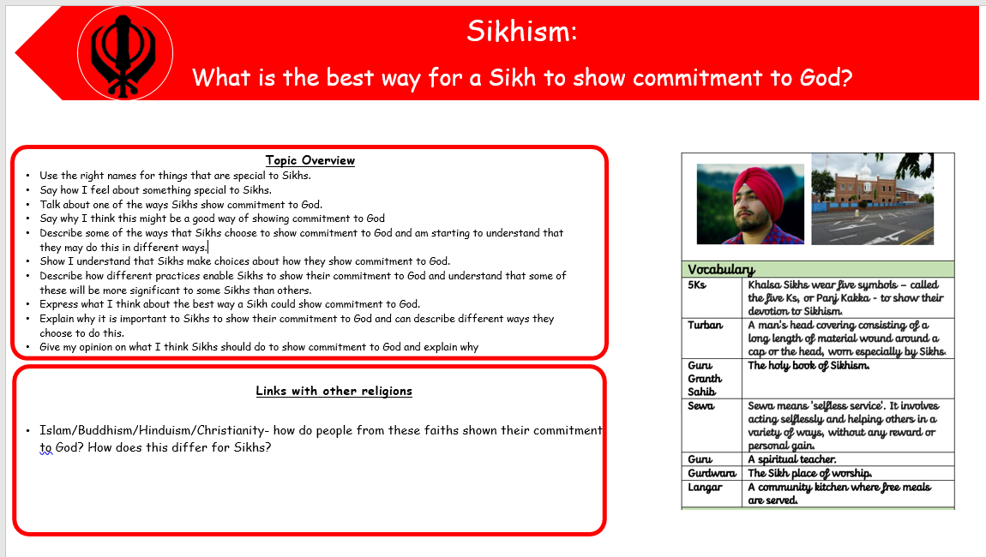

Gospel Value:
Curious and Active- To be curious about a Sikh’s commitment to Allah and active in our own commitment to God

RE Knowledge Organiser
UKS2 Year A– Summer 2

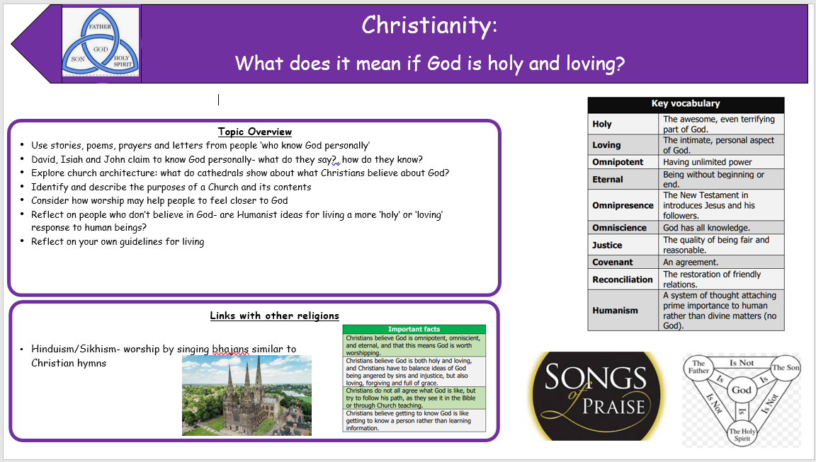

Gospel Value:
Compassionate and Loving- To learn from God’s example of being loving and recreate this within our own relationships.

RE Knowledge Organiser
UKS2 Year B– Autumn 1

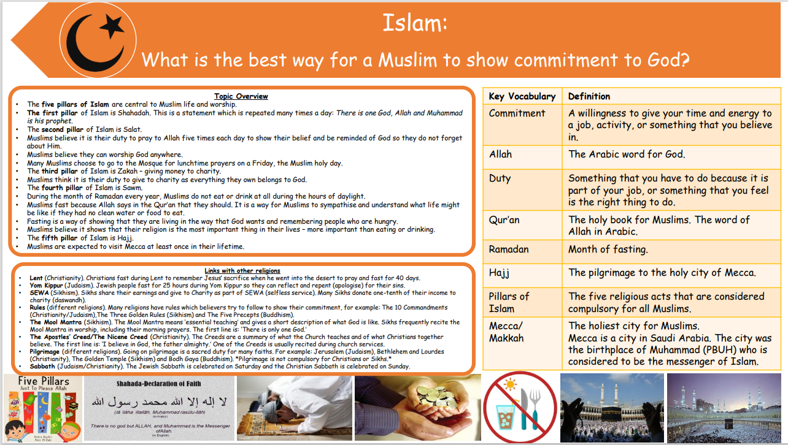

Gospel Value:
Curious and Active- To be curious about a Muslim’s commitment to Allah and active in our own commitment to God

RE Knowledge Organiser
UKS2 Year B– Autumn 2

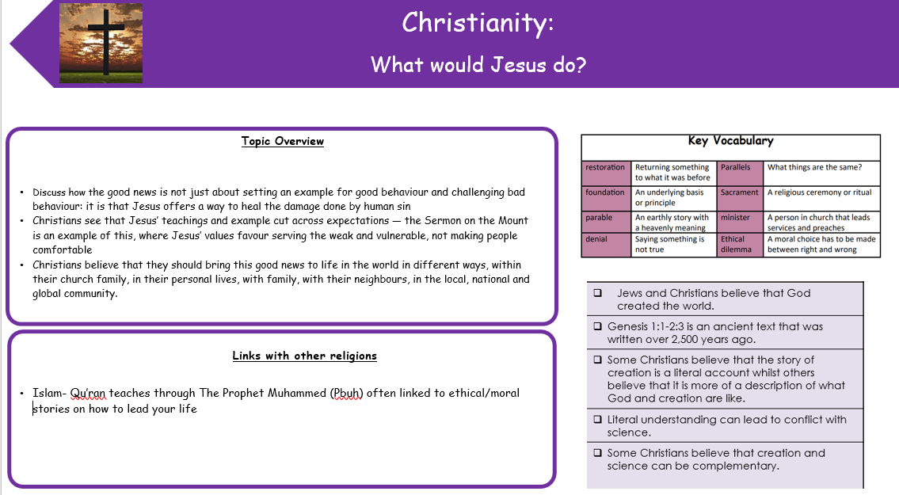

Gospel Value:
Intentional and Prophetic- To learn from Jesus and to consider and be prophetic in the examples we set to others.

RE Knowledge Organiser
UKS2 Year B- Spring 1

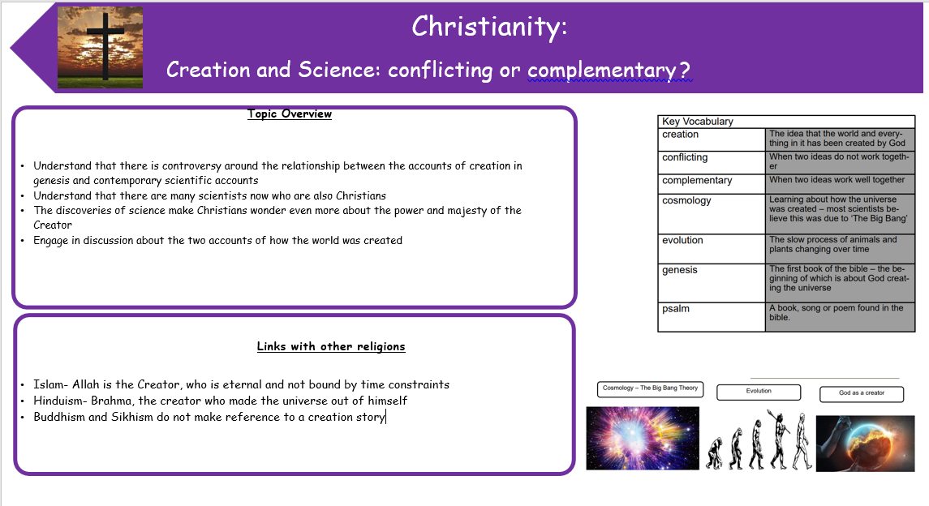

Gospel Value:
Learned and Wise- To be open to learning about topics from different perspectives and wise in the way we articulate our own views.

RE Knowledge Organiser
UKS2 Year B- Spring 2

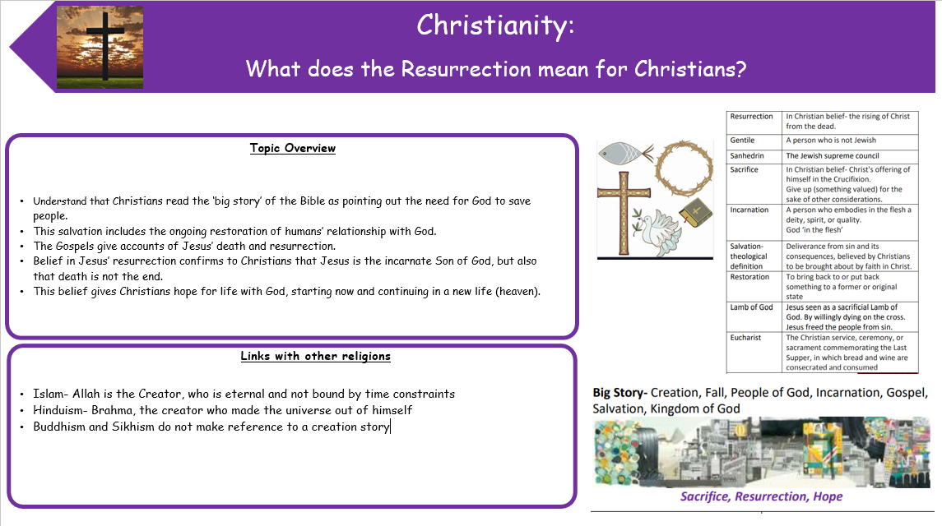

Gospel Value:
Grateful and Generous- To be grateful for the sacrifice made by Jesus and the blessings of each day.

RE Knowledge Organiser
UKS2 Year B- Summer 1

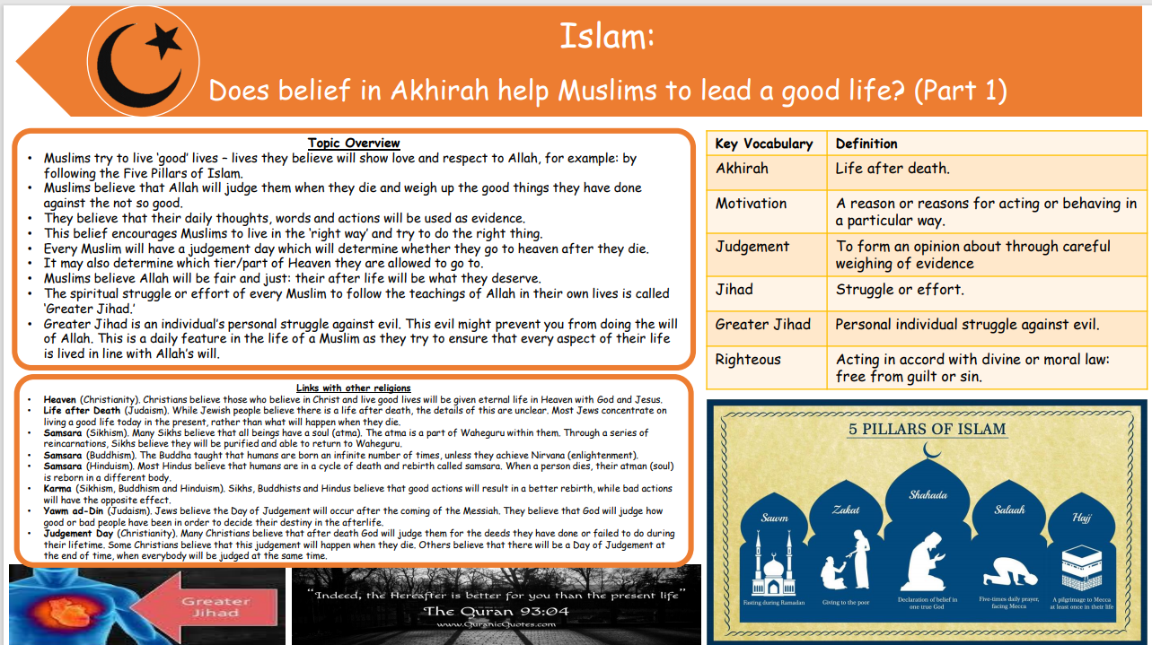

Gospel Value:
Attentive and Discerning- To be perceptive of the world around us and respectful of the choices we each make.

RE Knowledge Organiser
UKS2 Year B- Summer 2

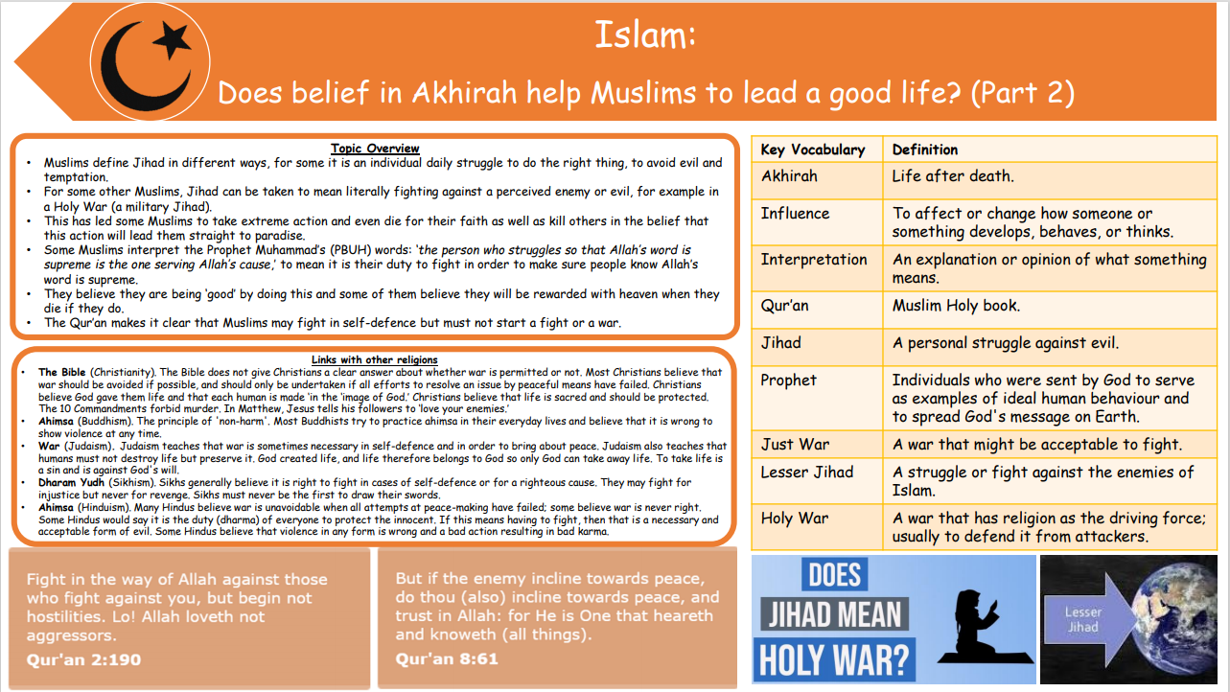

Gospel Value:
Faith-filled and Hopeful- To be hopeful for the future according to our own beliefs.

KS1 Assessment
 | Thinking about religion | Enquiring, investigating and interpreting | Creation and fall | God | Incarnation/ Salvation | Gospel
Working towards | •I can identify some features of religions and beliefs.  •I can retell some simple religious, spiritual and moral stories.  •I can describe some of the ways that people express their religion and beliefs. | •I can identify what I find interesting and puzzling about life.  •I recognise symbols of religious expression.  •I know that some questions about life are too difficult to answer. | • I know that Christians believe that God created the universe.  • I can explain that Christians believe Earth and everything in it are important to God.  • I can explain and give examples of how and why humans should care for the world. | • I can name the Christians’ holy book.  • Christians believe God is loving, kind, fair, and also Lord and King.  • I can describe how Christians worship God, and try to live in ways that please him. | • I can retell the story of Jesus’ birth.  • I can explain why Jesus was a special baby.  • I can describe how Christians celebrate Jesus’ birth and Advent. | • Christians believe Jesus brings good news for all people.  • Christians believe Jesus is a friend to the poor and friendless.  • Christians believe Jesus’ teachings show them the right way to live.
Working within | •I can identify and match features of religions and beliefs.  •I can retell religious, spiritual and moral stories and interpret the message.  •I can describe and give examples of ways that people express their religion and beliefs.  •I can identify similarities and differences in features of religions and beliefs. | •I can identify and discuss what I find interesting and puzzling about life.  •I recognise and describe symbols of religious expression and ways people demonstrate their beliefs.  •I know that some questions about life are too difficult to answer. | • I can describe how Christians believe the world was created.  • I can explain that Christians believe Earth and everything in it are important to God.  • I can explain and give examples of how and why humans should care for the world because it belongs to God. | • I can describe how Christians would find out more about their God by reading the Bible.  • I can describe what Christians believe God is like, using some Bible stories to help me.  • I can identify and give some examples of how Christians worship God, and try to live in ways that please him. | • I can talk about Christians’ belief that Jesus is God and that he was born as a baby in Bethlehem.  • I can explain why Jesus was a special baby and discuss the good news he was said to bring.  • I can describe and give examples of how Christians celebrate and prepare for Jesus’ birth and Advent. | • Christians believe Jesus brings good news for all people and this includes being loved by God.  • Christians believe Jesus is a friend to the poor and friendless. I can describe why this comforts Christians.  • Christians believe Jesus’ teachings make people think hard about how to live and show them the right way.
Working beyond | •I can recall features of religious, spiritual and moral stories and other forms of religious expression.  •I can retell religious, spiritual and moral stories and interpret the message.  •I can describe and give examples of ways that people express their religion and beliefs.  •I can identify similarities and differences in features of religions and beliefs. | •I can identify and discuss what I find interesting and puzzling about life and share my thoughts and examples.  •I can identify ways people demonstrate their beliefs.  •I can consider and share questions about life that are too difficult to answer.  •I can identify some possible meanings for symbols. | • I can describe in detail how Christians believe the world was created.  • I can explain that Christians believe Earth and everything in it are important to God.  • I can talk about God’s unique relationship with human beings as their Creator and Sustainer.  • I can explain and give examples of how and why humans should care for the world because it belongs to God. | • I can talk about where Christians would find more information about their religion and God and how the Bible is organised into the Old and New Testament.  • Christians believe God is loving, kind, fair, and also Lord and King; and there are some stories that show this.  • I can discuss and give examples of how Christians worship God, and try to live in ways that please him. | • I can talk about Christians belief that Jesus is God and that he was born as a baby in Bethlehem.  • The Bible points out that his birth showed he was extraordinary and that he came to bring good news.  • I can explain how Christians celebrate Jesus’ birth; Advent for Christians is a time for getting ready for Jesus’ coming. | • Christians believe Jesus brings good news for all people, this good news includes being loved by God, and being forgiven for bad things.  • Christians believe Jesus is a friend to the poor and friendless. I can give examples from the Bible to support this.  • Christians believe Jesus’ teachings make people think hard about how to live and show them the right way. I can give examples from the Bible to explain this.

LKS2 Assessment
 | Thinking about religion | Enquiring, investigating and interpreting | Creation and fall | God | Incarnation/ Salvation | Gospel
Working towards | • I can make links between beliefs, stories and practices.  • I can comment on connections between questions, beliefs, values and practices.  • I can describe similarities and differences within and between religions and beliefs. | • I can make connections for features of different religions and beliefs.  •I can identify and describe symbols for different religions. I can give some suggestions for the meanings of the symbols.  • I can organise information and select relevant ideas about religion and beliefs. | • I know Christians believe that God made the world.  • I can retell the story of Adam and Eve including God’s command to not to eat the fruit.  • I know that some people don’t believe that God made the world. | • I know Christians believe God is Trinity; Father, Son and Holy Spirit.  •I know that Christians try to describe God using symbols, similes, and metaphors, in song, story, poems and art and have created art to help to express this belief.  •I can describe what happens at a Baptism. |  | • I know that the Gospel of Jesus is about setting a good example and healing the damage done by sin.  • I can identify a range of Jesus’ teachings from the Bible.
Working within | • I can compare and make links between beliefs, stories and practices.  • I can identify the impacts of beliefs and practices on people’s lives.  • I can compare and comment on connections between questions, beliefs, values and practices. | • I can investigate and connect features of religions and beliefs.  • I can gather and organise information about religion and beliefs. I can use this to ask significant questions about religions and beliefs.  • I can describe and suggest meanings for symbols and other forms of religious expression. | • I know Christians believe that although God made the world the Bible tells in Genesis 3 how humans spoiled that friendship with God, and that Christians call this the Fall.  • I can retell the story of Adam and Eve including Gods command not to eat the fruit, the serpent tempting Eve, Adam and Eve hiding from God, Adam and Eve expelled from paradise.  • I understand that many Christians believe they are asked to be caretakers of God’s creation and how people try to put this into action. | • I know Christians believe God is Trinity. I can describe the three parts and what they represent. (Father, Son and Holy Spirit.)  •I know that Christians find God hard to describe, so they use symbols, similes, and metaphors, in song, story, poems and art. I can use one of these methods to explore a God’s representation.  • I can describe what happens at a Baptism and can retell the story of Jesus’ Baptism. |  | •I can explain how Jesus’ Gospel is not only to teach Christians how to set a good example but also how to resolve damage (created by sin) in the world.  • I can identify and retell a range of Jesus’ teachings from the Bible.  • I understand how these texts are fixed the way that different Christians have interpreted them over the years and will vary in in different cultures.
Working beyond | • I can identify the impacts of beliefs and practices on people’s lives.  • I understand the impact of beliefs and practices on individuals, groups and communities and can give examples to explain this.  • I can compare and contrast religions and beliefs to identify similarities and differences. | • I can investigate and connect features of religions and beliefs.  • I can identify, describe and suggest meanings for a range of forms of religious expression, using appropriate vocabulary.  • I can ask significant questions about religions and beliefs and suggest answers to some questions raised by the study of religions and beliefs. | • I can retell the story of Adam and Eve including Gods command not to eat the fruit, the serpent tempting Eve, Adam and Eve hiding from God, Adam and Eve expelled from paradise. Christians call this the Fall.  • I can talk about Christians’ belief that God wants to help people to get close to him again. He gives them guidelines and offers forgiveness when they fall short.  • I understand that many Christians believe they are asked to be stewards or caretakers of God’s creation and can talk about examples where Christians have tried to put this idea in to practice. | • I know that Christians believe God is Trinity: Father, Son and Holy Spirit. I can explain using words or illustrations, what this means to Christians and what each part represents.  • I can express my representation of God using symbols, similes, metaphors, songs, stories, poems or art work.  • I can find, retell and discuss Jesus’ Baptism from the Bible. I can explain the symbolism of the dove appearing. I can connect the Trinity to modern day baptisms and the language of ‘in the name of the father, son and the holy spirit’ |  | • I can explain how Jesus’ Gospel is not only to teach Christians how to set a good example but also how to resolve damage (created by sin) in the world. I can connect this to a Christian’s way of life.  • I can identify, retell and describe the impact of a range of Jesus’ teachings from the Bible. I can explain why Christian groups use these stories to relay messages and bring the stories to life.  • I understand and can describe how these texts are fixed the way that different Christians have interpreted them over the years and will vary in in different cultures.

UKS2 Assessment
 | Thinking about religion | Enquiring, investigating and interpreting | Creation and fall | God | Incarnation/ Salvation | Gospel
Working towards | • I can explain connections between questions, beliefs, values and practices in different belief systems.  • I can observe and identify the impact of beliefs on individuals and communities.  • I can describe some of the ways that beliefs are expressed by people. | • I can recognise diversity within religious expression.  • I can identify the influence of different viewpoints within religions and beliefs.  • I can interpret religions and beliefs from different viewpoints. | • I can explain that there are different viewpoints about creation from Genesis and Scientific accounts.  • I understand that not all Christian believe the same about the relationship between Creation and science. | • I understand that Christians believe God is omnipotent, omniscient and eternal. However, I understand that some people do not believe that God exists.  • I can identify different types of text in the Bible. | • I understand that Jesus was Jewish.  • I understand the meaning of Jesus’ name in Greek and why he is often referred to as ‘Messiah’.  • I can describe how most Christians believe Jesus is God incarnate and God’s long term plan to restore relationships between Humans and God. | • I understand that the Gospel of Jesus is about setting a good example and healing the damage done by sin. I can make connections to how Christians use Gospel to lead good lives.  • I can identify and retell a range of Jesus’ teachings from the Bible. I can link some of these to the messages he wanted to convey.
Working within | • I can recognise and explain the impact of beliefs and ultimate questions on individuals and communities.  • I can explain how and why differences in belief are expressed.  • I can recognise the reasons that diversity exists within and between religions, beliefs and cultures. | • I can refer to relevant sources and evidence for information to suggest answers for questions raised by study.  • I can identify the different viewpoints within religions and beliefs and describe the influence they may have.  • I can interpret the significance and impact of different forms of religious and spiritual expression. | • I understand and can describe that Genesis and scientific accounts of creation hold different viewpoints.  • I understand the significance of Psalm 8. | • I understand that Christians believe God is omnipotent, omniscient and eternal. However, I understand that some people do not believe that God exists. I can describe the meaning of these terms.  • I can identify and give examples of different types of text in the Bible. | • I understand that Jesus was Jewish but that Jews do not hold the same beliefs as Christians do about Jesus being the Messiah.  • I know that most Christians believe Jesus is God incarnate and they believe that his birth, life, death and resurrection were part of a longer plan by God to restore the relationship between humans and God.  • I understand that Christians believe that Jesus fulfilled these expectations, and that he is the Messiah. I can give my opinion on whether Jesus was the Messiah supported with evidence from relevant sources. | •I understand why Gospel is used by Christian groups to preach. I can explain how Jesus’ Gospel is not only to teach Christians how to set a good example but also how to resolve damage (created by sin) in the world.  • I can identify and retell a range of Jesus’ teachings from the Bible, linking the stories with Jesus’ message.  • I understand how these texts are fixed the way that different Christians have interpreted them over the years and will vary in in different cultures. I can give an example of these stories.
Working beyond | • I can explain some of the challenges offered by the variety of religions and beliefs in the contemporary world.  • I can explain the reasons for, and effects of, diversity within and between religions, beliefs and cultures.  • I can use religious and philosophical terminology and concepts to explain religions, beliefs and value systems. | • I can suggest lines of enquiry to address questions raised by the study of beliefs and suggest answers using relevant sources and evidence.  • I can identify the different viewpoints within religions and beliefs and explain how these could influence others. | • I understand and can describe that Genesis and scientific accounts of creation hold different viewpoints. I can express my opinion based on the research and study I have done.  • I can explain the significance of Psalm 8. | • I understand that Christians believe God is omnipotent, omniscient and eternal. However, I understand that some people do not believe that God exists and back this up with reasoning. I can describe the meaning of these terms.  • I can give an example of how biblical ideas about holiness, love or forgiveness have made a difference in the world for example Coventry Cathedral. | • I can discuss the meaning of Jesus’ name and the other names linked with this.  • I know that most Christians believe Jesus is God incarnate and they believe that his birth, life, death and resurrection were part of a longer plan by God to restore the relationship between humans and God.  • I can validate my point of view by answering the question ‘Was Jesus the Messiah?’ supported by a reasoned argument. | • I can explain and discuss how Jesus’ Gospel is not only to teach Christians how to set a good example but also how to resolve damage (created by sin) in the world. I can connect this to a Christian’s way of life.  • I can identify, retell and describe the impact of a range of Jesus’ teachings from the Bible. I can explain why Christian groups use these stories to relay messages and bring the stories to life.  • I can describe and give examples of how these texts are fixed the way that different Christians have interpreted them over the years and vary in in different cultures.

