PSHE Curriculum

PSHE Vision and Aims
RE Over RE Overview
view

Inspired by our Christian faith, we guide children on a personalised journey towards achievement. As a learning community, we are committed to ensuring that children are equipped with, skills and aspirations to reach their full potential in mind, body, heart and spirit.

All areas of our curriculum are underpinned by our Gospel values and we ensure that our curriculum makes links to these values.
At the heart of each subject is a set of core skills which form a subject learning journey, this journey is built from EYFS through to year 6 and the skills progressive as you move through the school. Knowledge is communicated to ensure coverage of National curriculum and it is through this knowledge that children apply their skills.

Children at St Giles’ and St George’s leave with a secure knowledge of both the academic knowledge and skills needed for the next stage of their education. They will have developed a clear set Christian and moral values which they can apply in all areas of their lives and will have taken part in real-life experiences which will have raised their aspirations and given them a thirst for wisdom
and knowledge.

PSHE Whole School Overview
PSHE Curriculum

 | Autumn Term |  | Spring Term |  | Summer Term
 | Being Me In My World | Celebrating Difference | Dreams and Goals | Healthy Me | Relationships | Changing Me
Nursery | Self-identity  Understanding feelings  Being in a classroom  Being gentle  Rights and responsibilities | Identifying talents  Being special  Families  Where we live  Making friends  Standing up for yourself | Challenges  Perseverance  Goal-setting  Overcoming obstacles Seeking help  Jobs  Achieving goals | Exercising bodies  Physical activity  Healthy food  Sleep  Keeping clean  Safety | Family life  Friendships  Breaking friendships Falling out  Dealing with bullying Being a good friend | Bodies  Respecting my body Growing up  Growth and change  Fun and fears  Celebrations
Reception | Feeling special and safe Being part of a class  Rights and responsibilities Rewards and feeling proud Consequences  Owning the Learning Charter | Similarities and differences  Understanding bullying and knowing how to deal with it  Making new friends Celebrating the differences in everyone | Setting goals  Identifying successes and achievements  Learning styles  Working well and celebrating achievement with a partner  Tackling new challenges Identifying and overcoming obstacles Feelings of success | Keeping myself healthy Healthier lifestyle choices Keeping clean  Being safe Medicine safety/safety with household items  Road safety  Linking health and happiness | Belonging to a family  Making friends/being a good friend  Physical contact preferences  People who help us Qualities as a friend and person  Self-acknowledgement Being a good friend to myself  Celebrating special relationships | Life cycles – animal and human  Changes in me  Changes since being a baby  Differences between female and male bodies (correct terminology) Linking growing and learning  Coping with change Transition
Year 1 | Hopes and fears for the year  Rights and responsibilities Rewards and consequences  Safe and fair learning environment  Valuing contributions Choices  Recognising feelings | Assumptions and stereotypes about gender Understanding bullying Standing up for self and others  Making new friends Gender diversity Celebrating difference and remaining friends | Achieving realistic goals Perseverance  Learning strengths Learning with others Group co-operation Contributing to and sharing success | Motivation  Healthier choices Relaxation  Healthy eating and nutrition  Healthier snacks and sharing foo | Different types of family Physical contact boundaries  Friendship and conflict Secrets Trust and appreciation  Expressing appreciation for special relationships | Life cycles in nature Growing from young to old  Increasing independence Differences in female and male bodies (correct terminology) Assertiveness  Preparing for transition
Year 2 | Setting personal goals  Self-identity and worth Positivity in challenges Rules, rights and responsibilities  Rewards and consequences  Responsible choices  Seeing things from others’ perspectives | Families and their differences  Family conflict and how to manage it (child-centred) Witnessing bullying and how to solve it  Recognising how words can be hurtful  Giving and receiving compliments | Difficult challenges and achieving success  Dreams and ambitions New challenges  Motivation and enthusiasm  Recognising and trying to overcome obstacles Evaluating learning processes  Managing feelings  Simple budgeting | Exercise Fitness Challenges Food labelling and healthy swaps  Attitudes towards drugs Keeping safe and why it’s important online and off line scenarios  Respect for myself and others  Healthy and safe choices | Family roles and responsibilities  Friendship and negotiation Keeping safe online and who to go to for help  Being a global citizen. Being aware of how my choices affect others Awareness of how other children have different lives  Expressing appreciation for family and friends | How babies grow Understanding a baby’s needs  Outside body changes Inside body changes Family stereotypes Challenging my ideas Preparing for transition
Year 3 | Being part of a class team Being a school citizen Rights, responsibilities and democracy (school council)  Rewards and consequences  Group decision-making Having a voice  What motivates behaviour | Challenging assumptions Judging by appearance Accepting self and others Understanding influences Understanding bullying Problem-solving Identifying how special and unique everyone is First impressions | Hopes and dreams Overcoming disappointment  Creating new, realistic dreams  Achieving goals  Working in a group Celebrating contributions Resilience  Positive attitudes | Healthier friendships Group dynamics  Smoking  Alcohol  Assertiveness  Peer pressure  Celebrating inner strength | Jealousy  Love and loss  Memories of loved ones Getting on and Falling Out Girlfriends and boyfriends Showing appreciation to people and animals | Being unique  Having a baby  Girls and puberty Confidence in change Accepting change Preparing for transition Environmental change
Year 4 | Planning the forthcoming year  Being a citizen  Rights and responsibilities Rewards and consequences  How behaviour affects groups  Democracy,  having a voice, participating | Cultural differences and how they can cause conflict  Racism Rumours and name-calling  Types of bullying  Material wealth and happiness  Enjoying and respecting other cultures | Future dreams  The importance of money Jobs and careers  Dream job and how to get there  Goals in different cultures Supporting others (charity)  Motivation | Smoking, including vaping Alcohol  Alcohol and anti-social behaviour  Emergency aid  Body image  Relationships with food Healthy choices  Motivation and behaviour | Self-recognition and self-worth  Building self-esteem  Safer online communities Rights and responsibilities online  Online gaming and gambling  Reducing screen time Dangers of online grooming  SMART internet safety rules | Self- and body image Influence of online and media on body image Puberty for girls  Puberty for boys Conception (including IVF) Growing responsibility Coping with change Preparing for transition
Year 5 | Identifying goals for the year  Global citizenship Children’s universal rights Feeling welcome and valued  Choices, consequences and rewards  Group dynamics Democracy, having a voice Anti-social behaviour  Role-modelling | Perceptions of normality Understanding disability Power struggles Understanding bullying Inclusion/exclusion Differences as conflict,  Difference as celebration Empathy | Personal learning goals, in and out of school  Success criteria  Emotions in success Making a difference in the world  Motivation Recognising achievements Compliment | Taking personal  responsibility  How substances affect the body  Exploitation, including ‘county lines’ and gang culture  Emotional and mental health  Managing stress | Mental health  Identifying mental health worries and sources of support  Love and loss  Managing feelings  Power and control Assertiveness  Technology safety  Take responsibility with technology use | Self-image Body image Puberty and feelings Conception to birth Reflections about change Physical attraction Respect and consent Boyfriends/girlfriends Sexting Transition
Year 6 | Personal identity  What influences personal identity  Identify personal strengths  How do others see me? Group identity  My growing sense of personal identity and independence  Online and global identity Expectations | Assertiveness  Prejudice and discrimination  My values and those of others  Challenging stereotypes Discrimination in school How prejudice and discrimination fuels bullying  Being inclusive | What are my dreams and goals?  Steps to success  Coping when things don’t go to plan  Rewarding my dreams Intrinsic and extrinsic motivation  Keeping my dreams alive How dreams and goals change in response to life | Healthy choices about my emotional health  Managing stress  Managing my choices around substances Managing my nutritional choices  Medicines and immunisation  Healthy choices about physical activity and rest/sleep | My changing web of friendships  Support I need now and in the future  Developing positive relationships  What external factors affect relationships, e.g. media influences? Assertiveness in relationships  The changing role of families | My changing body and feelings  What is self-image?  Coping during times of change  My changing ways of thinking  Managing my changes in mood  Moving forwards into my next year of education

PSHE Knowledge Organisers
Reception- Autumn 1

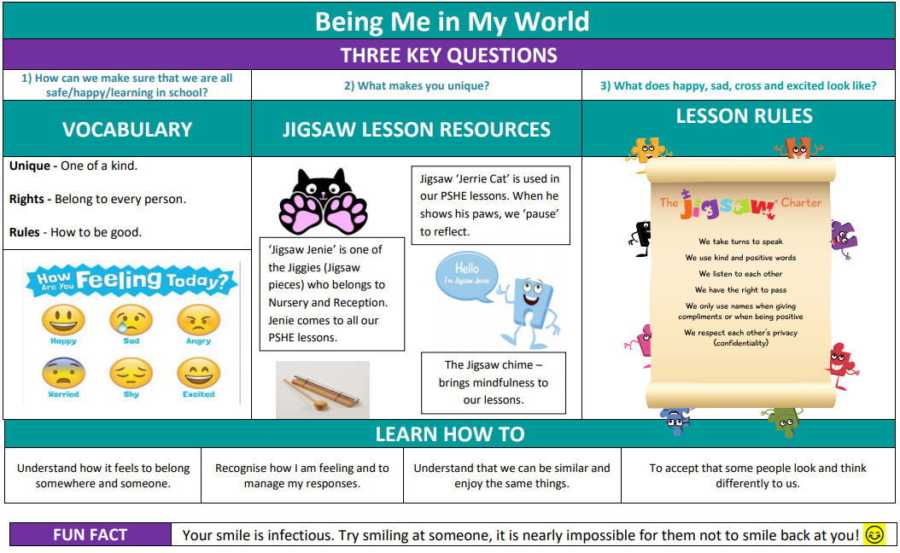

Gospel Value:
Attentive and Discerning- To be considerate in the choices we make and how they could affect others.

PSHE Knowledge Organisers
Reception – Autumn 2

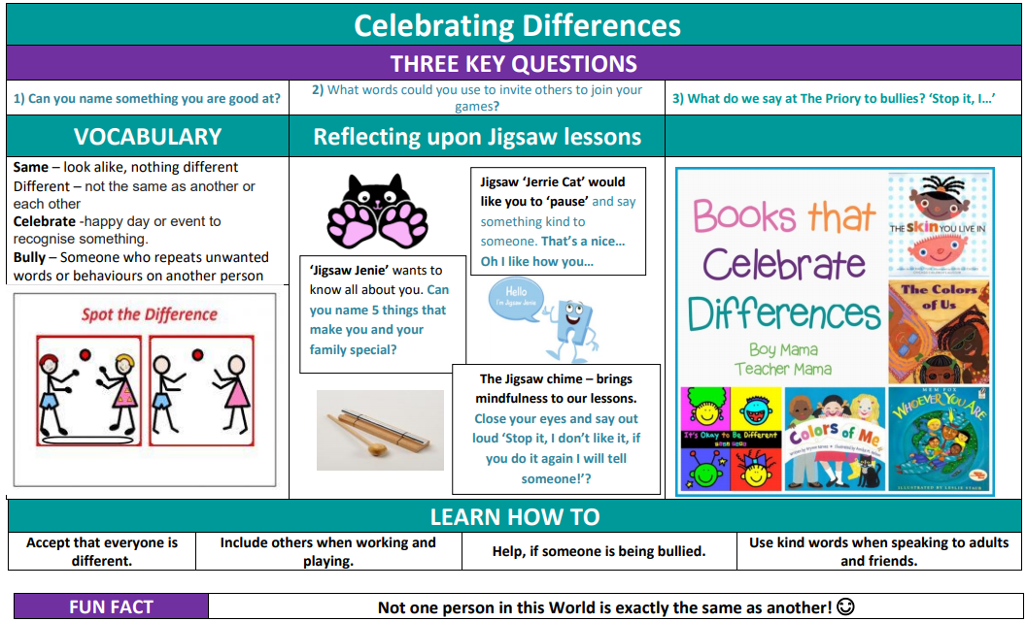

Gospel Value:
Grateful and Generous- To be grateful to God for being a special human being that is unique.

PSHE Knowledge Organisers
Reception – Spring 1

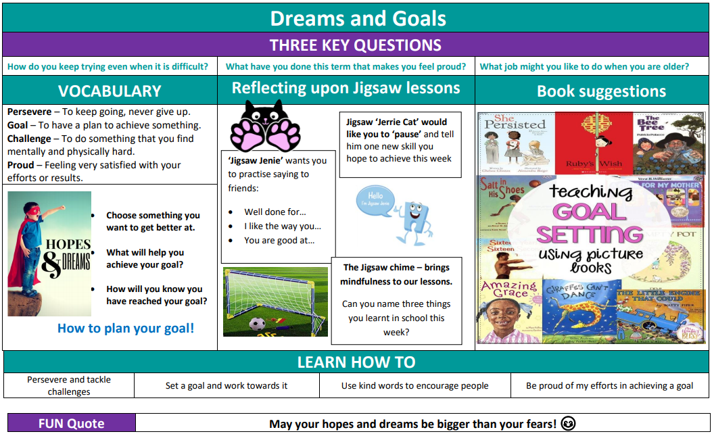

Gospel Value:
Faith-filled and Hopeful- To be hopeful for the new year and what we can do.

PSHE Knowledge Organisers
Reception – Spring 2

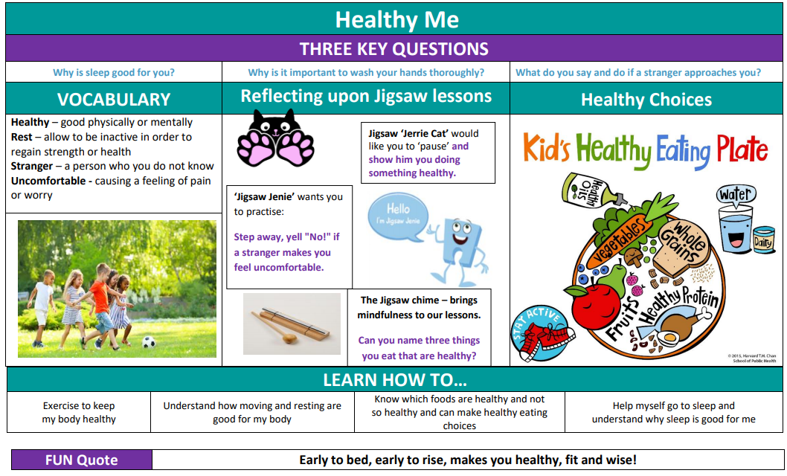

Gospel Value:
Intentional and Prophetic- To plan to live a healthy life by eating the right foods and exercising.

PSHE Knowledge Organisers
Reception - Summer 1

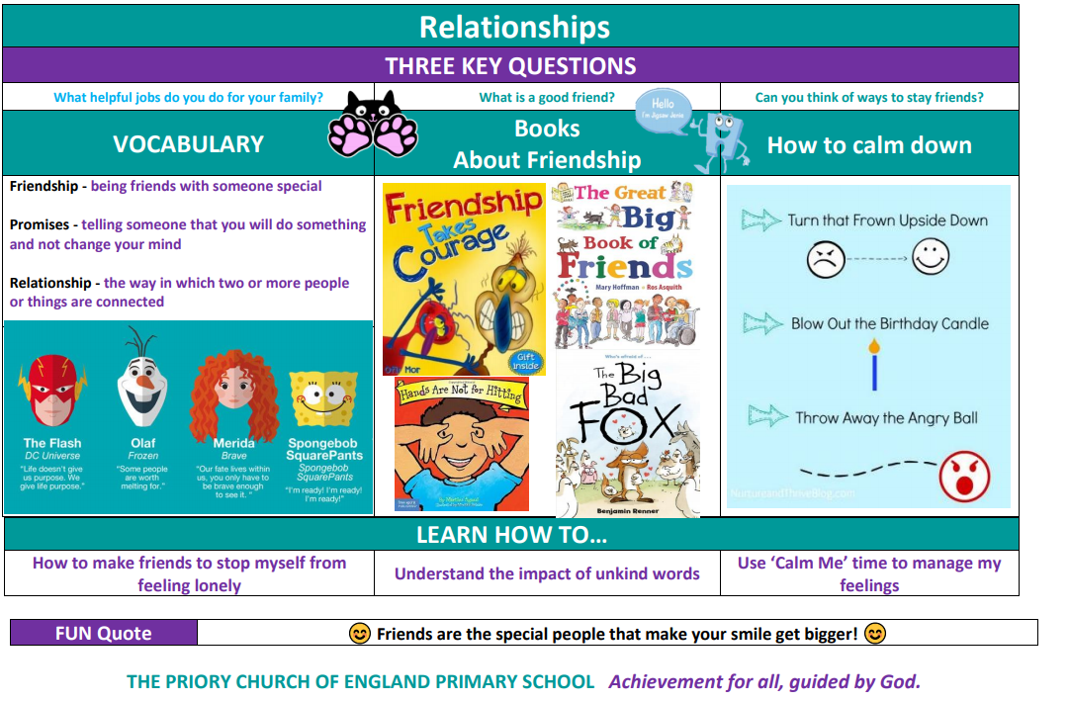

Gospel Value:
Compassionate and Loving- To show kindness to our friends.

PSHE Knowledge Organisers
Reception – Summer 2

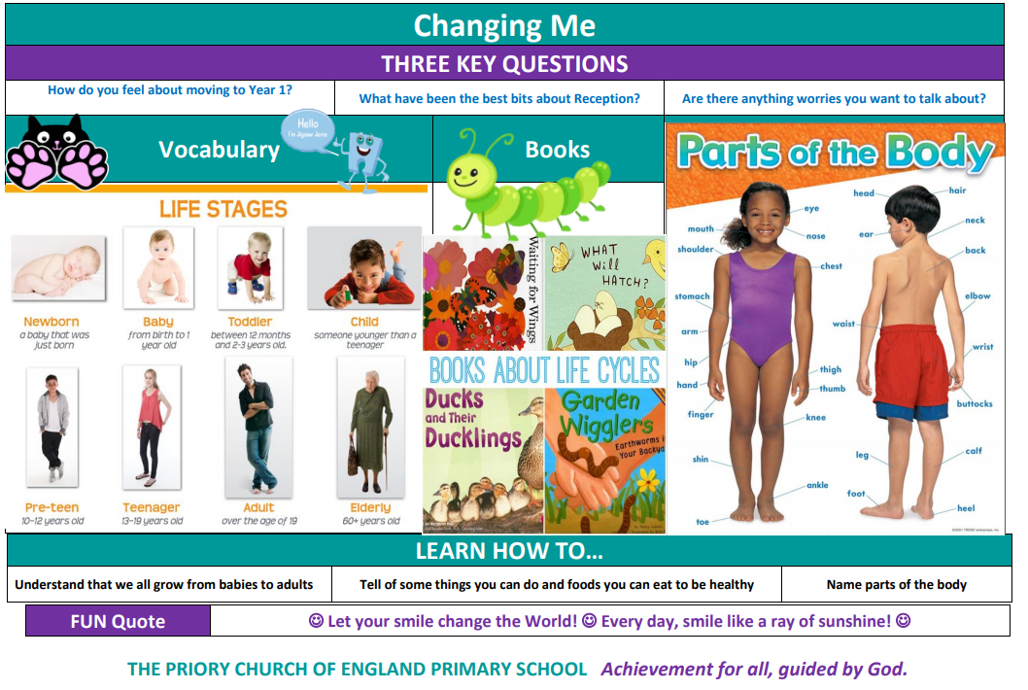

Gospel Value:
Curious and Active- To be curious about the way our bodies change and to actively look after ourselves.

PSHE Knowledge Organisers
Year 1– Autumn 1

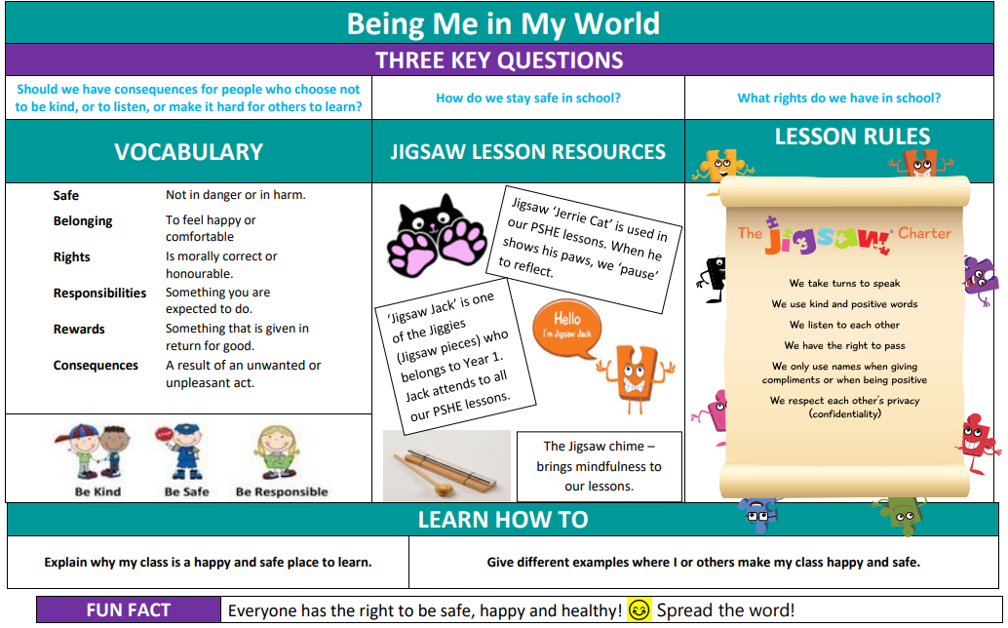

Gospel Value:
Attentive and Discerning- To be considerate in the choices we make and how they could affect others.

PSHE Knowledge Organisers
Year 1– Autumn 2

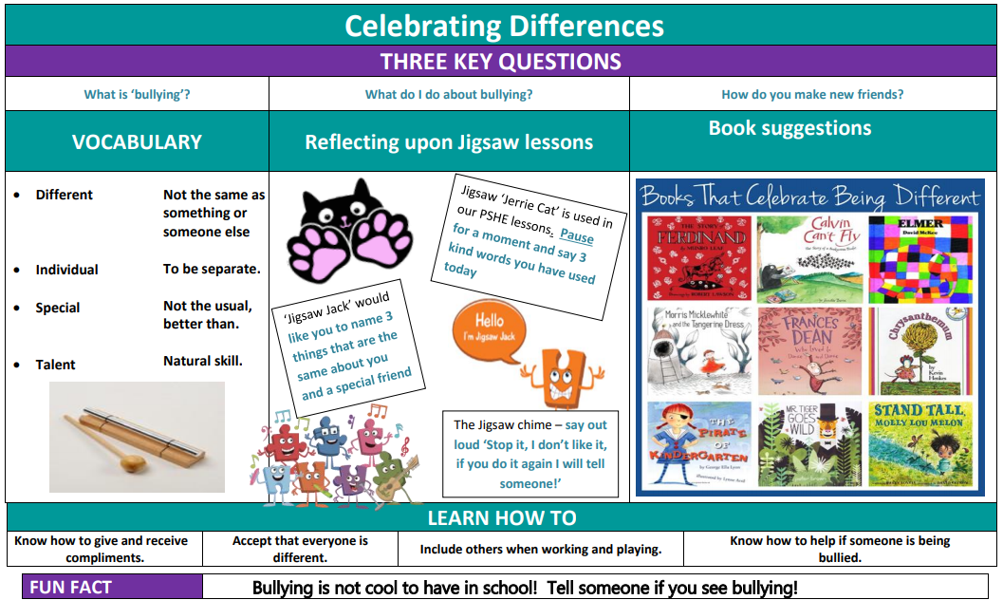

Gospel Value:
Grateful and Generous- To be grateful to God for being a special human being that is unique.

PSHE Knowledge Organisers
Year 1– Spring 1

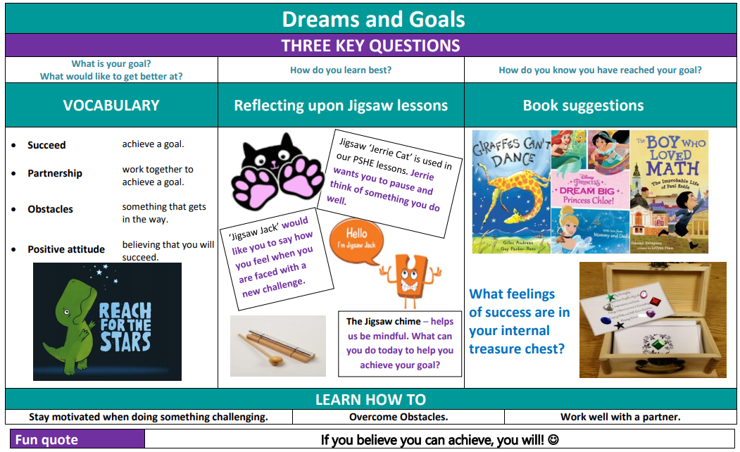

Gospel Value:
Faith-filled and Hopeful- To be hopeful for the new year and what we can achieve.

PSHE Knowledge Organisers
Year 1– Spring 2

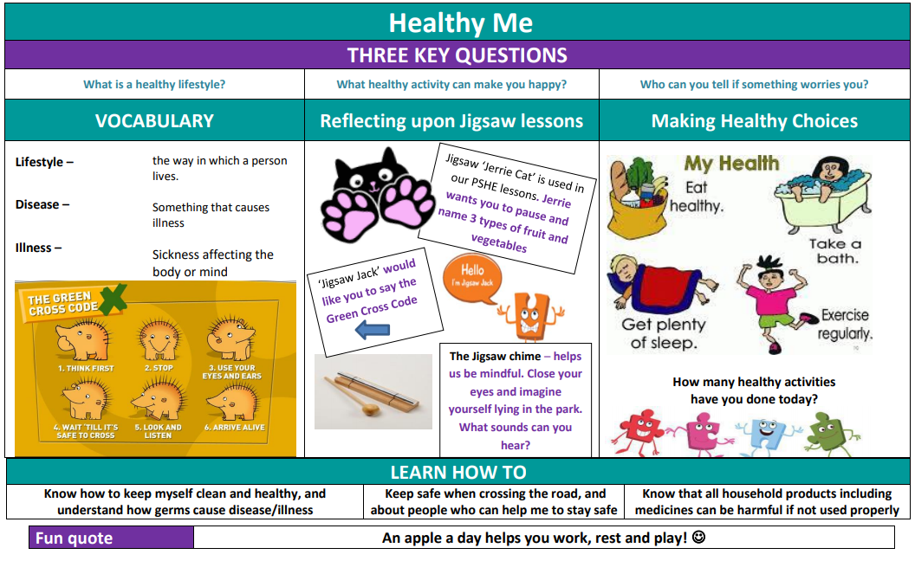

Gospel Value:
Intentional and Prophetic- To plan to live a healthy life by eating the right foods and exercising.

PSHE Knowledge Organisers
Year 1– Summer 1

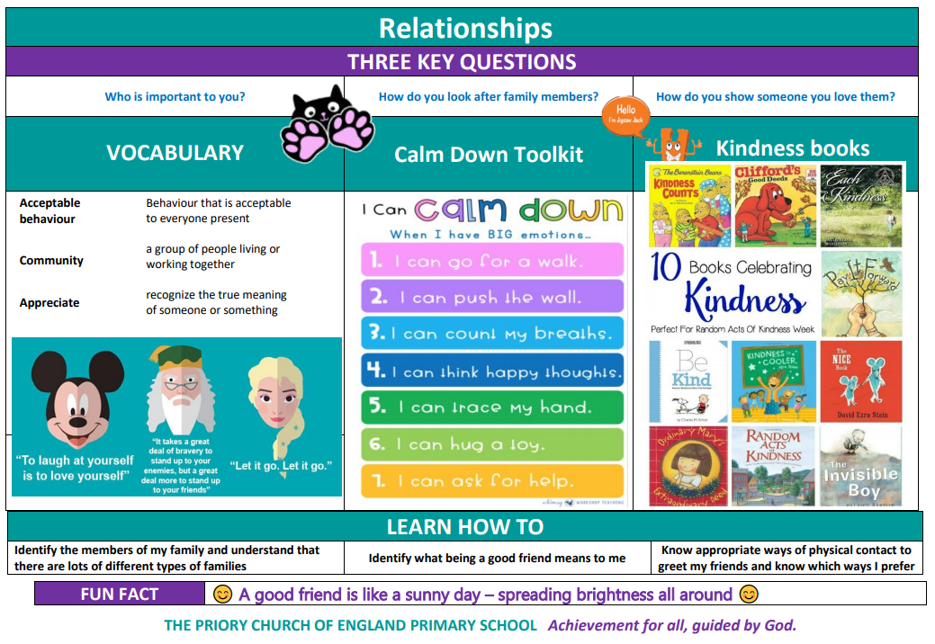

Gospel Value:
Compassionate and Loving- To be kind, compassionate and loving to our friends and family.

PSHE Knowledge Organisers
Year 1– Summer 2

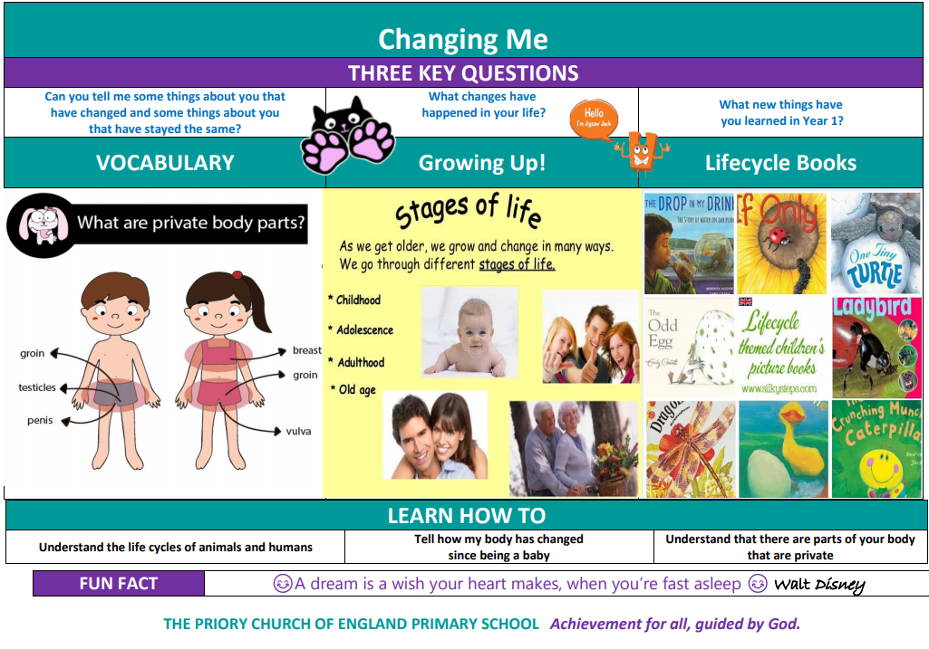

Gospel Value:
Curious and Active- To be curious about the way our bodies change and to actively look after ourselves.

PSHE Knowledge Organisers
Year 2– Autumn 1

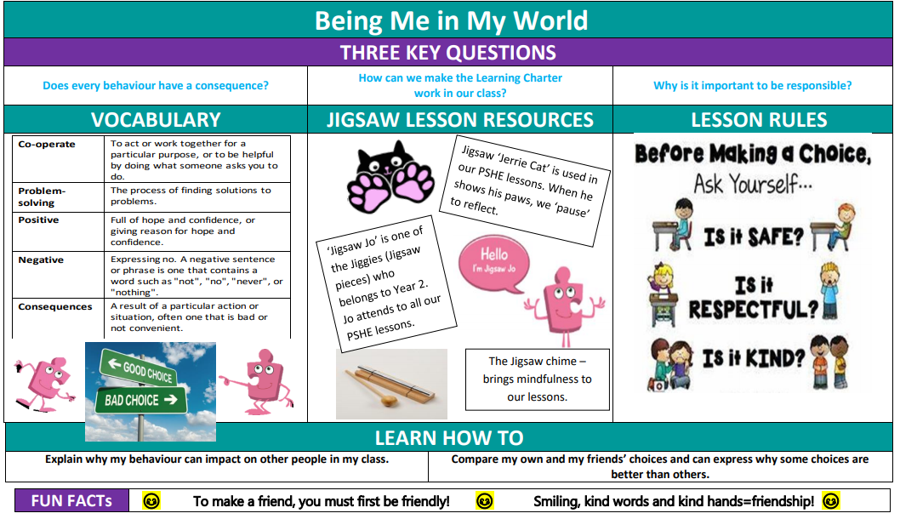

Gospel Value:
Attentive and Discerning- To be considerate in the choices we make and how they could affect others.

PSHE Knowledge Organisers
Year 2– Autumn 2

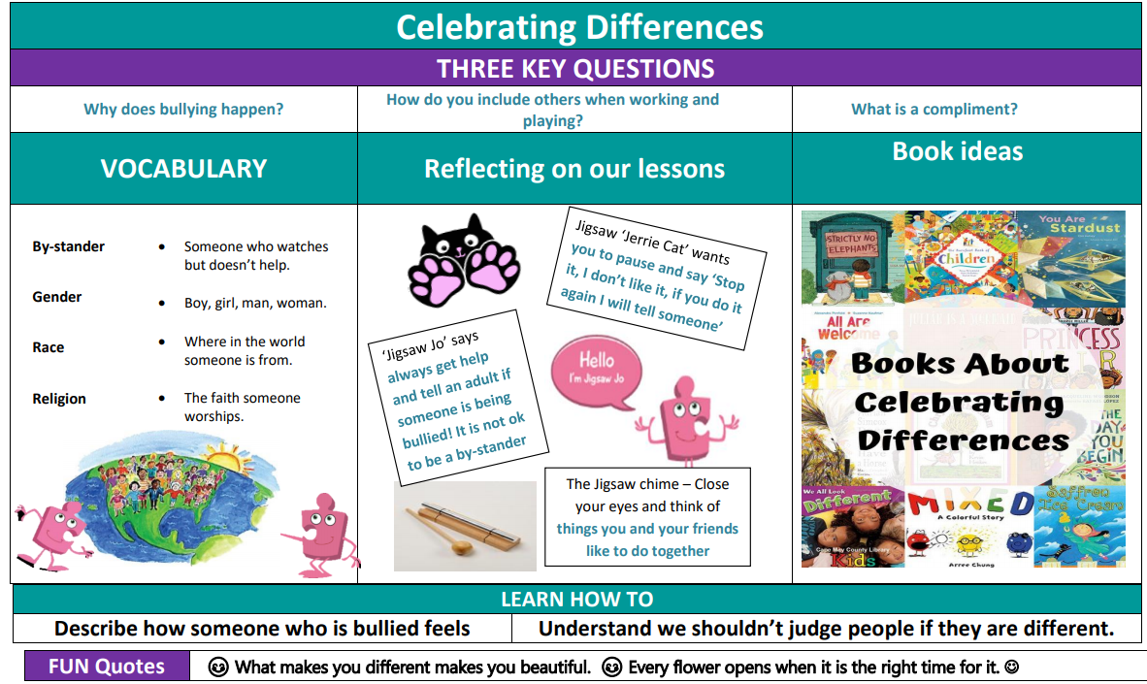

Gospel Value:
Grateful and Generous- To be grateful to God for being a special human being that is unique.

PSHE Knowledge Organisers
Year 2– Spring 1

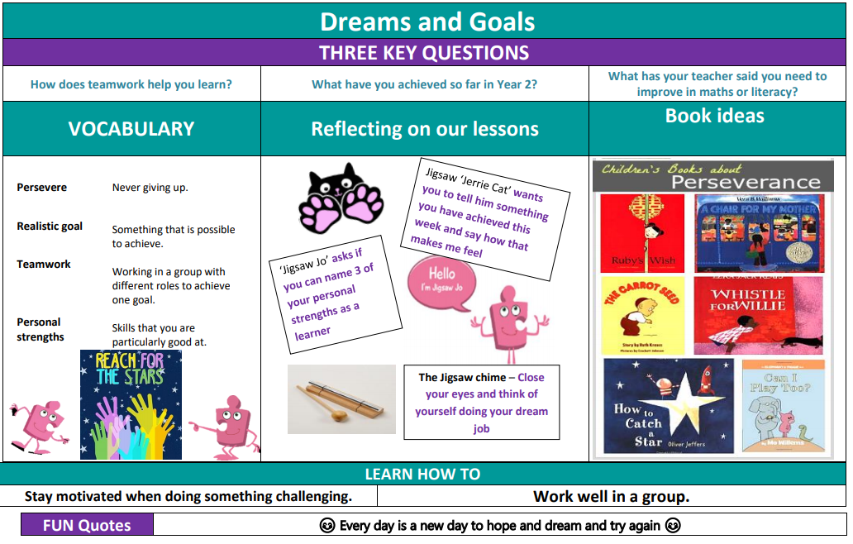

Gospel Value:
Faith-filled and Hopeful- To be hopeful for the new year and what we can achieve.

PSHE Knowledge Organisers
Year 2– Spring 2

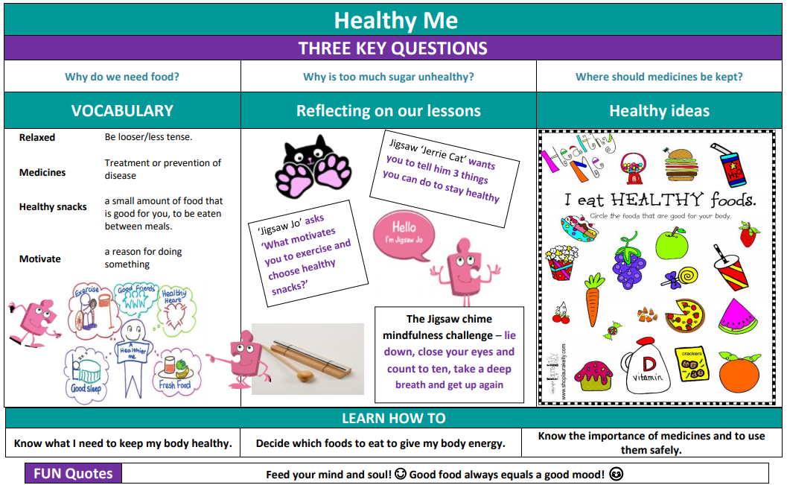

Gospel Value:
Intentional and Prophetic- To plan to live a healthy life by eating the right foods and exercising.

PSHE Knowledge Organisers
Year 2– Summer 1

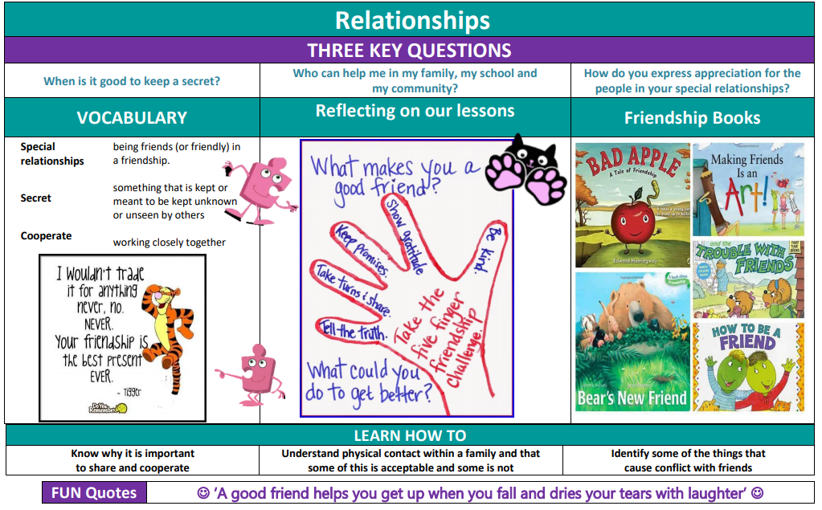

Gospel Value:
Compassionate and Loving- To be kind and loving towards our friends.

PSHE Knowledge Organisers
Year 2– Summer 2

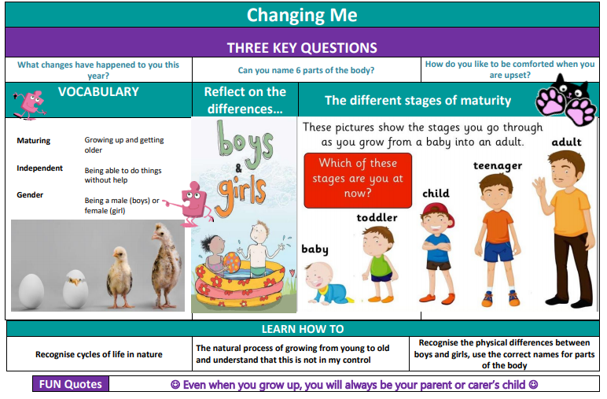

Gospel Value:
Curious and Active- To be curious about the way our bodies change and to actively look after ourselves.

PSHE Knowledge Organisers
LKS2 Year A– Autumn 1

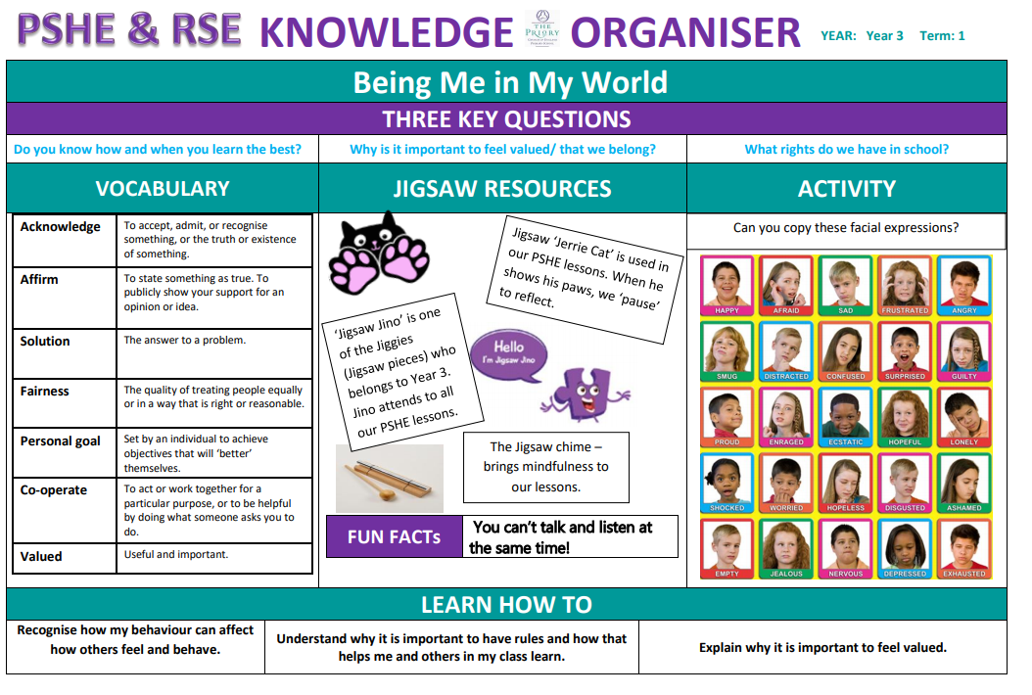

Gospel Value:
Attentive and Discerning- To be considerate in the choices we make and how they could affect others.

PSHE Knowledge Organisers
LKS2 Year A– Autumn 2

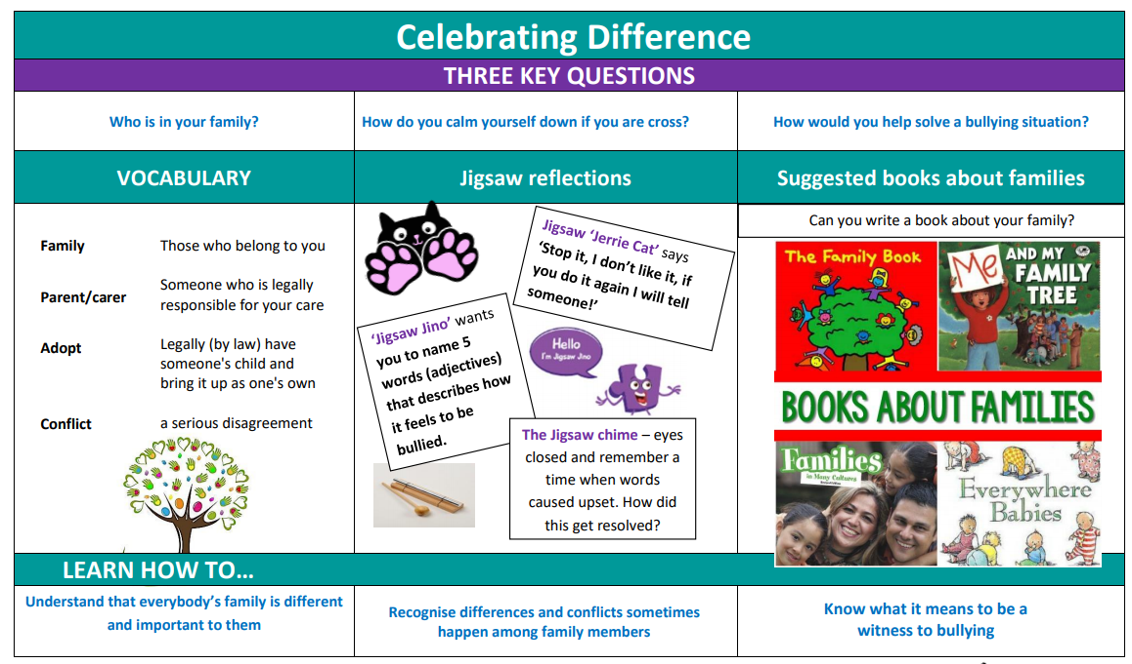

Gospel Value:
Grateful and Generous- To be grateful to God for being a special human being that is unique.

PSHE Knowledge Organisers
LKS2 Year A– Spring 1

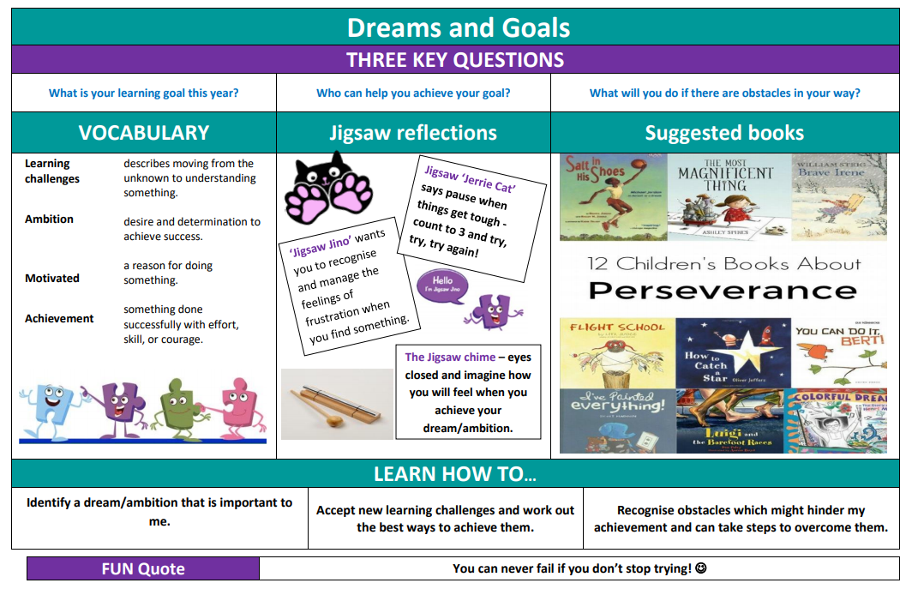

Gospel Value:
Faith-filled and Hopeful- To be filled with faith and hope for the new year.

PSHE Knowledge Organisers
LKS2 Year A– Spring 2

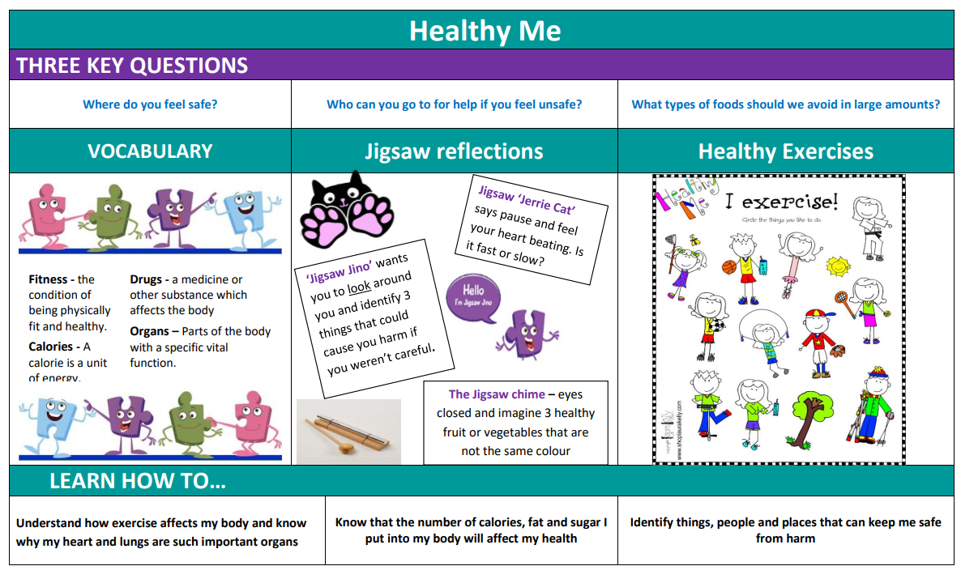

Gospel Value:
Intentional and Prophetic- To intentionally live a healthy life and look after our bodies.

PSHE Knowledge Organisers
LKS2 Year A– Summer 1

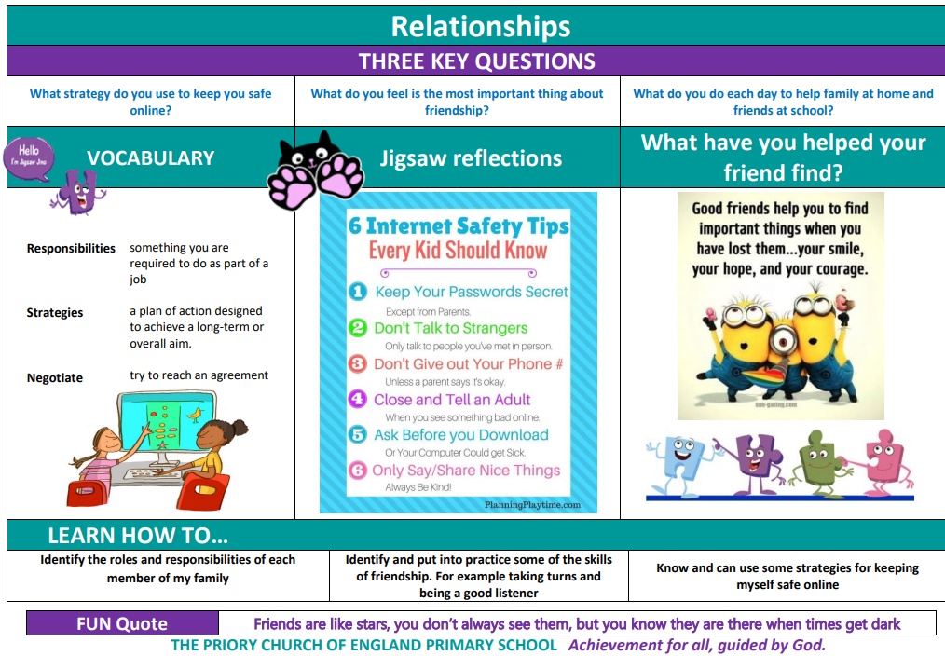

Gospel Value:
Learned and Wise- To be wise and identify when something online is not correct and know what action you should take.

PSHE Knowledge Organisers
LKS2 Year A–Summer 2

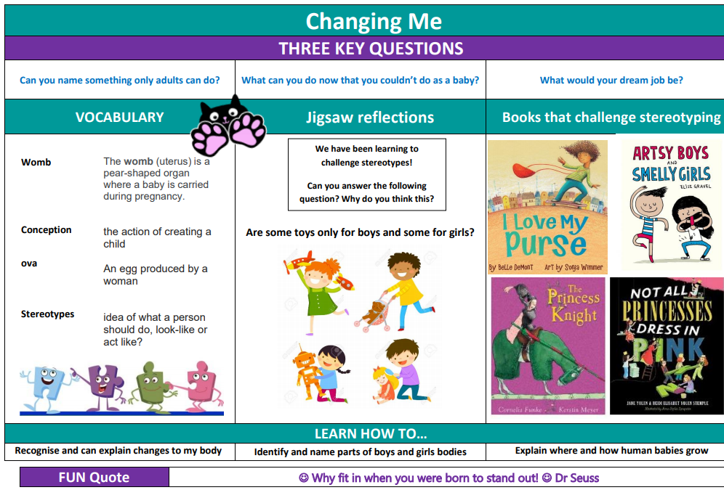

Gospel Value:
Curious and Active- To be curious about the way our bodies change and to actively look after ourselves.

PSHE Knowledge Organisers
LKS2 Year B– Autumn 1

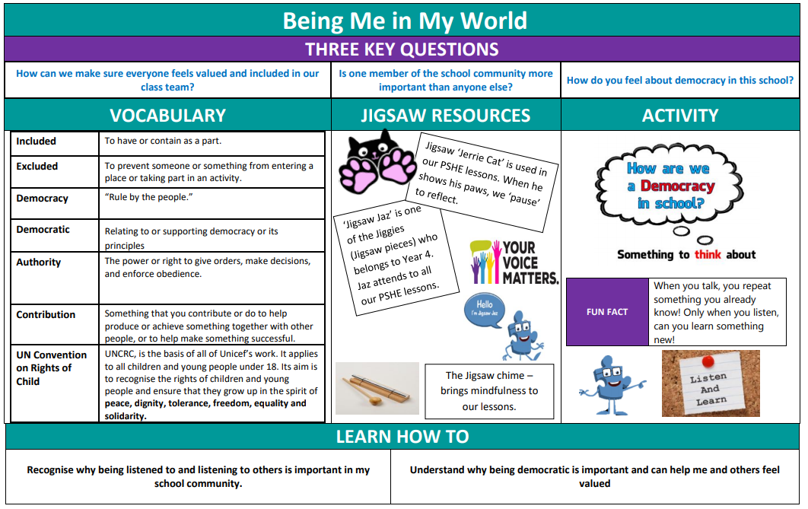

Gospel Value:
Attentive and Discerning- To be considerate in the choices we make and how they could affect others.

PSHE Knowledge Organisers
LKS2 Year B– Autumn 2

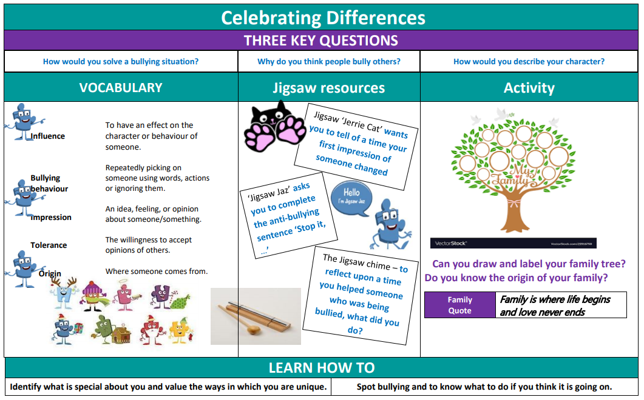

Gospel Value:
Grateful and Generous- To be grateful to God for being a special human being that is unique.

PSHE Knowledge Organisers
LKS2 Year B– Spring 1

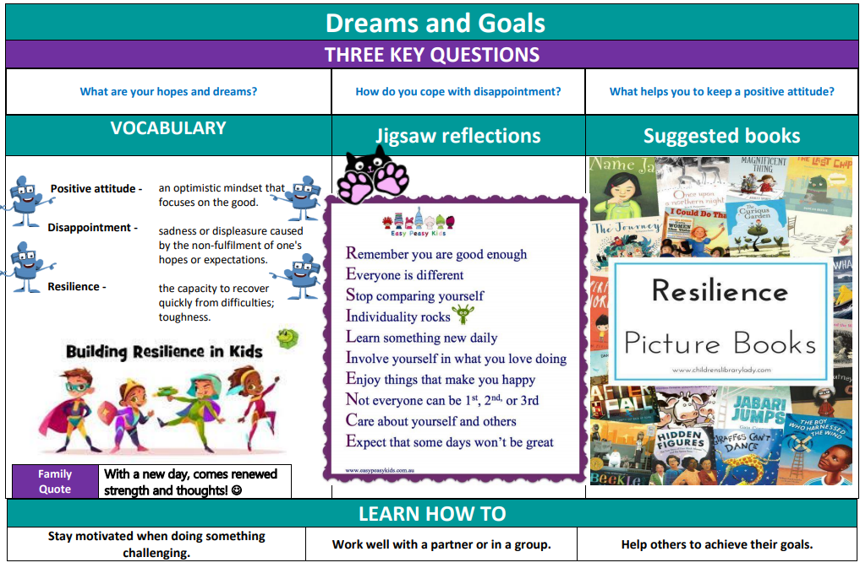

Gospel Value:
Faith-filled and Hopeful- To be filled with faith and hope for the new year.

PSHE Knowledge Organisers
LKS2 Year B– Spring 2

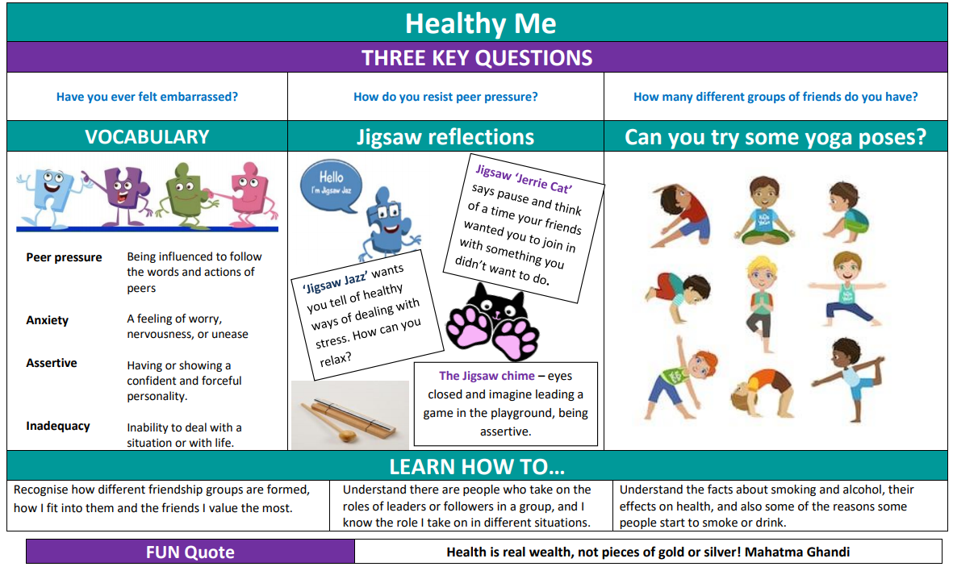

Gospel Value:
Intentional and Prophetic- To intentionally live a healthy life and look after our bodies.

PSHE Knowledge Organisers
LKS2 Year B– Summer1

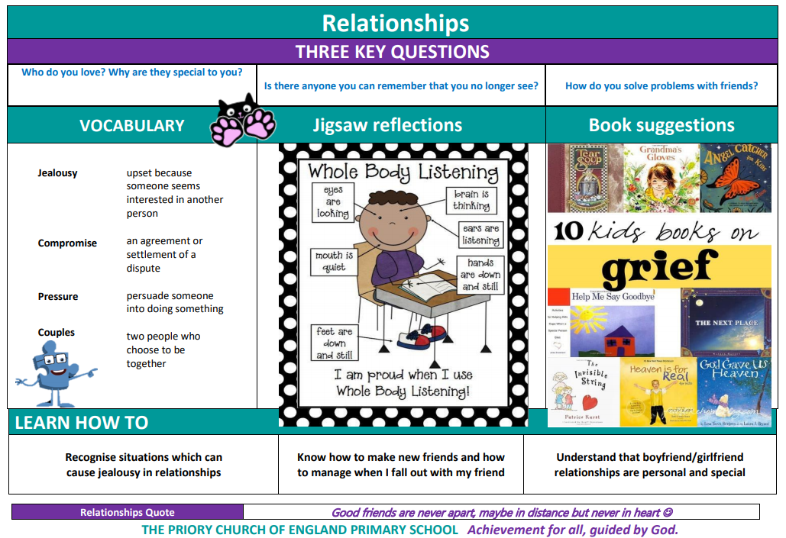

Gospel Value:
Compassionate and Loving- To be compassionate towards others and their needs; love and support friends in difficult times.

PSHE Knowledge Organisers
LKS2 Year B– Summer 2

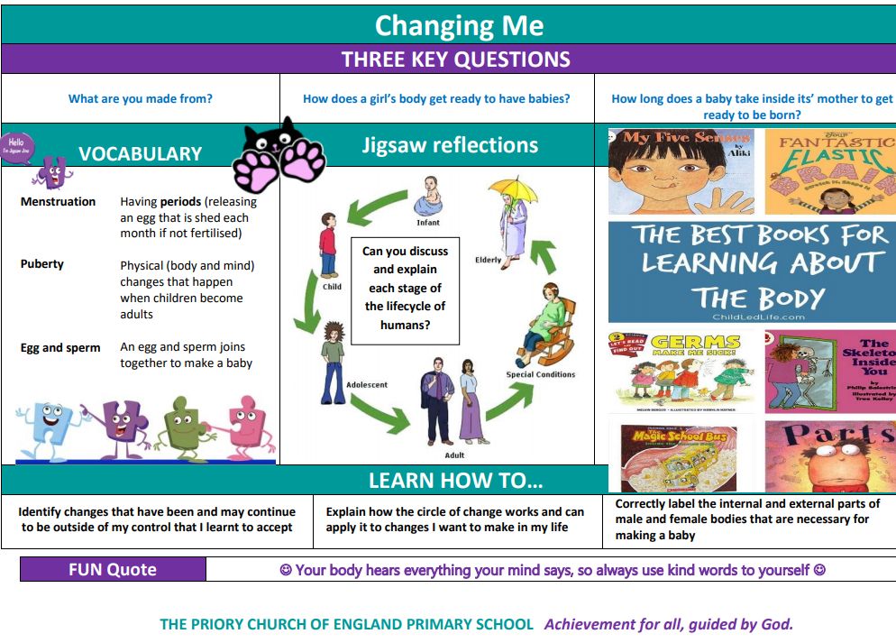

Gospel Value:
Curious and Active- To be curious about the way our bodies change and to actively look after ourselves.

PSHE Knowledge Organisers
UKS2 Year A– Autumn 1

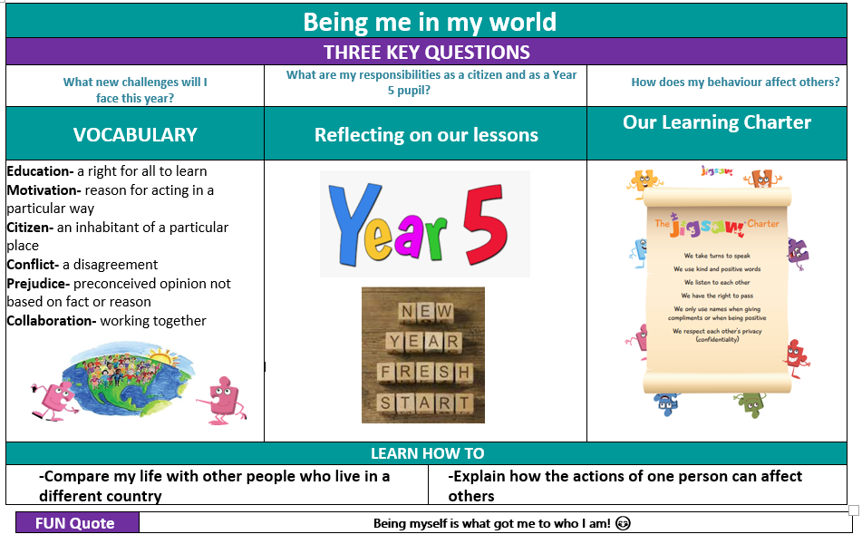

Gospel Value:
Attentive and Discerning- To be discerning in the choices we make and how they could affect others.

PSHE Knowledge Organisers
UKS2 Year A– Autumn 2

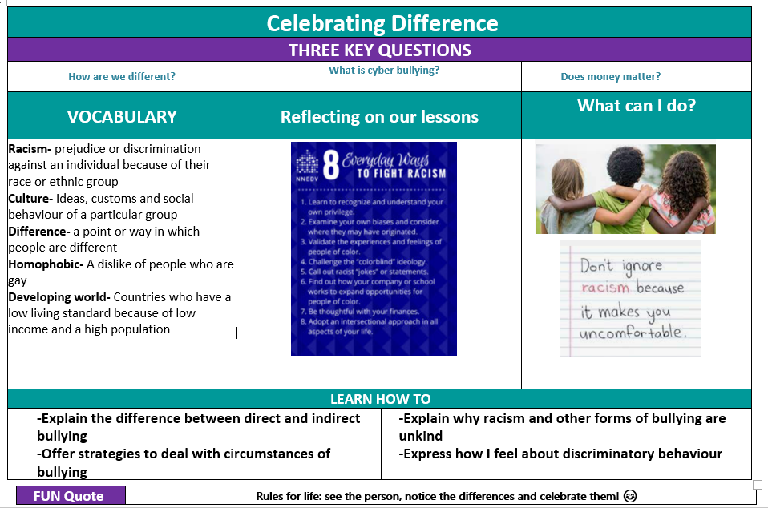

Gospel Value:
Grateful and Generous- To be grateful to God for the variety and people and generous in the way we include everyone.

PSHE Knowledge Organisers
UKS2 Year A– Spring 1

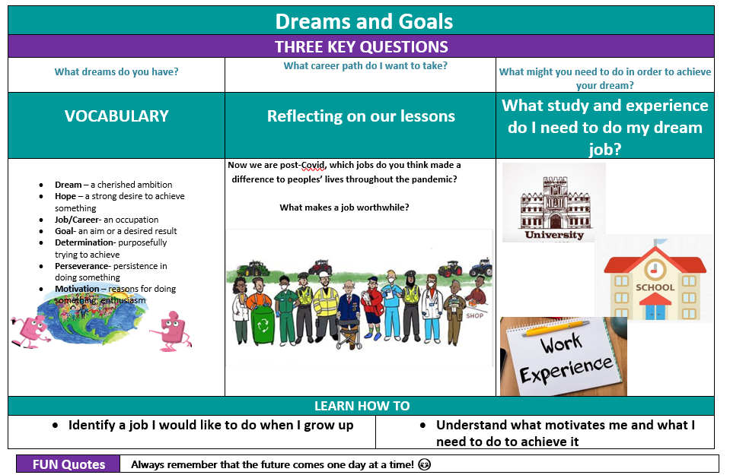

Gospel Value:
Faith-filled and Hopeful- To be filled with faith and hope for the new year.

PSHE Knowledge Organisers
UKS2 Year A– Spring 2

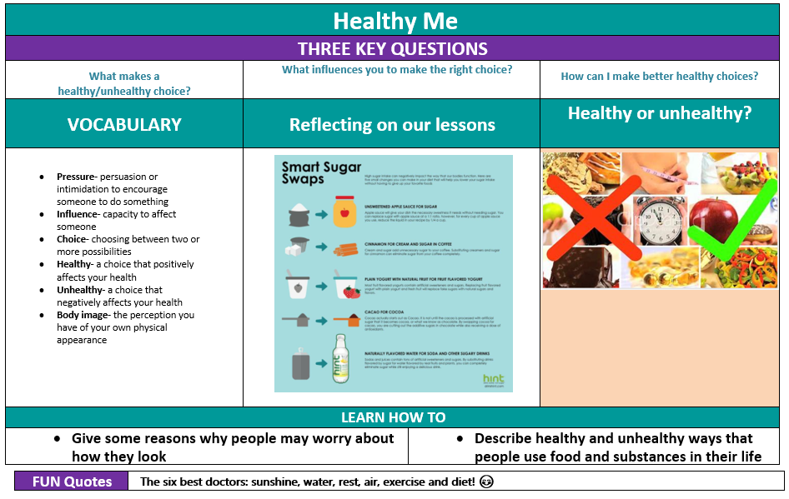

Gospel Value:
Intentional and Prophetic- To intentionally live a healthy life and look after our bodies.

PSHE Knowledge Organisers
UKS2 Year A– Summer 1

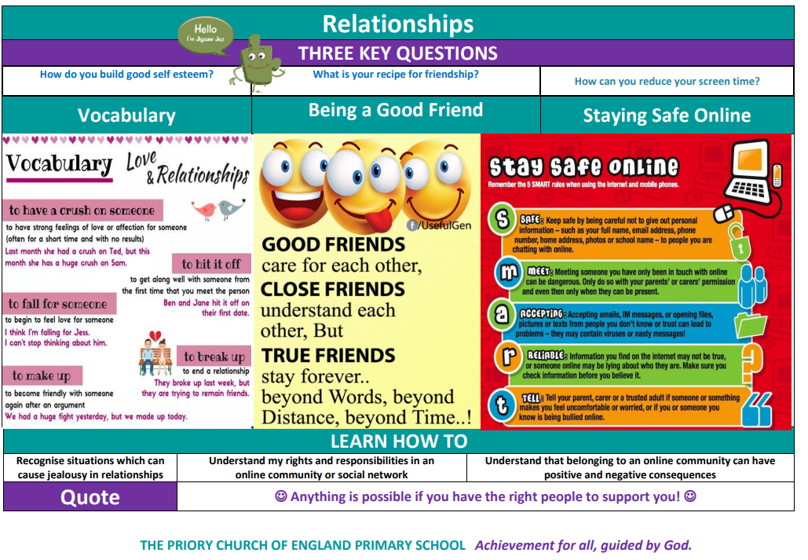

Gospel Value:
Learned and Wise- To be wise and identify when something online is not correct and know what action you should take.

PSHE Knowledge Organisers
UKS2 Year A– Summer 2

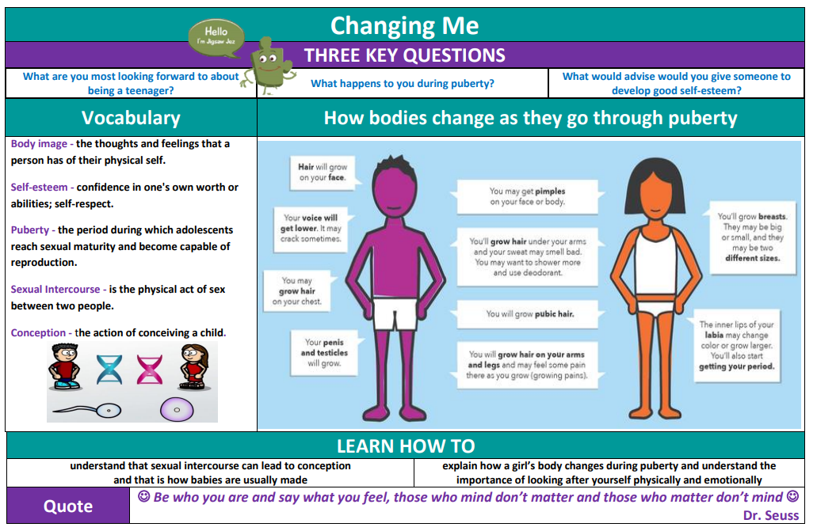

Gospel Value:
Curious and Active- To be curious about the way our bodies change and to actively look after ourselves.

PSHE Knowledge Organisers
UKS2 Year B– Autumn 1

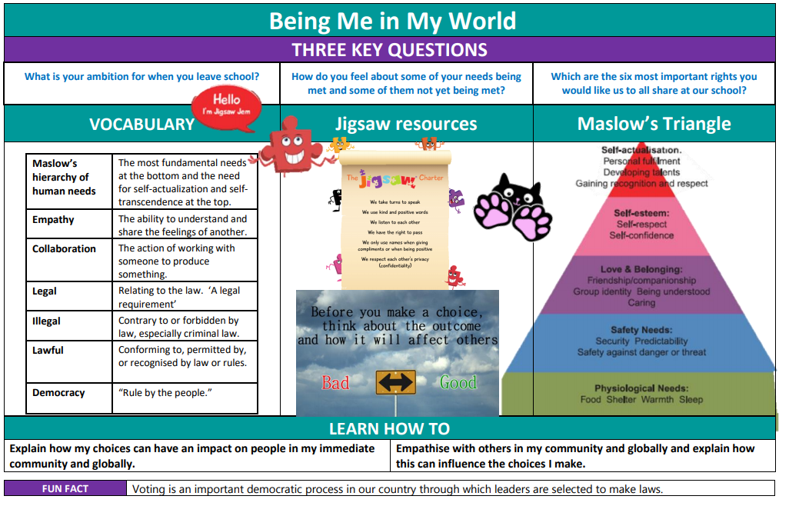

Gospel Value:
Attentive and Discerning- To be discerning in the choices we make and how they could affect others.

PSHE Knowledge Organisers
UKS2 Year B– Autumn 2

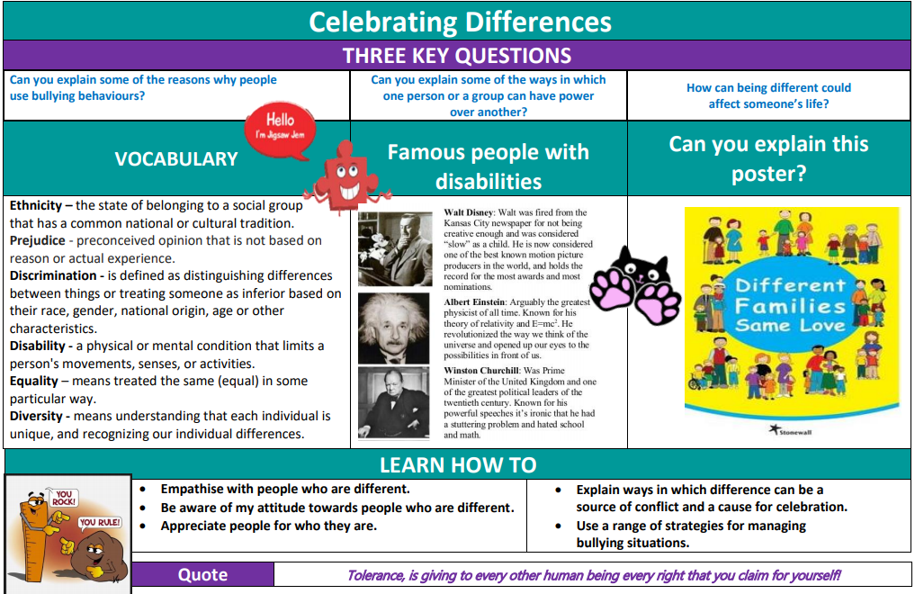

Gospel Value:
Grateful and Generous- To be grateful to God for being a special human being that is unique.

PSHE Knowledge Organisers
UKS2 Year B- Spring 1

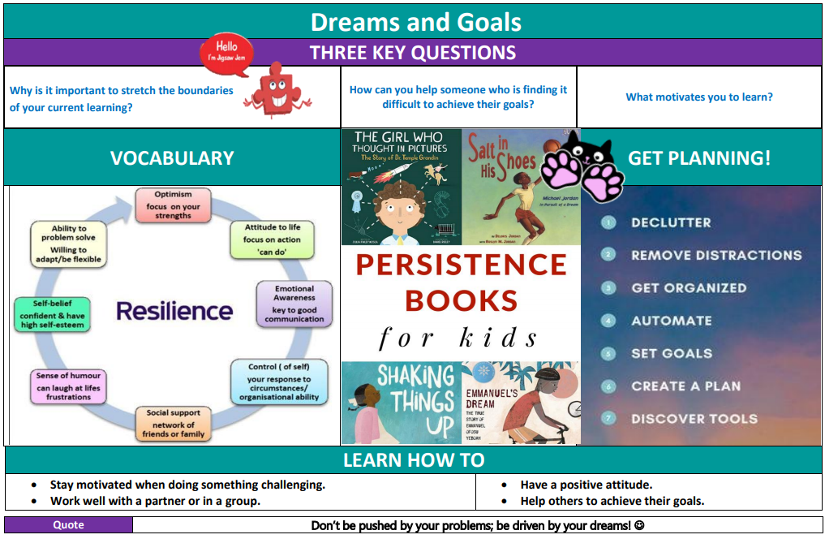

Gospel Value:
Faith-filled and Hopeful- To be filled with faith and hope for the new year.

PSHE Knowledge Organisers
UKS2 Year B- Spring 2

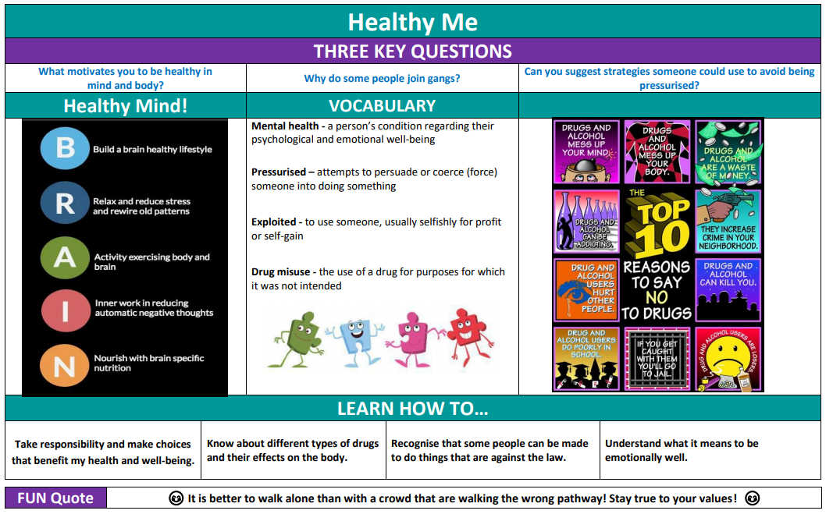

Gospel Value:
Intentional and Prophetic- To intentionally live a healthy life and look after our bodies.

PSHE Knowledge Organisers
UKS2 Year B- Summer 1

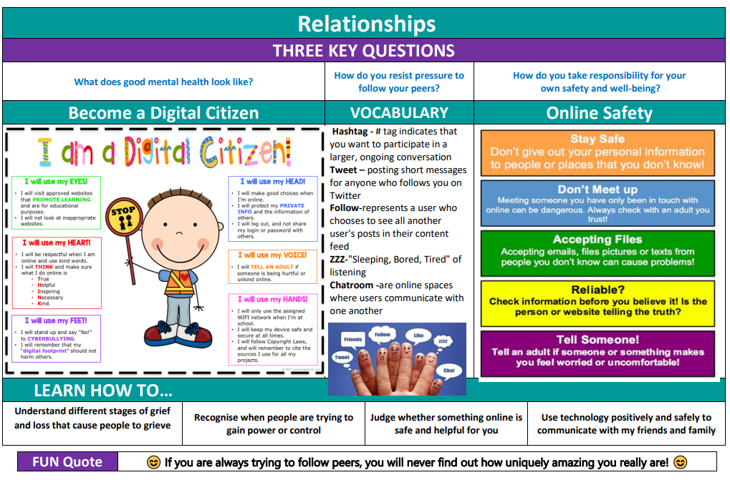

Gospel Value:
Compassionate and Loving- To show compassion and love towards our family and friends.

PSHE Knowledge Organisers
UKS2 Year B- Summer 2

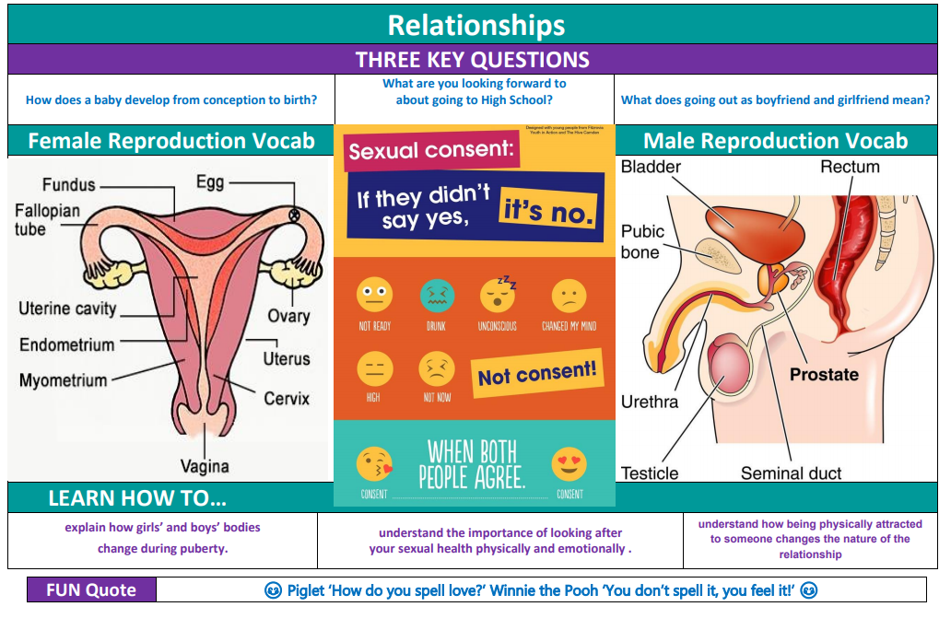
Changing me

Gospel Value:
Curious and Active- To be curious about the way our bodies change and to actively look after ourselves.

