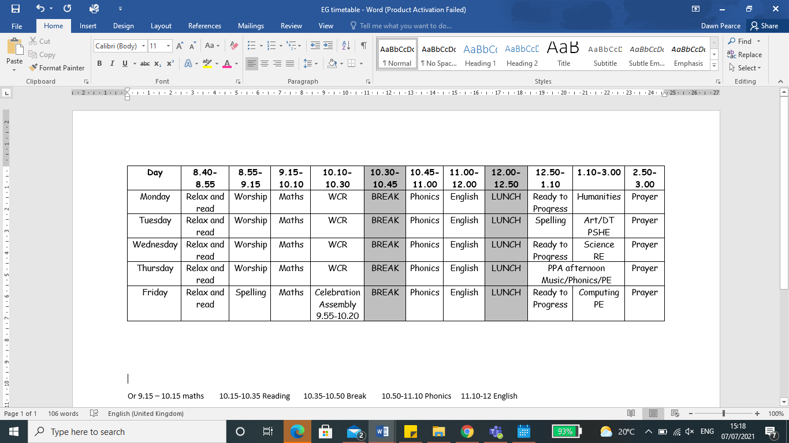

**I hope you have a super summer holiday!**

**I am really looking forward to being**

**your class teacher in September.**

Children will need to wear their PE kits on the days when PE is to be taught – currently this will be THURSDAY and FRIDAY (but this may be subject to change).

**HOMEWORK** - There will be a set menu of homework tasks. Weekly, children will need to practise spellings - linked to the end of year common exception word list and spelling patterns being taught in school - and daily reading - just a couple of pages followed by a discussion about what has been read. We will also provide your child with a log on for EdShed which they can use to log on and practise their spelling and Maths skills at home.

Then please encourage your child to complete as many of the activities from the year group menu as they like at home, but NO LESS than 3 over the half term. This can be recorded (if appropriate) in our homework books or submitted via Teams. A new menu will be available at the start of each holiday. Homework can be done as and when you get time and offers some choice to your child too.

**THE SCHOOL DAY**

School begins at 8:40 on Thursday 2nd September. Our classroom can be found by entering through one of the doors on the main playground – please look out for my photograph so you know which door to come through. Please come to school on this day with your uniform, school shoes, bag, coat and a water bottle.

**This is our proposed timetable next year:**

My name is Miss Thurley and I am one of the teachers in Year 2.

I will also be the Music and French Lead in September 2021. I have been teaching at St.Giles’ and St, George’s for over sixteen years and I am looking forward to returning from maternity leave and teaching Year 2.

Outside of school, I enjoy spending time with my family and friends, days out, reading and swimming.

**Welcome to YEAR 2 AT**