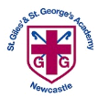
St Giles’ and St George’s Primary Academy
Homework Menu
Class: Nursery Theme: Nursery Rhymes Term: Autumn 1
Set Menu: Daily shared reading
We are asking children to share their library book each week and for parents to record this in their child’s reading record. You can introduce early reading skills such as: turning the pages carefully, holding the book correctly, talking about the pictures and anticipating what might happen next.
Added Extras:
Please encourage your child to complete as many activities from the menu as they can, but NO LESS than 3 over the half term. We will ask for homework to be handed in during the last week of each half term, in order for us to share and celebrate this learning.

Draw/Write it | Practise it | Research it
Can you draw Incy Wincy?  (Or a character from your favourite nursery rhyme)  Can you use anticlockwise circles and horizontal lines?  You could create your picture using any mark making materials you like (paint, crayon, pen). 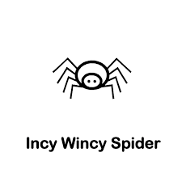 | Practise going to the toilet and washing your hands independently.  If you can do this already practise recognising your name from a group of up to three names. | Can you find out what your family members favourite Nursery Rhyme is? Why do they like that one best? Can you sing that rhyme and do you know the actions?
Make it | Design it | Sing it
Pat-a-cake, Pat-a-cake! Can you bake with your grown up? You can make a cake, bread, biscuit or something else of your own choosing. Can you follow the recipe, measure out the ingredients and stir your mixture in anticlockwise circles?  (You can send in a picture of your bake.)  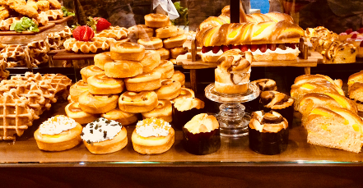 | Can you design and make a ‘twinkle twinkle little star’? You can add glitter, sparkles, paint and more!  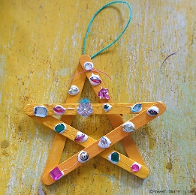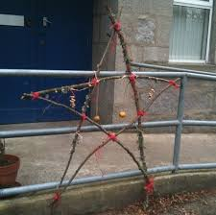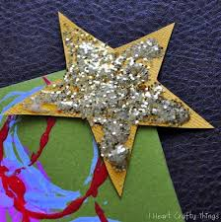 | Perform and sing “The wheels on the bus” (or another of your favourite nursery rhymes.)  Can you remember the words and actions?  