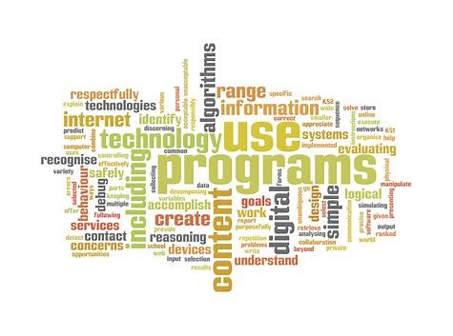

Computing Learning Journey
Computing Overview
 |  | Following instructions | Music Makers |  | Playing games | Controlling devices | Taking Pictures |  | Being Creative |  | Technology  Outside | Changing Roles |  | Recording and listening | Using Computers |  | Learning Outside | Keeping healthy
Nursery |  | We have confidence | We can record soundtracks |  | We are game players | We are successful | We are designers |  | We can count |  | We can drive | We are talkers |  | We can listen | We can e-mail |  | We can observe | We can exercise
 |  | E-Safety Smartie The Penguin Story 1 |  |  |  |  | E-Safety Smartie the Penguin Story 2 |  |  |  |  |  |  | E-Safety Smarite the Penguin Story 2
Reception |  | We are DJ’s | We can understand messages |  | We are Creative | We have feelings | We are shape makers |  | We are film producers |  | We can take turns | We are digital readers |  | We can understand instructions | We can blog |  | We are community members | We are healthy
 |  | E-Safety – Smartie the Penguin |  |  |  |  | E-Safety – Buddy the Dog |  |  |  |  |  |  | E-Safety – Traditional Tales
 |  | Coding  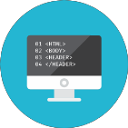 |  |  | Computational Thinking |  | Creativity |  |  |  | Computer Networks |  |  | Communication  Collaboration |  |  | Productivity
Year 1 |  | We are Treasure Hunters  Bee- Bots  E-Safety – Keep it Private |  | We are TV chefs  IMovie  E-Safety – My creative work |  |  |  | We are Painters  Paint  E-Safety – Going Places Safely |  | We are Collectors  Web browser  E-Safety – ABC Searching |  |  | We are Story Tellers  2 Create a story  E-Safety – Sending an E-mail |  |  | We are celebrating  Word
Year 2 |  | We are Astronauts  Scratch Jnr  E-Safety – Staying Safe Online |  | We are Games Testers  Scratch Jnr  E-Safety – Sites I like |  |  |  | We are Photographers  Picasa  E-Safety – Follow the Digital Trail |  | We are researchers  PowerPoint  E-Safety – Using Key Words |  |  | We are Detectives  E-mail  E-Safety – Screen out the Mean |  |  | We are Zoologists  Excel
Year 3 |  | We are Programmers  Scratch  E-Safety – Powerful Passwords |  | We are Bug Fixers  Scratch  E-Safety – Online Community |  |  |  | We are Presenters  IMovie  E-Safety – Things for Sale |  | We are Vloggers  Google PowerPoint  E-Safety – Show respect online |  |  | We are communicators  E-mail  E-Safety – Writing Good Emails |  |  | We are opinion Pollsters  Google forms  Excel  Word
Year 4 |  | We are Software Developers  Scratch  Pyonkee  E-Safety – Rings of Responsibility |  | We are Toy Designers  Scratch  Pyonkee  E-Safety – Private and Personal |  |  |  | We are musicians  Isle of Tune  Garage Band  E-Safety – The Power of Words |  | We are HTML editors  FireFox  Chrome  E-Safety – The key to key words |  |  | We are Co-authors  MediaWiki  Google sites  E-Safety – Whose is it anyway |  |  | We are meterologists  Excel  PowerPoint
Year 5 |  | We are game Developers  Scratch  E-Safety – Strong Passwords |  | We are cryptographers  Scratch  E-Safety – Digital Citizenship |  |  |  | We are artists  Inkscape  E-Safety – You’ve Won a Prize |  | We are web developers  WordPress  E-Safety – How to cite a site |  |  | We are bloggers  Wordpress  E-Safety – Picture Perfect |  |  | We are Architects  Trimble  SketchUp
Year 6 |  | We are adventure  Gamers  Python  Trink.io  E-Safety – Talking Safely online |  | We are computational thinkers  Scratch  E-Safety – Super Digital Citizen |  |  |  | We are advertisers  MovieMaker  IMovie  E-Safety – Privacy Rules |  | We are network technicians  Scratch  E-Safety – Cyber Bullying |  |  | We are travel writers  iMovie  E-Safety – Selling Stereotypes |  |  | We are Publishers  Publisher  Book Creator
Computing Skills Progression

Nursery
Core Skills | To name and use a keyboard, mouse and track pad with developing control.  To recognise that a keyboard has letters that can be used to write on the screen.
Programming | I can make a beebot move forwards and backwards
Multimedia | Can I explore sounds?  Can I use a digital device to take a photograph?  To draw a simple picture using touch technology.
Technology in our lives | I can name and use a keyboard and mouse with developing control  I can recognise some technology that is used in places such as homes and schools  I can use technology appropriately through role play
Data Handling | I can collect and discuss data as a class
E-Safety | I can speak to an adult about what I have seen
Gospel Values | Faith Filled - I can appreciate the wonders of God’s world and use technology to record this.  Curious and Active - I can collect data about the creatures in God’s world.
Reception
Core Skills | To write name with a capital letter, using a keyboard, on different devices.  To know how to turn on an iPad and laptop.  To know what the save and print icons look like.  To print work using the print icon.
Programming | I can use a range of control toys and devices
Multimedia | To use a digital camera, iPad or digital video camera to take pictures.  To understand the purpose of and experiment with hardware such as cameras, computers, ipads, voice recorders etc  To draw a simple picture using the computer mouse.  To use a simple paint programme with increasing mouse control.
Technology in our lives | I can recognise a range of technology that is used in places such as homes and schools  I can select and use technology for a particular purpose  I can name and use a keyboard and mouse with developing control  I can access and use simple activities using touch technology with increasing control
Data Handling | Can I insert data into a pictogram, as a class?  Can I answer simple questions relating to the pictogram as a class?
E-Safety | Talk about good & bad choices in real life e.g. taking turns, saying kind things, helping others, telling an adult if something  upsets you.  Play appropriate games on the Internet.  Talk about good and bad choices when using websites – being kind, telling a grown up if something upsets us & keeping ourselves safe by keeping information private
Gospel Values | Grateful – I can appreciate the technology that we have.  Active – I can collect data for our class pictogram.  Wise – I can pick appropriate games to play and make wise choices if something upsets me.
Year 1
Core Skills | To use the keyboard to type a simple username and password into a given program.  To load programs with support by double clicking.  To save their work to a folder and retrieve it when needed (with support).  To close a program using the red cross.  Look at different parts of school ‘desktop’. How is the interface different to an iPad.  To begin to use the appropriate computing vocabulary.  To log off and shut down a computer.
Programming | I can give instructions to my friend and follow their instructions to move around.  I can describe what happens when I press buttons on a robot.  I can press the buttons in the correct order to make my robot do what I want.  I can describe what actions I will need to do to make something happen and begin to use the word ‘algorithm’.  I can begin to predict what will happen for a short sequence of instructions. I can begin to use software/apps to create movement and patterns on a screen.  I can use the word ‘debug’ when I correct mistakes when I Program.
Multimedia | To draw a detailed picture using the computer mouse.  To create an image relating to a topic covered in class and add a title.  To start using various tools including brushes and pens in a paint package.  To enter text with a keyboard, using the space bar, backspace and return key.  To enter text to an open word document using upper and lower case letters.  To use the Shift key to create a capital letter.  To understand how to use the delete/backspace key if they have mistyped or repeated a letter.  To draw a detailed picture using the computer mouse.  To create an image relating to a topic covered in class and add a title.  To start using various tools including brushes and pens in a paint package.
Technology in our lives | I can recognise the way we use technology in our classroom.  I can recognise ways that technology is used in my home and community.  I can use links to websites to find information.  I can begin to identify some of the benefits of using technology  To be aware that digital pictures and video can be saved on a computer.  To capture and download images from a camera with support.  To record a short video.
Data Handling | I can talk about the different ways in which information can be shown.  I can use technology to collect information, including photos, video and sound.  I can sort different kinds of information and present it to others.  I can add information to a pictograph and talk to you about what I have found out.
E-Safety | I can keep my password private.  I can tell you what personal information is.  I can tell an adult when I see something unexpected or worrying online.  I can talk about why it’s important to be kind and polite.  I can recognise an age appropriate website.  I can agree and follow sensible e‐safety rules.
Gospel Values | Wise - I can make wise choices about how to keep information private.  Grateful – I can appreciate how technology impacts on my life in and out of school.  Curious and active – I can be active in using technology to record things and active in sharing this with others.  Faith Filled - I can appreciate the wonders of God’s world and use technology to record this.
Year 2
Core Skills | To word process short texts using word lists.  To use both hands on the keyboard.  To cut, copy and paste on to a document.  To begin to understand how to edit and copy information using a variety of media.  To save own work to a folder and retrieve it when needed.  To explain their work and how they have used ICT.  To use appropriate ICT vocabulary.  To understand right clicking and that brings up options.
Programming | I can give instructions to my friend (using forward, backward and turn) and physically follow their instructions.  I can tell you the order I need to do things to make something happen and talk about this as an algorithm.  I can program a robot or software to do a particular task.  I can look at my friend’s program and tell you what will happen.  I can use programming software to make objects move.  I can watch a program execute and spot where it goes wrong so that I can debug it.
Multimedia | I can use technology to organise and present my ideas in different ways.  I can tell you about an online tool that will help me to share my ideas with other people.  To use a digital camera or digital video camera to take appropriate pictures or video for a specific purpose. (E.g. as part of their topic)  To film short scenes.  To change the colour or pattern of the paintbrush, paint bucket or spray can in a paint package.  To use the line tool in a paint package.  To independently use various tools including brushes and pens in a paint package.
Technology in our lives | I can tell you why I use technology in the classroom.  I can tell you why I use technology in my home and community.  I am starting to understand that other people have created the information I use.  I can identify benefits of using technology including finding information, creating and communicating.  I can talk about the differences between the internet and things in the physical world.
Data Handling | I can talk about the different ways I use technology to collect information, including a camera, microscope or sound recorder.  I can make and save a chart or graph using the data I collect.  I can talk about the data that is shown in my chart or graph.  I am starting to understand a branching database.  I can tell you what kind of information I could use to help me investigate a question.
E-Safety | I can explain why I need to keep my password and personal information private.  I can describe the things that happen online that I must tell an adult about.  I can talk about why I should go online for a short amount of time.  I can talk about why it is important to be kind and polite online and in real life.  I know that not everyone is who they say they are on the internet.
Gospel Values | Wise – I can be wise in which personal information should not be shared.  Hopeful – I can be hopeful about the developments that technology will have in the future and try to develop technology in lessons.  Compassionate and Loving – I can be loving and compassionate with the things I say to others online.
Year 3
Core Skills | To understand how to edit and copy information using a variety of media.  To load programs independently.  To understand how to edit and copy information using a variety of media into a word document.  To understand what word can be used for.  To access and open a word processing document.  To develop speed when typing and use a simple document with increasing control.  To format their text to refine and improve. e.g. underline, italics, bold.  To change the font style, size and font colour.  To use the cursor (arrow) keys for simple on screen editing.  To change the layout of the page (margins, orientation).
Programming | I can break an open‐ended problem up into smaller parts.  I can put programming commands into a sequence to achieve a specific outcome.  I keep testing my program and can recognise when I need to debug it.  I can use repeat commands.  I can describe the algorithm I will need for a simple task.  I can detect a problem in an algorithm which could result in

Multimedia | I can create different effects with different technology tools.  I can combine a mixture of text, graphics and sound to share my ideas and learning.  I can use appropriate keyboard commands to amend text on my device, including making use of a spellchecker.  I can evaluate my work and improve its effectiveness.  I can use an appropriate tool to share my work online.  To use a digital camera or digital video camera to take appropriate pictures or video for a specific purpose.  To discuss which videos to keep and why.
Technology in our lives | I can save and retrieve work on the internet, the school network or my own device.  I can talk about the parts of a computer.  I can tell you ways to communicate with others online.  I can describe the World Wide Web as the part of the internet that contains websites.  I can use search tools to find and use an appropriate website.  I can think about whether I can use images that I find online in my own work.
Data Handling | I can talk about the different ways data can be organised.  I can search a ready‐made database to answer questions.  I can collect data to help me answer a question.  I can add to a database.  I can make a branching database.  I can use a data logger to monitor changes and can talk about the information collected.
E-Safety | I can talk about what makes a secure password and why they are important.  I can protect my personal information when I do different things online.  I can use the safety features of websites as well as reporting concerns to an adult.  I can recognise website and games appropriate for my age.  I can make good choices about how long I spend online.  I ask an adult before downloading files and games from the internet.  I can post positive comments online.
Gospel Values | Curious and Active – I can be curious about the technology and active in debugging and developing technology.  Curious – I can be curious about the way technology works and how this might change over time.
Year 4
Core Skills | To access and open a power point document.  To develop speed when typing and use a simple document with increasing control.  To use headings for slides.  To be able to include bullet points on a slide.  To include a slide transition between two slides on a show.  To print a slide show more than one slide to a page.
Programming | I can use logical thinking to solve an open‐ended problem by breaking it up into smaller parts.  I can use an efficient procedure to simplify a program.  I can use a sensor to detect a change which can select an action within my program.  I know that I need to keep testing my program while I am putting it together.  I can use a variety of tools to create a program. I can recognise an error in a program and debug it.  I can recognise that an algorithm will help me sequence more complex programs.  I recognise that using algorithms will also help solve problems in other learning such as maths, science and design technology.
Multimedia | I can use photos, video and sound to create an atmosphere when presenting to different audiences.  I am confident to explore new media to extend what I can achieve.  I can change the appearance of text to increase its effectiveness.  I can create, modify and present documents for a particular purpose.  I can use a keyboard confidently and make use of a spellchecker to write and review my work.  I can use an appropriate tool to share my work and collaborate online. I can give constructive feedback to my friends to help them improve their work and refine my own work.  To film short scenes and edit with others (inserting these into a power point).  To discuss which videos to keep and why.  Include sounds in their slideshow that will play when clicked.  To create a power point show including images children have edited themselves.  To add images and clip art images.
Technology in our lives | I can tell you whether a resource  I am using is on the internet, the school network or my own device.  I can identify key words to use when searching safely on the World Wide Web.  I think about the reliability of information I read on the World Wide Web.  I can tell you how to check who owns photos, text and clipart.  I can create a hyperlink to are source on the World Wide Web.
Data Handling | I can organise data in different ways.  I can collect data and identify where it could be inaccurate.  I can plan, create and search a database to answer questions.  I can choose the best way to present data to my friends.  I can use a data logger to record and share my readings with my friends.
E-Safety | I can choose a secure password when I am using a website.  I can talk about the ways I can protect myself and my friends from harm online.  I can use the safety features of websites as well as reporting concerns to an adult.  I know that anything I post online can be seen by others. I choose websites and games that are appropriate for my age.  I can help my friends make good choices about the time they spend online.  I can talk about why I need to ask a trusted adult before downloading files and games from the internet.  I comment positively and respectfully online.
Gospel Values | Compassionate and Loving – I can be compassionate and loving when communicating with others online.  Curious and Active – I can be curious about algorithms and active in solving problems I might find.
Year 5
Core Skills | To use publisher for a particular purpose.  To access and open a publisher document.  To insert text boxes, word art, images and borders into publisher.  To insert a second page thinking carefully about where the text would end up if it were a leaflet.  To edit line spacing between paragraphs.  To include captions by an image.
Programming | I can decompose a problem into smaller parts to design an algorithm for a specific outcome and use this to write a program.  I can refine a procedure using repeat commands to improve a program.  I can use a variable to increase programming possibilities.  I can change an input to a program to achieve a different output.  I can use ‘if’ and ‘then’ commands to select an action.  I can talk about how a computer model can provide information about a physical system.  I can use logical reasoning to detect and debug mistakes in a program.  I use logical thinking, imagination and creativity to extend a program.
Multimedia | I can use text, photo, sound and video editing tools to refine my work.  I can use the skills I have already developed to create content using unfamiliar technology.  I can select, use and combine the appropriate technology tools to create effects that will have an impact on others.  I can select an appropriate online or offline tool to create and share ideas.  I can review and improve my work and support others to improve their work.
Technology in our lives | I can describe different parts of the internet.  I can use different online communication tools for different purposes.  I can use a search engine to find appropriate information and check its reliability.  I can recognise and evaluate different types of information I find on the World Wide Web.  I can describe the different parts of a webpage.  I can find out who the information on a webpage belongs to.
Data Handling | I can organise data in different ways.  I can collect data and identify where it could be inaccurate.  I can plan, create and search a database to answer questions.  I can choose the best way to present data to my friends.  I can use a data logger to record and share my readings with my friends.
E-Safety | I protect my password and other personal information.  I I can explain why I need to protect myself and my friends and the best ways t do this, including reporting concerns to an adult.  I know that anything I post online can be seen, used and may affect others.  I can talk about the dangers of spending too long online or playing a game.  I can explain the importance of communicating kindly and respectfully.  I can discuss the importance of choosing an age appropriate website or game.  I can explain why I need to protect my computer or device from harm.  I know which resources on the internet I can download and use
Gospel Values | Intentional and Prophetic – I can be intentional with the choice of ideas that I want to share with the world.  Compassionate and Loving – I can be compassionate and loving with the things I decide to share online.  Wise – I can make wise choices about what I play/share online.
Year 6
Core Skills | To use excel for a particular purpose.  To understand how to edit and copy information using a variety of media.  To load programs independently.  To understand how to edit and copy information using a variety of media into excel.  To understand the use and some capabilities of excel.  To access and open an excel spreadsheet.  To input text into the cells and understand the layout.  To insert a basic formula into excel to add and subtract other cells.  To begin to input more difficult formulas and if statements into cells.  To insert a graph using the data they have inputted.
Programming | I can deconstruct a problem into smaller steps, recognising similarities to solutions used before.  I can explain and program each of the steps in my algorithm.  I can evaluate the effectiveness and efficiency of my algorithm while I continually test the programming of that algorithm.  I can recognise when I need to use a variable to achieve a required output.  I can use a variable and operators to stop a program.  I can use different inputs (including sensors) to control a device or onscreen action and predict what will happen.  I can use logical reasoning to detect and correct errors in algorithms and programs.
Multimedia | I can talk about audience, atmosphere and structure when planning a particular outcome.  I can confidently identify the potential of unfamiliar technology to increase my creativity.  I can combine a range of media, recognising the contribution of each to achieve a particular outcome.  I can tell you why I select a particular online tool for a specific purpose.  I can be digitally discerning when evaluating the effectiveness of my work and the work of others.
Technology in our lives | I can tell you the internet services I need to use for different purposes.  I describe how information is transported on the internet.  I can select an appropriate tool to communicate and collaborate online.  I can talk about the way search results are selected and ranked.  I can check the reliability of a website.  I can tell you about copyright and acknowledge the sources of information that I find online.
Data Handling | I can plan the process needed to investigate the world around me.  I can select the most effective tool to collect data for my investigation.  I can check the data I collect for accuracy and plausibility.  I can interpret the data I collect.  I can present the data I collect in an appropriate way.  I use the skills I have developed to interrogate a database.
E-Safety | I protect my password and other personal information.  I can explain the consequences of sharing too much information about myself online.  I support my friends to protect themselves and make good choices online, including reporting concerns to an adult.  I can explain the consequences of spending too much time online or on a game.  I can explain the consequences to myself and others of not communicating kindly and respectfully.  I protect my computer or device from harm on the internet.
Gospel Values | Grateful – I am grateful for technology and how it can support the world  Wise – I am wise in the way I use technology  Active – I am active in developing different things using technology and am able to share these with others.  Faith Filled – I am faith filled about the beauty of God’s world and can share this in a variety of was using technology.

Nursery

We have confidence
In this unit you will:  Use a computer/laptop and microphone.  You will play a game that requires the player to identify another child’s voice.  Work in small groups.  Develop social and emotional and communication skills. | Word Bank:  Laptop  Computer  Voice  Microphone  Recording  Photograph  PowerPoint
We can record a soundtrack
In this unit you will:  Use a computer/laptop and microphone.  You will record a soundtrack that tells their favourite story.  Develop social and emotional and communication skills.  Express themselves through making music. | Word Bank:  Laptop  Keyboard  Computer  Voice  Microphone  Recording  Soundtrack  Media
We are game players
In this unit you will:  Use a computer/laptop and microphone.  You will play a game that requires the player to identify another child’s voice.  Understand the world: technology.  Develop social and emotional and communication skills.  Solve problems | Word Bank:  Laptop  Computer  IPad  Website  Online  Digital
We are successful
In this unit you will:  Show children’s achievements or special events.  Be active in their own learning.  Discuss what you are proud of and why you think this makes you successful.  Use a camera – either digital or on an iPad.  Describe themselves in positive terms. | Word Bank:  Digital Camera  Computer  Laptop  Success  Confident
Nursery

We are designers
In this unit you will:  Control a remote controlled toy.  Be able to move a toy and make it travel around the room.  Use everyday language to talk about position, distance to solve problems. | Word Bank:  Remote  Control  Toy  Move  Position
We can count
In this unit you will:  Control a BeeBot.  Direct and control a beebot to travel along a path.  Use everyday language to talk about position, distance to solve problems. | Word Bank:  Programme  Movement  Direction  Backwards/forwards  BeeBot
We can drive
In this unit you will:  Explore how different items are controlled. Use cameras to document how different objects move. Use the photographs to enhance the outdoor environment. | Word Bank:  Computer/Laptop  Camera  PowerPoint  Word  Wheeled toy  Photograph  IPad  Memory Card  Permission
We are talkers
In this unit you will:  Create video clips of children retelling a story.  Children will develop their speech and language and confidence. | Word Bank:  Computer  Video  Clip  Movie Maker  PowerPoint  Record  Memory

Nursery

We can listen
In this unit you will:  Use technology to communicate verbally.  Explore how we use technology today to communicate verbally.  Explore technologies used to communicate verbally through role play areas. | Word Bank:  Walkie Talkies  Radio  Telephone  Communicate  Verbal
We can email
In this unit you will:  Explore how technology is used to communicate nonverbally.  Write an ‘email’ to reply to the three bears (Teacher supported). | Word Bank:  Email  Internet  Online  Communication  Written
We can observe
In this unit you will:  Take photographs using a digital microscope.  Use a handheld digital microscope to explore objects, materials and living things around them. | Word Bank:  Observe  Photograph  Labels  Computer  Digital
We can exercise
In this unit you will:  Create an interactive display about the importance of exercising.  Move in a variety of ways.  Develop an understanding of the positive effects of exercise. | Word Bank:  IPad  Application  Timer  Talking Tin  Recorder
Reception
We are DJ’s
In this unit you will:  Select a music video and dance to it. Understand that music/video/sounds can be recorded, played and replayed very easily. | Word Bank:  Internet  Word  PowerPoint  IWB  Lights  Karaoke
We can understand messages
In this unit you will:  Children will find ‘treasure’ by listening and understanding recorded messages.  By listening to recorded clues, the children will hunt for treasure. | Word Bank:  Ipad  Talking tins  Record  Listen  Understand
We are creative
In this unit you will:  Create digital artwork of an unusual coloured animal.  Children will take inspiration from Eric Carle’s books and use different art packages to create patterns and colours on their unusual animal. | Word Bank:  IWB  Computer  Screen  Monitor
We have feelings
In this unit you will:  Children will create a digital presentation illustrating how faces and bodies show feelings.  Take photographs of their faces and body language showing a variety of emotions. | Word Bank:  Digital camera  Microphone  Tripod  Photo story  Feelings  Body Language

Reception
We are shape makers
In this unit you will:  Make regular or irregular shapes and patterns.  Identify shapes. Create pictures or patterns from regular and irregular shapes. | Word Bank:  Light Box  Visualiser  IWB  Pattern  Shape  Regular/Irregular
We are film producers
In this unit you will:  Create a short video film of a story. Children will record a variety of video clips and put them together to form a film of a short story. | Word Bank:  Film  Video  Recording  Computer  Laptop  Ipad
We can take turns
In this unit you will:  Create a picture or pattern generated by taking turns.  Use simple on-screen activities, creating pictures or patterns by touching the screen or using the mouse. Take turns and share in order to create one final piece. | Word Bank:  IWB  Touch screen  Monitor  Word  Powerpoint
We are digital readers
In this unit you will:  Explore read and discuss digital stories.  Become familiar with digital texts.  Choose and read texts and develop an understanding of how digital texts are different from other. | Word Bank:  Ipad  Text  Book  Digital

Reception
We can understand instructions
In this unit you will:  Follow instructions to create sticky flapjacks made in a microwave. Children will follow verbal or written instructions to make flapjacks. The children will record what they have done through photographs, writing and voice recording. | Word Bank:  Microwave  Computer  Word PowerPoint Audacity
We can blog
In this unit you will:  Create a blog recording the events of a setting.  Contribute to a blog diary for an audience. Work in groups/individually and in pairs. | Word Bank:  Blog  Recording  Camera  Computer  Microphone  Audience  Viewer
We are community members
In this unit you will:  Create a multimodal digital text celebrating the child and their family as part of the community.  Find out about their community and make a digital poster or book. | Word Bank:  Community  Computer  Mouse  Media  Poster  Video Camera
We are healthy
In this unit you will:  Create a digital healthy eating plate with images from a simple google search.  Use child friendly online sources. Share information they have found through group discussions and sharing of the healthy eating plates. | Word Bank:  Healthy  Internet  Search  Decisions  Choices

Year 1
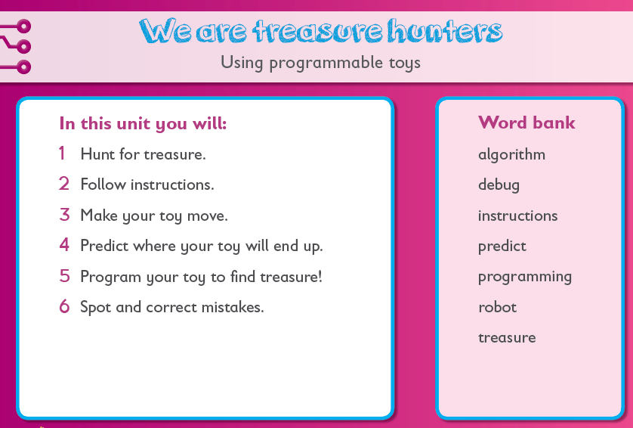
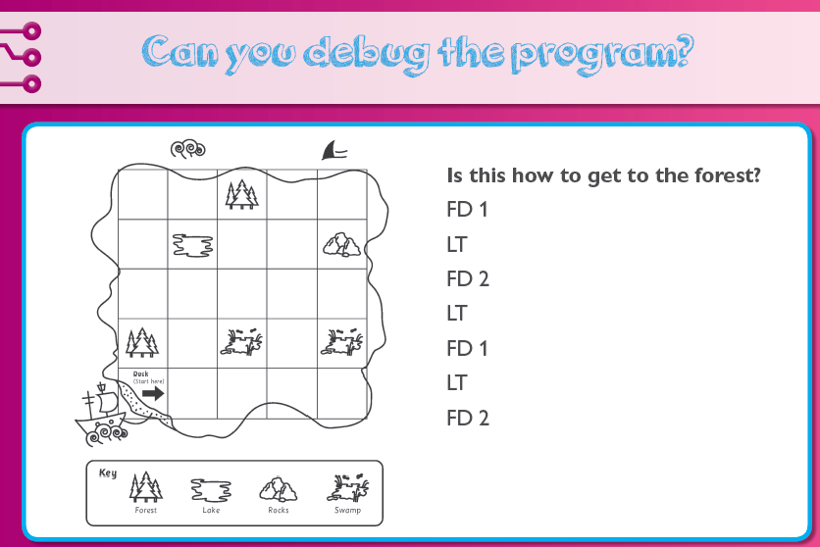

Year 1
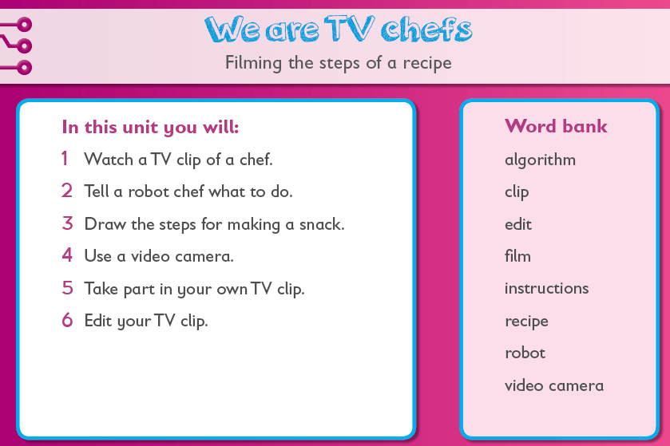
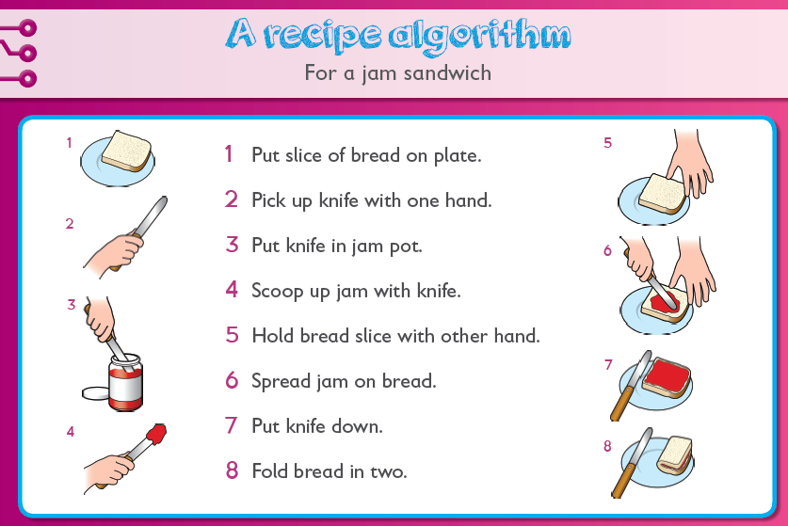

Year 1
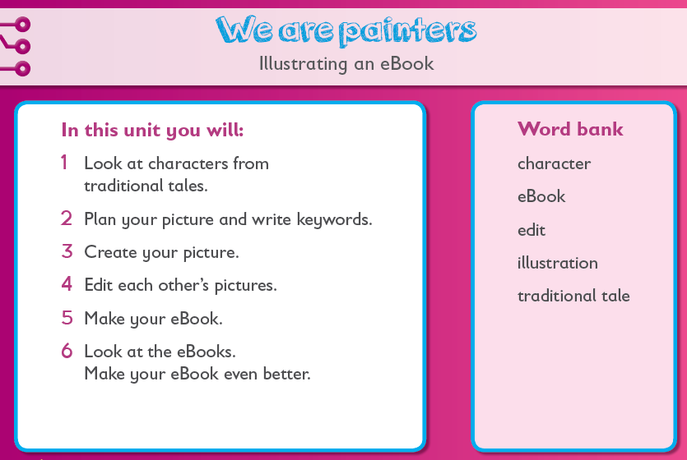
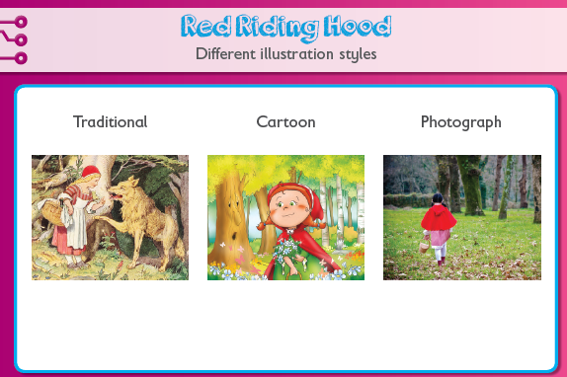
Year 1
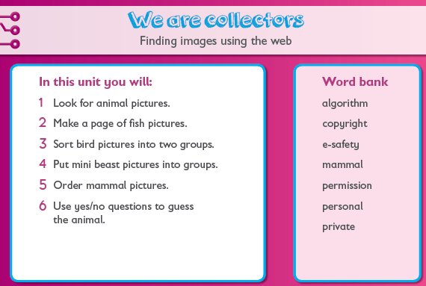
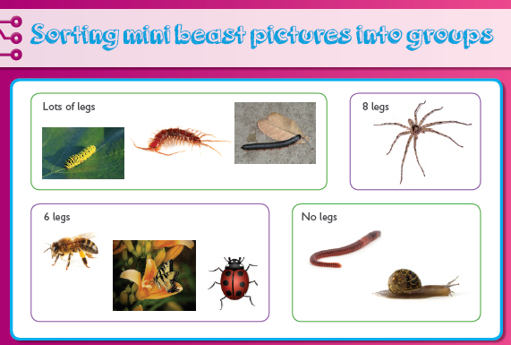
Year 1
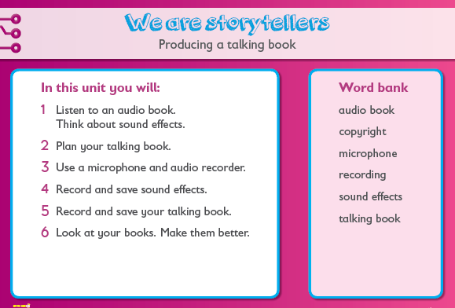
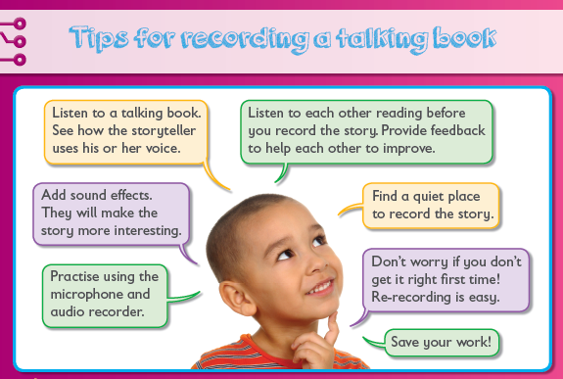

Year 1
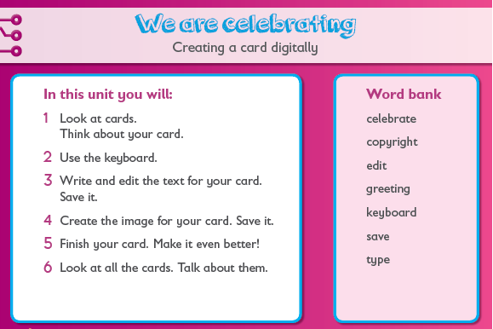
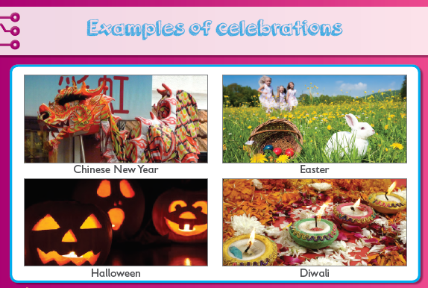
Year 2
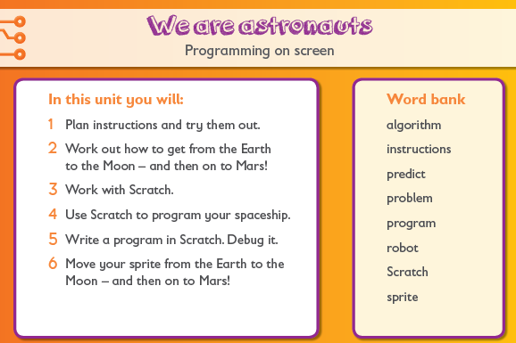
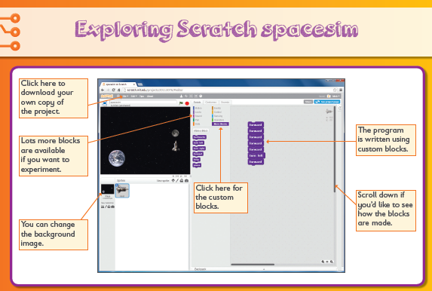
Year 2
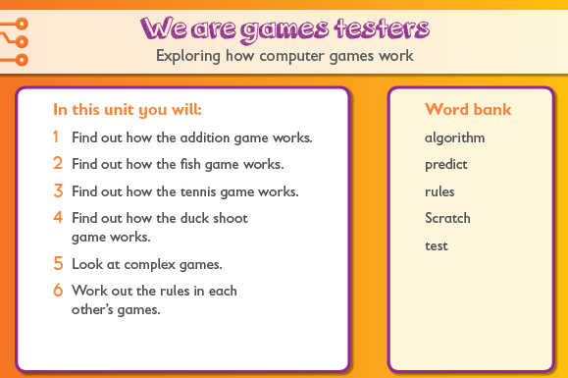
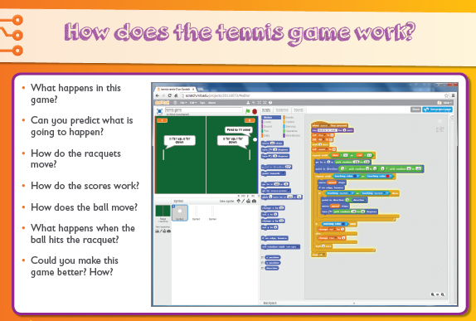
Year 2
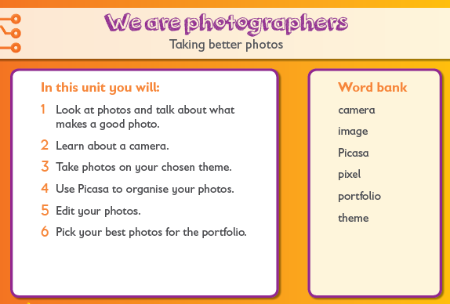
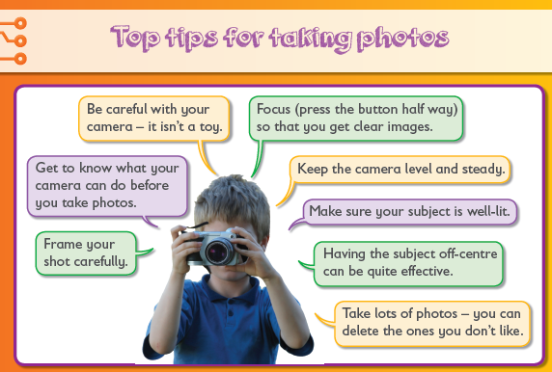
Year 2
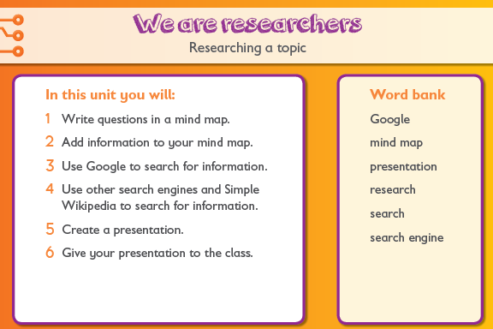
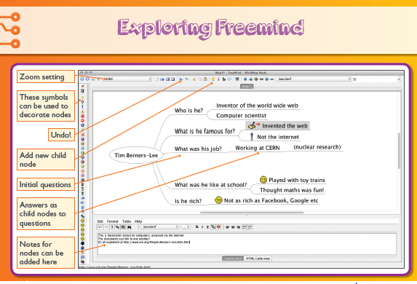
Year 2
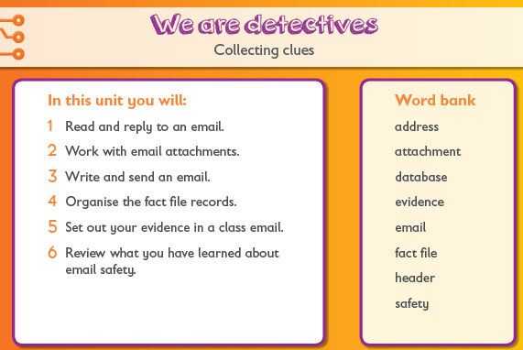
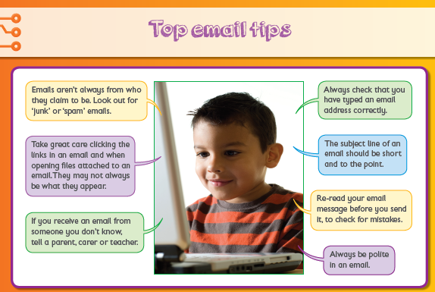
Year 2
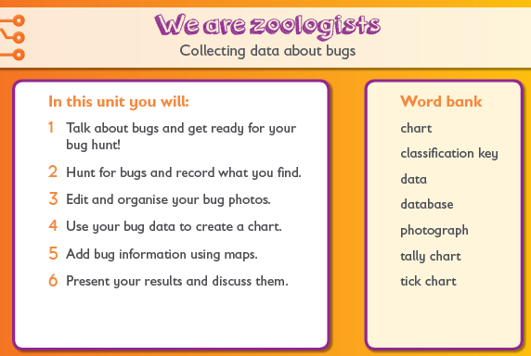
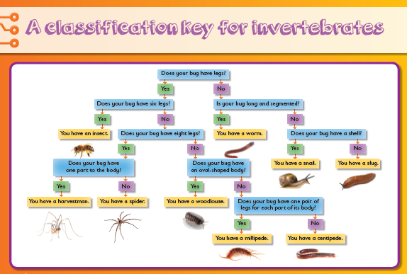
Year 3
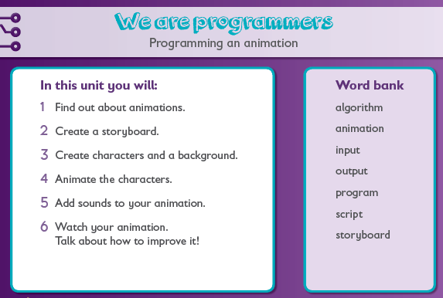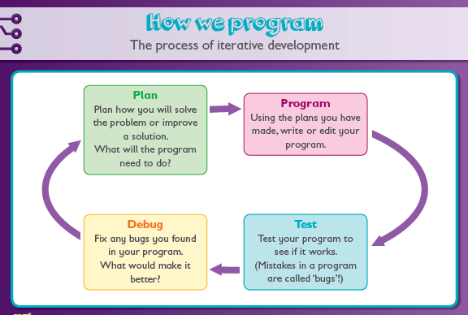
Year 3
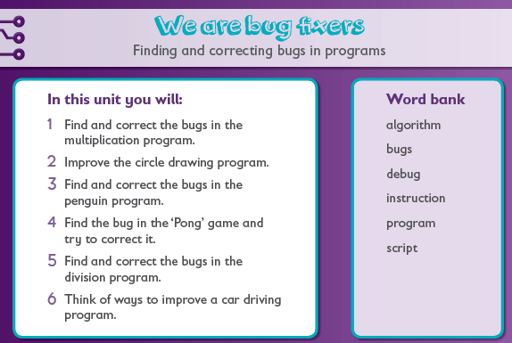
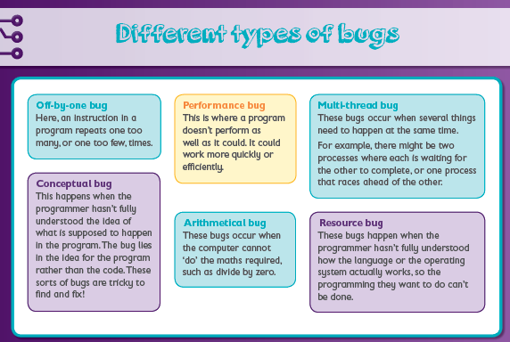
Year 3
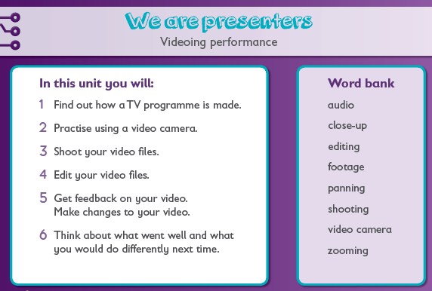
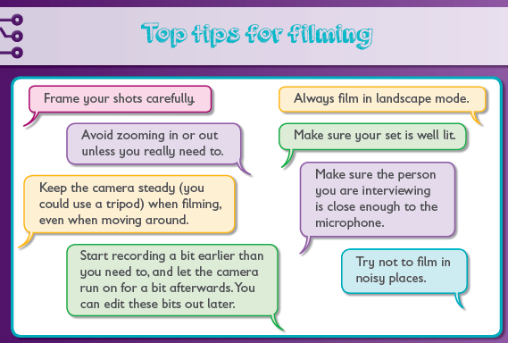
Year 3
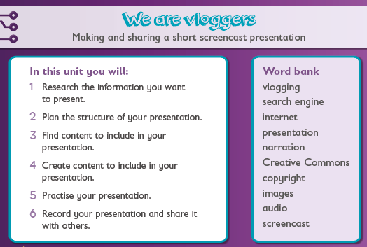
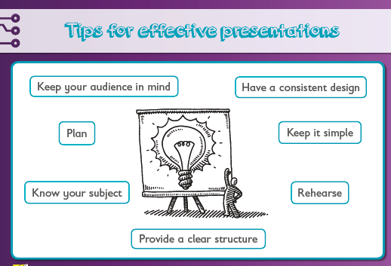
Year 3
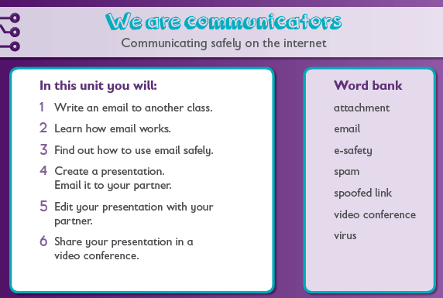
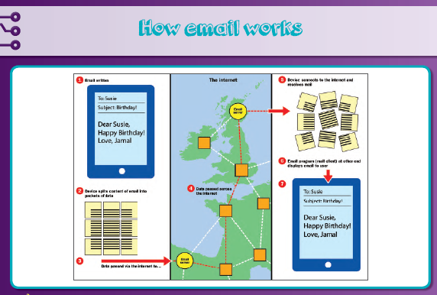
Year 3
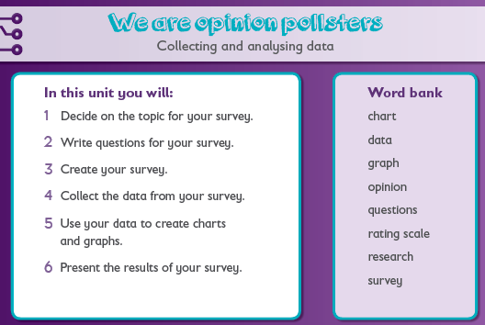
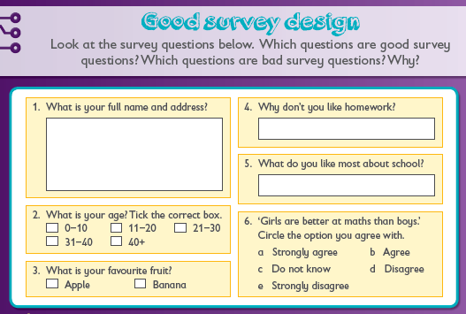
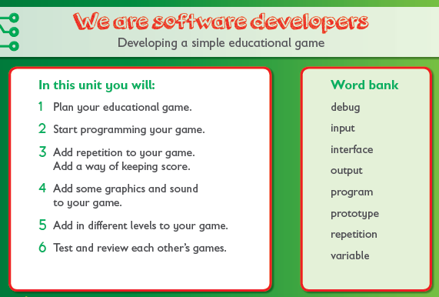
Year 4
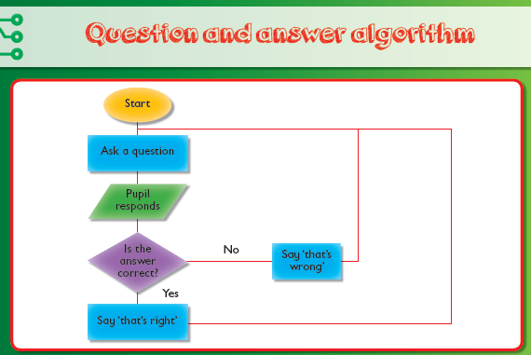
Year 4
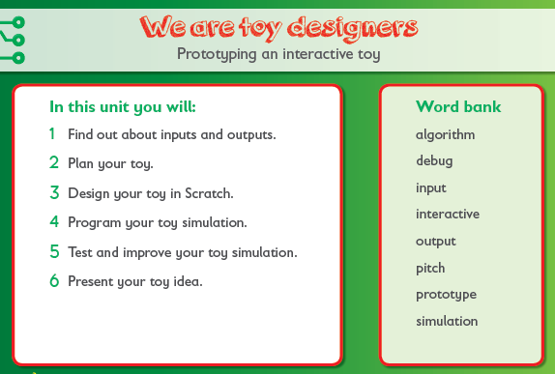
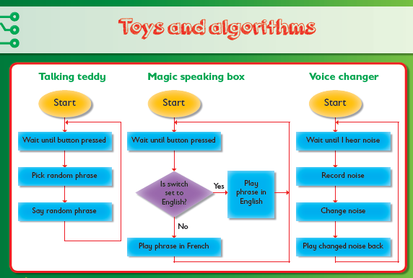

Year 4
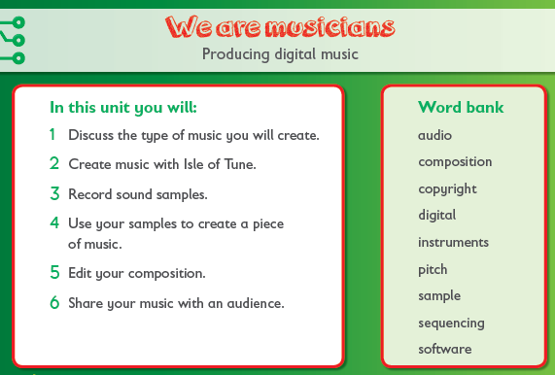
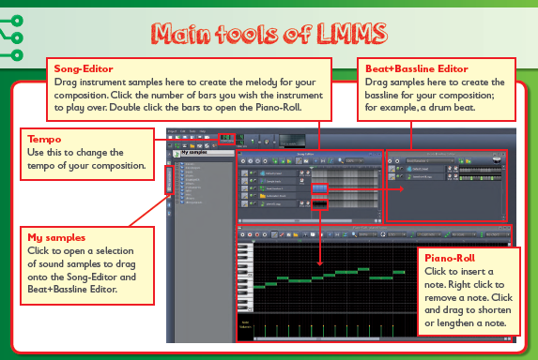
Year 4
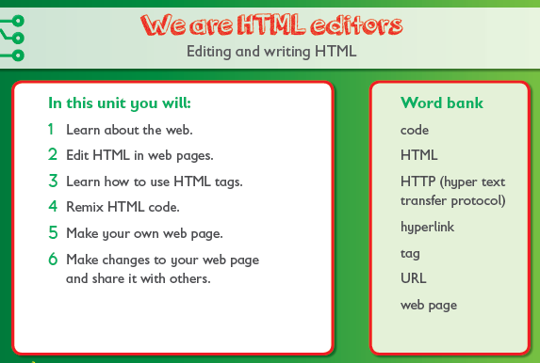
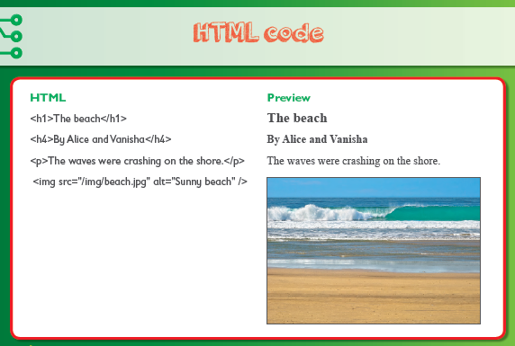
Year 4
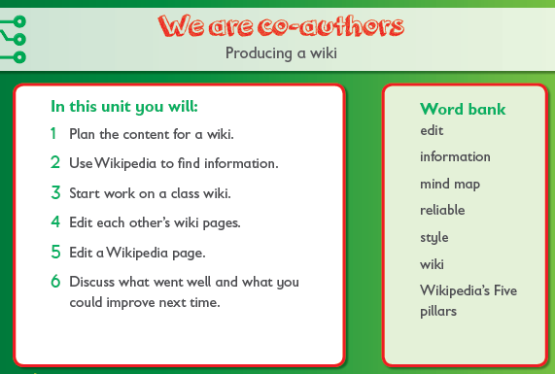
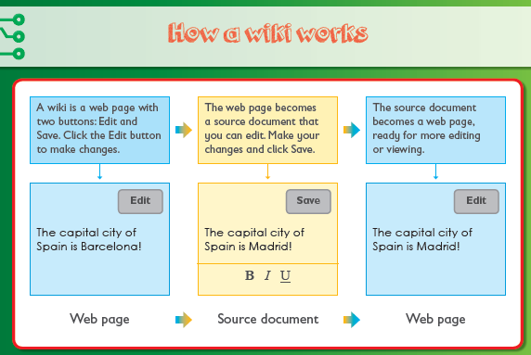
Year 4
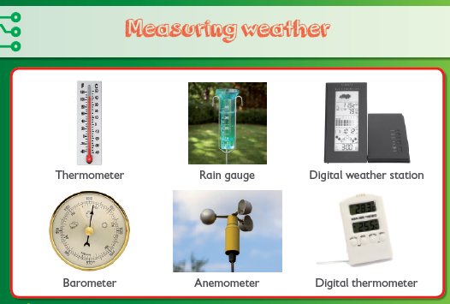
Year 5
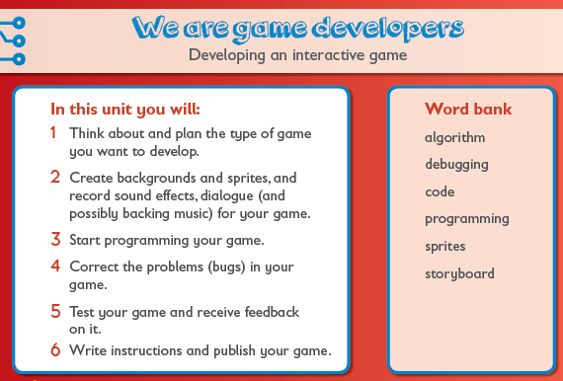
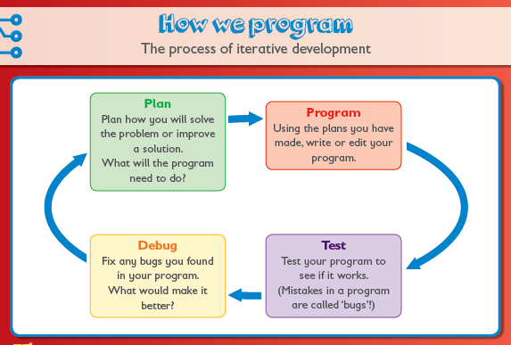
Year 5
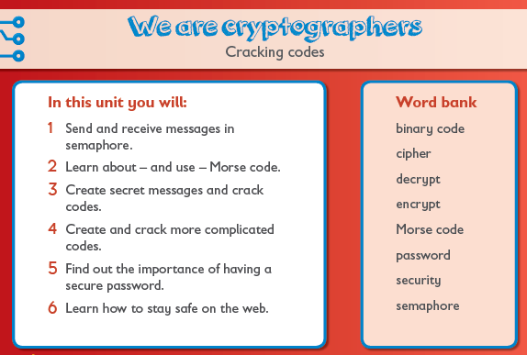
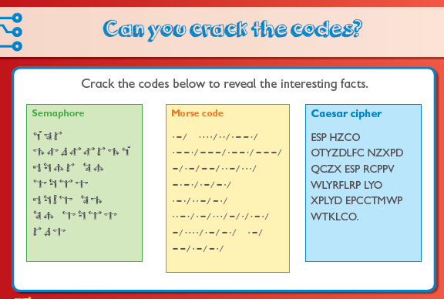
Year 5
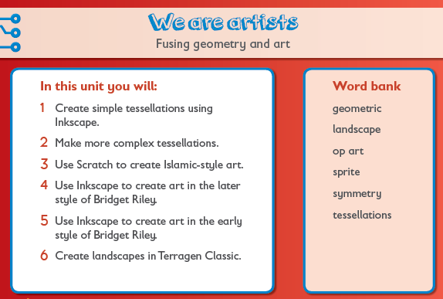
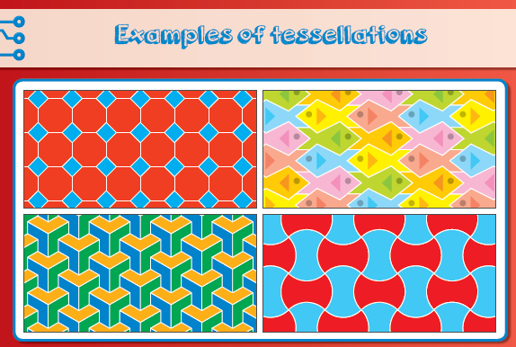
Year 5
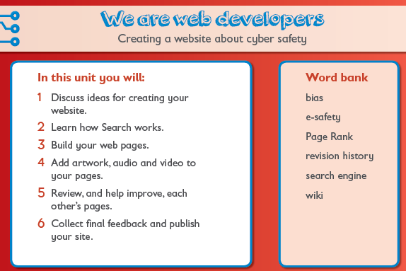
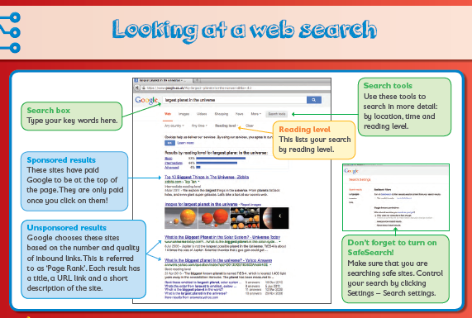
Year 5
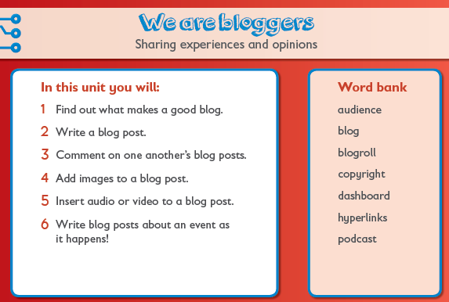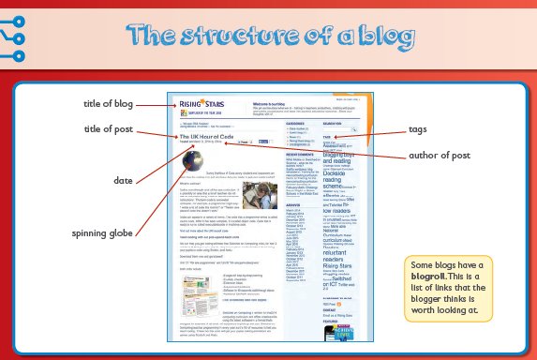
Year 5
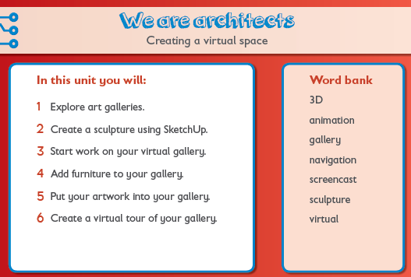
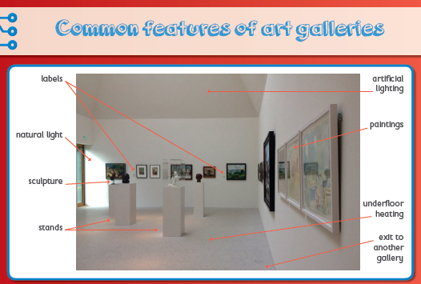
Year 6
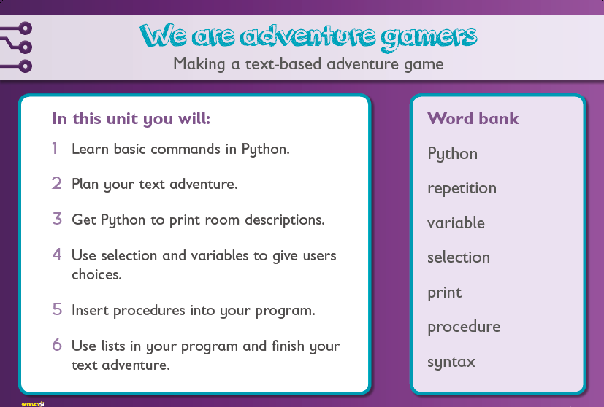
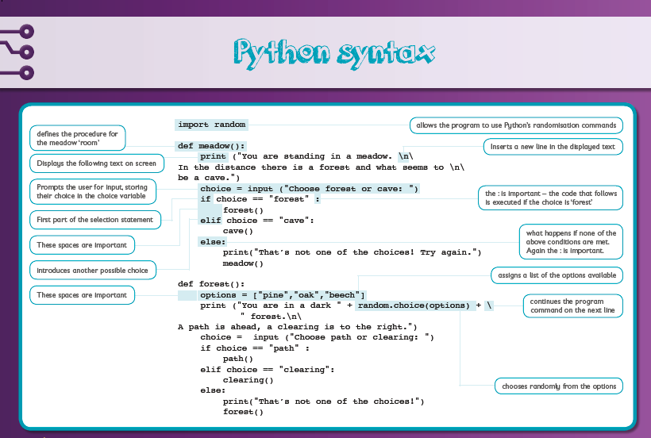
Year 6
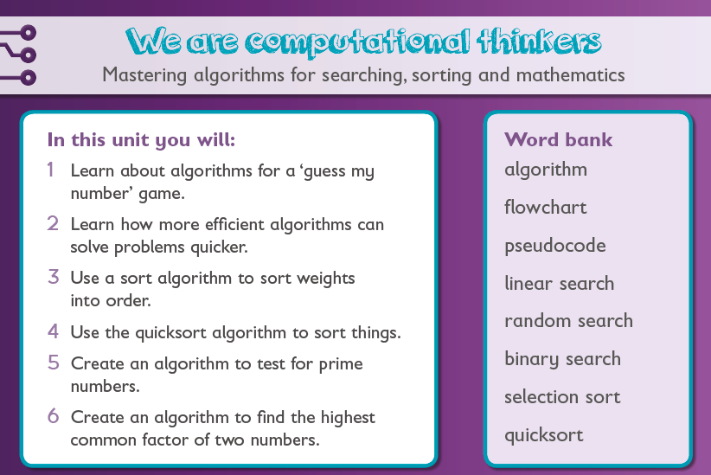
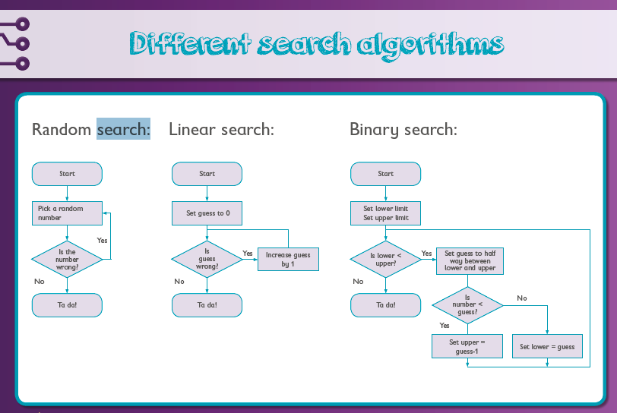
Year 6
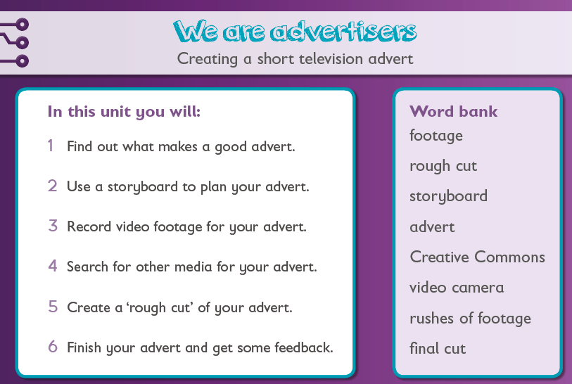
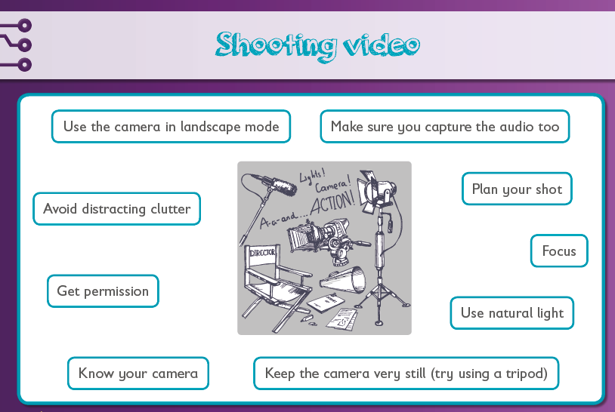
Year 6
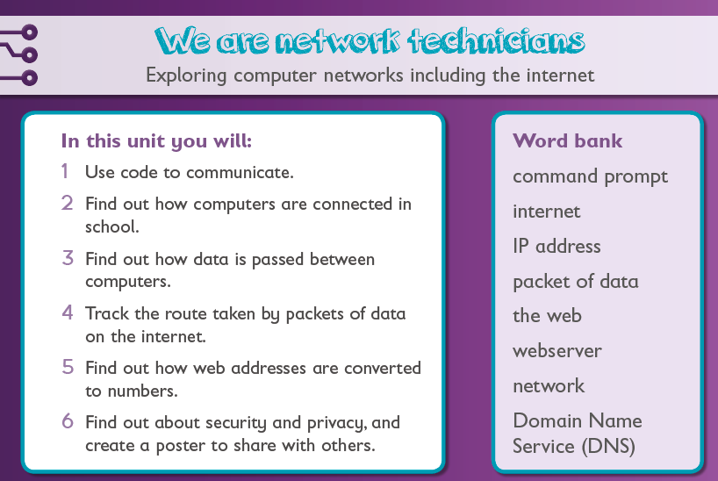
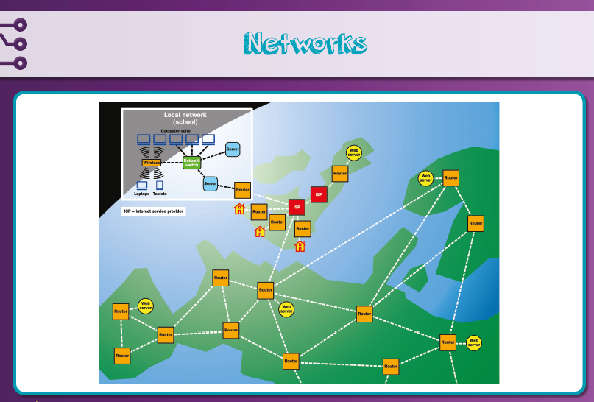
Year 6
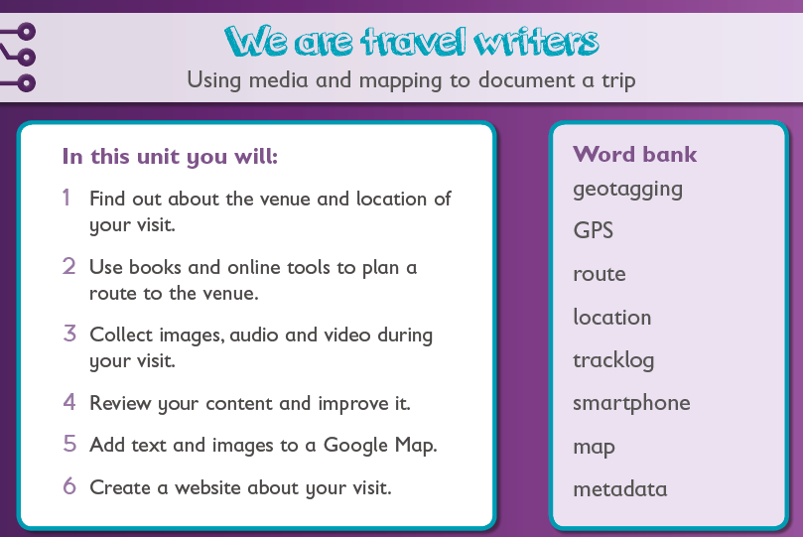
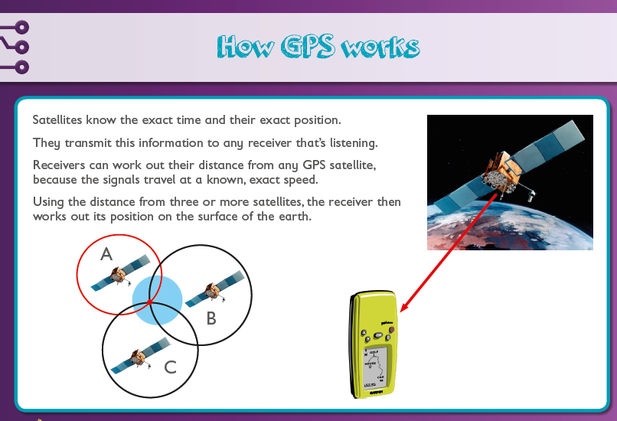

Year 6
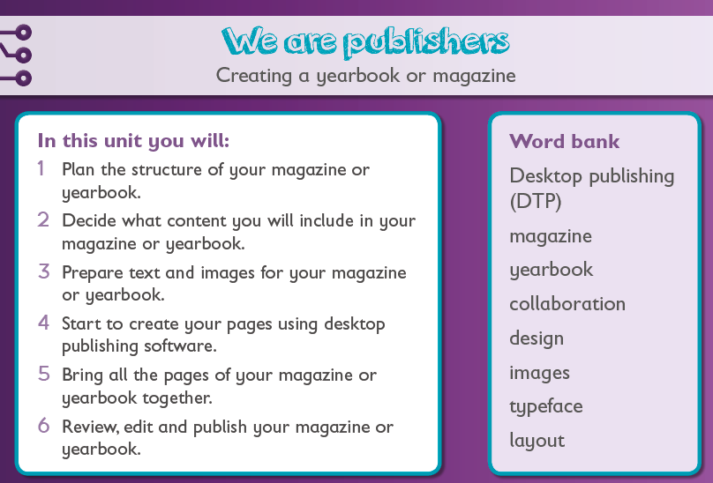
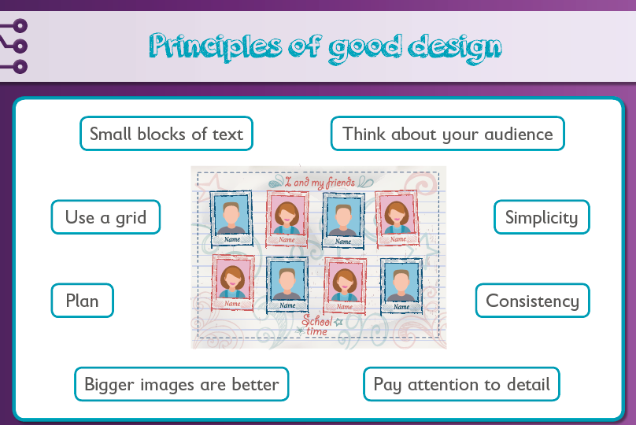
To keep track of children’s individual progress, use the example assessment spreadsheet.
E-Safety assessment will come from their understanding of the E-Safety unit and the score on the assessment at the end of the E-Safety session.
Use the statements relating to each unit and key stage below to assess if a child is Working Towards, Working Within or Greater Depth.
Up to 60% of statements highlighted = Working Towards
61-90% of statements highlighted = Working Within
90%+ of statements highlighted = Greater Depth
Assessment
Nursery | Autumn Term |  |  |  |  | Spring Term |  |  |  |  | Summer Term
 | We have confidence |  |  | We can record soundtracks |  | We are designers |  | We can count |  |  | We can listen |  | We can e-mail
Objectives | I can use a laptop and microphone.  I can work in a group. |  |  | I can record a story.  I can express myself through music |  | I can control a remote controlled toy.  I can use language about position. |  | I can control a beebot.  I can direct it along a path. |  |  | I can communicate using technology.  I can explore technology used to communicate. |  | I can explore how we communicate non-verbally.  I can write an email (supported)
 | We are game players |  |  | We are successful |  | We can drive |  | We are talkers |  |  | We can observe |  | We can exercise
 | I can identify a friends voice.  I can play a game with others. |  |  | I can discuss what I am proud of.  I can use the camera to take pictures. |  | I can discuss how different things are controlled.  I can use a camera |  | I can retell a story.  I can discuss to a camera why this is my favourite. |  |  | I can take photographs.  I can explore living things using technology. |  | I can create an interactive display about exercise.  I can move in a variety of ways.
Reception | Autumn Term |  |  |  |  | Spring Term |  |  |  |  | Summer Term
 | We are DJ’s |  |  | We can understand messages |  | We are shape makers |  | We are film producers |  |  | We can understand instructions |  | We can blog
Objectives | I understand how music/videos and sounds can be recorded. |  |  | I can listen to recorded messages and use the clues. |  | I can make patterns. |  | I can record a video.  I can put videos together to make a story. |  |  | I can follow instructions and take pictures of each stage. |  | I can work individually and in pairs to write a blog post.
 | We are creative |  |  | We have feelings |  | We can take turns |  | We are digital recorders |  |  | We are community members |  | We are healthy
 | U can create a picture of a coloured animal using technology. |  |  | I can take photographs.  I can create a digital presentation |  | I can take turns. I can create patterns by touching the screen and using the mouse. |  | I can listen to digital stories. I can describe the differences between digital texts. |  |  | I can find out about my community and make a poste using technology. |  | I can create a digital healthy eating plate using images from google.
Year 1 |  | Autumn Term |  |  | Spring Term |  |  |  | Summer Term |  |  | KS1 Objectives
 |  | We are Treasure Hunters | We are TV chefs |  | We are painters |  | We are collectors |  | We are story- tellers | We are celebrating |  | Computing PoS Statements
Objectives |  | I can follow instructions.  I can record a set of instructions.  I can program a toy.  I can give instructions.  I know what input, program and output means for a robot toy.  I can create a program.  I can spot mistakes in a program.  I can predict where a set of instructions will take a toy.  I can look for ways to make a program work better. | I can write and/or draw the steps of a recipe.  I can change my recipe to make it better.  I know what will happen when others use my recipe.  I can use a video camera to record a video.  I can move files from the camera onto the computer.  I can edit video. |  | I can use a paint program.  I can edit an image.  I can use a paint program to show details.  I can put more than one image into a document.  I can save my work.  I can find images on the web.  I know how to let my teacher know if I am worried about an image.  I can give helpful feedback.  I can see how digital images are created.  I can see how images are stored on a computer. |  | I can look for pictures on the web.  I can copy a picture and put it into my presentation.  I can resize pictures.  I can choose the best picture of my collection.  I know that there are some pictures I can copy and some I can’t.  I can use yes or no questions to find a picture.  I can see how drawings and photos are different.  I can add labels to my presentation. |  | I can practise the sound effects for my book.  I can record the sound effects.  I can listen to the sounds and make them better.  I can practise and record the dialogue for my book.  I can put the sound effects and dialogue together.  I can save my work and open it when I next need it.  I know how my recording is saved on the computer.  I can see how talking books and reading books are different. | I can type words.  I can type symbols.  I can type carefully and check my work for mistakes.  I can change the way words look.  I can find pictures on the web.  I can edit a picture to suit my card.  I can listen to my friends’ ideas and make my work better.  I can save my work and open it when I need it.  I can see how cards on paper and the computer are different. |  | Understand what algorithms are; how they are implemented as programs on digital devices; and that programs execute by following precise and unambiguous instructions.  Create and debug simple programs.  Use logical reasoning to predict the behaviour of simple programs.  Use technology purposefully to create, organise, store, manipulate and retrieve digital content.  Recognise common uses of information technology beyond school.  Use technology safely and respectfully, keeping personal information private; identify where to go for help and support when they have concerns about content or contact on the internet or other online technologies.

Year 2 | Autumn Term |  | Spring Term |  | Summer Term |  | KS1 Objectives
 | We are astronauts | We are game testers | We are photographers | We are researchers | We are detectives | We are zoologists | Computing PoS Statements
Objectives | I can plan a route from one place to another.  I can plan a route to more than one place.  I can pretend to be a robot and follow instructions.  I can program a toy.  I can program a sprite to move in Scratch.  I can predict where instructions will take a person.  I can record instructions to move a toy or sprite from one place to another.  I can spot and correct mistakes in a program.  I can solve problems with the most efficient solution. | I can talk about what happens in a computer game.  I can see that a computer game works by following instructions.  I can see how computer games are similar.  I can test a computer game.  I can find and understand the code for a computer game in scratch.  I can change the code for a computer game.  I know how to tell someone if I am worried about a game.  I know that some games are for older children. | I can take photos.  I can make sure that they are in focus and of high quality.  I can decide if a photo is worth keeping.  I can edit photos to make them look better.  I can talk about how I took, edited and chose my best photos.  I can give helpful feedback to my friends.  I know how to let my teachers know if I am worried about an image.  I know that some photos I should not put on the web. | I can add questions to a mind map.  I can organise questions in my mind map.  I can find information to add to my mind map.  I can use search engines.  I can use the web to find information.  I know that it is important to say where I found information.  I know that there are some images I can and can’t copy.  I can add images to my presentation.  I know how to let someone know if I am worried about something on the web.  I can create a presentation which shows my research. | I can read an email.  I can write and reply to an email.  I can check for mistakes before I send it.  I can see if an email and attachments are from someone I trust.  I can read and understand the headers of an email.  I know how important it is to type an email address correctly.  I can see how an email address has two parts.  I can see that the domain name in an email address gives important information.  I can create and organise a spread sheet. | I can take photos of bugs.  I can make sure that the photos are in focus and high quality.  I can edit my photos.  I can label my photos.  I can move my photos onto the computer.  I can use yes or no questions to decide which group a bug fits into.  I can create a chart.  I can add a title and label the axes.  I can change the way my chart looks.  I can show my results in different ways.  I can use a digital map to find a place.  I can use GPS to show where I found my bugs. | Understand what algorithms are; how they are implemented as programs on digital devices; and that programs execute by following precise and unambiguous instructions.  Create and debug simple programs.  Use logical reasoning to predict the behaviour of simple programs.  Use technology purposefully to create, organise, store, manipulate and retrieve digital content.  Recognise common uses of information technology beyond school.  Use technology safely and respectfully, keeping personal information private; identify where to go for help and support when they have concerns about content or contact on the internet or other online technologies.

Year 3 | Autumn Term |  |  |  | Spring Term |  |  |  | Summer Term |  |  | KS2 Objectives
 | We are programmers |  | We are bug fixers |  | We are presenters |  | We are vloggers |  | We are communicators |  | We are opinion pollsters | Computing PoS Statements
Objectives | I can create a story board for an animation.  I can include action and dialogue in my story.  I can write a computer program for an animation.  I can put scratch blocks in the right order.  I can correct mistakes in my program.  I can create sound and graphics for my animation.  I can explain how he story board and animation link.  I can use ‘repeat’ blocks. I can find and correct bugs. |  | I can correct ‘off-by-one’ mistakes in a program.  I can make a simple drawing program work better.  I can try out different variables in a simulator game’s program.  I can describe how simple maths programs work.  I can correct a program so animations are more realistic.  I can explain how to correct bugs.  I can explain how dialogue programs work and how to correct them.  I can describe how a ‘pong’-style program works. |  | I can work a video camera.  I can record footage.  I can upload and edit my footage.  I can record an audio commentary for my video.  I can study sports programmes to learn how they are filmed.  I can record high quality footage.  I can export my final video in a standard format.  I can look at my footage and decide what does and doesn’t work.  I can record original and interesting footage.  I can use and explain data in my audio commentary.  I can use more difficult editing tools e.g. transitions. |  |  |  | I can see how email and video conferencing work on the internet.  I can use email and video conferencing to communicate.  I can write an email and speak on a video.  I can follow my school’s rules and use email and video conferencing safely.  I can see that the internet and web are different,  I can work well with my partner and show respect to their ideas.  I can let my teacher know if I am unsure about something in an email.  I can plan my work and explain to my partner what does and doesn’t work.  I know the dangers of opening emails. |  | I can collect data through the internet.  I can show respect for the information people tell me.  I can use software to collect data.  I can present the results of my data.  I can judge how useful my surveys and presentations are.  I can move information between different applications.  I can look at data and explain what it shows me.  I can explain how a google data centre server collects data.  I know how important it is to keep personal data private.  I can judge my data and see what does and doesn’t work. | Design, write and debug programs that accomplish specific goals, including controlling or simulating physical systems; solve problems by decomposing them into smaller parts.  Use sequence, selection, and repetition in programs; work with variables and various forms of input and output.  Use logical reasoning to explain how some simple algorithms work and to detect and correct errors in algorithms and programs.  Understand computer networks including the internet; how they can provide multiple services, such as the world wide web; and the opportunities they offer for communication and collaboration.  Use search technologies effectively, appreciate how results are selected and ranked, and be discerning in evaluating digital content.  Select, use and combine a variety of software (including internet services) on a range of digital devices to design and create a range of programs, systems and content that accomplish given goals, including collecting, analysing, evaluating and presenting data and information.  Use technology safely, respectfully and responsibly; recognise acceptable/unacceptable behaviour; identify a range of ways to report concerns about content and contact.
Year 4 |  | Autumn Term |  |  |  | Spring Term |  |  |  | Summer Term |  | KS2 Objectives
 |  | We are software developers |  | We are toy designers |  | We are musicians |  | We are HTML editors |  | We are co-authors | We are meteorologists | Computing PoS Statements
Objectives |  | I can design an interactive educational game.  I can develop an interactive game.  I can put scratch blocks in the right order.  I can use the if/then/else blocks.  I can use the random number block and use variable to work out the score.  I can include sound.  I can correct mistakes.  I can include a countdown timer.  I can use the mouse to control my game.  I can explain algorithms. |  | I can design a toy with computer controlled input and output.  I can write a program to show an output.  I can use scratch to show how it would work.  I can create a version of my toy on scratch.  I can use both the mouse and keyboard to control the toy.  I can find and correct bugs.  I can explain how I find bugs in my program.  I can work out ways around problems by breaking them into smaller steps. |  | I can explain how technology can be used to create music.  I can use sequencing to create music.  I can record my own sound samples.  I can export the file of my piece of music in a standard, compressed format.  I can explain how people listen to and buy music through technology.  I can edit sound samples.  I can work on and make my music sound better.  I can use software that uses staff notation.  I can respect other people’s copyright. |  | I can see how the internet and the web are different.  I can see that web pages are written in HTML.  I can use some HTML tags.  I can edit the HTML for a web page.  I can create web pages that keep another person’s details private.  I can explain the parts of a URL.  I can use the <a href=”…”>…</a> tag correctly.  I can be safe and responsible when I create a webpage.  I can show how HTTP works.  I can use the <img/> and </iframe> tags. |  | I can find and read an article on Wikipedia.  I can create content for a wiki.  I can edit the content on my wiki.  I can edit the HTML for a web page.  I can show where I found information I used in my research.  I can work with others to plan a project.  I can work out if an article is accurate and reliable.  I can edit another person’s content.  I can see how important it is that content is fair and balanced.  I can see how important Wikipedia’s Five pillars are. | I can use weather measurement equipment safely.  I can enter weather data in a spreadsheet.  I can take digital photographs.  I can create simple charts.  I can describe and make predictions about the weather.  I can add measurements and descriptions to photos.  I can present an interesting and useful weather forecast to my classmates.  I can spot weather data that looks unusual.  I can make accurate predictions. | Design, write and debug programs that accomplish specific goals, including controlling or simulating physical systems; solve problems by decomposing them into smaller parts.  Use sequence, selection, and repetition in programs; work with variables and various forms of input and output.  Use logical reasoning to explain how some simple algorithms work and to detect and correct errors in algorithms and programs.  Understand computer networks including the internet; how they can provide multiple services, such as the world wide web; and the opportunities they offer for communication and collaboration.  Use search technologies effectively, appreciate how results are selected and ranked, and be discerning in evaluating digital content.  Select, use and combine a variety of software (including internet services) on a range of digital devices to design and create a range of programs, systems and content that accomplish given goals, including collecting, analysing, evaluating and presenting data and information.  Use technology safely, respectfully and responsibly; recognise acceptable/unacceptable behaviour; identify a range of ways to report concerns about content and contact.

Year 5 | Autumn Term |  | Spring Term |  | Summer Term |  | KS2 Objectives
 | We are game developers | We are cryptographers | We are artists | We are web developers | We are bloggers | We are architects | Computing PoS Statements
Objectives | I can create a story board for an algorithm for my game.  I can create sound and graphics in Scratch.  I can put instructions in the right order.  I can find mistakes in my game.  I can create and add music for my game.  I can use selections and repetition.  I can add instructions to my game.  I can break the game down into smaller parts and work on them.  I can animate characters.  I can use variables.  I can add comments to the script. | I can send and receive messages in Morse Code and Semaphore.  I can create and decode secret messages using Caesar/substitution ciphers.  I can see how important it is to keep passwords secret.  I can see hoe secret code needs to be used sometimes when using the web.  I can decode messages.  I can check if a webpage is in secret code ‘encrypted’.  I can explain the algorithm for the Caesar cipher.  I can check security certificates. | I can create a tessellating pattern.  I can write a program to draw a simple shape.  I can create a pattern using overlapping shapes.  I can create a pattern using repeated shapes.  I can create a computer generated image of a landscape.  I can use repetition in scratch to draw a complicated geometric shape.  I can use the tile clone tool to create a pattern.  I can create a computer generated image of a landscape. | I can check and comment on others’ content.  I can see how Google chooses and shows webpages.  I can name other search engines.  I can create and organise others’ content on e-safety and using technology properly.  I can create and organise others’ content for using the web in the right/wrong way.  I can decide if web sources are balanced and of good quality.  I can prof read and correct mistakes.  I can use tools to get the best results in a search.  I can explain how google orders web pages ‘Page Rank’. | I can use blogs safely and responsibly.  I can see that the internet makes blogging possible.  I can write a blog post.  I can add an image, audio or video.  I can see what it takes to make a good blog post.  I can see that blogs are stored as HTML.  I can comment on other posts with respect.  I can see what is acceptable and unacceptable when commenting on a post.  I can explain the difference between database-driven sites and static HTML pages.  I can blog about an event as it happens. | I can use the web to find out about virtual galleries.  I can create simple objects using SketchUp.  I can create a gallery and add furniture to my gallery.  I can add my own artwork to my gallery.  I can create a virtual tour of my gallery.  I can create a detailed 3D object using SketchUp.  I can add textures and finishing touched to my gallery.  I can add an audio commentary to the virtual tour.  I can use Movie Maker to edit the virtual tour of my gallery. | Design, write and debug programs that accomplish specific goals, including controlling or simulating physical systems; solve problems by decomposing them into smaller parts.  Use sequence, selection, and repetition in programs; work with variables and various forms of input and output.  Use logical reasoning to explain how some simple algorithms work and to detect and correct errors in algorithms and programs.  Understand computer networks including the internet; how they can provide multiple services, such as the world wide web; and the opportunities they offer for communication and collaboration.  Use search technologies effectively, appreciate how results are selected and ranked, and be discerning in evaluating digital content.  Select, use and combine a variety of software (including internet services) on a range of digital devices to design and create a range of programs, systems and content that accomplish given goals, including collecting, analysing, evaluating and presenting data and information.  Use technology safely, respectfully and responsibly; recognise acceptable/unacceptable behaviour; identify a range of ways to report concerns about content and contact.

Year 6 | Autumn Term |  | Spring Term |  | Summer Term |  | KS2 Objectives
 | We are adventure gamers | We are computational thinkers | We are advertisers | We are network technicians | We are travel writers | We are publishers | Computing PoS Statements
Objectives | I can use Python’s interactive shell.  I can plan a text-based adventure.  I can use the print command in Python.  I can use variables.  I can use if/elif/else statements.  I can use procedures in Python.  I can create lists.  I can spot and correct syntax errors.  I can import a library and use functions from a library. | I can use random, linear and binary search to play ‘Guess my number’.  I can implement a search algorithm as a program.  I can use an algorithm to sort things into order.  I can debug a program to sort numbers.  I can use an algorithm to test if a number is prime.  I can write a program to test if a number is prime.  I can use an algorithm to find the highest common factor of a pair of numbers.  I can write a program to find the highest common factor of a pair of numbers. | I can work out what makes a good advert.  I can storyboard a video.  I can shoot a video.  I can find media online.  I can appreciate the need to observe copyright conditions.  I can import footage into editing software.  I can assembler a rough cut of a video.  I can produce video with a clear understanding of audience and purpose.  I can use advanced tools in editing software. | I understand how information can be represented digitally on computers.  I can name some of the hardware that connects computers. I can describe the way hardware works.  I can talk about how my computer in class is linked to a web server. I can describe how data passes across the internet.  I can use ping, ipconfig and tracert commands.  I can keep myself safe when using networks.  I understand why I need to be careful on the internet. | I can research a venue for a visit.  I can plan an efficient route to a destination.  I can understand the algorithm for finding a route to a destination. U can capture digital content.  I can record and use GPS metadata.  I can select and edit digital content across a range of media.  I can locate content on digital maps.  I can use GPS metadata with digital maps.  I can write online content about a visit.  I can combine text and media and can organise a website. | I can help plan a magazine or yearbook.  I can source content for pages.  I can use word processor to type up stories.  I can combine text and images.  I can apply principles of good design to page layout,  I can spot and correct mistakes.  I can provide constructive feedback to others.  I can take a lead in managing a group project. | Design, write and debug programs that accomplish specific goals, including controlling or simulating physical systems; solve problems by decomposing them into smaller parts.  Use sequence, selection, and repetition in programs; work with variables and various forms of input and output.  Use logical reasoning to explain how some simple algorithms work and to detect and correct errors in algorithms and programs.  Understand computer networks including the internet; how they can provide multiple services, such as the world wide web; and the opportunities they offer for communication and collaboration.  Use search technologies effectively, appreciate how results are selected and ranked, and be discerning in evaluating digital content.  Select, use and combine a variety of software (including internet services) on a range of digital devices to design and create a range of programs, systems and content that accomplish given goals, including collecting, analysing, evaluating and presenting data and information.  Use technology safely, respectfully and responsibly; recognise acceptable/unacceptable behaviour; identify a range of ways to report concerns about content and contact.

