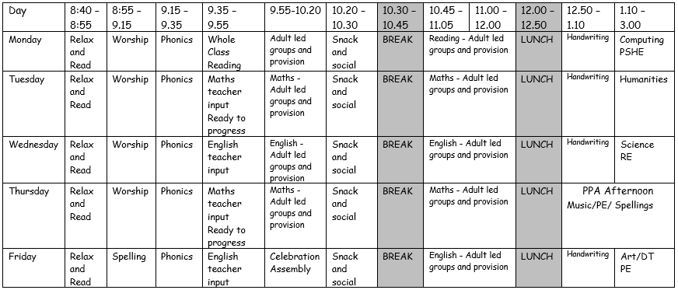

**THE SCHOOL DAY**

School begins at 8:40 on Thursday 2nd September. Our classroom can be found by entering through the first door on the KS1 playground – please look out for our photographs so you know which door to come through. Please come to school on this day with your uniform, school shoes, bag, coat and a water bottle.

**This is our proposed timetable next year:**

My name is Mrs Gray and I am one of the teachers in Year 1, I am also the Key Stage 1 lead and Pastoral lead. I have been teaching for over 7 years and I have taught in different year groups from Reception to Year 2. Outside of school, I enjoy reading to my daughter and spending time with my family.

My name is Mr Greathead and I am part of the wonderful team of teachers in year 1. This will be my first year teaching as an early career teacher however I do have experience teaching a variety of ages. Outside of school, I like to volunteer my time as a gymnastics coach and keep active.

**Welcome to YEAR 1LG**

Children will need to wear their PE kits on the days when PE is to be taught – currently this will be **THURSDAY** and **FRIDAY** (but this may be subject to change).

**HOMEWORK** - There will be a set menu of homework tasks.

Each week, children will need to practise spellings - linked to the end of year common exception word list and spelling patterns being taught in school - and daily reading - just a couple of pages followed by a discussion about what has been read. We will also provide your child with a log on for EdShed which they can use to log on and practise their spelling and Maths skills at home.

**Homework menu** - Please encourage your child to complete as many of the activities from the year group menu as they like at home, but NO LESS than 3 over the half term. This can be recorded (if appropriate) in our homework books or submitted via Teams. A new menu will be available at the start of each holiday. Homework can be done as and when you get time and offers some choice for your child too.

**We hope you have a super summer holiday! We are really looking forward to being**

**your class teachers in September.**