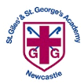
St Giles’ and St George’s Primary Academy
Homework Menu
Class: 3/4 SH/JD Teacher: Mrs Heaps and Mrs Dodds Topic: Vikings and Anglo-Saxons Term: Autumn 1
Set Menu: Daily reading, spellings, my maths, TT rockstars
We are asking children to read at least 3 times each week and for parents to record this in their child’s reading record. Listening to children read will enable them to practise their sounds and develop their reading fluency. Please talk to your child about their book, the pictures inside and what might happen next. This will help to develop their comprehension skills and have a better understanding of the text. Furthermore, we ask that children practise their spellings regularly, as they will be tested on them in school. Children are also required to access My Maths and TT Rockstars on a regular basis, as activities will be set on there for them to complete. We are grateful for your support with this.
Added Extras:
Please encourage your child to complete as many activities from the menu as they can, but NO LESS than 3 over the half term. Please record the activities in your child’s homework book, this can include photographs. We will ask for homework books handed in during the last week of each half term, in order for us to share and celebrate this learning.
Sketch it | Create it | Research it
This half term we are focussing on Anglo-Saxons.  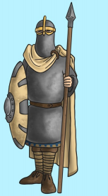  Sketch out a portrait of an Anglo-Saxon soldier. | Create your own word search including the vocabulary below:  - Anglo-saxon  - Alfred the Great  - Solider  - Edward the confessor  - Britain  - Battle of Badon  - Runes  - St. Bede | Research the Anglo-Saxons and write a fact file.
Make it | Write it | Write it
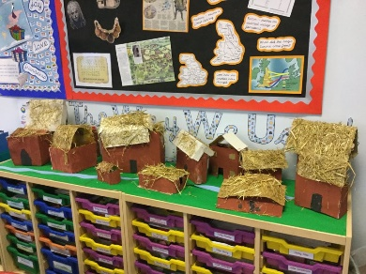  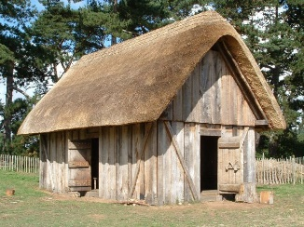  Take a look at Anglo-Saxons houses. Use your research to make your own. Be as creative as you like. | The Anglo-Saxons wrote using an alphabet that consisted of symbols called runes.  Have a go at using the runic alphabet to write your own name. | Write a food diary for one day as if you were a member of an Anglo Saxon household.

