ASPIRE BELIEVE ACHIEVE

STRATEGY FOR DISADVANTAGED PUPILS
Key Indicators of Effective Disadvantaged Provision
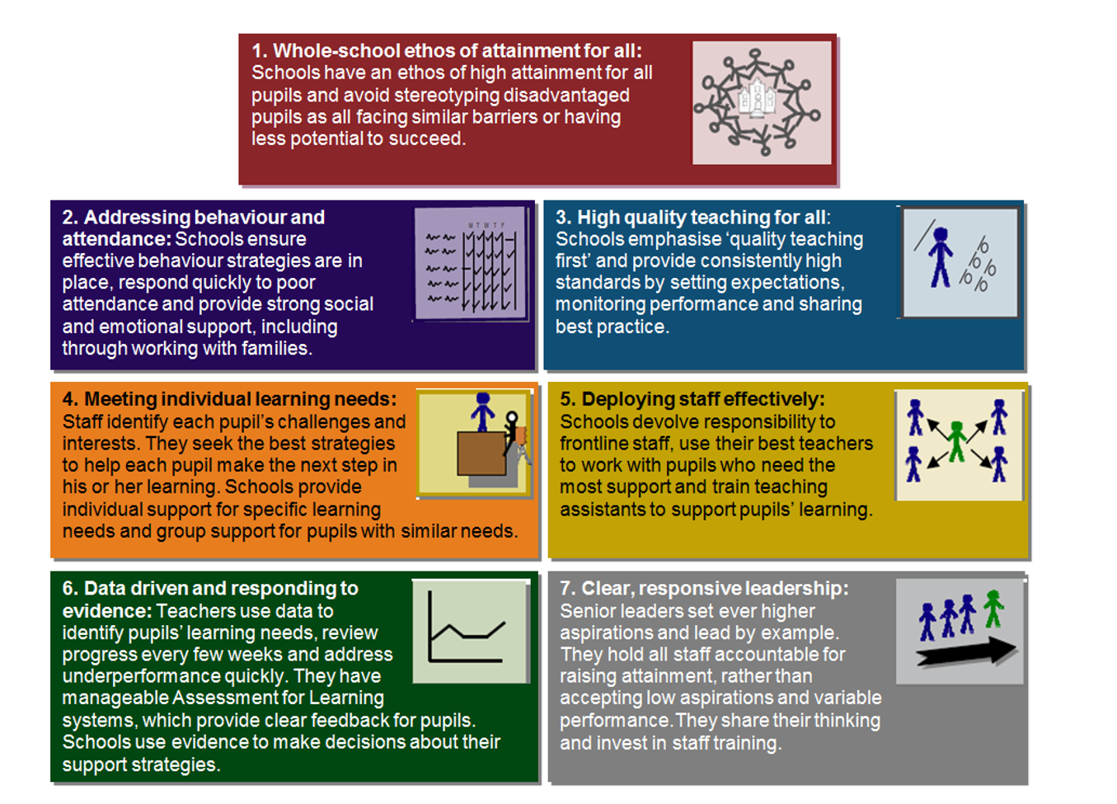

At St Giles’ and St George’s C of E Academy we aim to implement this through the following:

Quality First Teaching
Our Leaders believe this is the key to the success of the vast majority of our pupils.
- The high expectations of our staff, strong knowledge of educational pedagogy and the national curriculum content ensure lessons will move swiftly using AfL precisely to respond to needs in each lesson
- Our classrooms promote an honest, open and independent approach to learning where misconceptions are used wisely to embed and deepen learning.
- Pace is ambitious, weaving in time to practice, embed and deepen knowledge
- Reasonable adjustments are made to ensure all learners meet at least age related expectation and intervention is both swift, purposeful and specific to ensure those who are working below expected levels can achieve.
- Formative and summative assessment is used effectively to identify the gains pupils have made and our staff respond appropriately
- The deployment of resources such as staff is flexible and reflective to need.

Aspiration
- We will promote a no excuses culture across all our school where barriers are quickly challenged.
- Target setting will avoid all stereotyping and will ensure that opportunities are provided for our most disadvantaged pupils.
- Our school recognises the need to enhance the breadth and range of ‘life’ experiences for many of our most disadvantage, this forms part of our ‘Curriculum Tree’
- We will do this by ensuring all attend clubs, have access to all trips, are encouraged to learn how to play a musical instrument, are provided with access to high quality and wide range of reading materials and have time to learn and use a wide range of subject specific and creative vocabulary.
- We work tirelessly to ensure parents can engage with our school and take an active role in enhancing life beyond the school gates as much as possible through ‘Shine Days’ Homework Sharing, Information workshops and 1:1 conversation with staff.

Attendance and Behaviour
- Our school provide clear behaviour and attendance policies which are applied with consistency by all.
- Strong CPD support leaders to monitor, tackle and rectify any issues relating to behaviour, SEMH and poor attendance.
- Our school provides an In-school trained counsellor and ‘Rainbow room’ where individual counselling is given to those children in need.
- The school dogs provide a safe place for those children who feel overwhelmed or struggle to attend school.
- Intervention when needed will be rapid, personalised and supportive, also extending into the home if appropriate.

We have adopted the predict, profile and prevent strategy to drive our identification of pupil needs and also to recognise barriers to achievement via the use of our profiling tool. In order to challenge our provision, we have also defined what the success of our most disadvantaged pupils must look like.

Success Indicators for our Most Disadvantaged Pupils
Parental
support
Aspirational
culture

Reasonable adjustments beyond classroom

Know the child personally
Accessing
the full
curriculum entitlement
Valued
member of our school community

Healthy mind and body

95% +
attendance
Success
Accelerated
progress
Know the
child academically
Reasonable
adjustments in the classroom

How do we identify the needs of our DA Children?

By using the criteria above we can identify areas of achievement and those which required further consideration in order for a
pupil to thrive, succeed and achieve.
Once this has been completed staff will use the following toolkit to predict and prevent underachievement in any of the 5 key areas above for a disadvantaged pupil.

Attendance
Success = Attendance will be at least 95%
Predict typical barriers/issues:  - Parents priorities  - Lack of routine  - Transport/ Lack of wider family support  - Parent illness/medical  - Parent expectations  - Equipment & Clothing  - Confidence  - Finances – Trips  - Parents working from home/shits 10. Overprotective parents (illness) 11.SEN i.e time telling  12. Not seeing the importance of attending  13. Social Issues (i.e lack of uniform/shoes/kit)  14. Lack of wider family support | We will prevent identified barriers/issues by:  - Text reminders  - Parenting drop-ins/clinic  - School to collect/school to fund taxi/Before/after school club  - As above  - Regular coffee mornings/Parent & Toddler group/invite parents to volunteer/trip so they can experience school life  - School bank of resources and equipment (Forest school, swimming, PE kits, dressing up clothes etc) More simple dress up ideas  - Nurture for children  - Funding/free trips  9. Counselling/ Rainbow Room/ School Dogs  11. Offer Workshops  12. Promote, encourage, reward and work with families  13. Provide uniform, offer to wash and clean, donated spare kit  14. Kit purchased for them  15. Build relationship with school families/peers

Pastoral Profile:
Success = Staff will know each DA child personally
Predict typical barriers/issues:  - Transition – first few weeks  - Lack of communication with parents/families  - Busy timetable – not getting to know the children individually  - Reluctance of parents  - Background, not knowing parents’/home life/setting  - Child has barriers up against us trust issues  - Parental Influence  - Nursery - if they don’t attend a school nursery  - New child – Handovers  - No family contact in order to understand their overall background  - Time with teachers – Not enough/pressures throughout the year  - Stable staffing and staff absences 1  - Curriculum  14. Time pressures no time to talk  15. Children may have a favoured member of staff that they will attach to and build up  trust | We will prevent identified barriers/issues by:  - Additional transition  - Up to date contact numbers – teachers speaking to families face to face  - Designate a time to catch up (end of the day)  - Build relationships with families – invite them to coffee mornings etc  - As previous  - Getting to know the child’s interest to build upon trust, offering learning around their praise and encouragement  - Build a positive relationship with parents as soon as you can  - Communicate with external settings, could we have a profile which gets passed up between year groups?  - Welcome date before they start/stay and play  - Sourcing information from other sources, LST, Homestart, Glow  - Timetable at the start of the year to get to know parents and throughout, what can we do to nurture.  12. Staff wellbeing and support 13. DA enrichment opportunities  14. PSHE Jigsaw programme  15. Nurture sessions, Speaking/keeping an eye on open dialogue with previous teachers to know what works/doesn’t work

Healthy Mind and Body:
Success = Every DA child will have a healthy body and mind
Predict typical barriers/issues:  - Lack of sleep  - Lack of food/nutrition  - Lack of exercise  - Lack of self-respect/worth  - Lack of hygiene  - Lack of understanding of how to be healthy  - Lack of resilience  - Friendships  - Fixed mindset  - Money  - SEMH difficulties  - Split families  - Staying up too late/gaming/tired  - Clubs that charge | We will prevent identified barriers/issues by:  - Parenting support  - School Foodbank  - Provide breakfast club  - Parent workshops, clubs, outside agencies  - Support in school – pupil leadership team involvement  - School Nurse, promote why health/exercise/hygiene important/parent workshops  - Cooking Class/Cooking on a budget  - In School counsellor, promote calm corner in the class, Rainbow room educate parents and children to what is appropriate  - After school activities and care club  - Health school focus/break the mould  Signpost to agencies, free fruit, milk etc in school  - Understanding of the importance of good health e.g. drinking regularly/counselling  - Budgeting for families/support for parents  - Try to educate the parents to the impact of staying late and importance of school  - Promote teacher run clubs

Academic Profile:
Success = DA child will be making accelerated progress.
Staff will know each child academically
Predict typical barriers/issues:  - Stereotype with other siblings  - Parental expectations  - Parental support/Reading at home  - No internet  - Lack of resources  - Lack of conversations  - Fixed mindset of not being able to achieve  - Change of circumstances that haven’t been flagged up  - Attendance 10. Basic needs  11.Rapid interventions  - Teacher expectations and mindset (only DA can’t do)  - Child mindset, willingness, worthiness and attitude  - PSED - Emotions, confidence, trust in carers  - Home background | We will prevent identified barriers/issues by:  - Assess the child correctly/as an individual  - Get parents into parents evening/informal chats/share what child can do  - Rewards – daily reading at school/praise/homework club  - Homework club/TT Rockstars club/spelling logs  - Further reading/talking  - Celebrate the smallest of achievements (tell Headteacher/phone parents/tell other members of staff)  - Ensure that any changes get shared and flagged up. Staff meeting/briefing, time to share information with other staff (e.g. changes in family circumstances)  - Collect from home, reward time with the dogs  - Have breakfast, snack (fruit in all classes)  - Communication between teachers, more bump up  - Same expectations for all if not higher  - Growth mindset – can’t do it yet  - Make time intervene quickly, Wellbeing referral (In House), Rainbow Room Pass, mental health specialists  - Shine Days/Social Meetings/Support Groups/Pair up with other  parents  - TA provision based on where the needs arise

- Need extra adult time for interventions, carefully planned timing, so not to miss other learning  - Readiness for learning – all needs met 19. Accurate start point  - Resources  - Wider general knowledge experiences 22. Language – Vocabulary  23. Self-esteem  24. Lack of enrichment  25. Homework/reading/spellings not completed | 18.Teaching mindset, knowing who to go for help, nurture in a discreet way.  School to be well supplied/stocked with spare clothes, breakfast etc 19. Adapt/be aware of start points/don’t assume  20. Provide with books/pens etc. 21. Providing opportunities e.g. Theatre Trips 22. Rich language in class  23. Circle time/peer support/positive praise 24. After school club  25. Homework club
Curriculum Entitlement:
Success= Every DA child will be and feel a valued member of the school community and will
be accessing their full curriculum entitlement
Predict typical barriers/issues:  - Behaviour  - Parental support/involvement  - Their attitude/love of subject/resilience/drive  - Self-belief  - Parents knowledge  - Resources/Money  - Time  - Not feeling valued/like they belong  - Lack of Confidence  - Can’t go or participate in clubs (e.g. bike club – no bike)  - Assuming experiences  - Staff reluctant to pick these children to represent the school  - Not having access to uniform or clean uniform or costumes  - Trips being able to afford 15. Clubs  - Parents ability/willingness to take to clubs/collect afterwards  - Experiences e.g. Young Voices, attend rehearsals but don’t go to the event  - Homework  - Attendance  - Parental Support  - Home background  22.Pre-conceived ideas from others 23. Curriculum clubs  24.Unknown timetable in afternoons  25.Parents dismissive of achievements | We will prevent identified barriers/issues by:  - Clear sanction and reward system  - Text/Facebook/Home-time communication  - Promoting strategies to promote a positive behaviour/model behaviour (resources/roles and building up responsibilities)  - Promoting a can-do attitude to build confidence  - Regular communication/parent workshops/simplified technology  - Planning/Celebrate home achievements/Involve parents/ ALWAYS club  - Individual whole School roles  - Nurture, constant reassurance and effort  - Donations/PE budget to be spent 11.  - Practical experience e.g. party/shop  - Spare uniform to be provided  - School to approach parents to offer school support if needed (individual cases)  - DA to get first refusal  - More clubs in school time so parents don’t have to come back to school 16. Communication find reasons why they don’t go money/parental concerns  - Homework club  19. Text, school clubs, paid Care club offer, rewards, transport offer  20. Transport, dinner time clubs, paid Care club offer, paid swimming clubs, paid trips  - Show them confidence/value. Parent workshops to show involved in learning, club invite for parent  - Build new relationships, don’t assume family stereotypes  - Priority clubs access, especially within school time to build life experience 24. Visual Timetable  25. Celebration assemblies/rockstars/shout outs in class/ ALWAYS club

This document was created with school staff and Directors during Autumn 2019 consulting the following documents:

- Supporting the attainment of disadvantaged pupils: articulating success and good practice Research report November 2015.
- EEF Guide to the Pupil Premium
- EEF Closing the Attainment Gap
- EEF The Big Picture
5) NFER Supporting the Attainment of Disadvantaged Pupils

