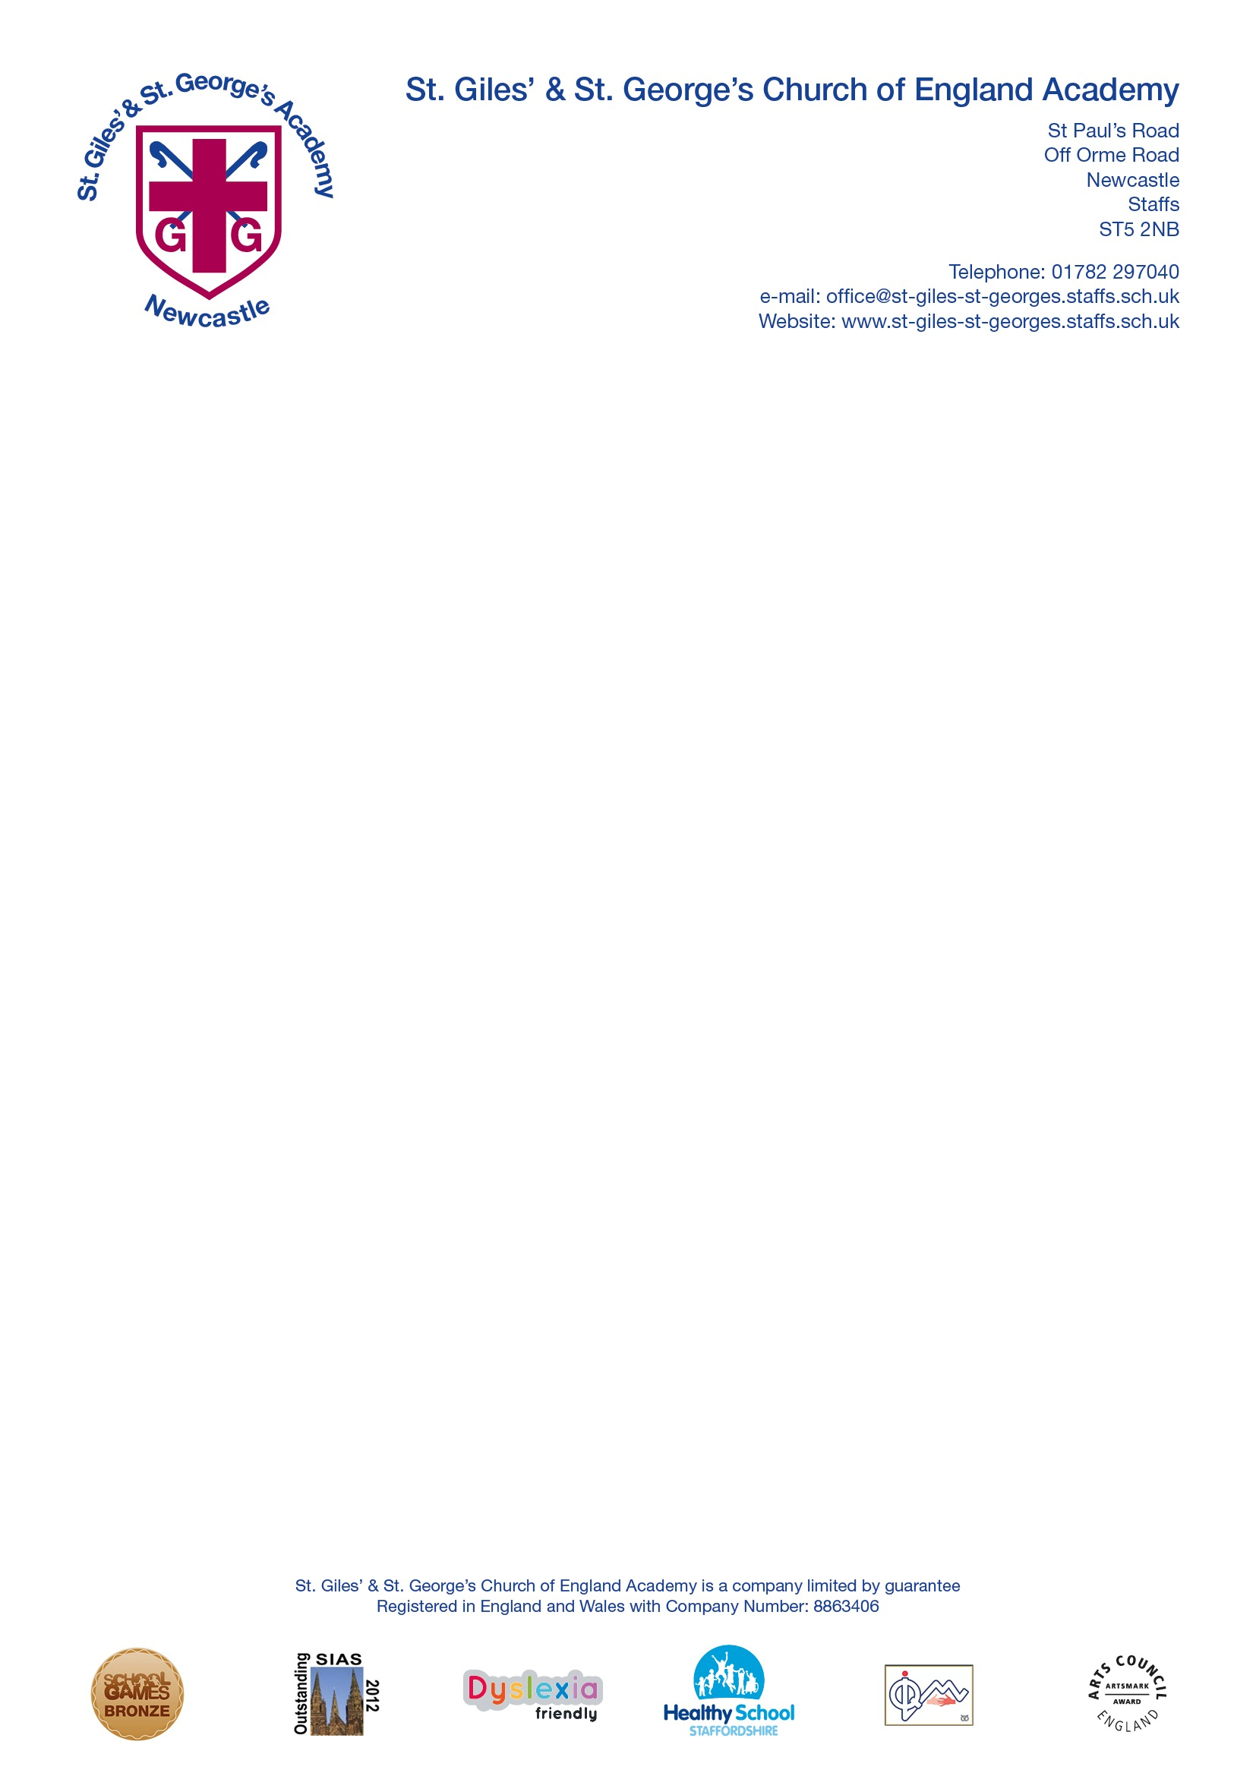

Phonics Policy

2020

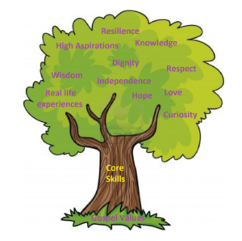

“The more you read, the more things you will know. The more that you learn, the more places you'll go.” Theodor Seuss Geisel (March 2, 1904 – September 24, 1991)

Introduction

At St Giles’ and St George’s Academy we strive to ensure that all children become successful, fluent readers by the end of Key Stage One and believe this is achievable through a combination of strong, high quality, discrete phonics teaching combined with a whole language approach that promotes a ‘Reading for Pleasure’ culture.

The Rose Report (2006) emphasised high quality phonics as an important part of the word decoding skills required by children to develop higher level whole language and comprehension skills. This approach is in alignment with our belief that we first ‘learn to read’ and then ‘read to learn’.

This policy is aimed at reinforcing a consistent, high quality approach to the teaching of phonics across the Early Years Foundation Stage, (EYFS,) Key Stage One and on into Key Stage Two for children who still need this further support.

Aims

• To teach children aural discrimination, phonemic awareness and rhyme to aid reading, writing and spelling development.

• To encourage the use of segmenting and blending so that decoding skills provide a sound foundation for reading, writing and spelling.

• To ensure the teaching of phonics is lively, interactive and investigative. • To enable children to use phonic awareness across the curriculum.

• To ensure that children know the 44 phonemes within the English language.

• To teach children to recognise the graphemes within words and associate them with the appropriate phoneme when reading.

• To provide children with strategies to identify and decode ‘tricky words.’

Objectives

• To provide consistent, high quality phonics teaching that ensures all children have a strong foundation upon which to tackle the complex processes of reading and writing.

• To ensure that the teaching of synthetic phonics is systematic and progressive throughout the foundation stage, key stage one and key stage two for those children needing interventions to support phonetic knowledge and understanding.

• To ensure that children have sound phonetic knowledge, understanding and skills so that they can decode words confidently and engage with higher order reading and writing skills.

Curriculum, Teaching and Learning Guidance

At St Giles’ and St George’s Academy, we follow the Letters and Sounds document’s principles and practice across the EYFS and Key Stage One – this is supported by teachers using elements from Jolly Phonics, Phonics Play and Twinkl Phonics to support the effective delivery of phonics lessons by catering for all children’s needs. This will be continued into Key Stage 2 where needed for individuals.

Teachers use assessment to inform effective provision for all children, using this to plan and deliver lessons that engage and challenge all children within the lesson. This assessment should inform the rate at which children progress through the phases and secure a sound understanding of phonics.

All Year One children take the ‘Phonics Screening Check’ - a statutory assessment required by legislation. Those who do not meet the pass mark will be given support and further phonics teaching in Year Two to provide them with sufficient knowledge and understanding to re-take the ‘Phonics Screening Check’ and obtain a pass mark. Those children who do not obtain the required level set by the ‘Phonics Screening Check’ will receive phonics teaching throughout Key Stage Two as needed.

Planning and Teaching Phonics

Planning for phonics will be done separately from literacy but with the understanding that good phonics teaching should link to the literacy needs of the children within a literacy lesson and across the curriculum.

Each Phonics lesson should include the following sections on a Flipchart:

• **Revise** – Overlearn the previous graphemes and words.

•**Teach** – Introduce a new grapheme / words.

• **Practise** – Develop GPCs (grapheme phoneme correspondences) /read and spell new

words.

• **Apply** – Use the new graphemes / words in games and activities to secure knowledge.

• **Assess** – Monitor progress within each phase to inform planning.

The planning format for weekly phonics teaching can be found in **Appendix 1.**

Examples of phonics teaching flipcharts can be found in Phonics on **Teams**.

The Letters and Sounds documentation can be found in Phonics on **Teams**.

Organisation

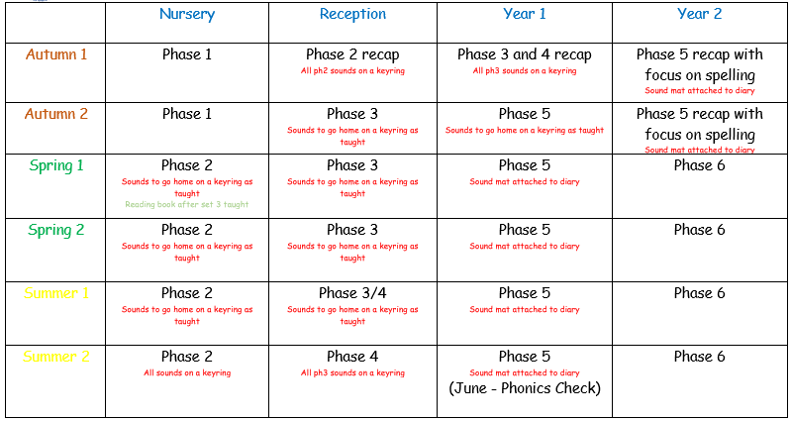

Children in Nursery should be taught the 7 aspects of Phase 1 though a differentiated approach within the setting on a daily basis. In the Spring and Summer term they will be taught Phase 2 in short discrete phonic sessions.

As children enter Reception from various preschool settings, Phase 2 is recapped in the Autumn Term. Children in Reception will be taught a discrete phonics session daily as a whole class. They will be taught to blend using ‘**sound buttons’**, they will practise this in reading and writing sounds. Phonics skills are also embedded in writing and whole class reading tasks. The driving ethos should be for all children to complete Phase 4 by the end of Reception and have a sound understanding in order to start Phase 5 by the start of Autumn Term 2 in Year 1. Children are introduced to the ‘**tricky words’** and aim to read and write the high frequency words for Phases 2 to 4 before they enter Year 1. For children who have not reached the expected level at the end of Reception have extra individual or small group phonics intervention.

Children in Year 1 have access to high quality daily phonics sessions. Groups will be differentiated to ensure all children reach their full potential. The underlying aim of Year 1 should be to ensure all children have completed Phases 4 and 5 and be ready to begin Phase 6 upon entry into Year 2. They should have plenty of practise in recognising ‘alien’ or pseudo words, in readiness for the Phonic Screening Check and to give them the confidence to read any word. Children should aim to read and write all the common exception words for Year 1.

Children in Year 2 will have access to high quality daily phonics lessons. Provision should be differentiated to ensure all children reach their full potential. In the Autumn Term Phase 5 will be revisited with the focus being on using the correct graphemes for spelling. The underlying aim in Year 2 is to ensure that all children have successfully completed Phase 6 while revisiting earlier phases to reinforce previous learning and to also re-experience ‘tricky words’ that they have encountered before.

Children in Year 3 who have not reached a sufficiently proficient level in Grapheme Phoneme Correspondence awareness and application should be given access to a daily phonics session across the Autumn term. Children who by the end of the Autumn term have still not reached a sufficiently skilled level of phonetic awareness will have intervention programmes arranged to provide for this need.

Children in Key Stage 2 who have not attained a sufficient skill level in GPC awareness and application will have provision in small intervention groups in regards to phonics and/or spelling across the key stage.

The phonics teaching order, tricky words for reading and words for spelling can be found in **Appendix 2**.

Homework

Parental involvement is key in the acquisition of Phonics. Each child in Nursery and Reception receives a keyring with sounds on when they have been taught. Children are given tricky words to be learnt at home, alongside the daily Phonics lesson. They are given reading books that they can read 90% independently. Children in Year 1 and 2 receive unit spellings to learn.

Assessment

In the EYFS and KS1 we assess pupil progress alongside the school reading scheme, they should be reading books applicable to their phonic level. This will be moderated termly by the Phonics Leader. Children in Year 1 are assessed regularly on their grapheme recognition and ‘alien’ word reading. From January onwards, Year 1 pupils will be given practise papers to identify specific skills or any gaps in learning, scores are recorded on a Phonics tracker grid.

Monitoring and Review of this Policy

This policy was drawn up by the Phonics Subject Leader. It was completed in May 2020.

This policy is used in context with the school’s Reading Policy.

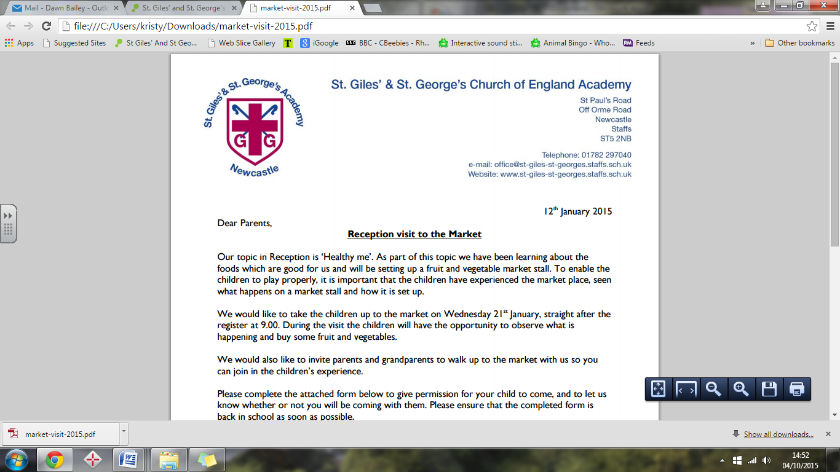Appendix 1

**Year 1 Phonics**

**Phase: Teacher**: **WB:**

|  |  |  |  |  |  |
| --- | --- | --- | --- | --- | --- |
|  | Monday | Tuesday | Wednesday | Thursday | Friday |
| **Revisit and review**  Previously learned phonemes |  |  |  |  |  |
| **Teach**  Teach new phoneme/quick words. |  |  |  |  |  |
| **Practise**  Practise reading/spelling. |  |  |  |  |  |
| **Apply**  Read and write using HfW and new sounds. |  |  |  |  |  |

Appendix 2

Order to teach phonics sounds and tricky words

Phase 2

|  |  |  |
| --- | --- | --- |
| Set | Sounds | Tricky words reading |
| Set 1 | s,a,t,p | to, the |
| Set 2 | i,n,m,d | to, the |
| Set 3 | g,o,c,k, | no, go, I |
| Set 4 | ck,e,u,r | no, go, I |
| Set 5 | h,b,f,ff,l,ll,ss | no, go, I, into |

Phase 3

|  |  |  |  |
| --- | --- | --- | --- |
| Set | Sounds | Tricky words for reading | Tricky words for spelling |
| Set 6 | j,v,w,x | Revision of all Phase 2 tricky words |  |
| Set 7 | y,z,zz,qu | he, her, she | to, the |
| Set 8 | ch,sh,th,ng | we, me, be | to, the |
| Set 9 | ai,ee,igh,oa,oo(long), oo (short) | was, my, | no, go, I |
| Set 10 | ar, or, ur, ow, oi | they, you | no, go, I |
| Set 11 | ear, air, ure, er | all, are | to, the, no, go, I |

Phase 4

|  |  |  |  |
| --- | --- | --- | --- |
| Set 12 | Adjacent Consonants | Tricky words for reading | Tricky words for spelling |
|  | Teaching blending for reading words:  CVCC  CCV  CCVC  CCVCC  CCCVC  CCCVCC | some  one  said  come  do  so  were  when  have  there  out  like  little  what | he  she  we  me  be  was  my  you  her  they  all  are |

Phase 5

|  |  |  |  |
| --- | --- | --- | --- |
| Set | Sounds | Tricky words for reading | Tricky words for spelling |
| Set 13 | zh,wh,ph | oh, their, people | said, so |
| Set 14 | ay, a-e, eigh/ey/ei (long a) | Mr, Mrs, looked | have, like |
| Set 15 | ea, e-e, ie/ey/y (long e) | called, asked | some, come |
| Set 16 | ie, i-e, y, i (long i) | water, where, who | were, there |
| Set 17 | ow, o-e, o/oe (long o) | again, thought | little, one |
| Set 18 | ew, ue, u-e, (long u) u/oul (short oo) | through, work | do, when |
| Set 19 | ew, au, al | mouse, many | what, out |
| Set 20 | ir, er ear | laughed, because | oh, their |
| Set 21 | ou, oy, ve | different, any | people, looked |
| Set 22 | ere/eer, are/ear | eyes, friends | Mr, Mrs |
| Set 23 | c, k, ck, ch | once, please | called, asked |
| Set 24 | ce/ci/cy, sc/stl,se | Recap all phase 5 tricky words | Recap all phase 5 spelling |
| Set 25 | ge/gi/gy, dge | Recap all phase 5 tricky words | Recap all phase 5 spelling |
| Set 26 | le, mb, kn/gn, wr | Recap all phase 5 tricky words | Recap all phase 5 spelling |
| Set 27 | tch, sh, ea, (w)a, o | Recap all phase 5 tricky words | Recap all phase 5 spelling |

Phase 6

|  |  |
| --- | --- |
| Suffixes | **s and -es**: added to nouns and verbs, as in cats, runs, bushes, catches;  **ed and -ing**: added to verbs, as in hopped, hopping, hoped, hoping;  **ful**: added to nouns, as in careful, painful, playful, restful, mouthful;  **er**: added to verbs to denote the person doing the action and to adjectives to give the comparative form, as in runner, reader, writer, bigger, slower;  **est**: added to adjectives, as in biggest, slowest, happiest, latest;  **ly**: added to adjectives to form adverbs, as in sadly, happily, brightly, lately;  **ment**: added to verbs to form nouns, as in payment, advertisement, development;  **ness**: added to adjectives to form nouns, as in darkness, happiness, sadness;  **y**: added to nouns to form adjectives, as in funny, smoky, sandy |
| Prefix | re- redo, revisit, retell, rework, rewind, reheat,  un- untie, unwell, undo, unkind, unlock, unfair, unpack, unsafe |
| Homophones and Near Homophones | hear, here, there, their, bear, bare, quiet, quite |

Assessment Judgements:

|  |  |  |
| --- | --- | --- |
| Phase 1 | Lower | * Aspect 1: Can identify environmental sounds * Aspect 2 – Can head and describe instrumental Sounds * Aspect 3 – Can create sounds using body percussion |
| Middle | * Aspect 4 – recognise rhythm and rhyme * Aspect 5 – Recognise alliteration * Aspect 6 – Identify and create different voice sounds |
| Upper | * Aspect 7 – Oral Blending and Segmenting. Children can blend phonemes in simple words and recognise the whole word. They can segment a word and identify sounds in CVC words. |
| Phase 2 | Lower | * Give the sound when shown **s, a, t, p, i, n, m, d** * Be able to read the 5 tricky words **the, to, I, no, go** * Be able to orally blend and segment in order to read and spell VC and then * CVC words with the above letters ie as, in, am – sat, pin |
| Middle | * Give the sound when shown **g ,o, c, k, ck ,e, u ,r** * Be able to orally blend and segment in order to read and spell VC and then * CVC words with lower phase 2 and the above letters |
| Upper | * Give the sound when shown **h, b, f, ff, l ,ll, ss** * Be able to orally blend and segment in order to read and spell CVC words * with all phase 2 letters * Read, write a caption using one or more high-frequency words and words * containing phase 2 letters |
| Phase 3 | Lower | * Be able to spell the tricky words **the, to, I, no, go** * Be able to read the tricky words **he, she, we, me, be,** * Give the sound when shown **j, v, w ,x, y, z ,zz, qu** * Write each letter correctly when following a model * Be able to blend and segment CVC words with phase 2 letters and the * above |
| Middle | * Be able to read and spell the tricky words **he, she, we, me, be** * Give the sound when shown the consonant digraphs **ch, sh, th, ng** * Give the sound when shown the vowel digraphs **ai, ee ie, oa, oo, ue** * Be able to blend and segment CVC words and CCVC words |
| Upper | * **Working on: Knowing one grapheme for each of 43 phonemes** * Give the sound when shown the vowel digraphs **oo, ar, or, ur, ow, oi, ear,** * **ure, er** * Be able to read and spell the tricky words **was, my, you, they, her, all, are** * • Be able to blend and segment CVC words and CCVC words |
| Phase 4 | Lower – I can do some of these things. | **This phase consolidates knowledge of graphemes in reading and spelling**  **words containing adjacent consonants and polysyllabic words.**  • Be able to blend and read words containing adjacent consonants  • Be able to segment and spell words containing adjacent consonants  • Be able to read the tricky words **some, one, said, come, do, so, were,**  **when, have , their, out, like, little, what** |
| Middle – I can do most of these things. |
| Upper – I can do all of these things. |
| Phase 5 | Lower | * Read and spell words containing: zh, wh, ph and alternates for ay (a-e, eigh, ey, ei, long a) ea (e-e ie ey y long e) ie (i-e y I long i) oa (ow o-e – oe) (units 13-17) * Read and spell first 30 of the 100 HF words |
| Middle | * Read and spell words containing alternatives for ew (ue u-e long u oul short oo) aw (au al) ir (er ear) ou (oy) ere/eer, are/ear (units 18-22) * Read and spell first 60 of the 100 HF words |
| Upper | * Read and spell words containing alternatves for c (k ck ch) ce/ci/cy, sc/stl, se, ge/gi/gy, dge, le, mb, kn/gn, wr, tch, sh, ea (w)a, o (units 23-27) * Read and spell all 100 of the 100 HF words |
| Phase 6 | Lower – I can do some of these things. | **Reading**  • Longer and less familiar texts.  • Learn rarer GPCs  • Greater familiarity with graphemes of two or more letters.  • Spelling work focused on structure of words supports decoding.  • Increased numbers of words which can be read automatically.  • Use context to support decisions about where to place stress in a polysyllabic word.  • Greater emphasis on developing a range of comprehension strategies.  **Spelling**  • Continue to segment words into phonemes but developing accuracy through making informed choices of graphemes where there are alternatives.  • Using spelling conventions and guidelines to support this (see p187 fat book).  • Learn conventions for adding common suffixes e.g. –ed, ing (p189).  • Develop strategies for independent spelling and proof reading. |
| Middle – I can do most of these things. |
| Upper – I can do all of these things. |

Assessment expectations throughout the year

|  |  |  |  |  |
| --- | --- | --- | --- | --- |
|  | Nursery | Reception | Year 1 | Year 2 |
| Autumn  (Dec) | Phase 1 | Upper Phase 2 | Phase 4 | Upper Phase 5 |
| Spring  (April) | Lower Phase 2 | Lower/middle Phase 3 | Lower Phase 5 | Lower Phase 6 |
| Summer  (July) | Middle Phase 2 | Upper Phase 3 | Middle Phase 5 | Middle/Upper Phase 6 |