St Giles’ and St George’s Primary Academy
Homework Menu
Class: 3/4NB Teacher: Miss Bowers Topic: Romans Term: Summer 1
Set Menu: Daily reading, spellings, my maths, TT rockstars
We are asking children to read at least 3 times each week and for parents to record this in their child’s reading record. Listening to children read will enable them to practise their sounds and develop their reading fluency. Please talk to your child about their book, the pictures inside and what might happen next. This will help to develop their comprehension skills and have a better understanding of the text. Furthermore, we ask that children practise their spellings regularly, as they will be tested on them in school. Children are also required to access My Maths and TT Rockstars on a regular basis, as activities will be set on there for them to complete. We are grateful for your support with this.
Added Extras:
Please encourage your child to complete as many activities from the menu as they can, but NO LESS than 3 over the half term. Please record the activities in your child’s homework book, this can include photographs. We will ask for homework books handed in during the last week of each half term, in order for us to share and celebrate this learning.
Research it | Create it | Puzzle it
Research a Roman town. Present your findings however you choose. You could research:  - Rome  - Istabul  - Pompeii  - Herculaneum  - Chester  - Colchester | Create a comic strip telling the story of a major even in Roman history. It should include pictures and text. You could choose:  - The death of Caesar  - The Punic Wars  - The fall of Rome  - The destruction of Pompeii | 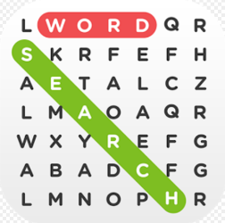  Create either a word search or a crossword based on the Romans.
Write it or Rap it | Spell it out | Bake it
Write a poem or rap about the Romans. It can be about any aspect of the Roman Empire (army, gladiators, emperors etc.). | 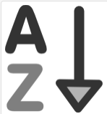  Create an A-Z of the Roman Empire with a definition for each word e.g.  A – Amphitheatre: the centre of entertainment during Roman times.  B – Baths: a public place where Romans went to relax and wash. | Find a recipe for Roman bread and follow it. Include a picture of what you have made and a copy of the recipe.  