Dear parent/carer,
As you may be aware, schools are required to have a remote learning plan in place so that any child who cannot attend school because of COVID-19 does not miss out on their learning. This letter explains our plans for remote learning for children who have to self-isolate, or where local or national restrictions mean that children need to stay at home.
Our remote learning plan
Our remote learning plan has been made with our pupils and their families in mind. We believe that this strategy will work best for the children at our school. For the first two days your child is at home, they will need to log onto Teams and access the assignments page. Here they will find activities for each day to complete. From day 3, each day the children will be expected to be online via Teams at 9am and 1pm for the register (If children are not present and the office have not been contacted then this will be recorded as an unauthorized absence). The class teacher will then be available online throughout the day so the children can listen to the main input for the lessons and then be set work to complete. If the children have any questions, they will need to type them into the chat section and a member of staff will respond as soon as they can. They will be set English and Maths work alongside other foundation subjects such as history or art. The work will be in the assignments section on the class channel of Teams. Work that has been completed should be sent back to the class teacher (as an electronic document or photo) via assignments.
What you’ll need at home
Your child will need access to a laptop or ipad in order to access the learning they need to complete. Your child’s log on for Teams can be found on the original letter sent home and on a label in their diary.
If you are struggling to find it, please contact the school office. They will also need paper and pens etc. If you need any support with resources whilst accessing remote learning, please contact school. For those families who do not have access to a laptop or I pad (or who have more than one child at home and therefore need extra devices) we have limited resources we can provide to families, so please contact school.
What you can do to help
We appreciate that if this situation arises, it may present some challenges for you. We kindly ask for your support so that we can continue to provide high-quality education for your child during this time. Younger children in particular may need support in accessing online materials and staying focused with their remote learning. We ask that you help them as much as you can.
Our top tips:
- Try to encourage your child to be ready and dressed for the start of the day
- Distinguish between weekdays and weekends, and make it clear when the school day is over, to separate home and school life
- Plan breaks and exercise into the day to help keep your child active
Please keep in touch with us and do let us know if you’re having any difficulties with remote learning, or if you have any questions.
Yours faithfully,
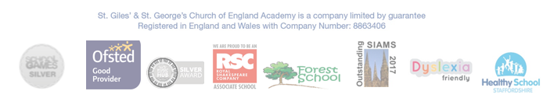
Mrs Pointon

