St Giles’ and St George’s Primary Academy
Homework Menu
Class: Reception Topic: A pirate’s life for me! Term: Summer 1
Set Menu: Daily reading, sound fans
We are asking children to read at least 3 times each week and for parents to record this in their child’s reading record. Listening to children read will enable them to practise their sounds and develop their reading fluency. Please talk to your child about their book, the pictures inside and what might happen next. This will help to develop their comprehension skills and have a better understanding of the text. We will be sharing a variety of texts related to our Pirates topic and helping your child to foster a love of books. We are grateful for your support with this. We also ask that you practise saying the sounds and tricky words on your sound fan daily. Please see the link on our website to ‘Mr Thorne does Phonics’ if you are unsure as to how we pronounce the Phase 2 sounds.
Added Extras:
Please encourage your child to complete as many activities from the menu as they can, but NO LESS than 3 over the half term. Please record the activities in your child’s homework book, this can include photographs. We will ask for homework books handed in during the last week of each half term, in order for us to share and celebrate this learning.

Perform it | Wear it | Design it
Can you learn and perform the I’m a pirate song? Can an adult video it and send it to us via Parent Share on Evidence Me? | Fold paper to make your own pirate hat. Create a design to go on the front. This could be your own pirate logo. Can you complete the outfit and dress as a pirate? Send pictures into your class teacher.  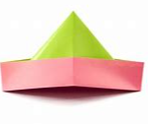 | Create your own treasure map. Where will the x mark the spot? Can you tea stain your map so it looks weathered and old?  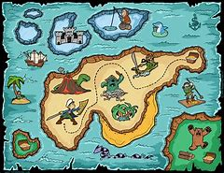
Make it | Balance it | Solve it
Can you make your very own pirate treasure chest? What will you keep in it? Where will you bury it?  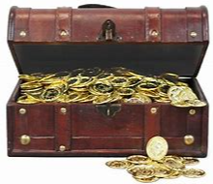 | Can you practise balancing? Find lots of different things to balance on in case you have to walk the plank. Can you make your own ‘walk the plank’? | Can you use the addition sheet to solve the treasure chest calculations? You may also like to create your own calculations by adding and taking away treasure from your chest.
