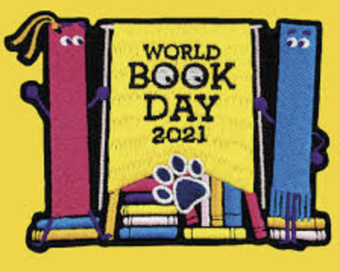

**World Book Day 2021**

On Thursday 4th March, we will be taking part in World Book Day both in school and online.



As part of this day, we will be completing lots of book-linked activities and even having a ‘virtual’ visit from an author!

**On the day, we would like everyone to come (either in school or virtually) dressed as their favourite book character. We are looking forward to seeing all your wonderful costumes.**