UKS2 Recovery Curriculum March 2021
Concerns following lockdown | Suggested activities/teaching | Expected outcome
Children will have missed their friends and being part of a bigger school community. | - Outdoor team building activities (e.g. den making linked to text)  - Forest schools (Faces activity) to be used to get the children to express ideas and emotions  - Y5 & 6 (Summer term) put on their usual end of year production as they have missed out on so many opportunities – children to decide which play they would like to do – uks2 vote  - Using Skellig by David Almond, children will have opportunities for individual and class art/DT project – making their own skellig creatures and a 3D model of the garage and Skellig from the book.  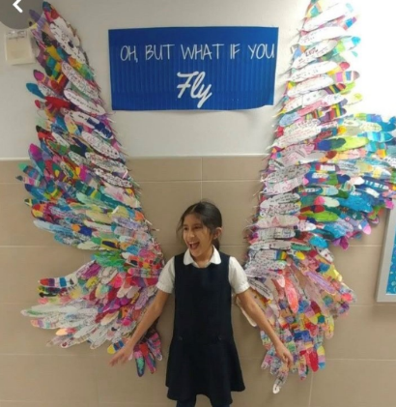  - Work collaboratively to create a display for Skellig – children to write their dreams or hopes on a feather and then have their picture taken. Printed and sent home to remind them of it. | Children reconnect with their friends and school community and feel confident and optimistic for the future
Children will have missed their relationships with their peers and staff.  Children may feel anxious about returning to school after a lot of time away from children. | Use book: Skellig by David Almond  This book is about a child who is experiencing lots of changes in his life and when he moves to a new house, he finds a creature in his garage. He isn’t sure what or who it is but starts to build a relationship and help ‘Skellig’. Explores emotions and changes of characters and their lives.  - Talk about changes that have happened in their lives recently and how this has made them feel- are some good or some bad?  - Explore the feelings of the characters in the book and make links to our lives – explore empathy and understanding what others are going through and how to help them  - Calm brain used to help slow down, quiet and think  - Explore the character of Mina (a girl who is home-schooled) and the pros/cons in children coming to school. Reflect on the missed relationships and the support network that we now have back, in school.  Allow opportunities for children to talk with one another and share their lockdown experiences. Create a class worry jar and share worries anonymously (if appropriate) and get children to generate coping strategies or solutions to the worries of others. | Children will be able to interact and play positively with adults and peers.  Children will be calm and behaviour will be appropriate for inside and outside play.  Children will show empathy towards others who are struggling and know how to support them.
Lack of routine during lockdown, both at home and in school. | - Clear structure to the day which is shared with the children through the daily timetable.  - Visual timetables up in all classrooms to support children with anxieties  - High expectations – revisiting class charter with clear instructions - make sure this is displayed clearly  - Adapted timetable to ensure children still have a clear routine, which includes time for mindfulness, talk, creative learning and team building. | Children will feel safe and welcomed back into their class.  Children will feel ready to learn as they know what to expect.
Children will not be able to reflect upon and express their emotions. | Use book: Skellig  - Discuss key events in the book and explore how the actions of others impacted on the lives of key characters, how the characters helped each other in times of struggle.  - Thought bubbles activity from the perspective of different people in the book and real life  - Explore different ways to show we care and how to help others – create posters using Publisher or paints/pens  Use Twinkl Mind well-being activites: https://content.twinkl.co.uk/resource/9d/45/t-tp-2550427-my-wellbeing-challenge-booklet_ver_1.pdf?__token__=exp=1613836537~acl=%2Fresource%2F9d%2F45%2Ft-tp-2550427-my-wellbeing-challenge-booklet_ver_1.pdf%2A~hmac=a8fca8e9dd85715ea3a19e5cea5becad126ea6c8765434638254eec23b7806ee  Use the poems: The Schoolboy and The Tyger by William Blake  Make links between the themes of the poem and the characters/events of Skellig and their own experiences of school/freedom/being ‘trapped’.  Children to write poems to express their feelings about remote learning/school life.  - Spring 2 PSHE Healthy Me – works through understanding well-being, how to control your own, how to look after your body and mind and how to manage stress. Activities will sensitively reflect upon experiences during lockdown and how to deal with those stresses now moving forward | Children will be able to express and understand their feelings. They will know strategies to help with their worries and they will be able to reflect upon what has been going on.
Children’s resilience and independence will be low from extra parental support/online learning. | - Adapt levels of challenge to ensure that children are working within their comfort zone (green pen>pink pen) before moving them to the learning zone when ready (learning zone model).  - Use of behaviour management and dojos to be consistent. Reiterate behaviour expectations on entry. Lots of dojos given to promote positive ethos.  - Explore possible dojo afternoon rewards to encourage children and to give them the opportunity to experience some of the fun activities they have missed out on.  - Work to be shared regularly on facebook and school webpage to encourage working ethos  - Children to be given challenges to encourage perseverance even if they don’t get to the right answer  - POP UK songs – Never Give Up/Stronger  Use Twinkl Mind well-being activites: https://content.twinkl.co.uk/resource/9d/45/t-tp-2550427-my-wellbeing-challenge-booklet_ver_1.pdf?__token__=exp=1613836537~acl=%2Fresource%2F9d%2F45%2Ft-tp-2550427-my-wellbeing-challenge-booklet_ver_1.pdf%2A~hmac=a8fca8e9dd85715ea3a19e5cea5becad126ea6c8765434638254eec23b7806ee | Children will be resilient to constructive feedback.  Children will persevere when faced with a challenge

