LKS2 Recovery Curriculum March 2021
Concerns following lockdown | Suggested activities/teaching | Expected outcome
Children will have missed their friends and being part of a bigger school community. | - Socially distanced drama games – working together as a team and interacting with each other  - Forest schools (from Spring 1) to be used to get the children to work together  - Create a unique flower with children putting on what makes them special  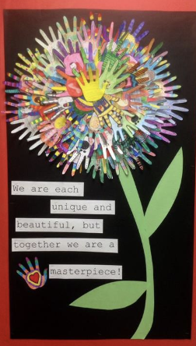 | Children reconnect with their friends and school community and feel confident in asking for help and support
Children will have missed their relationships with their peers and staff.  Children may feel anxious at returning to school after lots of time away from children. | Use book: While we can’t Hug and Hedgehugs  - Talk about things they like to do with their friends. Are there things they can’t do? How could they adapt it so they can?  - Different ways to show you care – PSHE activity (write something you like about the person and pass it round the room so the person gets a list of lots of things); create a card/letter for a friend  - Explore different ways to show we care (while keeping socially distanced) – create posters of the different ways  - Art of Brilliance – Random Acts of Kindness Video – create a Random Acts of Kindness menu for the classroom -which have you done today? Link to Advent and Evan Almighty  - Cosmic Kids Yoga Zen Den activities | Children will be able to interact and play positively with adults and peers.  Children will be calm and behaviour will be appropriate for inside and outside play.
Lack of routine during lockdown, both at home and in school. | - Clear structure to the day which is shared with the children through the daily timetable.  - Visual timetables up in all classrooms to support children  - High expectations – revisiting class charter with clear instructions - make sure this is displayed clearly  - Adapted timetable to ensure children still have a clear routine, which includes time for mindfulness and team building. | Children will feel safe and welcomed back into their class.  Children will feel ready to learn as they know what to expect.
Children will not be able to reflect upon and express their emotions. | Use book: The Boy, The Mole, The Fox and the Horse  - Thought bubbles as characters in the book -how are they feeling and why?  - Create their own character for the book based on them and how they are feeling  - Two characters (two of the children in the class chosen at random) work together to solve their feelings/problems through drama  - Discuss feelings and topics such as ‘Why does kindness make us happy?’  - Create mindfulness posters – a quote that would help you cope with your feelings | Children will be able to express and understand their feelings. They will know strategies to help with their worries and they will be able to reflect upon what has been going on.
Children’s resilience and independence will be low from extra parental support/online learning. | Use book: Giraffes can’t dance  - Complete activities linked to The Power of Yet (https://youtu.be/XLeUvZvuvAs and https://youtu.be/pWp6kkz-pnQ and https://ideas.classdojo.com/b/growth-mindset)  - Adapt levels of challenge to ensure that children are working within their comfort zone (green pen>pink pen) before moving them to the learning zone when ready (learning zone model).  - Use of behaviour management and dojos to be consistent. Reiterate behaviour expectations on entry. Lots of dojos given to promote positive ethos.  - Work to be shared regularly on facebook and school webpage to encourage working ethos  - Children to be given challenges to encourage perseverance even if they don’t get to the right answer  - POP UK songs – Never Give Up/Stronger  - Complete work on Growth Mindset https://www.twinkl.co.uk/resource/t-c-255027-lks2-growth-mindset-lesson-plan-and-differentiated-resource-pack | Children will be resilient to constructive feedback.  Children will persevere when faced with a challenge

