St Giles’ and St George’s Primary Academy
Homework Menu
Class: Reception Topic: Life on the farm Term: Spring 2
Set Menu: Daily reading, sound fans
We are asking children to read at least 3 times each week and for parents to record this in their child’s reading record. Listening to children read will enable them to practise their sounds and develop their reading fluency. Please talk to your child about their book, the pictures inside and what might happen next. This will help to develop their comprehension skills and have a better understanding of the text. We will be sharing a variety of texts related to our Marvellous Me topic and helping your child to foster a love of books. We are grateful for your support with this. We also ask that you practise saying the sounds and tricky words on your sound fan daily. Please see the link on our website to ‘Mr Thorne does Phonics’ if you are unsure as to how we pronounce the Phase 2 sounds.
Added Extras:
Please encourage your child to complete as many activities from the menu as they can, but NO LESS than 3 over the half term. Please record the activities in your child’s homework book, this can include photographs. We will ask for homework books handed in during the last week of each half term, in order for us to share and celebrate this learning.

Perform it | Research it | Design it
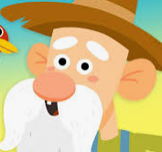  Learn and practise the song ‘Old MacDonald had a farm’. You may like to put some actions to your song to match the animals. Once you have practised and you think you are ready for an audience, why not perform to some people in your household. We would love to see videos. | 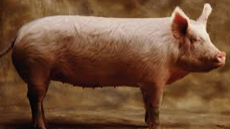  Can you pick a farm animal to research? Can you write some facts about the animal you are researching? Remember to use your writing skills – use your sounds, finger spaces between words, full stops at the end of sentences, capital letters at the beginning of sentences. | 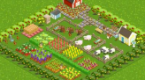  Design a farm. What animals would you keep? Think about where you would place your animals. What crops would you grow? What would your farm house look like?
Grow it | Invent it | Solve it
Grow a bean from Jack and the beanstalk. Watch it grow in a clear plastic bag so that you can see the changes that are happening. Create a bean diary to show how it grew and changed.  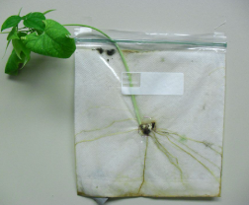 | 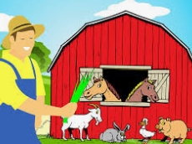  Can you invent your own farm animal? What features would it have? What would it live in on your farm? What would it eat? | 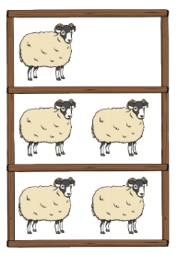  Solve the maths problem by putting all of the animals in pairs to make even numbers. How many of each do you have now?

