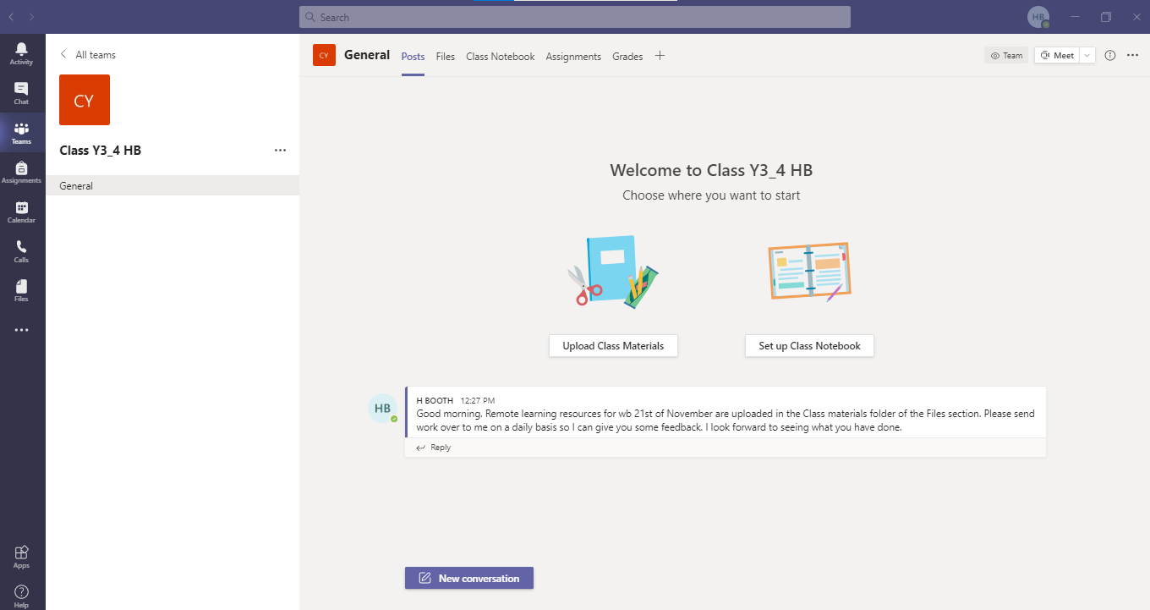

Username:

Password:

**REMOTE LEARNING VIA TEAMS**

* Work will be added to the files section of the channel
* Work can be sent back to the teacher via file/photo upload on the posts section of the main channel or via the private chat
* Online lessons (via the calendar tab) will be used if whole ‘bubbles’ are sent home from school.

The posts tab at the top allows you to start a conversation with everyone in the class or reply to conversations that have already been started. Just click on either reply or new conversation and type your message. It is also possible to upload files and photos to you message by clicking on the paper clip symbol from the options below the box you type in. 

The files tab at the top takes you to a folder called class materials and within that folder you will find all the documents you need for remote learning including an overview of the week.

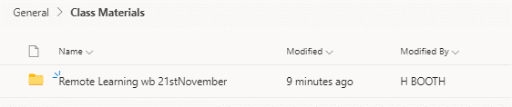

The chat tab on the left allows you to send a private message to the class teacher and once again you can upload files and photos to send along with the message.

**NB: Children are not able to send private messages to each other as this has been disabled.**

The calendar tab on the left allows you to find any events or online lessons that your child is involved in. For online lessons, there will be an option to join the meeting on the blue band and this will take you into the meeting.

