PE Policy

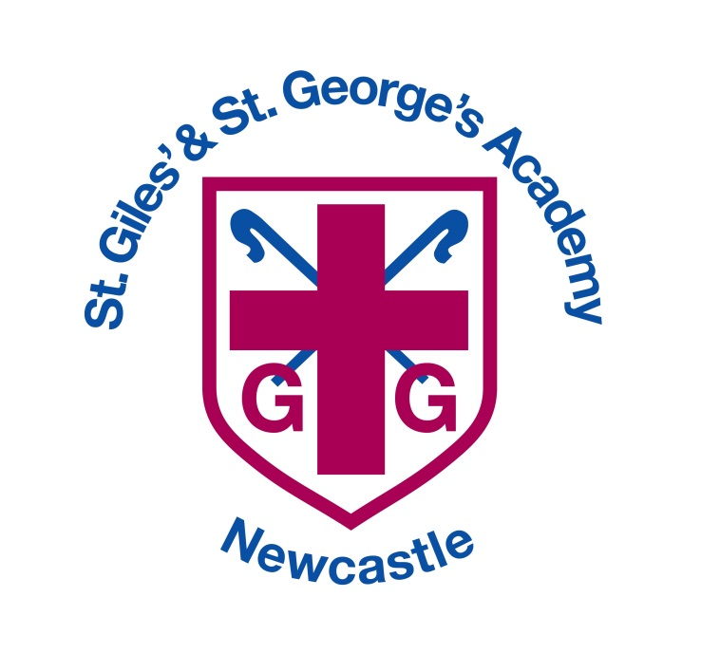

Autumn 2020

Approved by: Date: September 2020
Last reviewed on: September 2020
Next review due by: September 2021

Rationale

A high-quality physical education curriculum inspires all pupils to succeed and excel in competitive sport and other physically demanding activities. It should provide opportunities for pupils to become physically confident in a way which supports their health and fitness. Opportunities to compete in sport and other activities build character and help to embed values such as fairness and respect.

Aims
Our overarching aim for PE at St. Giles’ & St. George’s CE Academy is to promote high standards and to provide opportunities for pupils to become physically confident. We aim to ensure that all pupils:
- develop competence to excel in a broad range of physical activities

- are physically active for sustained periods of time

- engage in competitive sports and activities

- lead healthy, active lives

Guidelines for teaching PE

Children are taught in their class groups. One lesson is taught by specialised PE coaches (Bee active) and the other session by class teachers. Swimming lessons for target year groups are held at Jubilee 2 swimming baths and are led by a qualified swimming teacher usually, unfortunately due to Covid restrictions these cannot take place currently.

All staff are responsible for the planning and teaching of physical education.

As we are following the GetSet4PE scheme this year we not only focus on physical skills but also social, emotional and thinking skills in every session. Fair play and good sporting behaviour are encouraged at all times. Children are also expected to behave in a considerate, responsible manner, showing respect for other people and equipment.

During physical education activities, children are encouraged to discuss safety implications concerning themselves and others.

Special needs pupils are fully integrated and have equality of access to physical education at their appropriate level.

Music and themes used in lessons are balanced to ensure an equal interest level for both boys and girls.

Health and science education issues are addressed in physical education lessons such as the effect of exercise on the heart.

Children are trained to move and store equipment in a safe manner. Points of safety in the use of equipment are taught (Appendix 2)

The teacher must check all equipment before it is used.

Any defects in equipment must be reported to the office and to the co-ordinator and removed from use.

All accidents, however small should be reported, as described in the school health and safety policy.

PE kit and earrings

All children should change into P.E. kit for their practical lessons. Which consists of;
- Plain white shirt

- Navy or black shorts

- Navy or black tracksuit trousers / leggings for cold weather

- Trainers for outdoor work

All earrings must be removed before PE, the child themselves may be asked to remove them, if they are unable to do so a member of staff may ring home to seek permission to remove them.

Staff should wear appropriate clothing and footwear during P.E. lessons.

Any child who is deemed not safe to take part in PE due to incorrect kit will be given the role of coach or official to enable them to take part appropriately.

PE curriculum planning
Our PE curriculum is based on Get Set 4 PE (although it has been adapted to suit the school). While there are opportunities for children of all abilities to develop their skills and knowledge in each teaching unit, the progression planned into the scheme of work means that the children are increasingly challenged as they move through the school.
We teach PE in EYFS as an integral part of the topic work covered during the year during continuous provision and pupils also have a session with our Bee active coaches. We relate the physical aspects of the children’s work to the objectives set out in the Early Learning Goals (ELGs) which underpin the curriculum planning for children aged three to five. PE contributes to a child’s personal and social development.
Assessment

Physical Education assessment is used to inform teachers and pupils of their current attainment and their rates of progress. Formative assessment is used to plan for the next step in learning. Notes on how the children are accessing the steps are noted on the bottom of the medium term plan, pink if children are struggling with an area and green if they are excelling.
The outcomes of the teacher assessments (based on the notes made on medium term plans) are recorded on DC Pro.
Assessment takes place as the children’s work is in progress. It is an ongoing activity and can be conducted in a number of ways. e.g.
· Observing what children are doing
· Listening to the children’s discussions
· Questioning the children on their work
· Discussing children’s work with them
· Collecting evidence of children’s work while it is in progress.
Evaluation of outcomes should:
· Take place at the end of a unit of work and at the end of a key stage
· Be made with evidence from assessment
· Require specific criteria to measure achievement
· Be linked to the objectives set for particular unit of work for the end of key stage statements
· Provide a basis for recording and reporting children’s achievements.
Inclusion

At our school we teach PE to all children, whatever their ability and individual needs. PE forms part of the school curriculum policy to provide a broad and balanced education to all children. We strive to meet the needs of the SEND pupils so they can access all of the provision outlined in this policy at their appropriate level. Intervention strategies and one-to-one support are used by teaching staff to meet the learning needs of specific pupils.

Resources

All of the resources linked to the Get Set 4 PE sessions can be found in the PE store or the hall store (such as gymnastics equipment that will be used in the hall).

