St Giles’ and St George’s C of E Academy
Homework Menu
Year Group: 5/6 Topic: Our Changing World Term: Spring 1
Set Menu Timetables, spellings, daily reading, phonics practise
We will be looking for children to be reading at home with their parents or carers. Listening to children read will enable them to grow in confidence as they become fluent readers. Once children are able to read fluently and with expression, hold discussions around the comprehension of the text (we will provide a bank of ideas to support this). If your child is reluctant to read they could listen to audio books. We want them to foster a love of books so please do not underestimate the value of reading to your child.
Added Extras
We will encourage your child to complete as many of the activities for the menu as they like at home but NO LESS than 3 over the half term. This can be recorded (if appropriate) in our home books. We will ask for homework books on the last Monday of each half term in order for us to share and celebrate the learning.
Read it | Research it | Design it
Visit the library or your school MyOn account to read books and write reviews about our changing world as part of our topic this half term. On your MyOn account, there is a collection of books linked to this topic for you to read, review and complete AR quizzes on. | - Research the different types of erosion and weathering that can happen to coastlines.  - Research a local place/landscape that has changed in its appearance. Can you find any pictures to support this? How has Newcastle changed over time? | Design a rainforest species that you may find in this habitat. Remember to link it’s characteristics to suit this environment so it will thrive.
Practise it | Write it | Make it
Use the SPaG sheet you have been given to learn the key grammar vocabulary in the grey and green sections. Use the maths fact sheet 3 at the back of your school diary to learn the key facts.  These will be visited within school throughout the half term. | Write a fact file about the Amazon rainforest or an animal that lives in there.  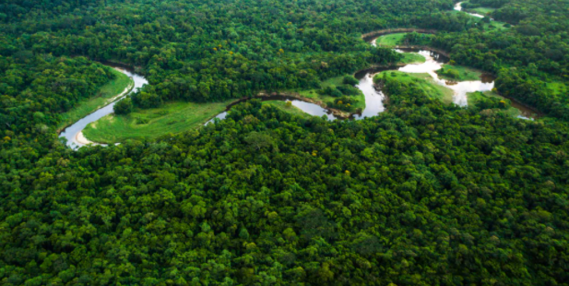 | Make a 3D globe, can you identify the seven seas? Can you identify coastlines?  