St Giles’ and St George’s
Homework Menu

Class: 1HG/1HM Teacher: Mrs Gray/ Miss Maqsood Term: Spring 1
Set Menu: Daily reading, spelling, mental maths.
We are asking children to read at least 3 times each week and for parents to record this in their child’s reading record. Listening to children read will enable them to practise their sounds and develop their reading fluency. Please talk to your child about their book and the pictures inside, this will help to develop their comprehension skills and have a better understanding of the text. Use the coloured book mark to support you with questioning. We will be sharing a variety of texts related to our Toys topic and helping your child foster a love of books. We are grateful for your support with this.
Added Extras:
Please encourage your child to complete as many activities from the menu as they can, but NO LESS than 3 over the half term. Please record the activities in your child’s homework book, this can include photographs. We will ask for homework books handed in during the last week of each half term, in order for us to share and celebrate this learning.

Map it out | Photograph it | Work it out
Draw an aerial map of a room in your house. Remember to include a key.  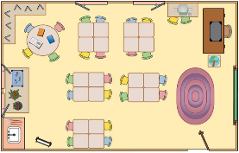 | Go for a walk in the local area looking for signs of Winter. Take photographs/collect objects and write about them. | Complete the maths booklet provided.  Choose from any of the maths games on the link below.  https://www.education.com/games/numbers-11-20/
Watch it | Write it | Research it
Watch the local weather for a week and ask an adult to show you our local area. Record your findings using weather symbols e.g. Type of weather and temperature. | Record a detailed journey about how you get from home to school? What do you see on the journey? What buildings do you pass by? | In science our topic is ‘Animals Including Humans’. Choose and research an animal that is either a bird, fish, reptile, mammal or amphibian. Present your research as a poster.

