St Giles’ and St George’s Primary Academy
Homework Menu
Class: Reception Topic: Once upon a time… Term: Spring 1
Set Menu: Daily reading, sound fans
We are asking children to read at least 3 times each week and for parents to record this in their child’s reading record. Listening to children read will enable them to practise their sounds and develop their reading fluency. Please talk to your child about their book, the pictures inside and what might happen next. This will help to develop their comprehension skills and have a better understanding of the text. We will be sharing a variety of texts related to our Marvellous Me topic and helping your child to foster a love of books. We are grateful for your support with this. We also ask that you practise saying the sounds and tricky words on your sound fan daily. Please see the link on our website to ‘Mr Thorne does Phonics’ if you are unsure as to how we pronounce the Phase 2 sounds.
Added Extras:
Please encourage your child to complete as many activities from the menu as they can, but NO LESS than 3 over the half term. Please record the activities in your child’s homework book, this can include photographs. We will ask for homework books handed in during the last week of each half term, in order for us to share and celebrate this learning.

Perform it | Rhyme it | Work it out
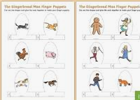  Cut out and fix together the ‘Gingerbread man’ puppet characters. Then use them to tell the story. Act it out with your family or even perform it for your family. | 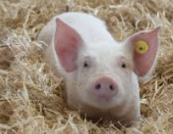  Think of and write down a rhyming string. Think of at least five words that rhyme with ‘pig’. Write them down, get a grown up to help you or draw the pictures to match the word. | Little Red Riding Hood took 4 cakes and 2 biscuits in her basket to Grandma’s house. Work out how many treats she had altogether.  Draw the calculation to help you. Can you write the number sentence to match?  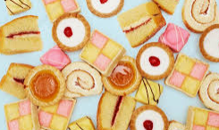  Challenge yourself by thinking of your own addition number story.
Create it | Map it out | Bake it
Create a mask of a character from your favourite traditional tale. Think about how the character is feeling and the expression on their face.  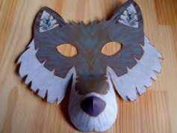 | Draw an imaginary map to show Little Red Riding Hood how to get to Grandma’s house. Think about features and symbols that are on a map.  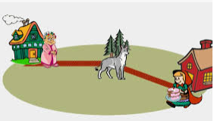 | 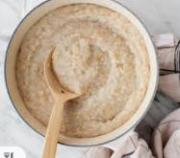  Why not try out your baking skills and make some gingerbread men or try making some porridge that is just how Goldilocks likes it. You could try it with different toppings.

