St Giles’ and St George’s Primary Academy
Homework Menu
Class: Nursery Theme: Bedtime Stories Term: Spring 1
Set Menu: Daily reading, sound fans
We are asking children to share their library book each week and for parents to record this in their child’s reading record. You can introduce early reading skills such as: turning the pages carefully, holding the book correctly, talking about the pictures and anticipating what might happen next.
Added Extras:
Please encourage your child to complete as many activities from the menu as they can, but NO LESS than 3 over the half term. We will ask for homework to be handed in during the last week of each half term, in order for us to share and celebrate this learning.

Draw/Write it | Practise it | Research it
Can you draw your favourite character from a bedtime story?  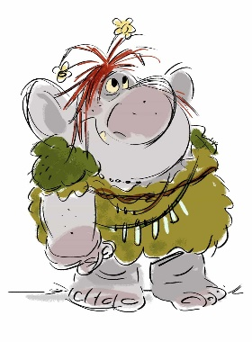 | Practise putting your shoes and socks on.  If you can do this why not…  practise getting dressed without your grown ups help. | Can you find out what your family members favourite bedtime story is? Why do they like that one best? Who is their favourite character?
Make it | Design it | Read it
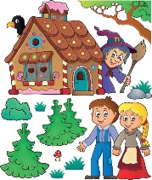  Can you make a model house for the witch in Hansel and Gretel. This could be out of cardboard, playdough or even out of gingerbread, whatever you choose. | Can you design new boots for Puss in Boots? What colour will they be? How will they fasten? | What’s your favourite bedtime story? Can you retell it to a grown up?

