4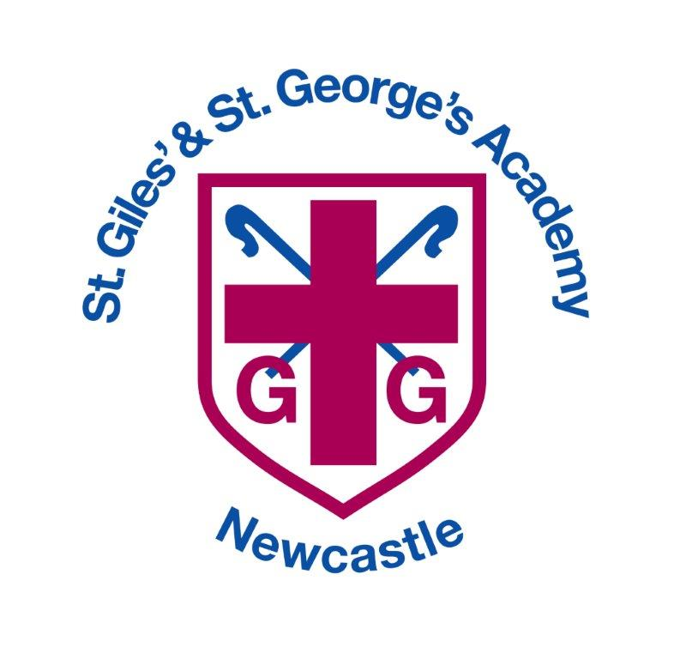

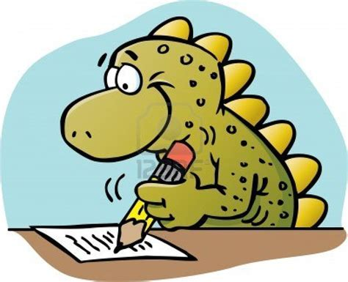
English Curriculum

English Curriculum
2020 – 2021

Intent – writing
Whole class reading
Intent – handwriting
Overview Nursery/Reception
Overview – Year 1 and 2
Overview – LKS2 A and B
Overview – UKS2 A and B
Overview - Writing for Purposes
Nursery
Reception
Year 1
Year 2
LKS2 A
LKS2 B
UKS2 B
Learning journeys

Intent - Writing

As a Church of England school, our English curriculum is underpinned by our gospel values. These values are used and applied throughout the English curriculum. Our children are learned and wise in the way that they practise and apply English skills in a variety of different contexts and use these skills to write for a real purpose. They show curiosity, attentiveness and active learning through their independence within lessons, following their own learning journey, taking charge of their own learning by using a variety of resources, including their working wall and continuously acting on their ‘pink pen’ feedback through active marking within each lesson. Our gospel values create a solid moral background for our children and encourage them to become better members of society.

At the heart of our English curriculum is our core skills, evident in our termly learning journeys. These skills are progressive and are built on year after year from EYFS all the way through to Year 6. This ensures that children are given opportunities to practise and apply English skills, for instance composition, grammar, spelling and comprehension in different contexts and make good progress in all areas. These learning journeys enable our pupils to be ready to access the next stages in their education, culminating in them being well-equipped in their English education for secondary school.

Our children come from a wide range of backgrounds and many are not equipped with the English skills and experiences they need to become the best readers and writers that they can be. We have worked together to create our main outcomes that we want for our children. In English, we want to instil curiosity and a love of learning through immersion in high quality texts. Real-life experiences provide children with purposeful contexts for their writing. Our class/lesson set-up and marking policy promotes independence, resilience and high aspirations through our bronze, silver and gold learning journeys.

Our gospel values, core skills and key outcomes will raise aspirations and ensure that our children are more than ready for the next stages in their English journey.

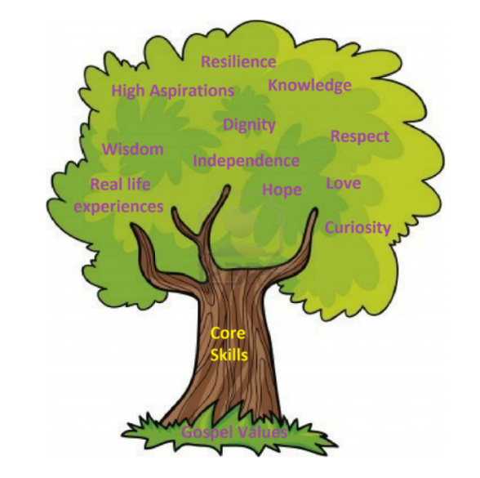

Whole Class Reading

Harriet and Henry – Our reading heroes!
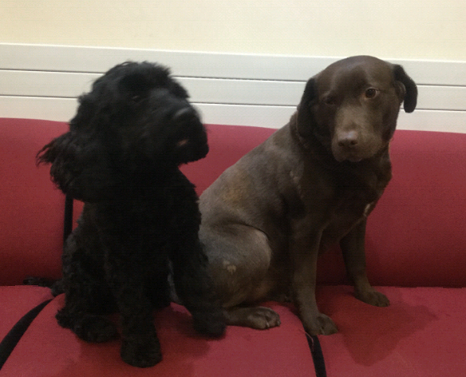

At St Giles’ and St George’s Academy, reading skills are taught explicitly through four 20-25 minute whole class reading sessions per week. Within these, children are exposed to a variety of reading strategies to promote fluency, expression and word recognition, such as choral, paired, echo and individual reading.

We use the same quality text to teach both reading and writing skills, meaning that children become very familiar with the vocabulary, structure, characters and key themes within the text. Each reading skill (content domain) is linked to a reading dog, meaning that children are very familiar with what each dog relates to.

Key Stage 1 Reading Dogs Key Stage 2 Reading Dogs
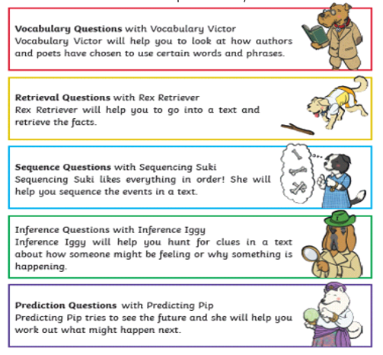
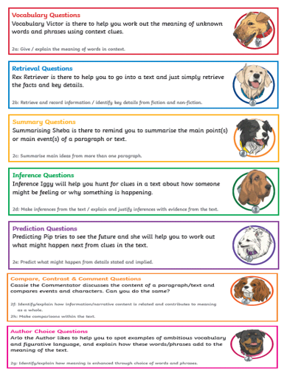

Intent - Handwriting

We aim for our children to leave in Year 6 with the ability to write using their own style of fast, fluent, legible and sustainable handwriting, as well as other styles of writing for specific purposes. In addition to teaching handwriting during our regular handwriting lessons, we have high expectations that what is taught and practiced in handwriting lessons will be used in all writing activities. We believe that handwriting is integral to a child’s personal development and know that children’s engagement and self-esteem can be improved by their satisfaction and pride in good quality presentation.

Handwriting is a taught skill that develops at different rates for different children. All of the teachers in our school put a priority on teaching handwriting and have high expectations for handwriting across the curriculum. Our school uses Penpals for Handwriting to ensure that:
- The importance of handwriting is recognised and given appropriate time.
- The progression of handwriting is consistent across the school.
- Handwriting is acknowledged to be a whole body activity and emphasis is placed on correct posture and pencil grip for handwriting.
- Expectations of left-handed children are equal to those of right-handed children, and appropriate advice and resources are available to ensure that they learn to write with a comfortable, straight wrist.
- Handwriting is linked into grammar, punctuation and spelling in order to practice and contextualise all of the transcriptional and stylistic skills for writing.
- Children learn to self-assess their own writing and develop understanding and responsibility for improving it.
- Children learn to write in different styles for different purposes such as print for labelling a diagram, illustrated capitals letters for creating a poster, swift jottings for writing notes, making a ‘best copy’ for presentation and fast, fluent and legible writing across the curriculum.
Throughout their time at St Giles’ and St George’s Academy, children use a range of tools for different purposes and styles of handwriting including:
- A wide range of tools and media for mark-making in the EYFS.
- Whiteboard pens throughout the school.
- Fingers when writing on the interactive whiteboard.
- Art supplies including coloured pens and pencils for posters, displays and artwork.
- Sharp pencils for most writing until a pen licence is awarded.
- A handwriting pen for when they sustain a good level of presentation.
All of our children have equal access to handwriting lessons and to the resources available. We recognise that some children take longer to develop the necessary skills and we cater for those children by providing additional opportunities for skills development. Children who need specific fine motor or handwriting interventions are identified early and the impact of interventions is carefully monitored. Children with a physical disability are catered for, and progress is monitored, according to their additional support plans.

English Overview - Nursery

 |  | Autumn 1 | Autumn 2 | Spring 1 | Spring 2 | Summer 1 | Summer 2
Nursery | Writing  Genres | Sensory mark-making.  Gross motor movements.  Range of topic themed drawing developing clearer marks (vertical and horizontal lines, circles.) Fireworks, balloons, presents, baubles etc…  Listening to stories with good attention. |  | Range of topic themed drawings showing more detail with some description. Shoemaker tools, shoes, snowflakes, snowman, winter scene, maps, vehicles.  Listening to initial sounds.  Retelling Stories. |  | Range of topic themed drawings, clear picture, willingly discusses and with simple labelling.  CVC words/simple phrase  Can copy some letters  Predicting and suggesting ending to stories.
 | Core Text | - | The Secret Birthday Message  Eric Carle | The Elves and the Shoemaker  Alison Edgson  Jack Frost  Kazuno Kohara | The Jolly Postman  Allan Ahlberg  The Naughty Bus  Jan and Jerry Oke | The Gruffalo  Julia Donaldson  Whatever Next  Jill Murphy | The Lighthouse Keeper’s Lunch  David Armitage  The Very Hungry Caterpillar  Eric Carle
 | Additional  Text | - | Hovis the Hedgehog  Lynda Leigh-Crawford | Cinderella  Jess Stockham  Little Fern’s First Winter  Jane Simmons | People Who Help US book series  Mr Gumpy’s Outing  John Burningham | Monster Zoo  Amy Sparkes  Alien’s Love Underpants  Claire Freedman | The Train Ride  June Crebbin  The Tiger Who Came To Tea  Judith Kerr
Cycle 1 Cycle 2

English Overview - Reception

 |  | Autumn 1 | Autumn 2 | Spring 1 | Spring 2 | Summer 1 | Summer 2
Reception | Writing Genres | Labelling and captions  Character description | Retelling  Porridge recipe  Apology letter | Narrative  Letter  Recipe | tbc | tbc | tbc
 | Core Text | Funnybones  Handa’s Surprise  Super Duper You  What makes me a me? | The way back home  Peace at last  Beegu  The bog baby | Various fairy tales | tbc | tbc | tbc
 | Additional Texts | Argh there’s a skeleton inside you | Handa’s noisy night  Eileen Browne | Snowflake Mistake | tbc | tbc | tbc

English Overview - Year 1 and 2

 |  | Autumn 1 | Autumn 2 | Spring 1 | Spring 2 | Summer 1 | Summer 2
Year 1 | Writing Genres | Labels and captions | Simple retelling using pictures.  Missing poster | Thought bubble  Diary entry  Setting  descriptions | TBC | TBC | TBC
 | Core Text | Traction Man is Here!  Mini Grey | Dogger  Shirley Hughes | Tree: Seasons come, seasons go.  Patricia Hegarty | Wild  Emily Hughes | The paperbag princess  Robert Munsch | Look inside a castle  Conrad Mason
 | Additional Texts | Toys in Space  Mini Grey | Toys and Games by Sally Hewitt | The Grass House (poem) by Shirley Hughes | I am the seed that grew the tree  Fiona Waters | Castles  Colin Thompson | The Dragon Machine by Helen Ward
Year 2 | Writing Genres | Fictional recount | Postcards  Retelling | Diary  Recount of an experience | New chapter | Narrative 3rd person | Non-Chronological report  Detailed retelling developing setting and character.
 | Core Text | Bob the man on the moon  Simon Bartrum | Meerkat Mail  Emily Gravett | Vlad and the Great Fire of London  Kate Cunningham | Firecat  Pippa Goodhart | Flotsam  David Weisner | Lila and the secret of rain  David Conway
 | Additional Texts | Space Poems | Great Explorers  Alastair Humpreys | The Great Fire of London  Emma Adams | The Great Fire of London Unclassified  Nick Hunter | Seaside holidays  Stewart Ross | We’re from Kenya  Young Explorers  Viv Young

English Overview – LKS2 A and B

 |  | Autumn 1 | Autumn 2 | Spring 1 | Spring 2 | Summer 1 | Summer 2
LKS2 A | Writing Genres | Informal note  Description | Information text (biography)  Narrative | Thought bubble  Setting description  Poem | Retelling  Newspaper article | TBC | TBC
 | Core Text | Queen Victoria’s bathing medicineGloria Whelan | The Beast of Buckingham palace  David Walliams | The Flower  John Light | Escape from Pompeii  Christina Balit | Romans on the rampage  Jeremy Strong | You wouldn’t want to be a Roman soldier  David Stewart
 | Additional Texts | Kings and Queen: Usborne History of Britain | Kings and Queens by Tony Robinson | What is Pink? By Christina Rosetti | Eyewitness – Volcano and Earthquake Susanna Van Rose  Earth Shattering Events by Sophie Williams | Meet the Ancient Romans  James Davies | What the Romans did for us  Alison Hawes
LKS2 B | Writing Genres | TBC | Character Description  Story Retell  Letter  Non-Chronological Report | TBC | TBC | Poem  Playscript | TBC
 | Core Text | Beowolf  Michael Morpurgo | The Dragon’s Hoard  Lari Don | Once upon a raindrop: The story of water  James Carter and Nomoco | Around the world in 80 days  Rob Alcraft | The Egyptian Cinderella  Shirley Climo | The lost diary of Tutankhamun’s mummy  Clive Dickinson
 | Additional Texts | How to be an Anglo Saxon in 13 easy steps by Scoular Anderson | Vikings in 30 seconds by Philip Steele | The Rhythm of the Rain by Graeme Baker-Smith | Usborne Illustrated Stories from Around the World. | Meet the Ancient Egyptians  James Davies | Egypt Maginified by David Long and Harry Bloom

English Overview – UKS2 A and B

 |  | Autumn 1 | Autumn 2 | Spring 1 | Spring 2 | Summer 1 | Summer 2
UKS2 A | Writing Genres | Diary  Biography  Flashback story | Newspaper article  Poetry | Setting description  Diary  Narrative | Biography  Formal letter  Diary entries | Write your own myth  Non-chronological report | Playscript  Poetry
 | Core Text | Blitzed  Robert Swindells | Letters from the lighthouse  Emma Carroll | Journey to the river sea  Eva Ibbotson | Amazing Evolution  Anna Claybourne | A Visitor’s Guide to Ancient Greece  Lesley Sims | So you think you’ve got it bad: A kid’s life in Ancient Greece by Chae Strathie
 | Additional Texts | One Boy’s War  Lynne Huggins-Cooper | Whose for the game? by Jessie Pope (poem) | Charles Darwin and the Beagle Adventure by Amanda Wood | The Lost Words by Robert Macfarlane and Jackie Morris | Greek Myths  Marcia Williams | Great Greeks by Paul Perro
UKS2 B | Writing Genres
 | Core Text | Stig of the Dump by Clive King | The Jamie Drake Equation by Christopher Edge | A Potteries Boy by Jean Hayward | The Incredible Adventures of Professor Branestawm by Normal Hunter | The Boy in the Tower by Polly Ho-Jen | The Hero Twins: Against the Lords of Death. A Mayan Myth by Dan Jolley
 | Additional Texts | Stone Age Tablet by Andrew Langley | The Boy who Biked the World by Alastair Humphreys | Son of the Circus: A Victorian Story by E.L. Norry | Children’s History of the Potteries by Bob Fowke | History Detectives: Mayan Civilisation by Clare Hibbert | The Great Kapok Tree by Lynne Cherry

Nursery - Autumn

Core Text | Additional Text

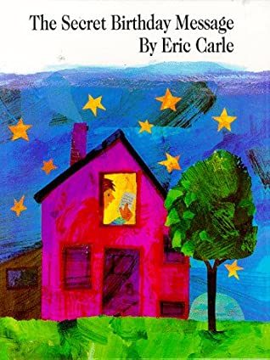

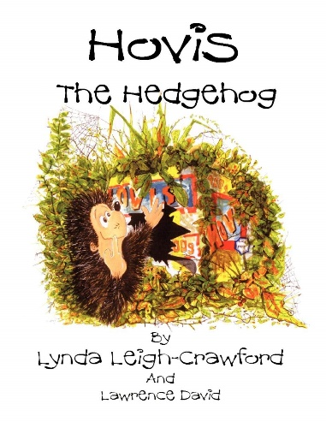

The Secret Birthday Message by Eric Carle Hovis the Hedgehog by Lynda Leigh-Crawford

Skill Information
Genre | Picture Book  Rhyme
Writing/drawing opportunities | Sensory mark-making.  Gross motor movements.  Range of topic themed drawing developing clearer marks (vertical and horizontal lines, circles.) Fireworks, self-portrait, birthday balloons, birthday presents, bauble design etc…  Listening to stories with good attention.
Outcomes | Distinguishes between different marks they make – clearer marks and willingly describes what it Shows when questioned.  Can make vertical and horizontal lines.  Can make circles.
Reading skills
Gospel Values | Compassionate and Loving – Festivals and Celebrations is a time to be with family and the people you love.

Nursery - Spring

Core Texts

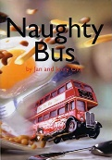
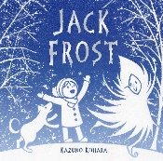
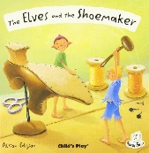
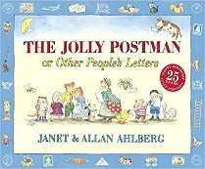

Additional Texts

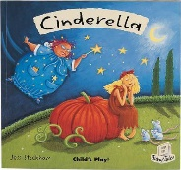
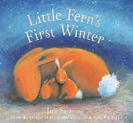
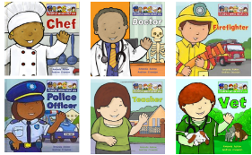
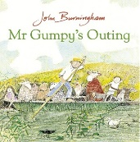
Skill Information
Genre | Rhyme, Narrative, Information Books
Writing /drawing Opportunities | Range of topic themed drawings showing more detail with some description. (Shoemaker tools, shoes, snowflakes, snowman, winter scene, winter animals, maps, vehicles, simple road signs, tools and equipment, observational drawings.)
Outcomes | Sometimes gives meaning to marks – clearer picture with some description.  Hear, says and writes initial and end sounds.  Is beginning to use three fingers (tripod grip) to hold writing tools
Reading skills
Gospel Values | Faith Filled and Hopeful – Never lose hope, always have faith that things will get better.  Attentive and discerning – How is the weather changing around me?  Grateful and generous – I understand how different people help us in different ways.  Curious and active – How have transport vehicles changed over time?

Cycle 1 or Cycle 2

Core Texts | Additional Text
Reception - Autumn 1

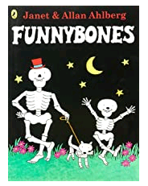
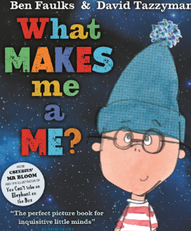
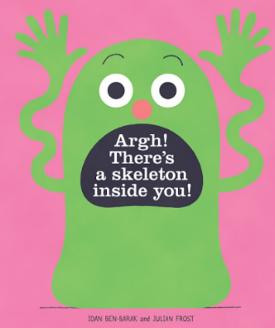

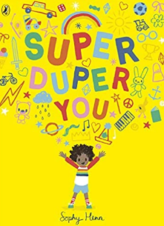
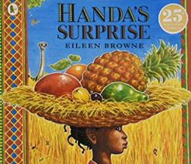

Skill Information
 | Unit 1 | Unit 2
Genre | Narrative | Non-fiction information
Writing skills | Draw a clear picture. Talk about pictures in detail.  Ascribe meaning to marks.  Hear the initial sound in words.  Form some recognisable letters.  Hold pencil correctly. | Hear initial sounds in words.  Represent sound correctly.  Write name correctly.  Write labels  Understand information can be found in books.
Writing opportunities | Story Map of Funny bones.  Drawing and labelling characters.  Labelling of Handa’s foods  Draw and label your own Super Duper You. | Drawing and labelling body parts – small scale and large scale.
Hot Write | Draw and label/write about what makes you, you. | Draw and label your family
Reading skills
Gospel Value | Love and Compassion – I have love and compassion for my family | Curious and Active – I am curious to find out more about myself and the people around me.

Reception - Autumn 2

Core Text | Additional Texts
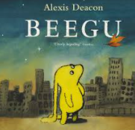
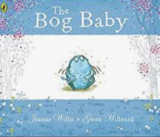

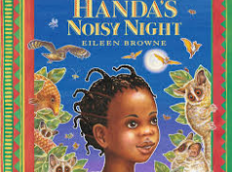

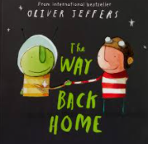
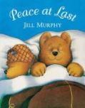

Skill Information
 | Unit 1 | Unit 2
Genre | Narrative, recipe, letter | Narrative, recount
Writing skills | To hear initial and final sounds in words.  Begin to hear more sounds in words.  Orally blend and segment words.  Know which letters represent some sounds.  Represent sounds correctly. | To hear initial and final sounds in words.  Begin to hear more sounds in words.  Orally blend and segment words.  Know which letters represent some sounds.  Represent sounds correctly.
Writing opportunities | Retelling the story.  Drawing and labelling characters.  Character speech bubbles.  Directions back to planet/your home.  Lost poster for Bob Baby | Descriptive words for animals, etc…  List of sounds that Handa can hear and animals.  Story map
Hot Write | Character profile of Beegu | Retelling story- sequencing
Reading skills
Gospel Values | Eloquent and truthful – I understand the importance of being truthful and understand right from wrong. | Grateful and Generous – I am grateful for the wonderful world around me.

Reception – Spring 1

Reception – A
Skill Information
 | Unit 1 | Unit 2
Genre | Narrative, non-narrative – letter, recipe | Narrative
Writing Skills | To hear initial and final sounds in words.  Begin to hear more sounds in words.  Orally blend and segment words.  Know which letters represent some sounds.  Represent sounds correctly.  Finger spaces between two words. | To hear initial and final sounds in words.  Begin to hear more sounds in words.  Orally blend and segment words.  Know which letters represent some sounds.  Represent sounds correctly.  Finger spaces between two words  Ordering of events
Writing opportunities | Labelling  Character description/comparison  Story map  Sentence level work | Instructions – how to make a snowflake
Hot Write | Letter of apology - Goldilocks | NA
Key Reading skills
Gospel Value | Intentional and prophetic – why was Goldilocks/the wolf in the wrong? What should they have done? | Curious and active – exploring changes in winter.
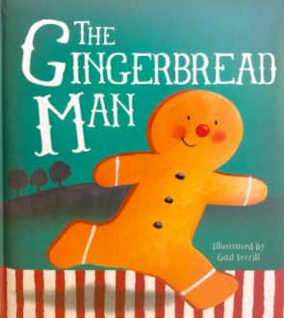
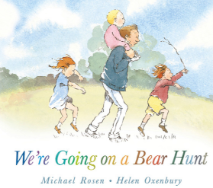  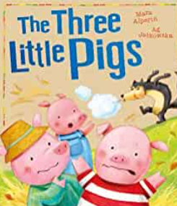  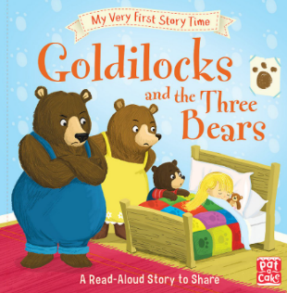  Core Text | 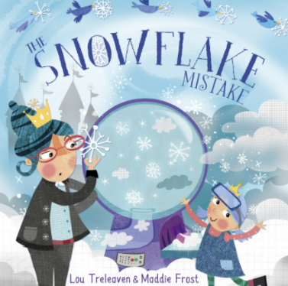  Additional Text
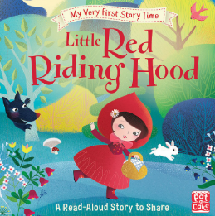

Year 1 - Autumn 1

Core Text | Additional Text
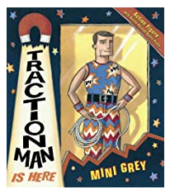  Traction Man is Here by Mini Grey | 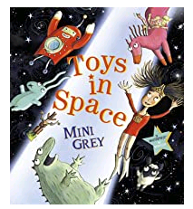  Toys in Space by Mini Grey

Skill Information
 | Unit 1 | Unit 2
Genre | Narrative | Fiction
Writing skills | Show correct pencil grip and sit correctly at a table.  Write a simple sentence that makes sense.  Use the personal pronoun ‘I’.  Know that a capital letter starts a sentence  Know that a full stop is used at the end of a sentence.  Consistently use finger spaces between each word. | Write sentences that makes sense.  Use the personal pronoun ‘I’.  Most writing can be read without mediation.  Know that a capital letter starts a sentence  Know that a full stop is used at the end of a sentence.  Consistently use finger spaces between each word.  Use conjunctions ‘and’ and ‘because’
Short write | Predictions  Speech/thought bubbles  List of settings  Describe a new setting  Draw and label a new suit  Character description | Front cover predictions  Sentences about pictures  Thought bubble  Story predictions with reasons  Descriptive sentences about Hoctopize  List for party
Hot write | Sentences relating to Traction Man’s adventures. | Retell the end of the story.
Reading skills
Gospel value | Wise - I can use my learning for the common good, like Traction Man helping others.. | Attentive and discerning – I am attentive and know how to make the right choices. Did Hoctopize make the right choices?

Year 1 - Autumn 2

Core Text | Additional Texts
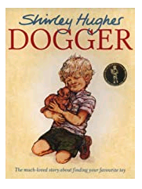  Dogger by Shirley Hughes | 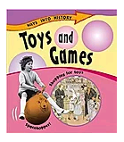  Toys and Games by Sally Hewitt

Skill Information
 | Unit 1 | Unit 2
Genre | Narrative | Non-fiction information
Writing skills | Write a simple sentence that makes sense.  Most writing can be read without mediation.  Use the personal pronoun ‘I’.  Know that a capital letter starts a sentence  Know that a full stop is used at the end of a sentence.  Use finger spaces between each word.  Use conjunction ‘and’ and ‘because’  Use adjectives to describe nouns  Begin to write list sentences. | Write a simple sentence that makes sense.  Most writing can be read without mediation.  Use the personal pronoun ‘I’.  Know that a capital letter starts a sentence  Know that a full stop is used at the end of a sentence.  Know that a question mark (?) is used at the end of a question.  Use finger spaces between each word.  Use conjunction ‘and’ and ‘because’  Use adjectives to describe nouns
Short write | Front cover predictions  Sentences about Dogger  Thought bubble for Dave  Lost poster  Retell beginning/middle | Make a list of toys (rich/poor)  Facts about Victorian toys  Comparing toys and games.
Hot write | Re-tell the end of the story | Sentences about how Victorian children played.
Reading skills
Gospel value | Loving and compassionate – I can empathise with Dave and understand how he might feel. | Curious and active – I am eager to find out new information.

Year 1 - Spring 1

 | Core Text |  | Additional Text
 | 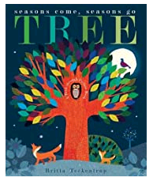  Tree: Seasons Come, Seasons Go by Patricia Hegarty |  | 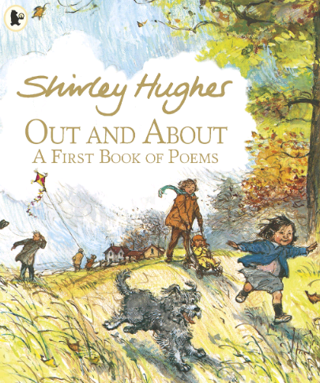  The Grass House (Poem) by Shirley Hughes
Skill Information
 |  | Unit 1 |  | Unit 2
Genre |  | Narrative |  | Poetry
Writing skills |  | Use capital letters and full stops accurately.  Use the personal prounoun ‘I’  Use adjectives to describe nouns.  Use the conjunctions ‘and’ ‘because’ and ‘but’ to join ideas.  Begin to write 2A sentences. |  | Use capital letters and full stops accurately.  Use the personal prounoun ‘I’  Use rhyming couplets.  Use adjectives to describe nouns.  Use the conjunctions ‘and’ ‘because’ and ‘but’ to join ideas.  Begin to write 2A sentences.  Use exclamation marks.
Short write |  | Thought Bubble  Sentences about a picture  Diary entry  Setting Description |  | Thought bubble  Writing in role
Hot write |  | Setting description |  | Stanza of a poem
Reading skills
Gospel value |  | Grateful and generous – I can observe the seasons and think about what I am grateful for, in nature. |  | Attentive and discerning – I can be attentive to my experiences and think of a place that makes me feel happy.

Year 2 - Autumn 1

Core Text Additional Text
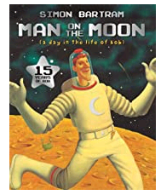
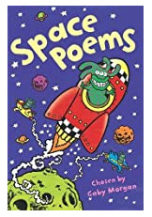

Man on the Moon by Simon Bartrum Space Poems by Gaby Morgan

Skill Information
 | Unit 1 | Unit 2
Genre | Narrative | Poetry
Writing skills | Simple and compound sentences punctuated correctly.  Expanded noun phrases  Time sentence starters  Co-ordinating conjunctions  Verb choices | Vocabulary is appropriate to the subject and is sometimes ambitious  Questions accurately punctuated with a ?  Verb choices
Short write | Sentences relating to illustrations. | Descriptions of planets.
Hot write | Recount of Bob’s day on the moon. | Where am I poem?
Reading skills
Gospel value | Curious and active – I wonder about the world and beyond. | Curious and active – I wonder about the world and beyond.

Year 2 - Autumn 2

Core Text Additional Text
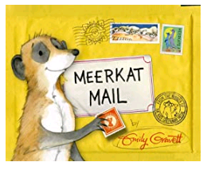
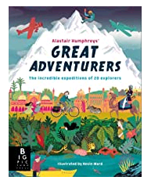

Meerkat Mail by Emily Gravett Great Adventurers by Alastair Humphreys

Skill Information
 | Unit 1 | Unit 2
Genre | Narrative | Non-fiction - information
Writing skills | Sequences of simple and compound sentences  Expanded noun phrases  Time sentence openers  Co-ordinating conjunctions  Verb choices  2A sentences | Word bank and planning is used to inform writing.  Simple past tense- ed.  Use of facts.  Sequences of simple and compound sentences  Vocabulary choices appropriate for the genre  Writes sentences in different forms – statement and question.
Short write | Postcard as Sunny  Research on Kalahari Desert | Fact file on Alastair Humphreys  What an explorer might need
Hot write | Report on the Kalahari Desert | Biography on Amelia Earhart
Reading skills
Gospel value | Curious and active – I am curious about the world around me. | Grateful and generous – I understand how explorers have helped so I can lead the life I do today.

Year 2 - Spring 1

Core Text Additional Text
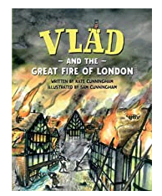
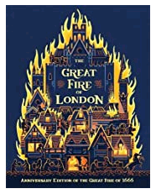

Vlad and the Great Fire of London by Kate Cunningham The Great Fire of London by Emma Adams

Skill Information
 | Unit 1 | Unit 2
Genre | First person Narrative | Non-fiction
Writing Skills | 2A sentences  Verb choices  Adverbs – ly endings  Co-ordinating and subordinating conjunctions.  Sentence types and punctuation. | Non-fiction layout features  Past tense  Consistent spelling of present tense verbs  Sentence openers – time adverbials.
Short Write | Sentences relating to illustrations. | Recount of events from Sunday 2nd September 1666.
Hot Write | Diary entry from the point of view of Boxton. | Chronological report on the great fire.
Reading skills
Gospel Value | Loving and compassionate – I can empathise with Vlad and Boxton. | We are curious and active – How did the great fire get so great?

LKS2 A - Autumn 1

Core Text | Additional Texts
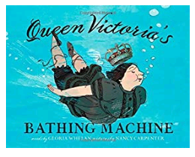  Week 1  Queen Victoria’s Bathing Machine by Gloria Whelan  Week 2Week s: 19-27 | 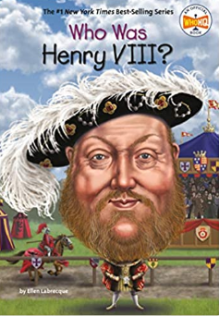  Who was Henry VIII by Ellen Labrecque
Skill Information
 | Unit 1 | Unit 2
Genre | Poetic Narrative based on fact | Non-fiction
Writing skills | - Punctuation (Capital letters and full stops, Question marks, exclamation marks, commas in a list and apostrophes for omission  - Use of conjunctions  - 2A sentences with a comma between two adjectives.  - Paragraphs to organise information around a theme – supported by planning.  - As/ like sentences.  - Paragraphs to organise information around a theme  - Adjectives, verbs, adverbs, prepositional phrases and similes.  - Verb/person sentences | - Writing demonstrates an awareness of purpose and audience.  - Present and past tense  - Technical language, where appropriate, to make writing convincing and useful.  - Commas after an opener  - Correct structural features for a non-narrative (headings and sub-headings)
Short write | Informal note | Labels and captions for a timeline and to label images associated with Kings and Queens
Hot write | Descriptive setting | Information text (biography)
Reading skills
Gospel value | Curious and active – I can find out more about Queen Victoria and her reign. | Loving and Compassionate – I can understand how life would be different in the past

LKS2 A - Autumn 2

Core Text | Additional Texts
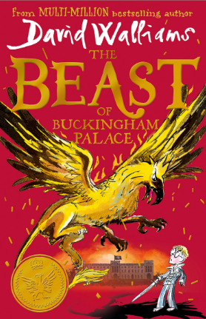  The Beast of Buckingham Palace by David Walliams | 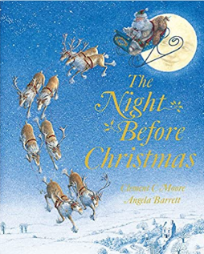  The Night Before Christmas by Clement Moore
Skill Information
 | Unit 1 | Unit 2
Genre | Narrative | Poetry
Writing skills | - Clear structure in the opening, build-up, problem, resolution and ending in writing narrative.  - Use simple and compound sentences.  - Conjunctions, adverbs and prepositions to express both time and cause  - Adventurous word choices  - Sentence types (emotion sentence and ly, ly sentences, outside, inside sentences)  - Direct speech  - use fronted adverbials of place, time and manner, including the use of a comma.  - paragraphs that are clear and linked using: controlled use of tenses; subordinating and coordinating conjunctions | - Adventurous and carefully selected word choices to add detail and engage the reader.  - appropriate nouns or pronouns within and across sentences to link ideas and avoid repeated words  - expanded noun phrases with modifying adjectives (‘the strict teacher with curly hair.’)
Short write | Thought bubbles in role as characters  Character description | Personal writing – their own reflections on Christmas
Hot write | Alternative chapter – what might happen next? | Own verses in the style of the poem
Reading skills
Gospel value | Loving and Compassionate – I can empathise with characters and their actions | Grateful – I can show gratitude for what I have of value in life

LKS2 A - Spring 1

Core Text | Additional Text
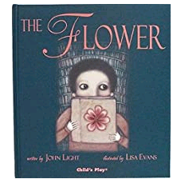  The Flower by John Light | 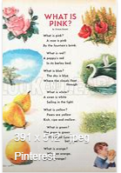  What is Pink? By Christina Rosetti
Skill Information
 | Unit 1 | Unit 2
Genre | Narrative – picture book | Poetry
Writing skills | - Commas for different uses  - Past and present tense  - Figurative language  - Conjunctions  - Direct speech  - Sentence types (2A, list, ly and ly)  - Expanded noun phrases | - Language choices  - Positioning of clauses  - Figurative language
Short write | Thought bubble  Setting description
Hot write | Retelling of the story | Create their own poem
Reading skills
Gospel value | Grateful and Generous  I am grateful that we have beauty in the world  Loving and Compassionate  I look after living things in the world | Curious and Active  I explore poetry and author’s use of language

UKS2 A - Autumn 1

Core Text | Additional Texts
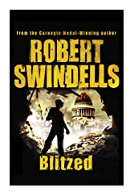  Blitzed by Robert Swindells | 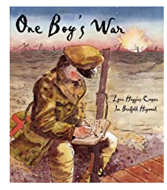  One Boy’s War by Lyn Huggins-Cooper

Skill Information
 | Unit 1 | Unit 2
Genre | Fiction | Fiction – picture book
Writing skills | Use paragraphs to organise ideas  Use some cohesive devices within and across sentences and paragraphs  Use the correct tense throughout my writing  Use a range of different sentence types  Choose, and use appropriate verb choices for effect  Using speech to move the action on  Show character’s feelings through action | Use commas accurately within writing  Use modal verbs to suggest possibility  Correct subject-verb agreement (I was / We were)  A clear voice, which is evident across the text.
Short write | Setting description | Thought bubble  Note home to Ma
Hot write | Biography  Flashback story inspired by Blitzed (back in time to WW2) | Series of diary entries in role as Sydney
Reading skills
Gospel value | Curious and active – interested in finding out about the past and its impact on the present day | Loving and compassionate – empathise with character’s thoughts and feelings

UKS2 A - Autumn 2

Core Text | Additional Texts
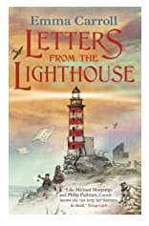  Letters from the Lighthouse by Emma Carroll | 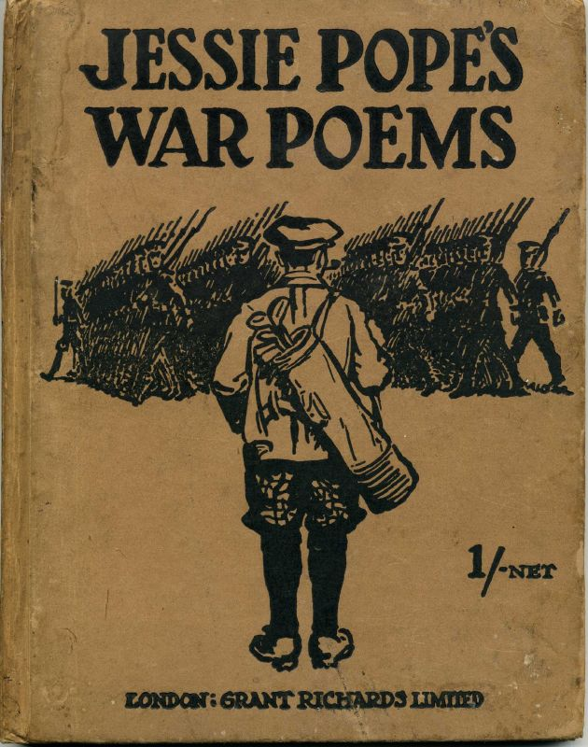  Who’s for the game? by Jessie Pope

Skill Information
 | Unit 1 | Unit 2
Genre | Fiction | Poetry
Writing skills | Punctuation (directed speech)  Use of active and passive voice  vocabulary and grammatical structures that reflect the level of formality.  the appropriate form, register, structure and layout.  the correct tense throughout my writing.  parenthesis (brackets, commas, dashes). | A wide range of clause structures, sometimes varying their position in the sentence.  Use of rhetorical questions  modal verbs to suggest degrees of possibility.  A thesaurus to develop word understanding.
Short write | Conversation about the closing of the lighthouse (direct and reported speech)  Letter in role as a character | N/A
Hot write | Write a newspaper report, breaking the news that the lighthouse is to be removed. | Response poem to Jessie Pope’s Whose for the game?
Reading skills
Gospel value | Faith filled and hopeful – engage with the story with a hopeful heart believing faithfully in a happy ending. | Attentive and discerning - Think carefully about how the decisions and messages of others can influence people’s decisions.

UKS2 - Spring 1

Core Text | Additional Text
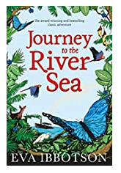  Journey to the River Sea by Eva Ibbotson | 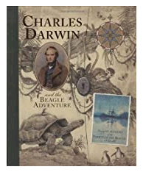  Charles Darwin and the Beagle Adventure by Amanda Wood

Skill Information
 | Unit 1 | Unit 2
Genre | Fiction | Non-fiction
Writing skills | Modal verbs  Adverbs and prepositions  Expanded noun phrases  Sentence types  Commas | Paragraphs  A range of sentence types  Relative clauses  Manage shifts in time  Parenthesis  Figurative language
Short write | Apply of adverbs and modal verbs for detail | N/A
Hot write | Setting description of the Amazon  Alternative chapter ending | Darwin description  Darwin diary entry
Reading skills
Gospel value | Loving and compassionate- appreciating our environment  Intentional and prophetic- looking after God’s world | Loving and compassionate- appreciating our environment  Intentional and prophetic- looking after God’s world

Writing Learning Journeys
Nursery -Y6

My Nursery Learning Journey – Writing
I can write for a range of purpose and audiences, making use of:
WTS / EXS
GDS
Composition  Write simple phrases and sentences that can be read by others (ELG) | - Sometimes gives meaning to marks – clear picture and willingly discusses picture with detail on most occasions.  - Can copy some letters e.g. letters from their name.  - Can make vertical and horizontal lines.  - Can make circles.  - Can write name correctly  - Give meaning to marks as I draw and paint.
Grammar
Punctuation | - Know that a capital letter starts at the beginning of their name.
Spelling  Spell words by identifying sounds in them and representing the sounds with a letter or letters. (ELG) | - Hear and say the initial sound in words.  - Ascribes meanings to marks that they see in different places  - Can segment the sounds in simple VC and CVC words and blend them together.  - Link sounds to letters, naming and sounding the letters of the alphabet.  - Represent some sounds correctly and in sequence.
Handwriting  Write recognisable letters, most of which are correctly formed. (ELG) | - Holds a pencil between thumb and two fingers, no longer using whole-hand grasp  - Begin to form recognisable letters  - Use some clearly identifiable letters to communicate meaning.

My Reception Learning Journey – Writing
I can write for a range of purpose and audiences, making use of:
WTS / EXS
GDS
Composition  Write simple phrases and sentences that can be read by others (ELG) | - Begin to show correct pencil grip and sit correctly at a table  - Write multiple sentences regularly.  - Write a simple sentence that makes sense.  - Most writing can be read without mediation.  - Write independent sentences which make sense, that can be mediated by any adult.  - Use of WOW words to make sentences wore interesting to the reader  - Writing structure is complete, no missing elements e.g. beginning, middle and end
Grammar | - Use the personal pronoun ‘I’.  - Use the correct terminology –sentence, capital letter, full stop.  - Consistent use of the pronoun I in writing.
Punctuation | - Begin to show evidence of CL in writing.  - Show evidence of full stops at the end of sentences in writing.  - Use finger spaces between each word.  - Punctuates sentences consistently using a capital letter and a full stop.  - Consistent use of finger spaces between each word.
Spelling  Spell words by identifying sounds in them and representing the sounds with a letter or letters. (ELG) | - They write some irregular common words.  - Spell words containing Phase 3 phonemes.  - Spell words containing Phase 4 consonant clusters.  - Spell common Phase 2 and 3 tricky words.  - Hear and say initial, medial and final sounds within words.  - Applies consistently Phase 1 to 4 spellings to work.  - Consistently applies Phase 3 and 4 Phonics teaching to independent work.  - Spells Phase 4 tricky words correctly.
Handwriting  Write recognisable letters, most of which are correctly formed. (ELG) | - Form all lower case letters correctly.  - Form all numerals 0-9 correctly.  - All numbers 0-9 are formed correctly and applied to work.  - Lower case letter are correctly formed, consistent in size and match schools Handwriting policy.  - Ascenders and descenders are correct.

My Year 1 Learning Journey – Writing
I can think aloud as I collect ideas, write sentences and check that it makes sense:
WTS / EXS
GDS
Composition | - Show correct pencil grip and sit correctly at a table  - Most writing can be read without mediation.  - Write a sequence of simple sentences that makes sense independently.  - Use ‘and’, ‘but’ to join ideas.  - Read my sentences through to check that they make sense.  - Begin to choose different conjunctions – but, or, yet, so and because.  - Vocabulary is appropriate to the subject matter and sometimes ambitious.  - Uses noun phrases within writing regularly.  - Uses time conjunctions and adverbials correctly – first, next, finally, when, as soon as.  - Consistently write independent sentences which make sense,that can be mediated by any adult.  - Wide range of evidence showing appropriate and correct use of all above conjunctions.  - Ambitious word choices/synonyms which reflect what is being described.  - Correct use of time adverbials in independent writing, where appropriate.
Grammar | - Use the correct terminology – word, sentence, capital letter, full stop, noun and adjective  - Use capital letters for names and personal pronoun ‘I’  - Use capital letters for names, places, days of the week and the personal pronoun ‘I’.  - Sentence types (List and BOYS sentences)  - Consistent use of capital letters for days of the week, names, places and personal pronoun ‘I’.
Punctuation | - Use capital letters at the beginning of a sentence.  - End sentences with a full stop.  - Consistent use of clear finger spaces between words.  - Use exclamation marks.  - Use question marks at the end of questions.  - In a sequence of sentences, starts with a capital letter and ends each with a full stop.  - Uses exclamation marks appropriately and for effect.
Spelling | - Name the letters of the alphabet in order  - Spell words containing Phase 3 phonemes.  - Spell words containing Phase 4 consonant clusters.  - Spell common tricky words  - Spell words containing: zh, wh, ph and alternates for ay (a-e, eigh, ey, ei, long a) ea (e-e ie ey y long e) ie (i-e y I long i) oa (ow o-e – oe).  - Spell words containing alternatives for ew (ue u-e long u oul short oo) aw (au al) ir (er ear) ou (oy) ere/eer, are/ear.  - Add ‘un’ to the beginning of a word to change its meaning.  - Add ‘ing’ to a word where no change to the root word is needed.  - Add ‘er’ to make a comparative word.  - Add ‘ed’ to a word to make it past tense, where the root word stays the same.  - Add ‘s’ or ‘es’ to words to make them plural.  - Consistent application of all above spellings in independent writing.
Handwriting | - Form lower case letters correctly.  - Write numbers correctly 0-9.  - Understand that a line of writing isn’t always a sentence.  - Form capital letters correctly  - Ascenders and descenders are correctly oriented on the line.  - All lower case and upper case letters are correctly formed and placed on the line. Clear distinction in size between upper and lower case letters.  - Lower and upper case letters used consistently in writing

My Year 2 Learning Journey – Writing
I can write for a range of purpose and audiences, making use of:
WTS / EXS
GDS
Composition | - Sequences of simple and compound sentences link ideas together and make sense.  - Vocabulary is appropriate to the subject and is sometimes ambitious.  - Re-read sequences of sentences to check for spelling and punctuation errors.  - Simple plans and word banks are used to support writing (pictures, labels)  - Narrative writing is structured with a clear beginning, middle and ending.  - Non-narrative is structured appropriately for the genre e.g. recounts, fact pages, diary entries.  - Longer writing pieces flow with simple and compound sentences that link and are sequenced appropriately.  - Write effectively and coherently for different purposes, drawing on their reading to inform the vocabulary and grammar of their writing.  - Make simple addition, revisions and proof-reading corrections to their own writing.
Grammar | - Name and use expanded noun phrases to describe and specify [for example, the blue butterfly]  - Name and use verbs to describe actions  - Use subordination (using when, if, that, or because) and co-ordination (using or, and, or but)  - Write in the simple present and past tenses correctly and consistently.  - Use a range of sentence openers to start sentences, including time adverbials.  - Write sentences with different forms: statement, question, exclamation, command.  - Imperative verbs are used to instruct.  - Progressive form of verbs the present and past tenses correctly and consistently.  - Sentence types ( 2A sentence and … as a, … like a sentence)  - When appropriate, a range of different sentences types are used purposefully and add effect to writing.  - Adventurous word choices are used effectively to add detail and description.  - Adverbs used to start sentences.  - Use simple and compound sentences purposefully to engage the reader, creating atmosphere, detail and suspense.
Punctuation | - Capital letters and full stops used accurately and consistently when writing longer pieces.  - Commas used accurately for lists  - Questions accurately and consistently punctuated with a ?  - Exclamation sentences accurately punctuated with !  - Apostrophes are used accurately and consistently for contracted forms.  - Apostrophes are used to show possession (singular)  - All the above punctuation is used consistently in sustained pieces of writing
Spelling | Spell by:  - segmenting spoken words into phonemes and representing these by graphemes, spelling many correctly  - learning new ways of spelling phonemes for which 1 or more spellings are already known, and learn some words with each spelling, including a few common homophones  Alternative graphemes for reading and spelling  ay, ou, ie, ea, oy, ir, ue, ue, aw, wh, ph, ew, ew, oe, au, ey, a-e, e-e, i-e, o-e, u-e,  Alternative pronunciations.  a, e, i, o, u, ow (oa), ie (ee), ea (e), er, ou (oo), y (I), y (i), y (ee), ch (c), ch (sh), c (s), g (j), ey (ay)  - learning to spell common exception words  - learning new ways of spelling phonemes for which 1 or more spellings are already known, and learn some words with each spelling, including a few common homophones  Alternative spellings  ch – picture, capture, ch – catch, fetch, j – fudge, hedge, m – lamb, climb, n – gnat, sign, n – knit, knob.  r – wrap, write, s – listen, whistle, s – house, mouse, air – there, where, air – bear, wear, air – bare, care, or – four, pour, your, ur – learn, earth, ur – word, work.  - Follow the Y2 spelling rules to add suffixes ing and ed to present and past tense verbs.  - add suffixes to spell longer words including –er,  -est, –ment, –ness, –ful, –less, –ly  - learning to spell more words with contracted forms  - Spell words with Le/al/el/il endings  - Learning the possessive apostrophe (singular) [for example, the girl’s book]  - distinguishing between homophones and near-homophones  - Revise suffixes –s or –es for plurals and present tense verbs  - Revise suffixes –ing, -ed, -s, -er, -est, -y, -en, -ful, -ly, -ment, -ness  - Spelling rules and patterns from year 2 are accurately used, including exceptions to rules
Transcription | - form lower-case letters of the correct size relative to one another  - write capital letters and digits of the correct size, orientation and relationship to one another and to lower-case letters  - use spacing between words that reflects the size of the letters  - start using some of the diagonal and horizontal strokes needed to join letters and understand which letters, when adjacent to one another, are best left unjoined.  - Begin to join some of their handwriting using the diagonal and horizontal strokes.

My Year 3 Learning Journey – Writing
I can write for a range of purpose and audiences, making use of:
WTS / EXS
GDS
Composition | - Headings and sub-headings in non-narrative.  - Paragraphs to organise information around a theme  - Writing demonstrates an awareness of purpose and audience.  - Pictures, diagrams and jottings to plan what they wish to write.  - Clear structure in the opening, build-up, problem, resolution and ending in writing narrative.  - Sentences using a wider range of structures linked to grammar.  - Purpose and audience that is established and sustained throughout the text.  - Proof reading to check for inaccuracies in spelling, grammar and punctuation.  - Headings and sub-headings in non-narrative writing are selected independently to guide the reader.
Grammar | - Wide range of conjunctions – when, if, because, although  - Determiners (articles) ‘a’, ‘an’ and ‘the’ appropriately.  - A range of sentence openings.  - Make consistent use of the present and past tense.  - Use simple and compound sentences.  - Conjunctions, adverbs and prepositions to express both time and cause  - First and third person consistently throughout a piece of writing.  - Perfect form of verbs instead of the simple past.  - Adventurous word choices to add detail.  - Adventurous and carefully selected word choices to add detail and engage the reader.  - Technical language, where appropriate, to make writing convincing and useful.  - Sentence types ( emotion sentence; verb, person sentence; ly ly sentence)  - Simple, compound and complex sentences accurately and confidently to add to the flow of the writing.  - Effective and varied sentence openings.  - Conjunctions, adverbs and prepositions to sequence and to express place and cause confidently.  - Vocabulary deliberately chosen to create effects, including accurate use of technical or specific words.  - Adverbials and other added detail to build a picture for the reader.
Punctuation | - Commas for items within a list  - Full stops  - Capital letters (consistently for proper nouns)  - Question marks  - Exclamation marks  - Apostrophe for possession, including plural nouns.  - Commas following an opener  - Inverted commas consistently used to punctuate direct speech.  - Commas to mark phrases and clauses consistently accurate throughout text.
Spelling | - A dictionary to check the spelling of a word using the first 2 or 3 letters.  Spell the following accurately:  - wh and w words  - Common contractions  - Short vowel – double consonant  - ay using alternatives  - suffixes ing, er, en, ed  - u spelt ou  - I sound elsewhere in words  - Prefixes un, dis, mis, re, pre  - Word family spellings.  - Prefixes and suffixes added to root words (super, anti, auto)  - Adding the suffix –ly  - End sound ‘sure’  - End sound ‘ture’  - End sound ‘sion’  - End sound ‘tion’  - End sound ‘ssion’  - Grapheme ‘ch’ pronounced ‘k’  - Grapheme ‘ch’ pronounced ‘sh’  - Additional homophones (he’ll, heel, heal)  - Spelling rules and patterns from Year 3 and 4 accurately used, including exceptions to rules.
Transcription | - Diagonal and horizontal strokes that are needed to join letters.  - A consistent joined style of handwriting.

My year 4 Learning Journey – Writing
i can write for a range of purpose and audiences, making use of:

WTS / EXS
GDS
COMPOSITION | - a story with a clear structure, setting, characters and plot.  - key vocabulary and grammar choices that link to the style of writing (e.g. scientific / topic words).  - paragraphs that open with topic sentences and that are organised around a theme.  - endings / conclusions that draw ideas and/or events together.  - some sub-headings, bullet points to guide the reader.  - characters that are developed through their actions, speech and reactions.  - non-narrative texts that inform the reader well and give them lots of extra details and information.  - paragraphs that are well-structured, links ideas and guide the reader through the text.
GRAMMAR | - a range of sentences with more than one clause, using conjunctions.  - the correct article ‘a’ or ‘an’.  - sentences that are often opened in different ways to create different effects.  - appropriate nouns or pronouns within and across sentences to link ideas and avoid repeated words.  - use fronted adverbials of place, time and manner, including the use of a comma.  - use standard english, instead of spoken forms (we were, instead of we was).  - expanded noun phrases with modifying adjectives (‘the strict teacher with curly hair.’)  - adverbs and prepositions to express time, place and cause.  - paragraphs that are clear and linked using: controlled use of tenses; subordinating and coordinating conjunctions.  - Different sentence types (ing, ed sentences; outside, inside sentences; ad same ad sentences; 2 pairs sentences)  - a range of different sentence openings to create effects, including the positioning of clauses and the use of fronted adverbials.  - careful use of pronouns to avoid repetition and to help the flow of my writing.  - add carefully thought-out detail with noun phrases, which are expanded before and after the noun with  - careful and deliberate word choices, including specific and technical vocabulary.
PUNCTUATION | - correct sentence punctuation all through my writing (cl and fs).  - apostrophe for omission and possession  - inverted commas for direct speech.  - commas after the reporting clauses in direct speech.  - commas for fronted adverbials.  - all punctuation taught so far is securely used in all forms of writing.
SPELLING | - the first two or three letters of a word to check its spelling in a dictionary.  - spell the following accurately:  - words with ou  - prefixes: dis- / in- / mis- / un –  - words with -gue  - words with ei, eigh, ey  - adding im- to root words with m / p  - prefixes: re- / sub- / inter- / super- / anti - / auto-  - adding –ation to verbs to form nouns  - suffixes: -ous / -ian  - words with ‘s’ spelt ‘sc’  - possessive apostrophe with plural words  - homophones
TRANSCRIPTION | - increased quality of my handwriting: down strokes of letters are parallel; lines of writing are spaced clearly so ascenders and descenders are clear and do not touch.  - handwriting of increased legibility, consistency and quality.  - present written work formally for different purposes.  - handwriting that is joined and beginning to develop own style.

My Year 5 Learning Journey – Writing
I can write for a range of purpose and audiences, making use of:

WTS / EXS
GDS
Composition | - paragraphs to show different information or events (time, place, topic, person).  - paragraphs that are developed using a main point, topic, event, idea with an explanation or extra detail.  - D.A.d to develop characters (description, action, dialogue).  - well-chosen detail to interest my reader.  - make use of expanded noun phrases.  - manage shifts in time and place effectively and guide the reader through my text.  - settings to create atmosphere and also indicate change.  - use ideas from my reading.  - consistent use of Standard English.  - a clear style, aimed at informing, persuading or entertaining.  - dialogue between my characters which develops the reader’s understanding of my characters.  - different levels of formality, which is beginning to be developed and controlled.
Grammar | - the correct tense throughout my writing.  - a range of different sentence starters: -ed / -ing openers, adverbials, conjunctions, place (nearby, inside etc) manner (quick as a flash, with legs swinging in the air).  - A thesaurus for alternative word choices.  - Sentence types (Noun, which/where/who sentence; One word/phrase: definition sentence; some; others sentence; PC sentences)  - similes, metaphors and personification.  - modal verbs and adverbs to indicate degrees of possibility.  - changes to vocabulary, grammar and punctuation to enhance effects and clarify meaning.  - the perfect form of verbs to mark relationships of time and cause.  - words that are chosen deliberately for effect.  - carefully and deliberately chosen words, which clarify meaning, enhance effect, increase / slow pace and create mood.  - expanded noun phrases and relative clauses to add information or detail appropriate to the purpose and audience.  - paragraphs which support my plot structure (in stories) and clearly signal changes in time, place and events.  - all elements of grammar are used independently and expertly in a range of texts.
Punctuation | - colons to introduce a list.  - Colons for definitions  - inverted commas and other punctuation to accurately indicate direct speech.  - commas to clarify meaning and avoid ambiguity.  - brackets, dashes or commas for parenthesis.  - a colon or semi-colon to link separate clauses.
Spelling | - Spell the following accurately:  - words ending –ent  - words ending –ence  - words ending –ant, -ance, -ancy  - words ending -ible  - words ending –able  - words ending –ibly and –ably  - words with ei and ie  - words containing -ough  - homophones  - accurate and secure spelling.
Transcription | - clearly joined handwriting.  - handwriting that is maintained to a high personalised standard.

My Year 6 Learning Journey – Writing

I can write for a range of purpose and audiences, making use of:
WTS / EXS
GDS
Composition | - paragraphs to organise ideas.  - a thesaurus to develop word understanding.  - describe settings and characters.  - some cohesive devices within and across sentences and paragraphs.  - integration of speech to develop character and move the action on.  - vocabulary and grammatical structures that reflect the level of formality.  - the appropriate form, register, structure and layout.  - figurative language to add impact and develop meaning (metaphors, personification)  - a clear voice, which is evident across the text.  - manipulation of the features of the text type to create specific effects.  - well-managed shifts in time.  - well-managed shifts in formality through selecting vocabulary precisely and by manipulating grammatical structures.  - manage the shifts in formality both within, and across pieces.
Grammar | - the correct tense throughout my writing.  - modal verbs to suggest degrees of possibility.  - adverbs, prepositional phrases and expanded noun phrases to add detail.  - Sentence types (DE: DE sentences; 3 bad – dash question sentences; Imagine 3 sentences)  - a wide range of clause structures, sometimes varying their position in the sentence.  - the passive voice to emphasise information differently.  - correct subject-verb agreement (I was / We were).  - a wide range of clause structures, sometimes varying their position in the sentence.  - modal verbs and adverbs to develop an argument.  - a range of verb forms to create subtler meanings.  - vocabulary choices that are imaginative and words that are use precisely to create impact and add meaning.  - paragraphs to develop and expand ideas, themes and events in depth.  - a varied range of cohesive devices across and within paragraphs.  - select verb forms for meaning and effect.  - effective sentences, containing more than one clause and is used to elaborate and to convey complicated information clearly.  - passive voice to affect the presentation of information in both formal and information situations.  - a range of literary features such as: repetition, short sentences and figurative language to add impact.
Punctuation | - commas for clarity  - parenthesis (brackets, commas, dashes).  - semi-colons  - colons  - dashes  - hyphens  - All punctuation is consistently accurate.
Spelling | - spell silent letter words correctly  - spell –cious / -tious words  - spell words ending –cial / -tial  - add suffixes to words ending –fer  - plural nouns  - hyphenated words  - homophones  - spelling that is mainly accurate throughout.  - good attempts at the spelling of ambitious vocabulary.
Transcription | - keep the legibility, fluency and speed in my handwriting going through a piece of extended work.  - handwriting that is maintained to a high personalised standard.

Reading Learning Journeys
Nursery -Y6

Nursery Reading Journey
As a guide: WTS (8 – 13); WW (14 – 18); GDS (19 – 23)
Knows that information can be relayed in print.
Has some favourite stories, rhymes, songs, poems or jingles.

Handles books carefully.
Holds book the correct way up and turns pages carefully.
Shows interest in illustrations and print in books and print in the environment.

Recognise familiar print such as logos, name.
Listens to stories with increasing attention and recall.
Knows that print carries meaning.
Knows that in English, we read from left to right and top to bottom.
Suggests how a story might end.
Shows awareness of how stories are structured.
Shows awareness of rhyme and can continue a simple rhyme string – cat, pen.
Shows awareness of alliteration.
Enjoys and participates in rhyme and rhythmic activities.
Recognises rhythm in spoken words.
Repeats words or phrases from familiar stories.
Listens to and joins in with stories and poems, one-to-one and also in small groups.
Fills in the missing word or phrase in a known rhyme, story or game, e.g. "Humpty Dumpty sat on a ..."

Understand and copy sound talk – blending words containing 2 or 3 sounds.
Blend two or three sounds from sound talk to word.
Describes main story settings, events and principal characters.
Anticipates key events and phrases in rhymes and stories.
Can independently segment the sounds in simple VC and CVC words and blend them together.
Knows the sounds that some letters of the alphabet represent.

Recognises and reads some Phase 2 tricky words.
Reception Reading Journey
As a guide: WTS (8 – 13); WW (14 – 18); GDS (19 – 23)
Use phonetic strategies to decode regular words using phase 2 and 3 graphemes.

Can read on sight all phase 2 and 3 tricky words.
Can read some phase 4 tricky words.
Demonstrate an understanding when talking with others about what they have read.

Can confidently and fluently read Yellow book banded books.
Self-corrects words when reading.
Can retell familiar stories with detail, telling the main events in order.
Discuss the significance of the title and events.
Give my opinion on what I have read.
Happy to read when asked.
Readily discuss my reading book with an adult.
Name favourite stories.
Read phonically regular words of more than one syllable as well as many irregular but high frequency words.
Use phonic, semantic and syntactic knowledge to understand unfamiliar vocabulary.
Describe the main events in the simple stories they have read.
Word Reading (ELG) |  | Say a sound for each letter in the alphabet and at least 10 digraphs.
 |  | Read words consistent with their phonic knowledge by sound-blending.
 |  | Read aloud simple sentences and books that are consistent with their phonic knowledge, including some common exception words.
Comprehension (ELG) |  | Demonstrate understanding of what has been read to them by retelling stories and narratives using their own words and recently introduced vocabulary.
 |  | Anticipate (where appropriate) key events in stories.
 |  | Use and understand recently introduced vocabulary during discussions about stories, non-fiction, rhymes, poems and during role play.
Year 1 Reading Journey
As a guide: WTS (8 – 13); WW (14 – 18); GDS (19 – 23)
Can distinguish between a word, a letter and a space.
Can point to a full stop in the text and knows to pause at one when reading.
Can use phonic knowledge to attempt unknown words.
Can use pictures (unprompted) and text to identify meaning.
Can read all phase 3 and 4 high frequency words
Can read all phase 5 high frequency words
Can use knowledge of letters, sounds and words, when blending, to establish meaning when reading unfamiliar words aloud.
Is beginning to identify when reading does not make sense and attempts to self-correct.
Can read words in their contracted form
Can read compound words (playground, homework etc)
Looks all the way through words and recognises different endings (-s, -es, -ed, -ing, -er, -est)
Can tick a word that means the same as….
Can find and copy a word that means the same as…
Can locate specific information- when
Can locate specific information- where
Can locate specific information- what
Can locate specific information- who
Can tick whether a statement is true or false
Can sequence pictures about a story
- Can sequence events in a story by numbering statements
Can tick the correct statement about a story when the information is implied and not stated
Can write down an answer to a question where the information is not directly in the text (why)
Makes predictions about the text based on what has been read

Year 2 Reading Journey
As a guide: WTS (8 – 13); WW (14 – 19); GDS (20 – 25)
Can read the next 200 common high frequency words- fluent reading without segmenting and blending
Can use a range of phonic strategies to read unknown words – sounding out, trying alternative sound (find- might try short vowel then try long vowel)
Does not read through full stops
Phase 5 vowel diagraphs are recognised instantly however errors may occur when diagraph has more than one pronunciation (bread, read, beach etc.)
Can identify when reading does not make sense and self-corrects so text makes sense
Can read aloud with intonation, taking into account a wider range of punctuation (. ? ! , )
Can use syllables to read unknown polysyllabic words- chunking words, looking for familiar letter strings, using known affixes (un- import- ant)
Can read words with contractions (I’m, I’ll, we’ll) and understands the apostrophe represents an omitted letter
- Can tick a word/ group of words that mean the same as….
- Can find and copy a word that means the same as…
- Can match a word in the text to its implied meaning
- Can find and copy a word that means the same as.. (homophones or words with more than one meaning)

- Can locate specific information- who/ what/ where/ when
- Can locate specific information- why
- Can tick correct response in a table of different options
- Can tick whether a statement is true or false
- Can give more than one answer to the same question (give three types of weather in this poem..)
- Can sequence events in a story- picking out the main points
- Can number statements about the story putting them in time order
- Can tick the correct statement about a story when the information is implied and not stated
- Can write down one or more answer to questions where the information is implied
- Can find and copy words that show… (inferring meaning from context)
- Can find a quote in the text to back up their answer
- Can predict what might happen to a character from details stated or implied
- Can predict the ending or a story from what they have read so far.

Year 3 Reading Journey
As a guide: WTS (8 – 14); WW (15 – 20); GDS (21 – 25)
All KS1 high frequency words read on sight
Uses a range of strategies to decode words- visual, structural and meaning prompts to cross check whilst reading independently
Does not read through punctuation. Takes note of punctuation in longer sentences to help keep track. Uses expression and intonation when reading. Recognises the need to change tone for inverted commas (“ “) in dialogue
Self-checks- repeats phrases for clarity, tries different sounds, listens to themselves when reading and realises when something doesn’t make sense
Can find and copy a word that means the same as...
Can match the underlined word in a sentence to the correct definition
Can use a dictionary to look up the meaning of a word
Can locate information by skimming (for a general impression) and scanning (to locate specific information)
Can use text marking to retrieve information or ideas from texts (e.g. highlighting, notes in the margin).
- Can quote from the text to answer a retrieval question
Can explain what the topic of the paragraph is about
- Can order events in a text referring back to the text to support this
- Can answer true or false statements about the text

Can explain how and why main characters act in certain ways in a story or why events happen (How do you know, what evidence is there to suggest…)
- Uses quotes from the text to explain their inferences
Can make plausible predictions based on knowledge from text
- Can back up their predictions with a quote from the text
Can comment on why a title is large- to grab your attention, why something may be in bold (glossary, draw reader’s attention to it), in fiction can say how the beginning and ending of the story are similar or linked and why paragraphs are used
- Can label different parts of texts studied- sub headings, title, headline, diagram etc. Matches quotes to correct part of story (setting, action etc.)
Can explore potential meanings of ambitious vocabulary (WOW Words) read in context (using knowledge of etymology (the word origin), morphology (structure- the ‘root’ word plus prefix /suffix), or the context.
- Identifies how an author builds suspense
- Identifies how the author uses words or phrases to paint pictures in the readers mind
Can identify the differences between a wider range of non-fiction text types
Can recognise how a character is presented in different ways and use references from the text.
Identifies themes and conventions in texts and makes comparisons between texts

Year 4 Reading Journey
As a guide: WTS (8 – 14); WW (15 – 21); GDS (22 -27)
Decodes using all strategies, relates to prior knowledge of word classes or structure, breaks longer words down into smaller chunks and uses has an attempt at unfamiliar words
Can read a range of standard appropriate texts fluently and accurately.
Can skim and scan to identify key ideas in text.
Can read aloud with pace, fluency and expression, taking punctuation and author’s intent into account.
- Can find and copy a word that means the same as...
- Can match the underlined word in a sentence to the correct definition
- Can use a dictionary to look up the meaning of a word and a thesaurus if they are stuck
- Can quote from the text to answer a retrieval question with more than one answer (Give 3 things)
- Can identify and explain the difference between fact and opinion.
- Can explain what the topic of the paragraph is about
- Can order events in a text referring back to the text to support this
- Can answer true or false statements about the text
- Can read between the lines, using clues from action, dialogue and description to interpret meaning and / or explain what characters are thinking / feeling and the way they act (Ticks correct answer)
- Can understand and explain different characters’ points of view. (What evidence is there to suggest..)
- Can infer meaning, using evidence from the text and wider experiences (uses quotes to back up answer)

- Can make plausible predictions based on knowledge from text or what is implied
- Can back up their predictions with a quote from the text
- Can use knowledge of text structure to locate information (e.g. use appropriate heading and sub-heading in non-fiction, find relevant paragraph / chapter in fiction).
- Can compare the structure of different stories to discover how they differ in pace, build up, sequence, complication and resolution.
- Can identify the ways in which paragraphs are linked (e.g. use of connecting adverbs, pronouns for character continuity).
- Can clarify the meanings of ambitious words and / or phrases in context
- Can talk about the effects of different words and phrases to create different images and atmosphere (e.g. powerful verbs, descriptive adjectives and adverbs) and in non-fiction texts
- Can identify the point of view from which a story is told and how this affects the reader’s response
- Can discuss how an author builds a character through dialogue, action and description.
Can identify the differences between a wider range of non-fiction text types
Can recognise how a character is presented in different ways and use references from the text. | Can compare similarities and differences between texts / books in terms of characters, settings and themes
Identifies themes and conventions in texts and makes comparisons between texts

Year 5 Reading Journey
As a guide: WTS (6 – 12); WTS (13 – 20); GDS (21 – 27)
Can work out the meaning of unknown words from the way they are used in context.
Can understand and explain the function of sophisticated punctuation ( ... ; : - () and ’ for contraction and possession and “ ” for direct speech).
Can skim and scan non-fiction and fiction texts at speed for research/ to answer questions
- Can find and copy a word or a group of words that means the same as….
- Can match the underlined word in a sentence to the correct definition
- Give the meaning of words in certain sentences (words with more than one meaning)
- Can quote from the text to answer a retrieval question with more than one answer (Give 3 things)
- Can identify and explain the difference between fact and opinion.
- Can summarise what paragraphs are about and how they are linked
- Can order events in a text referring back to the text to support this
- Can answer true or false statements about the text
- Infers straight forward answers by ticking correct meaning (As the sun rose- ticks morning)
- Can refer to the text to support inferences about characters/setting/action (how can you tell that)
- Can refer to the text to support predictions and opinions (What evidence is there to suggest?)
- Can answer ‘according to the text questions’ using (PE model)
- Can make plausible predictions based on knowledge from text or what is implied
- Can back up their predictions with a quote from the text using (PE model point-evidence)
- Can explain the structural devices an author has used to organise a text (e.g. going beyond the superficially obvious in fiction, such as decisions about plot structure or flash backs)
- Can match quotes from the text to their relevant part (fact/opinion/setting etc.)
- Can identify the ways in which paragraphs are linked (e.g. use of connecting adverbs, pronouns for character continuity).
- Can discuss the difference between literal and figurative language and the effects of imagery- what impressions do you get of..
- Can evaluate how messages, moods, feelings and attitudes are conveyed in poetry, prose and non-fiction, making reference to the text.
- Can sometimes recognise the use of irony and comment on the writer’s intention (e.g. sarcasm, insincerity, mockery).
- Can say what impressions they get from the words used to describe settings/characters
Can confidently identify the point of view of some texts and how this impacts on the reader.
Can identify and discuss implicit and explicit points of view in some texts at an appropriate level
Can comment on the success of texts in provoking particular responses (e.g. anger, sadness).

Year 6 Reading Journey
As a guide: WTS (6 – 12); WW (13 – 21); GDS (22 – 28)
Reads with fluency and intonation across a range of texts, sustains silent reading for long periods for research or enjoyment
Can skim and scan non-fiction and fiction texts at speed for research/ to answer questions
- Can find and copy a word or a group of words that means the same as….
- Can match the underlined word in a sentence to the correct definition
- Give the meaning of words in certain sentences (words with more than one meaning)
- Can quote from the text to answer a retrieval question with more than one answer (Give 3 things)
- Can identify and explain the difference between fact and opinion.
- Can retrieve key points when the answer is implied- not stated directly in the text
- Can give reasons for their retrieval answers – back up quote from the text
- Can match paragraph summaries to relevant part of the text
- Can order events in a text referring back to the text to support this
- Can answer true or false statements about the text
- Infers straight forward answers by ticking correct meaning (As the sun rose- ticks morning)
- Can refer to the text to support inferences about characters/setting/action (how can you tell)
- Can refer to the text to support predictions and opinions (What evidence is there to suggest?)
- Can securely make deductions firmly rooted in the evidence in the text- ‘according to the text questions’ using (PE model point-evidence)
- Can make plausible predictions based on knowledge from text or what is implied
- Can back up their predictions with a quote from the text using PE model (point-evidence)
- Can give detailed insight into how the structural choices support the writer’s theme or purpose (e.g. decisions about plot structure, mapping character development through a whole text, flash backs)
- Can discuss the range of organisational features used and how they contribute to the overall effect of the text (e.g. how a writer changes viewpoints within a text; how a writer organises information)
- Can match quotes from the text to their relevant part (fact/opinion/setting etc.)
- Can discuss the difference between literal and figurative language and the effects of imagery- what impressions do you get of…
- Can evaluate how messages, moods, feelings and attitudes are conveyed in poetry, prose and non-fiction, making reference to the text. | Can compare similarities and differences between texts / books in terms of characters, settings and themes
- Can recognise the use of irony and comment on the writer’s intention (e.g. sarcasm, insincerity, mockery).
- say what impressions they get from the words used to describe settings/characters
Can confidently identify the point of view of some texts and how this impacts on the reader.
Can identify and discuss implicit and explicit points of view in some texts at an appropriate level / standard.
Can comment on the success of texts in provoking particular responses (e.g. anger, sadness).

