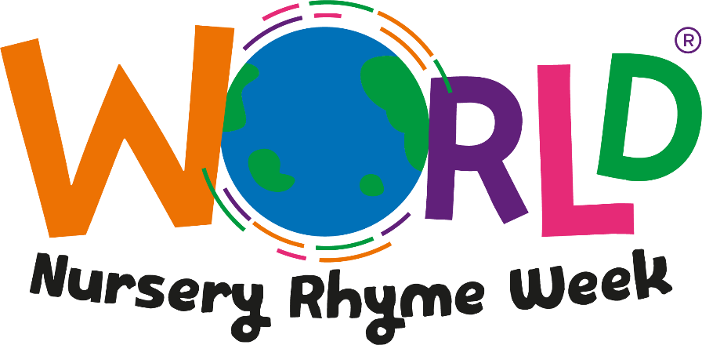

16TH - 20TH NOVEMBER 2020

Dear Parents,

We are delighted to let you know that EYFS will be taking part in World Nursery Rhyme Week this year. The initiative, which was launched in 2013, promotes the importance of nursery rhymes in early childhood development and education with a particular focus on how nursery rhymes boost early language and literacy skills.

We have a number of activities planned throughout the week including: learning and singing a nursery rhyme each day, complete with actions (which will be sent home with the children to practise. We hope to upload a selection of videos to showcase what we have learnt onto our website and Facebook, so look out for these.

Singing nursery rhymes is a wonderful activity you can enjoy doing together at home and all of the resources are available for you to download. You can access all of the free resources at: www.worldnurseryrhymeweek.com

Best wishes

Mrs Barclay

