Dear EYFS Parents,
We are in need of recyclable items for junk modelling activities. Junk modelling is very beneficial to your child’s development in the following ways: it encourages problem solving, exercises their creativity and improves their fine motor skills.
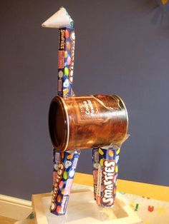
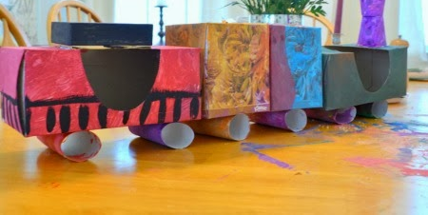

Examples of the sorts of items you could bring in:
- egg cartons
- plastic bottles
- cardboard packaging
- plastic packaging
- empty kitchen roll
- empty cereal boxes
- Bottle tops
- Jar lids

Thank you, we would really appreciate your recyclables!
EYFS Team

