St Giles’ and St George’s Primary Academy
Homework Menu
Class: Nursery Theme: Festivals and Celebrations Term: Autumn 2
Set Menu: Daily reading, sound fans
We are asking children to share their library book each week and for parents to record this in their child’s reading record. You can introduce early reading skills such as: turning the pages carefully, holding the book correctly, talking about the pictures and anticipating what might happen next.
Added Extras:
Please encourage your child to complete as many activities from the menu as they can, but NO LESS than 3 over the half term. We will ask for homework to be handed in during the last week of each half term, in order for us to share and celebrate this learning.

Draw/Write it | Practise it | Research it
Can you make a firework picture by drawing straight lines and anti-clockwise circles. You could create your picture using any mark making materials you like (paint, crayon, pen), and you could even add some glitter for that extra bit of sparkle. | 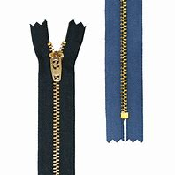  Practise doing your zip/buttons on your coat.  Can you put your coat on all by yourself?  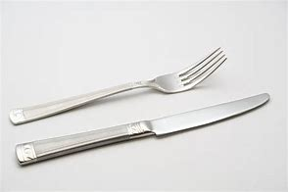  If you can do this why not…  practise using a knife and fork to eat your meals. | Can you find out what your family members favourite festival or celebration is? Why do they like that one best? How do they celebrate?
Make it | Design it | Sing it
Can you make a card to celebrate a birthday or Christmas (or a different festival of your choice).  What picture will you have on your card?  Who will your card be for? | 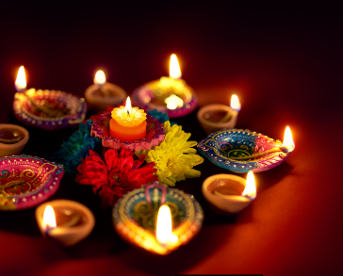  Can you design a candle or lamp to celebrate Diwali? You could even try and make the light you have designed!  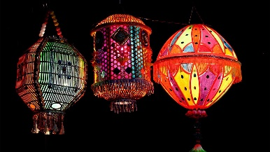 | Perform and sing We Wish You a Merry Christmas.

