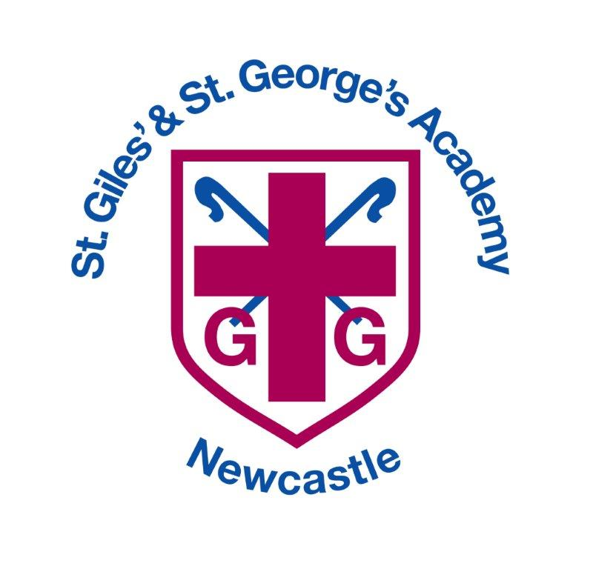

St Giles’ and St George’s C of E Academy
COVID_19 Catch up premium

Academic Year: 2020/2021 |  | Total fund allocated: £23,200 | Date Updated:
The catch-up premium has been designed to mitigate the effects of the unique disruption caused by coronavirus (COVID-19)
Resource and Cost |  | Implementation |  | Impact (measured termly)
Well-being Scheme of work | £1495 | Children have a year-long programme of virtual support which helps them to build a range of tools to improve their mental wellness
Rewards | £950 | An increase in tangible awards for positive behaviour which re-forces expectations for all children.
Increased hours for Welfare Officer | £12,013 | Increased capacity to support children at school who are suffering from poor mental health as a result of the current climate and long periods away from education. This also means there are less referrals to outside agencies and support can be given immediately.
Extra teaching Assistant Support |  | To support the widening gap in each classroom thus providing split teaching and scaffolded support to ensure that the curriculum is accessible to all

Signed off by
Head Teacher: | Mrs C Pointon
Date:
Governor: | Mr Martin Alcock
Date:

