St Giles’ and St George’s Primary Academy
Homework Menu
Class: 3/4NB Teacher: Miss Bowers Topic: Riotous Royalty Term: Autumn 2
Set Menu: Daily reading, spellings, my maths, TT rockstars
We are asking children to read at least 3 times each week and for parents to record this in their child’s reading record. Listening to children read will enable them to practise their sounds and develop their reading fluency. Please talk to your child about their book, the pictures inside and what might happen next. This will help to develop their comprehension skills and have a better understanding of the text. Furthermore, we ask that children practise their spellings regularly, as they will be tested on them in school. Children are also required to access My Maths and TT Rockstars on a regular basis, as activities will be set on there for them to complete. We are grateful for your support with this.
Added Extras:
Please encourage your child to complete as many activities from the menu as they can, but NO LESS than 3 over the half term. Please record the activities in your child’s homework book, this can include photographs. We will ask for homework books handed in during the last week of each half term, in order for us to share and celebrate this learning.
Map it out | Design it | Research it
Queen Victoria is well known for expanding the British Empire during her reign.  Use a map to show all of the countries that are still in the British Empire today and label them. | 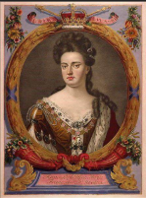  Queen Anne is as well known for her ill health as she is for her successful reign. She was usually pushed to parliament in a wheelchair and lifted into a very fancy chair.  Design a wheelchair fit for a queen. Make sure to annotate your drawings to explain the details and features. | Create a family tree stemming from our current royal family. How far back can you go?  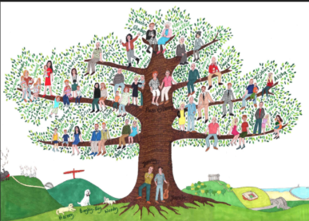
Report it | Compare it | Rhyme it!
Imagine the crown jewels have been stolen. Write a newspaper report outlining:  - What has happened  - What might have taken place  - What the police are planning to do next.  Don’t forget to include a headline, pictures and captions! | Choose two British queens from the list below and compare them, thinking about similarities and differences. Present this however you wish e.g. a Venn diagram, table, poster.  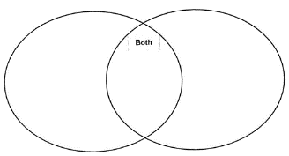  - Queen Anne  - Queen Victoria  - Queen Elizabeth II | Create a poem using a British queen as your inspiration.  Some ideas:  - An acrostic poem  - A shape poem  - A Haiku  - A limerick.

