UKS2 Spelling Log

Name: .....................................

Spelling Glossary
Word | Meaning
adjective | a word that describes someone or something (gentle, amazing)
adverb | a word that changes the meaning of a verb (ran quickly)
apostrophe | a punctuation mark that shows possession (Joe’s book) or a contraction (do not = don’t)
consonants | letters: b c d f g h j k l m n p q r s t v w x y z
contraction | shortened version of a word (I’m, can’t, didn’t)
grapheme | letter or letters that we use to make a sound (t and h together make th)
homophones | words that sound the same but have a different meaning and spellings (see / sea)
noun | a word for a place, object or person.
prefix | a group of letters at the front of a word to change its meaning (dis + grace = disgrace)
root word | part of the word that gives the most meaning.
silent letter | letters you can’t hear when you say the word (know)
suffix | a group of letters at the end of the word to change its meaning (help + ful = helpful)
syllable | part of a word that sounds like one beat (cat = 1 syllable, table = 2 syllables)
verb | an action or being word (running, enjoy)
vowels | letters: a e i o u
word family | groups of word that have a common feature or pattern (cry, crying, cried)
Contents
Sounds chart – consonants.............................
Sounds chart – vowels..................................
Spelling Challenges!
Unit 1: Words with silent letter b........................
Unit 2: Words with silent letter t........................
Unit 3: Silent letter mix (part one).......................
Unit 4: Silent letter mix (part two)......................
Unit 5: Plural nouns (part one)...........................
Unit 6: Plural nouns (part two)...........................
Unit 7: Plural nouns (part three)........................
Unit 8: Words ending in –ent..........................
Unit 9: Words ending in –ence.........................
Unit 10: Words ending in –ant, -ance, -ancy..........
Unit 11: Words ending in –ible..........................
Unit 12: Words ending in –able.........................
Unit 13: Words ending in –ibly and -ably..............
Unit 14: The spelling ei and ie..........................
Unit 15: Words containing –ough........................
Unit 16: Homophones (part one).........................
Unit 17: Homophones (part two).......................
Unit 18: Homophones (part three).....................
Unit 19: Homophones (part four)..........................
Unit 20: Homophones (part five)...........................
Unit 21: Words ending in shus spelt –cious................
Unit 22: Words ending in shus spelt –tious................
Unit 23: Words ending in shul spelt –cial or –tial.........
Unit 24: Adding suffixes to words ending –fer...........
Unit 25: Use of the hyphen................................
Silent Letters Chart.....................................
Y5 / Y6 Spelling List.......................................

Sounds Chart – consonants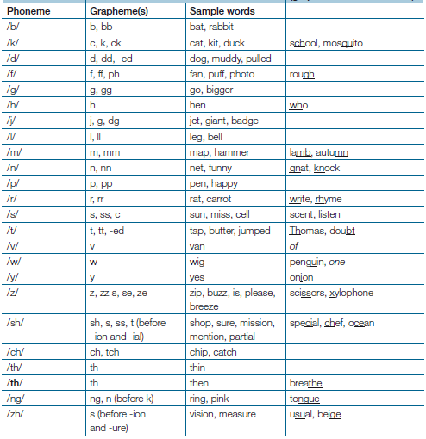

Sounds Chart – vowels
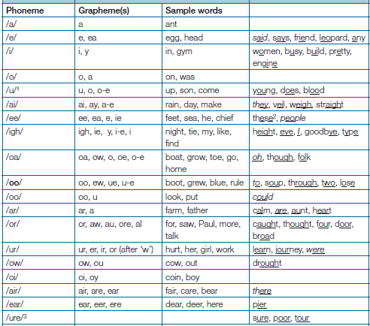

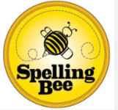Spelling Challenge!
Unit One: Words with silent letter b
Letters that cannot be heard when we say a word are called silent letters. Some common words with silent b are lamb, comb and climb.
Target Word | Date: | Date: | Date:
lamb
comb
thumb
climb
crumb
limb
subtle
tomb
numb
doubt
debt
plumber

Well done! You have achieved Unit One!
Unit Two: Words with silent letter t
Many of the words that have the silent letter t have other silent letters in them too! wrestle
Target Word | Date: | Date: | Date:
wrestle
whistle
listen
Christmas
mortgage
moisten
fasten
moisten
thistle

Well done! You have achieved Unit Two!

Unit Three: Words with silent letters (part one)
A good way of learning how to spell words with silent letters is to stress the letter when you say it eg, w-rong.
Target Word | Date: | Date: | Date:
know
knight
knowledge
wrong
sword
answer
two
gnome
gnaw
foreign
sign
design
ballet

Well done! You have achieved Unit Three!
Unit Four: Words with silent letters (part two)
Break up the word and decide how you are going to say it to yourself e.g. i – s – land.
Target Word | Date: | Date: | Date:
butcher
subtle
column
hymn
autumn
rhythm
honest
island
aisle
debris
salmon
could
should
tongue
guitar

Well done! You have achieved Unit Four

Unit Five: Plural nouns
If a noun plural makes an extra syllable to the word, it is spelt with –es at the end.
Target Word | Date: | Date: | Date:
boxes
foxes
churches
losses
wishes
dresses
brushes
buses
matches
glasses

Well done! You have achieved Unit Five!

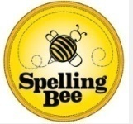 Unit Six: Plural nouns (part two)
For nouns ending in a consonant or the letter o, we usually add –es to make the plural. Those that end in f or fe, we usually swap for v before adding –es.
Target Word | Date: | Date: | Date:
potatoes
tomatoes
mosquitoes
loaves
wolves
leaves
knives
hooves
shelves
wives
thieves

Well done! You have achieved Unit Six!

Unit Seven: Plural nouns (part 3)
Some nouns either almost change entirely or stay exactly the same! You will need to learn these differences.
Target Word | Date: | Date: | Date:
men
children
mice
people
teeth
feet
deer
fish
sheep
octopi

Well done! You have achieved Unit Seven!

Spelling Challenge!
Unit Eight: Words ending in -ent
Always use the –ent ending after a soft c or g, e.g. magnificent, intelligent.
Target Word | Date: | Date: | Date:
innocent
decent
frequent
confident
independent
apparent
environment
excellent
government
parliament
sufficient

Well done! You have achieved Unit Eight!
Unit Nine: Words with -ence
For some words the noun ends in –ency instead of -ence, e.g. frequent / frequency, decent / decency.
Target Word | Date: | Date: | Date:
innocence
confidence
independence
obedience
absence
audience
condolence
disobedience
essence
excellence
impatience
offence

Well done! You have achieved Unit Nine!

Unit Ten: Words ending with –ant, -ance, -ancy.
A clue for spotting words ending in –ant, -ance or –ancy is if they have a related word with an –ation ending, e.g. observant, observance, observation.
Target Word | Date: | Date: | Date:
observant
observance
tolerant
tolerance
hesitant
hesitancy
expectant
expectance
expectancy
substance
dominance
dominancy
dominant

Well done! You have achieved Unit Ten!
Unit Eleven: Words ending in -ible
The –ible ending is normally found when the complete root word cannot be heard, e.g. horrible (where you cannot hear horrid). However, there are some exceptions, e.g. sensible.
Target Word | Date: | Date: | Date:
forcible
legible
accessible
horrible
sensible
edible
diffusible
deductible
gullible
impossible
irresistible
plausible
invincible
invisible
Well done! You have achieved Unit Eleven!
Unit Twelve: Words ending in -able
When adding –able to words ending in –ce or –ge, we must keep the final e to keep the soft c and g sounds, e.g. noticeable, changeable.
Target Word | Date: | Date: | Date:
noticeable
changeable
acceptable
accountable
applicable
considerable
tolerable
culpable
forgettable
immovable

Well done! You have achieved Unit Twelve!

Unit Thirteen: Words ending in –ibly and -ably
Words ending in –ably are much more common than words ending in –ibly. You can usually hear a complete root word before an –ably ending, e.g. considerably.
Target Word | Date: | Date: | Date:
considerably
adorably
applicably
considerably
tolerably
forcibly
possibly
horribly
incredibly
sensibly
visibly
audibly
irresistibly

Well done! You have achieved Unit Thirteen!
Unit Fourteen: Words with ie or ei
The ee sound is spelt ei if it comes after the letter c. “I before e, except after c, but sometimes the rule is broken!”
Target Word | Date: | Date: | Date:
alien
belief
friend
fierce
deceive
conceive
receive
perceive
ceiling
conscience
achieve
foreign
mischievous
sufficient

Well done! You have achieved Unit Fourteen!
Unit Fifteen: Words containing -ough
The –ough sound is one of the hardest to learn because it covers so many different sounds. If you learn the first six words on the list, you will know all of the possibilities!
Target Word | Date: | Date: | Date:
though
through
rough
cough
thought
bough
ought
although
plough
thorough
tough

Well done! You have achieved Unit Fifteen!

Unit Sixteen: Homophones (part one)
In some homophones nouns end in –ce and verbs end –se, e.g. advice is the noun and advise is the verb.
Target Word | Date: | Date: | Date:
advice
advise
device
devise
licence
license
practice
practise
prophecy
prophesy

Well done! You have achieved Unit Sixteen!

Unit Seventeen: Homophones (part two)
Coming up with your own memory tricks or learning the word in a sentence can help you to remember the different meanings.
Target Word | Date: | Date: | Date:
affect
effect
altar
alter
ascent
assent
bridal
bridle
cereal
serial
compliment
complement

Well done! You have achieved Unit Seventeen!
Unit Eighteen: Homophones (part three)
Why not create a word search or crossword puzzle for a friend to help you to become more familiar with the different meanings of homophones?
Target Word | Date: | Date: | Date:
farther
father
guessed
guest
heard
herd
lead
led
morning
mourning
past
passed
precede
proceed

Well done! You have achieved Unit Eighteen!

Unit Nineteen: Homophones (part four)
Homophones are words that sound the same but have different meanings.
Target Word | Date: | Date: | Date:
principal
principle
profit
prophet
stationary
stationery
steal
steel
wary
weary
who’s
whose

Well done! You have achieved Unit Nineteen!

Unit Twenty: Homophones (part five)
More tricky words that sound the same but have different meanings!
Target Word | Date: | Date: | Date:
descent
dissent
desert
dessert
draft
draught
their
they’re
there
isle
I’ll
aisle

Well done! You have achieved Unit Twenty!

Unit Twenty-One: Words with shus spelt –cious
If the root word ends in –ce, the shus ending is usually spelt –cious, e.g. grace, gracious.
Target Word | Date: | Date: | Date:
vicious
precious
conscious
delicious
malicious
suspicious
ferocious
atrocious
precocious
tenacious

Well done! You have achieved Unit Twenty-One!

Unit Twenty-Two: Words with shus spelt –tious
If the root word ends in –tion, the shus ending is usually spelt –tious, e.g. caution, cautious.
Target Word | Date: | Date: | Date:
cautious
ambitious
fictitious
infectious
nutritious
pretentious
scrumptious
Exception
anxious

Well done! You have achieved Unit Twenty-Two!
Unit Twenty-Three: Words with shul spelt –cial or –tial
-cial normally comes after a vowel and –tial usually comes before a consonant. However, there are exceptions, such as initial and financial!
Target Word | Date: | Date: | Date:
official
special
artificial
partial
confidential
essential
initial
financial
confidential
crucial
potential
circumstantial
facial

Well done! You have achieved Unit Twenty-Three!
Unit Twenty-Four: Adding suffixes to words ending –fer
We need to think about where the stress comes in the word to decide whether the r is doubled, e.g. preferred, transferring.
Target Word | Date: | Date: | Date:
transferring
referred
referral
preferring
preferred
transferring
transferred
reference
referee
preference
transference

Well done! You have achieved Unit Twenty-Four!

Unit Twenty-Five: Using a hyphen
Hyphens can be used to join a prefix to a root word, especially if the prefix ends in a vowel and the root word also begins with one.
Target Word | Date: | Date: | Date:
co-ordinate
re-enter
co-operate
co-own
re-sign
all-inclusive
cross-reference
X-ray
micro-organism

Well done! You have achieved Unit Twenty-Five!
Silent Letters Chart
Silent Letter | Top Tip | Examples
k | K used to be sounded before the letter n in these words. | knew, knowledge, knot, knight, knife, knee, kneel, knock
g | G used to be sounded before the letter n in these words. | gnat, gnarl, gnaw, gnome
t | Say the silent t quietly to yourself when you spell these words. | fasten, listen, soften, castle, rustle, bustle, wrestle, whistle
b | B is silent when it follows m or comes before t at the end of a word. | crumb, climb, comb, lamb, thumb, debt, doubt, subtle
u | U is silent when it follows g and comes before a vowel | guess, guest, guide, guilt, guitar
l | Silent letter l follows the vowel letters a or o | salmon, clam, half, calf, talk, yolk, folk
n | N is silent when it follows m at the end of a word | hymn, autumn, solemn, column

Year 5 and 6 Spelling Expectations:
By the end of Year 6 you should be able to spell all of the following words:
accommodate accompany according
achieve achieve aggressive
amateur ancient apparent
appreciate attached available
average awkward bargain
bruise category cemetery
committee communicate community
competition conscience conscious
controversy convenience correspond
criticise curiosity definite
desperate determined desperate
determined develop dictionary
dictionary disastrous embarrass
environment equipped especially
exaggerate excellent existence
explanation familiar foreign
forty frequently government
guarantee harass hindrance
identity immediately individual
interfere interrupt language
leisure lightning marvellous
mischievous muscle necessary
neighbour nuisance occupy
occur opportunity parliament
persuade physical prejudice
privilege profession programme
pronunciation queue recognise
recommend relevant restaurant
rhyme rhythm sacrifice
secretary shoulder signature
sincere soldier stomach
sufficient suggest symbol
system temperature thorough
twelfth variety vegetable
vehicle yacht

