St Giles’ and St George’s
Homework Menu
Class: Year 1 Teacher: Mrs Gray/ Miss Maqsood Topic: Toys Term: Autumn 1
Set Menu: Daily reading, spelling, mental maths.
We are asking children to read at least 3 times each week and for parents to record this in their child’s reading record. Listening to children read will enable them to practise their sounds and develop their reading fluency. Please talk to your child about their book and the pictures inside, this will help to develop their comprehension skills and have a better understanding of the text. We will be sharing a variety of texts related to our Toys topic and helping your child foster a love of books. We are grateful for your support with this.
Added Extras:
Please encourage your child to complete as many activities from the menu as they can, but NO LESS than 3 over the half term. Please record the activities in your child’s homework book, this can include photographs. We will ask for homework books handed in during the last week of each half term, in order for us to share and celebrate this learning.
Read it | Design it | Investigate it
Read a story with toys in then write the title and author of the book.  Draw and label pictures of the characters in the book.  Write captions or sentences about the book, this could be events in the story, your favourite part, which character you like the best or what you thought about the book. | Design a new toy. Draw a picture and label it or even make a model. Think about the different materials that each part of your toy would be made from. | Have a look at some of the toys in your house. Sort the toys into groups and label them e.g. the material they are made from or how they move.  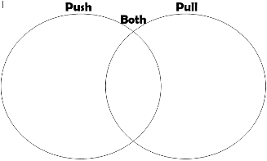  Draw your groups or take photographs and stick them in your book.  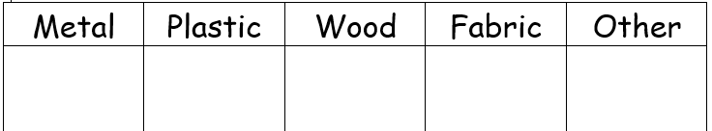
Play it | Write it | Watch it
Play a game with someone in your family, it could be one where you have to take turns and follow rules. It might be a board game, a card game or a different game altogether. Think about why it is important to take turns and follows the rules when you are playing the game.  Ask an adult to take a photograph of you playing your game. Draw and write about your game and write a sentence or two to describe it. | Write a list of 5 of your toys at home.  Write some sentences about one of your toys: how long have you had it, how you play with it, its name, what materials it is made from or anything else you would like to tell me about it. | Watch one of the Toy Story films with your family.  Write the title of the film.  Draw a picture of your favourite part of the film and write a sentence about what happened.  