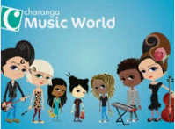

Music Curriculum

Music Overview

 | Autumn Term |  | Spring Term |  | Summer Term
 | Autumn 1 | Autumn 2 | Spring 1 | Spring 2 | Summer 1 | Summer 2
Rec | Me! | My stories | Everyone! | Our World | Big Bear Funk | Reflect, Rewind and Replay
Year 1 | Hey you! | Rhythm in the way we walk and the Banana Rap | In the Groove | Round and Round | Your Imagination | Reflect, Rewind and Replay
Year 2 | Hands, Feet, Heart | Ho ho ho | I Wanna Play in a Band | Zootime | Friendship Song | Reflect, Rewind and Replay
Year 3 | Let your spirit fly | Three Little Birds | Recorder Course |  | The Dragon Song | Bringing Us Together
Year 4 | Mamma Mia | Stop! | Glockenspiel Course |  | Lean on Me | Blackbird
Year 5 | Livin on a Prayer | Make me feel your Love | Ukele Course |  | The Fresh Prince of Bel Air | Dancing in the Street
Year 6 | Happy! | Classroom Jazz 1 and 2 | A New Year Carol | You’ve got a Friend | Music and Me |  | Reflect, Rewind and Replay

Music Skills Progression

Nursery
Join in with dancing and ring games.
Sings a few familiar songs.
Begin to move rhythmically in response to music.
Taps out simple repeated rhythm
Use movement to express feelings.
Sings to self and makes up simple songs.

Reception
-Listen and respond to different styles of music
Learn to sing or sing along with nursery rhymes and action songs
-Use voices expressively and creatively
-Play tuned and un-tuned instruments
-Listen with concentration and understanding to a range of music
-Experiment with, create, select and combine sounds

KS1
Listening and Appraising | - To know that music has a steady pulse, like a heartbeat.  ● To know that we can create rhythms from words, our names, favourite food, colours and animals.  - To know and recognise the sound and names of some instruments  - To know that rhythms are different from the steady pulse.  ● To understand the term pitch - high and low sounds
Singing | To learn how to sing notes of different pitches (high and low).  ● To learn that they can make different types of sounds with their voices – you can rap or say words in rhythm.  ● To learn to start and stop singing when following a leader.  - To know that unison is everyone singing at the same time.
Playing | - To learn the names of the notes in their instrumental part from memory or when written down.  ● To learn the names of the instruments they are playing.  To treat instruments carefully and with respect.  ● To play a tuned instrumental part with the song they perform.  ● To play an instrumental part that matches their musical challenge, using one of the differentiated parts (a one-note part, a simple part, medium part).  ● To listen to and follow musical instructions from a leader  - To know the names of untuned percussion instruments played in class.  - To play the part in time with the steady pulse.
Composing | - To create a simple melody using one, two or three notes.  ● To learn how the notes of the composition can be written down and changed if necessary
Gospel Values | To learn songs which tell gospel stories  To appreciate that songs can be prayers- listen to a variety  To appreciate that we are made in the image and likeness of God- we all have talents, listen to different musicians

LKS2
Listening and Appraising | To identify any musical dimensions featured in the song, and where they are used (texture, dynamics, tempo, rhythm and pitch)  To identify the main sections of the song (introduction, verse, chorus etc.)  To name some of the instruments they heard in the song  To confidently identify and move to the pulse.  To know the difference between pulse and rhythm.  To know how pulse, rhythm and pitch work together to create a song.  To know that every piece of music has a pulse/steady beat.
Singing | To sing in unison and in simple two-parts.  ● To demonstrate a good singing posture.  ● To follow a leader when singing.  ● To enjoy exploring singing solo.  ● To sing with awareness of being ‘in tune’.  ● To have an awareness of the pulse internally when singing.  ● To re-join the song if lost.  ● To listen to the group when singing.
Playing | To treat instruments carefully and with respect.  To play any one, or all four, differentiated parts on a tuned instrument – a one-note, simple or medium part or the melody of the song from memory or using notation.  To rehearse and perform their part within the context of the Unit song.  To listen to and follow musical instructions from a leader.  To experience leading the playing by making sure everyone plays in the playing section of the song.
Composing | To create at least one simple melody using one, three or all five different notes.  To plan and create a section of music that can be performed within the context of the unit song  To listen to and reflect upon the developing composition and make musical decisions about pulse, rhythm, pitch, dynamics and tempo.  To record the composition in any way appropriate that recognises the connection between sound and symbol (e.g. graphic/pictorial notation).
Gospel Values | To be grateful for the ability to refine our talents – chance to learn a variety of instruments  To work collaboratively and compassionately to create compositions  To actively seek to develop our musical skills  To share and listen to opinions about music
UKS2
Listening and Appraising | To be able to talk about the style indicators of the songs (musical characteristics that give the songs their style  To discuss any musical dimensions featured in the songs and where they are used (texture, dynamics, tempo, rhythm, pitch and timbre)  To Identify the structure of the songs (intro, verse, chorus etc.)  To name some of the instruments used in the songs  To discuss the historical context of the songs - What else was going on at this time, musically and historically?  To identify and move to the pulse with ease.  .To compare two songs in the same style, talking about what stands out musically in each of them  To use musical words when talking about the songs.  To talk about the music and how it makes you feel, using musical language to describe the music.
Singing | To sing in unison and to sing backing vocals.  To demonstrate a good singing posture.  To follow a leader when singing.  To experience rapping and solo singing.  To listen to each other and be aware of how you fit into the group.  To sing with awareness of being ‘in tune’.
Playing | To know the notes C, D, E, F, G, A, B + C on the treble stave  To play a musical instrument with the correct technique within the context of the Unit song.  To select and learn an instrumental part that matches their musical challenge, using one of the differentiated parts – a one-note, simple or medium part or the melody of the song from memory or using notation.  To rehearse and perform their part within the context of the Unit song.  To listen to and follow musical instructions from a leader.  To lead a rehearsal session.
Composing | To create simple melodies using up to five different notes and simple rhythms that work musically with the style of the Unit song.  To listen to and reflect upon the developing composition and make musical decisions about how the melody connects with the song.  To record the composition in any way appropriate that recognises the connection between sound and symbol (e.g. graphic/pictorial notation).
Gospel Values | To be hopeful for the future of music based on what we know from the past  To understand the meaning behind music and songs and respond compassionately  To be curious about developments in music throughout history  To understand how music can be used to develop our spiritual understanding and skills – meditation music during worship  music

Me!
Learn to sing nursery rhymes and action songs:
Pat-a-cake
1, 2, 3, 4, 5, Once I Caught a Fish Alive
This Old Man
Five Little Ducks
Name Song
Things for Fingers

Big Bear Funk
Listening and appraising Funk music
Embedding foundations of the interrelated dimensions of music using voices and instruments
Learning to sing Big Bear Funk and revisiting other nursery rhymes and action songs
Playing instruments within the song
Improvisation using voices and instruments
Riff-based composition
Share and perform the learning that has taken place

Our World
Learn to sing nursery rhymes and action songs:
Old Macdonald
Incy Wincy Spider
Baa Baa Black Sheep
Row, Row, Row Your Boat
The Wheels On The Bus
The Hokey Cokey

Everyone!
Learn to sing nursery rhymes and action songs:
- Wind The Bobbin Up
- Rock-a-bye Baby
- Five Little Monkeys Jumping On The Bed
- Twinkle Twinkle
- If You're Happy And You Know It
- Head, Shoulders, Knees and Toes

My Stories.
Learn to sing nursery rhymes and action songs:
I’m A Little Teapot
The Grand Old Duke Of York
Ring O’ Roses
Hickory Dickory Dock
Not Too Difficult
The ABC Song

Reflect, rewind and replay
This Unit of Work consolidates the learning that has occurred during the year. All the learning is focused around revisiting chosen nursery rhymes and/or songs, a context for the History of Music and the very beginnings of the Language of Music.
Reception Music Overview

Year 1 Music Overview
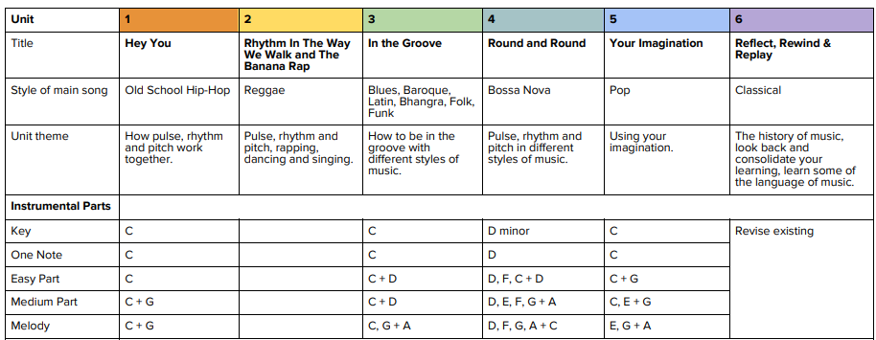

Year 2 Music Overview

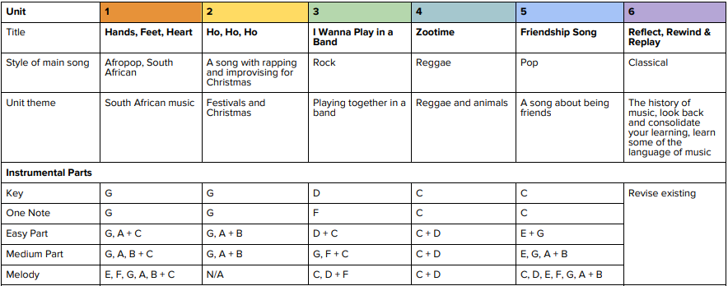

LKS2 Year A Music Overview

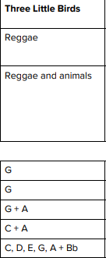
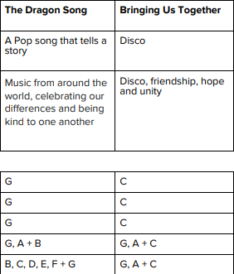
Recorder Course

Charanga Musical School’s Recorder Course is built around sixteen progressive pieces with fabulous interactive backing tracks. Pupils will learn the basics of how to play musically, the language of music and the first three notes; B, A and G.

There is also the chance to move onto other notes with the Blown Away Recorder books which are also available on charanga.

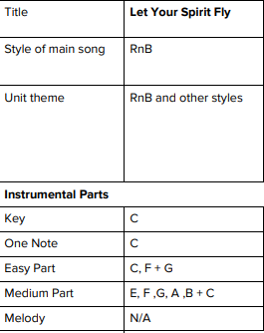

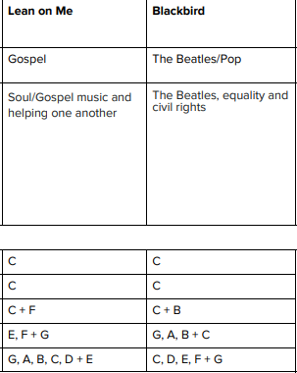
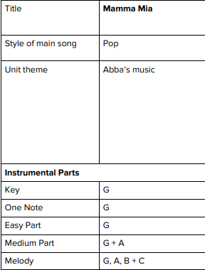
LKS2 Year B Music Overview

Glockenspiel Course

Children to work through Glockenspiel Stage 1 and Stage 2

The units introduce the children to learning about the language of music through playing the glockenspiel.

The learning is focused around exploring and developing playing skills through the glockenspiel and the recorder skills from Year 3 can also be integrated.

UKS2 Year A Music Overview

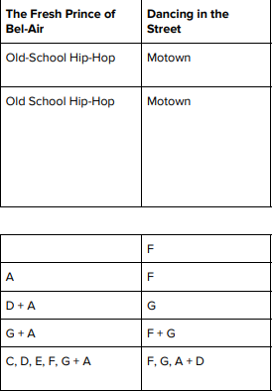
Ukele Course

Charanga Musical School’s Ukulele course is built around eighteen songs that take beginners from playing open strings to songs that use three chords. Pupils will learn the chords C, F, G7 and G in order of difficulty, beginning with the easiest; the chord of C.
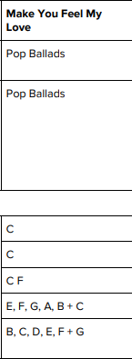
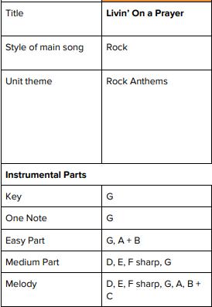

UKS2 Year B Music Overview

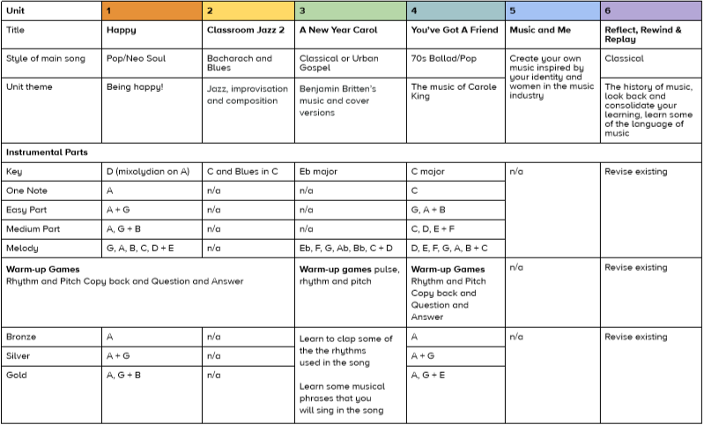

Assessment

KS1  Year 1 WTS (less than 6 bullet points)  Year 1 WW(6 – 8 bullet points)  Year 1 GDS (more than 8 bullet points)  Year 2 WTS (less than 10 bullet points)  Year 2 WW (10 – 12 bullet points)  Year 2 GDS (15 - 16 bullet points) | LKS2  Year 3 WTS (less than 3 bullet points and mainly bronze)  Year 3 WW (4 – 5 bullet points and mainly silver)  Year 3 GDS (more than 5 bullet points and mainly gold)  Year 4 WTS (less than 7 bullet points and mainly bronze)  Year 4 WW (7 – 8 bullet points and mainly silver)  Year 4 GDS (9 – 10 bullet points and mainly gold) | UKS2  Year 5 WTS (less than 3 bullet points and mainly bronze)  Year 5 WW (4 – 5 bullet points and mainly silver)  Year 5 GDS (more than 5 bullet points and mainly gold)  Year 6 WTS (less than 7 bullet points and mainly bronze)  Year 6 WW (7 – 8 bullet points and mainly silver)  Year 6 GDS (9 – 10 bullet points and mainly gold)
- Find the pulse as they are listening to the music  - Recognise and name two or more instruments they hear  - Copy back the rhythms they hear  - Clap the rhythm of their name over the track  - Clap the rhythm of your favourite colour.  - Create their own rhythm for others to copy  - Rap and sing in time to the music  - Lead the groups that are rapping and singing  - Play accurately and in time as part of the performance.  - Start to understand that pitch is high and low sounds.  - Dance to each style or move to the pulse  - Compose a simple melody using simple rhythms  - Identity five different musical styles: Blues, Baroque, Latin, Irish Folk, Funk and name some of them.  - Recognise that songs sometimes have a question and answer section and a chorus.  - Freestyle finding the pulse.  - Understand that songs have a musical style. | - Find the pulse while listening.  - Identify funky rhythms, tempo changes, and dynamics.  - Identify the instruments/voices you can hear  - Know the difference between pulse and rhythm.  - Know how pulse, rhythm and pitch work together to create a song.  - Identify the piece’s structure: Introduction, verse, chorus.  - Copy back, play, invent rhythmic and melodic patterns.  - Sing in unison  - Identify changes in texture.  - Make their own musical decisions - creating musical ideas for the group to copy or respond to.  NB: Within the scheme there are Bronze, Silver and Gold challenges based on the range of notes accessed by the children – this will need to be taken into account when forming a judgement | - Know the pulse, rhythm, pitch, tempo, dynamics, texture and structure work together to make a song sound interesting  - Identify the structure of songs in different styles  - Compare and contract music from different styles  - Identify a wide range of instruments  - Sing in two parts  - Complete rhythm and pitch copy back activities  - Take on a musical leadership - creating musical ideas for the group to copy or respond to  - Describe the style indicators of the song/music  - Talk about the musical dimensions used in the song  - Describe the mood created by the piece  NB: Within the scheme there are Bronze, Silver and Gold challenges based on the range of notes accessed by the children – this will need to be taken into account when forming a judgement

