St Giles’ and St George’s Primary Academy
Homework Menu
Class: Reception Topic: Marvellous Me! Term: Autumn 1
Set Menu: Daily reading, sound fans
We are asking children to read at least 3 times each week and for parents to record this in their child’s reading record. Listening to children read will enable them to practise their sounds and develop their reading fluency. Please talk to your child about their book, the pictures inside and what might happen next. This will help to develop their comprehension skills and have a better understanding of the text. We will be sharing a variety of texts related to our Marvellous Me topic and helping your child to foster a love of books. We are grateful for your support with this. We also ask that you practise saying the sounds and tricky words on your sound fan daily.
Added Extras:
Please encourage your child to complete as many activities from the menu as they can, but NO LESS than 3 over the half term. Please record the activities in your child’s homework book, this can include photographs. We will ask for homework books handed in during the last week of each half term, in order for us to share and celebrate this learning.

Draw it | Practise it | Research it
Draw and label a picture of your friends and family. Have a go at writing the beginning sound of each person that you have drawn. | Practise getting yourself dressed and undressed like we do for PE. Practise fastening and unfastening zips, buttons and the velcro on your shoes. | Talk to your family members about your family tree, then present it in whichever way you wish. Go back as far as you can.
Create it | Photograph it | Sing it
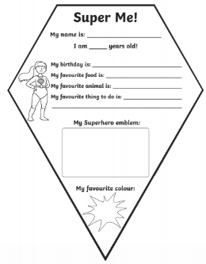  Complete the ‘Super me’ bunting sheet in your book so that we can create a class of ‘Super Me’s’. | 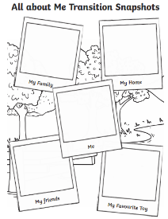  Complete the ‘all about me’ photograph sheet in your books. As an alternative, you could draw pictures or present your photographs in a different way to create your own poster. | 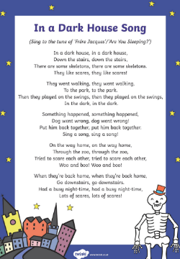  Have a go with a family member at learning the ‘In a dark house’ song. Why not try putting some actions to it?’

