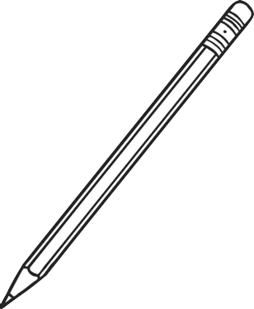
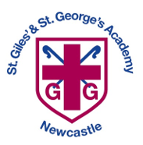
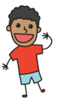
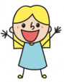
All About Me
Nursery Transition Booklet
My name is:
I was born on:
Me


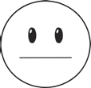
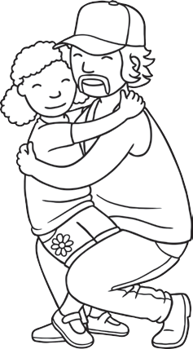
People Who Are Important to Me
Things I Would Like You to Know About Me
My family:
My special friends:
I like:
I don’t like:

Approach to learning,
disposition and attitude:
Things I can do:
(E.g Separate from main carer, settle within the group, communicate with adults, self-care, etc.)
Other people who are important to me:
1
Nursery Transition
twinkl.com
2

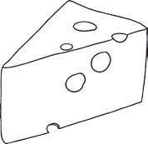
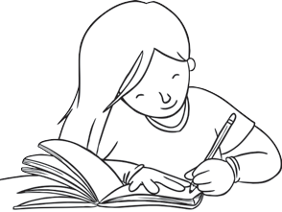
Things I Would Like You to Know About Me
Things I Would Like You to Know About Me
My favourite toys:
My favourite rhymes/stories:
Special things I need (dietary requirements, healthcare plan, etc.):
My special skills, sign language, words or symbols:
My family and I celebrate (religious celebrations, etc.):
My experience of being away from home (childcare etc.):
Things I need help with:
3
Nursery Transition
twinkl.com
4

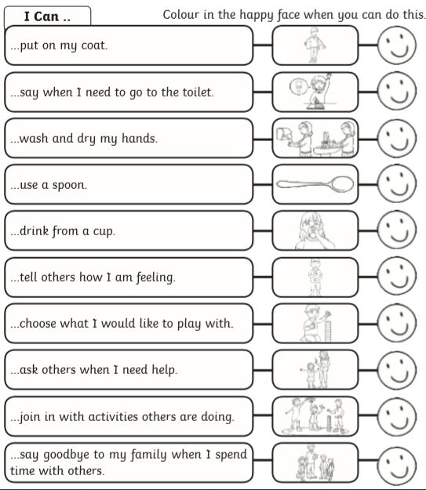
Box for Parents
Is there anything else you would like us to know about your child? Is there anything that you think would be useful for us to know?

5
Nursery Transition
twinkl.com
6

Nursery Readiness Checklist

