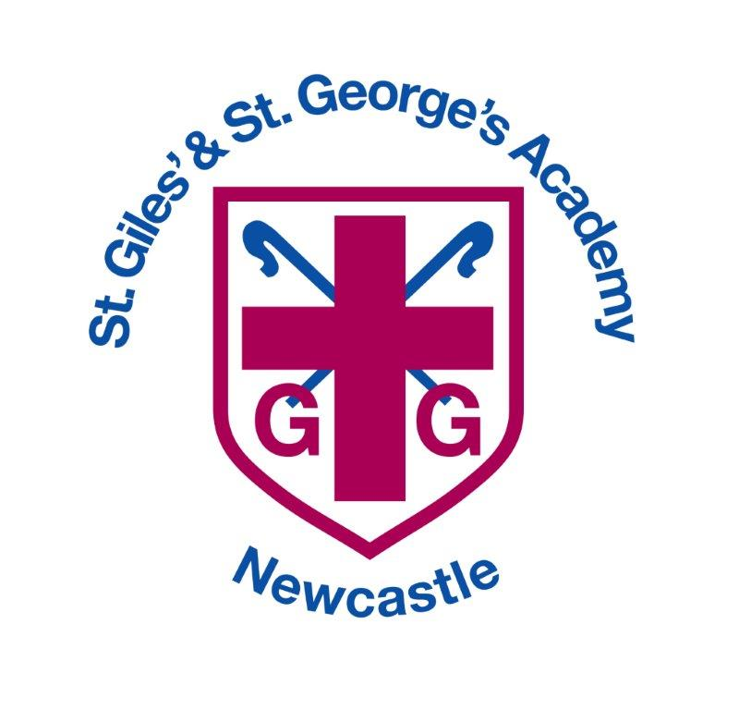

MfL (French) Curriculum – KS2

LKS2 French

 | Unit 1 | Unit 2 and 8 | Unit 3 and 7
French Unit Title | BONJOUR! | EN CLASSE  QUELLE HEURE EST-IL? | MON CORPS  ENCORE!
French Key Objectives | - Greet and say goodbye to someone  - Ask someone’s name and say your own  - Ask how someone is and respond to the same question  - Learn some basic nouns  - Count numbers 1 – 10  - Project work – French Chateaux | - Identify classroom objects  - Identify colours and describe and object’s colour  - Say your age  - Recognise and repeat classroom instructions  Extension  Unit 8  - Talk about activities  - Tell the time  - Talking about what time you do activities | - Identify parts of the body  - Describe eyes and hair appearance  - Recognise days of the week  - Give basic character descriptions  - Project work – Famous French People  Extension  Unit 7  - Revise ways of describing people  - Describe someone’s nationality  - Describe people using various adjectives

UKS2 French

French Unit Title | Unit 4 | Unit 5 | Unit 6 and 11
French Key Vocab and Objectives | LES ANIMAUX | MA FAMILLE | BON ANNIVERSAIRE!  ON MANGE!
 | - Identify animals and pets  - Recognise and use numbers 11 – 20  - Give someone’s name  - Describe someone  - Project work – Pets  Extension  Unit 9 Lesson 3 Count from 31 – 60  Unit 12 Lesson 3 and 4 - clothes | - Identify family members  - Recognise and spell with letters of the alphabet  - List household items  - Use basic prepositions sue and dans to describe position  - Project work – Alphabet Chart | - Recognise and  - ask for snacks  - Give basic opinions about food  - Use numbers 21 – 31  - Recognise and use months  - Form dates  Extension  Unit 11  - Go shopping for food  - Ask how much something costs  - Talk about activities at a party  - Give opinions about food and various activities

Year 3 Assessment Grid

UKS2 French and Speaking and Listening

Year 4 Assessment Grid

Year 4 Assessment Grid
Year 5 Assessment Grid

Year 6 Assessment Grid

