
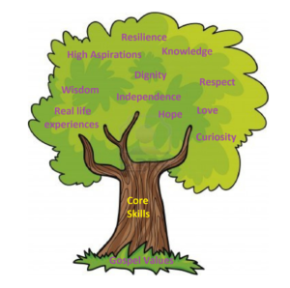

Units: The Human Body, Seasonal Changes

Key questions/ experiments:
Do the oldest children have the longest feet?

What are the main changes each season?
Art/Design Technology
Text: Dogger
Skills:
Continue to write simple sentences with capital letters, finger spaces and full stops.
Begin to generate their own more complex sentences.

Art – Drawing – Making your Mark
Show control when using string and chalk to draw lines. Experiment with a range of mark-making techniques, responding appropriately to music. Colour neatly and carefully, featuring a range of different media and colours. Apply a range of marks successfully to a drawing. Produce a drawing that displays observational skill, experimenting with a range of lines and mark making.

Unit: Improving Mouse Skills
Overview:
Use computers more purposefully
Log in and navigate around a computer
Drag, drop, click and control a cursor using a mouse
Use software tools to create art on the computer
E-Safety: Using the internet safely
Unit: Being Me in my World.
Overview:
Help others to feel welcome
Try to make our school community a better place
Think about everyone’s rights
Care about other people’s feelings
Work well with others.
Unit: Creation
Religion: Christianity

Key Question: Who made the world?
Religious Education
Unit: Keeping the Pulse
Key Skills:
Clap the rhythm of their name.
Tap in time to the pulse.
Sing a rhythm in time with the pulse.
Copy and create rhythms based on word pattern.
Keep the pulse while playing an instrument
Year 1 Curriculum Overview – Autumn 1

Units: White Rose – Place Value within 10, Addition and Subtraction within 10
Objectives include:
- Sort, count and represent objects
- Count forwards and backwards
- Find one more and one less
- Compare numbers and begin to use <>=
- Order numbers
- Explore a number line
- Add and subtract within 10
Author of the Half Term: Shirley Hughes
Fundamentals
Pupils will explore skills of balancing, running, changing direction, jumping, hopping and skipping. Pupils will be given opportunities to identify areas of strength and areas for improvement. Pupils will work collaboratively with others, taking turns and sharing ideas.
Forest School
Physical Education
English
Science
History - School/ Toys
Key Question: What was life like in the past?

- To know similarities and differences between their lives and those in the past.

Mathematics
Computing
Humanities
PSHCE
Music

